**Keeping Up with the Clock: Real-Time Systems Demystiﬁed**



## Welcome to Real-Time Systems

Let's dive into the world of *real-time systems* and understand how they keep up with the clock. We'll explore the challenges and benefits of  .

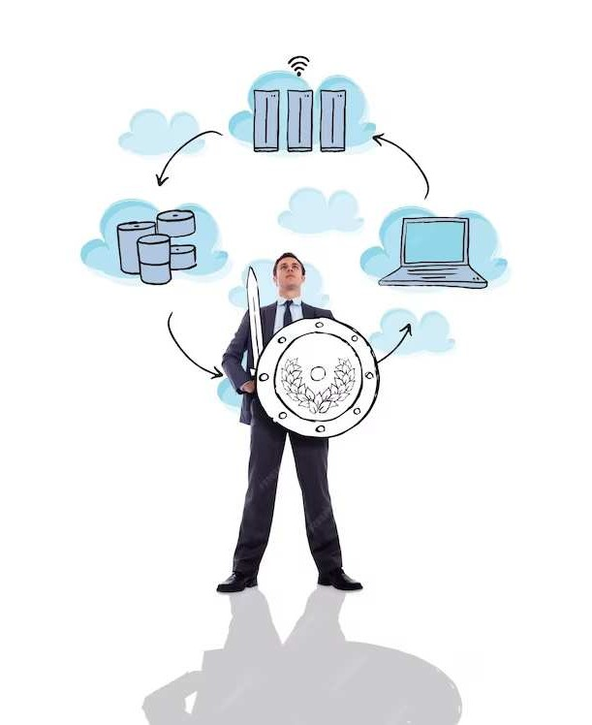

# Understanding Real-Time Concepts

What does *real-time* really mean? We'll

demystify the concept and explore the difference between  and

 systems.



**The Importance of Timing**

Timing is everything in the world of real-time systems. We'll discuss the critical role of  and  in ensuring timely performance.



**Challenges in Real-Time Processing**

Real-time systems come with their fair share of challenges. We'll explore the complexities of

, and



,

.

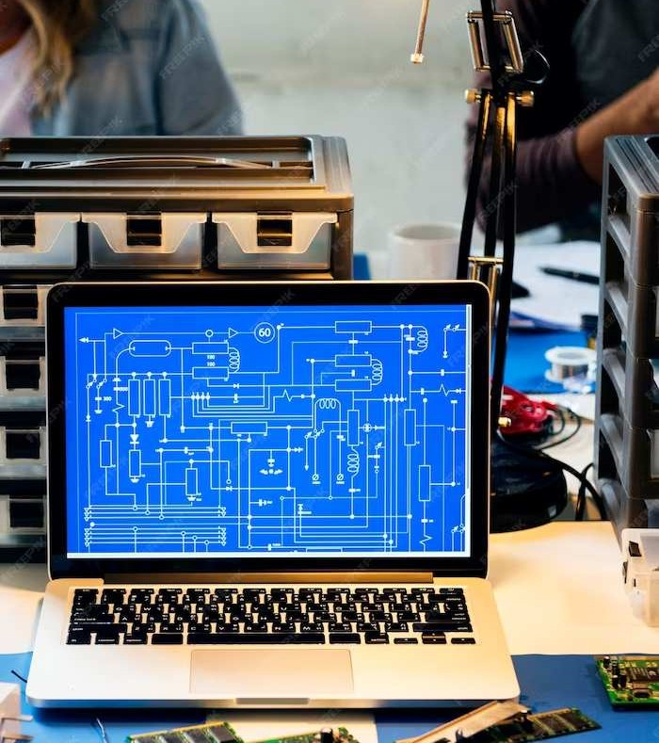

## Real-Time Operating

**Systems**

What makes an operating system suitable for real-time applications? We'll delve into the key characteristics of  and

their unique features.

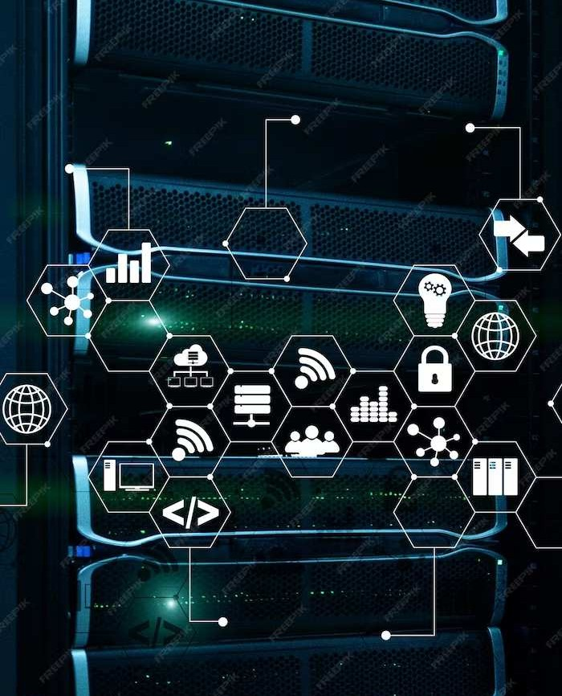

## Real-Time Communication Protocols

Communication is vital in real-time systems. We'll explore such as  and that facilitate seamless data exchange in real-time.

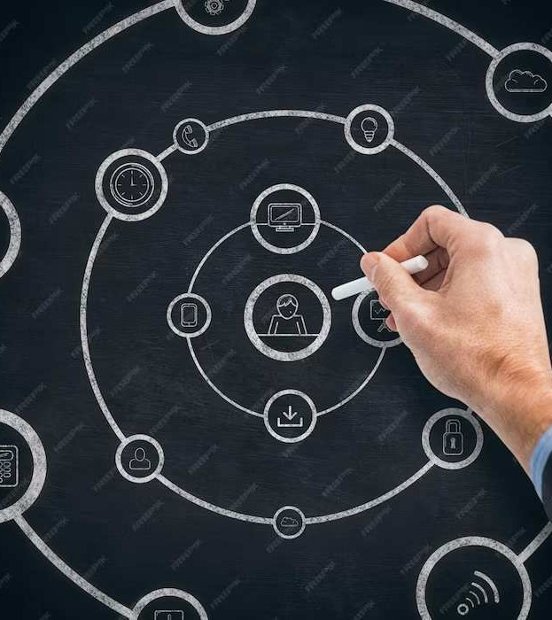

# Real-Time System Design

Designing for real-time requires careful consideration of , , and . We'll discuss best practices for building robust real-time

systems.

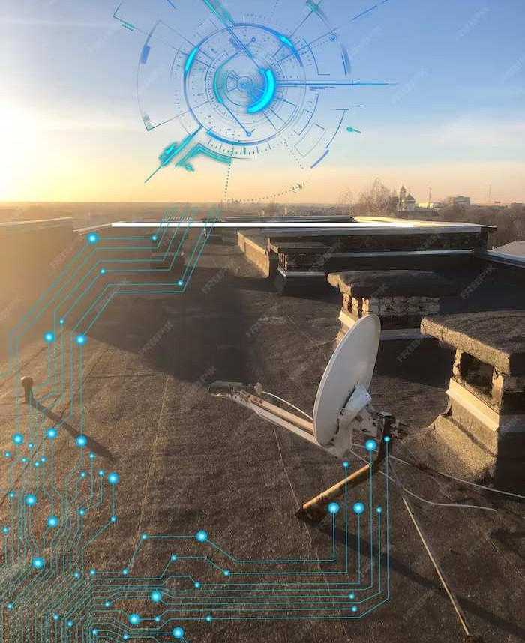

**Real-Time Applications**

Real-time systems are everywhere! From  to ,

we'll explore diverse applications that rely on real-time processing for critical operations.

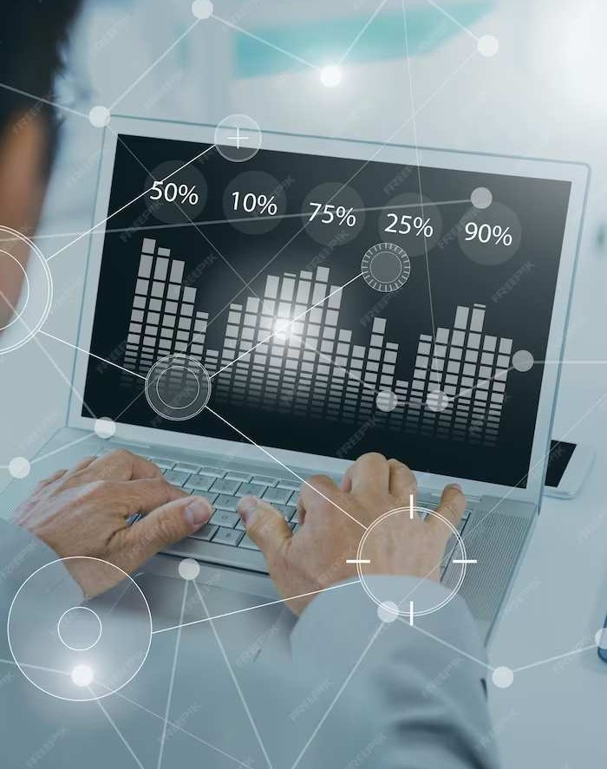

**Performance Optimization**

How do we ensure optimal performance in real- time systems? We'll uncover strategies for

, and



,

.



# Security in Real-Time Systems

Securing real-time systems is

paramount. We'll discuss

 and to

safeguard real-time data and prevent unauthorized access.

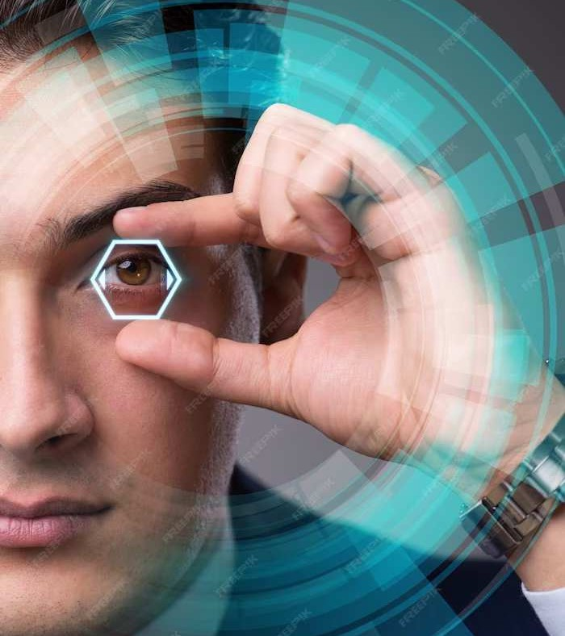

**Future Trends in Real-Time Technology**

What's on the horizon for real-time systems? We'll explore emerging trends such as ,

, and

shaping the future of real-time technology.



## Embracing Real-Time

**Innovation**

Real-time systems continue to evolve. It's time to embrace the potential of

 and leverage its capabilities for a dynamic future.



**In Conclusion: Embracing Real- Time Systems**

From understanding the essence of real-time to exploring its diverse applications, we've demystified the world of

. Let's keep up with the clock and embrace the power of real-time technology!

**Thanks!**

Do you have any questions? [akhilkoushik2035@email.com](mailto:akhilkoushik2035@email.com)

+91 7906919090

Akhil koushiik

