IPM

### Design rules

supported by psychological, cognitive, ergonomic, sociological, economical or computational theory.

Designers do not always have relevant background in these areas.

Designer rule used to increase the usability of a software product

**Dimensions**

– **Authority**: indication of whether a rule must be followed or whether it is just a suggestion.

– **Generality**: indication of whether the rule can be applied to many design situations or whether it can be only applied in some particular situations.

Design rules

* **Standards** (+ authority, - generality)
* Set by national or international institutions to ensure compliance with a set of design rules by a large community (uniformity, compatibility).
* Requires consistent underlying theory (stable).
* Hardware/software standards.
* High authority.
* **Guidelines** (- authority, + generality)
* Suggestive and more general
* Several books and technical reports contain huge catalogues of guidelines.

more general a design rule is, the greater possibility of it having a conflict with other rules.

**Metrics from ISO 9241**

* Usability
* Effectiveness
* Efficiency
* Satisfaction

### Schneiderman’s 8 Golden Rules

1. Strive for consistency
2. Seek universal usability
3. Offer informative feedback
4. Design dialogs to yield closure
5. Prevent errors
6. Permit easy reversal of actions
7. Keep users in control
8. Reduce short-term memory load

### Norman’s 7 Principles

1. Use both knowledge in the world and knowledge in the head.
2. Simplify the structure of tasks.
3. Make things visible: bridge the gulfs of Execution and Evaluation.
4. Get the mappings right.
5. Exploit the power of constraints, both natural and artificial.
6. Design for error.
7. When all else fails, standardize

### HCI Design Patterns

An approach to reusing knowledge about successful design solutions

A pattern is an invariant solution to a recurrent problem within a specific context.

Examples:

Light on Two Sides of Every Room (architecture)

### Visual information

Information consists of differences that makes the difference.

# Use of color

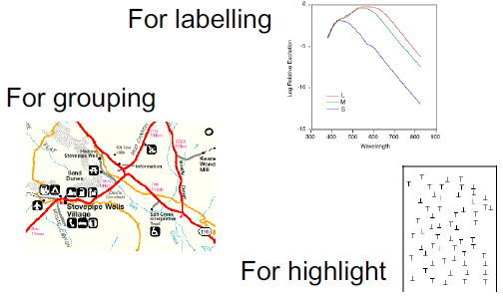

Use colours sparingly, for specific purposes

Use colour consistently across all of the user's applications

Avoid overuse of saturated colours and for small fields, this couse visual fatigue, because the eye must keep refocusing on different wavelengths

## Colour Interaction

The apparent colour of a target is always affected by the physical colour of adjacent areas, in space and time.

Symbols drawn with longwave light (reds) appear different in depth from shortwave (blues) symbols.

RED - there will have one different red in each of your minds (coca cola)

#### Simultaneous contrasts

In the top panel they have roughly the same appearance.

In the lower left panel, however, the pair that are physically identical have different colour appearances due to the simultaneous contrast effects of the green and magenta backgrounds.

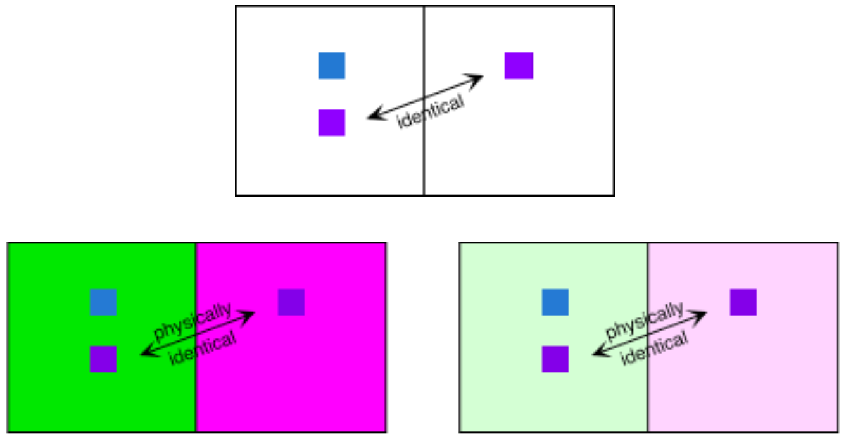

#### Successive contrasts

Successive contrast is the effect of previously-viewed colour fields ("inducing fields") on the appearance of the currently-viewed test field.

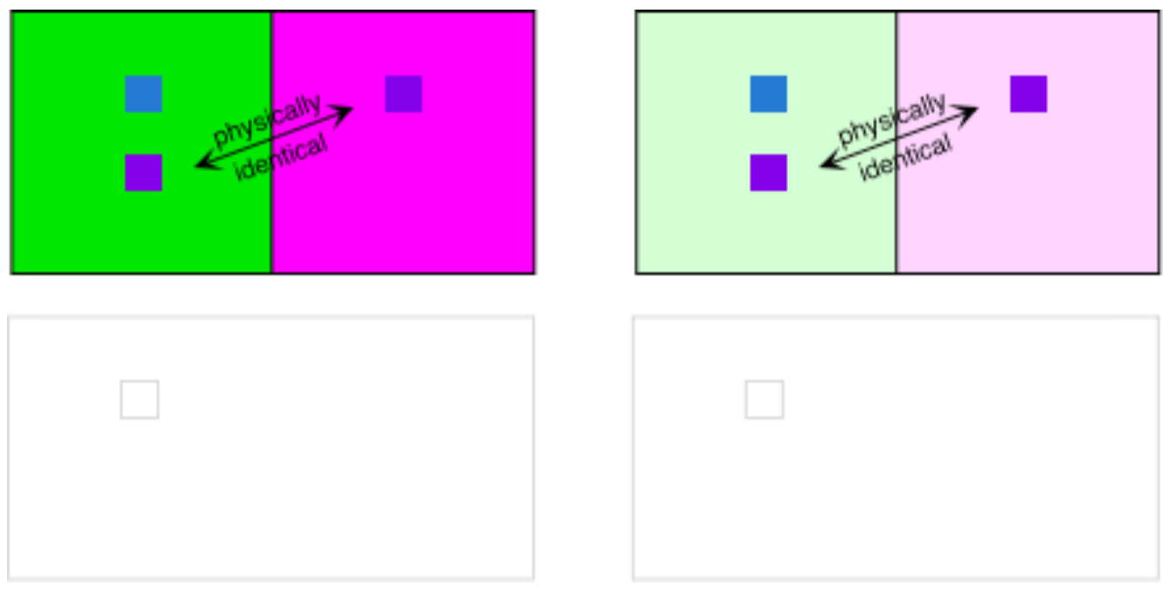

#### Spatial proximity

The effects of the inducing fields are largest when they are immediately adjacent to the test fields, and they fall off rapidly with increasing spatial separation of the fields.

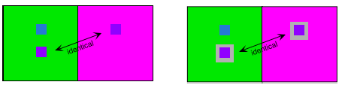

#### Temporal proximity

The effects of inducing fields are largest when they are viewed immediately prior to viewing the test field. Most of the after effect usually fades within several seconds, but in the majority of graphic applications this is long enough to be a serious problem.

## Legibility

Users' ability to read and discriminate the shapes of the symbols in the graphic.

**Luminance contrast:** brightness difference between symbols and their backgrounds.

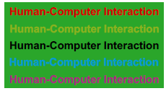

A symbol with the same luminance as its background will usually be illegible.

Get adequate luminance contrast.

Large hue differences between the text and background aren't enough to overcome insufficient luminance contrast.

**Blue primary**

Pure blue should not be used for fine detail or background

Yellow differs from white only in the absence of the blue primary, so they also make poor symbol/background combinations.

Blue can be used in most contexts if care is taken to achieve adequate luminance contrast

Use a pale blue (adding yellow light, increasing the luminance but decreasing the purity) on the black or outline the text

## Colour discrimination and identification

Small colour differences can be distinguished when the areas to be discriminated are:

* large,
* immediately adjacent to each other (share an edge near the viewed point)
* displayed at the same time.

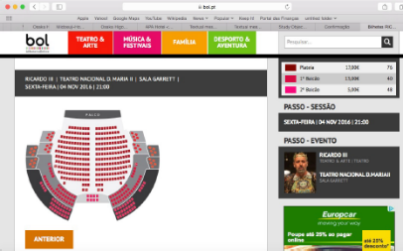Ex: visualization of quantized continuous data as in maps of weather or terrain.

* Colour discrimination is best when a sharp edge separates the colours to be discriminated.
* When a smooth gradient separates two colours, the difference of colour appearance is reduced.

#### Guidelines

* Use no more than six colours to label graphic elements
* Use colours in conformity with cultural conventions
* Use colour coding consistently across displays and
* pages
* Use colour coding redundantly with other
* graphic dimensions
* Don't use colour coding on small graphic
* elements
* Use neutral grey surrounds where colour
* judgments are critical
* Avoid saturated colours

#### ColorADD

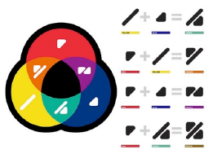 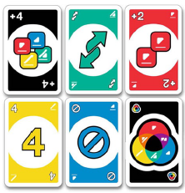

## Chosing Colour

Use colours schemes that seem to work well in other interfaces

Pick one colour and several shades of grey

Two colours at most (ask opinions)

Extract colours from a natural scene photograph

### Graphic design

Graphic design is the first and the last part of the user interface observed by the user.

Designers are constantly asked to resolve conflicting demands imposed by the problem, the budget, the schedule, and the desired quality level

* trade-offs must be continuously identified, evaluated, and decided on the basis of the best information available.
* **Functional** criteria govern the range of possibilities that can be explored
* **Aesthetic** possibilities that are not compatible with this minimum standard of usability must be discarded.

#### Guidelines:

* Simplicity (Less is more)
* Contrast
* White space
* Balance
* Alignment

# Simplicity

**Reduction**

* remove inessential elements

**Regularity**

* Use regular patterns
* Limit inessential variations among elements
* Make sure critical elements intended to stand out in the display are not regularized

**Combining elements for maximum leverage**

* Let elements play multiple roles
* Too much leverage can cause problems if it introduces
* complex mappings that must be remembered by the user

# Contrast

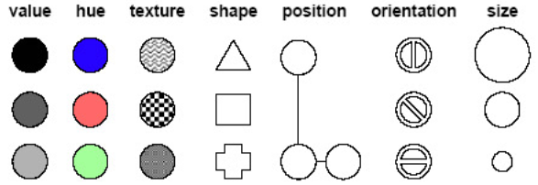

## Visual variables

**Scale** (kinds of comparisons):

* + - Nominal (equality comparison) 🡪 All variables
    - Ordered (> < comparison) 🡪 Position, size, value, texture granularity
    - Quantitative (compare amount of difference) 🡪 Position and size;

**Length** (number of possible values on each dimension):

* + - Shape: long (infinite variety)
    - Position: long (limited by display size and resolution) and fine-grained
    - Orientation: very short (+- 4 levels)
    - Other variables (+- 10 levels)

#### Interaction among visual variables

* 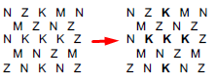Size and value are dissociative (they dominate perception and disrupt the processing of other correlated dimensions). It is difficult to determine the hue of a very small dot or thin line
* Shape is not selective

## Techniques for contrast

* Choose appropriate visual variables.
  + - Use as much length as possible (but minimize the number of distinct values)
    - Sharpen distinctions for easier perception:
* Multiplicative scaling, not additive
* Redundant coding when needed
* Cartoonish exaggeration when need
  + - “Squint test”

# White space

* Use white space to group interface elements.
* Use margins around interface elements.
* Objects should be scaled proportionally to its background.
* Do not crowd controls together, crowding creates spatial tension and inhibits scanning

Used to: separate; structure; highlight

# Balance and Symmetry

* Choose an axis (usually vertical)
* Distribute elements equally around the axis

## Typography

* **Displaying text on screen**: Key decisions - font and spacing
  + - **Reading process:** fixation and saccades
    - **Readability**: effectiveness of the whole reading process - Metrics: Speed, comprehension, error rate, subjective preference

**Proportional** (different character width) VS. **Monospace** (same character width)

## Font selection

* Don’t use more than 2 or 3 typefaces
* Use size, style and colour to establish contrast (Size – hierarchy)

## Spacing

Always leave margins around text

# Alignment

## Gestalt principles explain group recognition

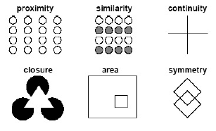

### Evaluation techniques

Goals:

System’s functionalities

Interface impact on the user

Identification of system’s specific problems

# GOMS

Modelling techniques to analyse the complexity of interactive systems.

User behaviour is modelled in terms of:

Goals

State what the user wants to achieve hierarchical decomposition in sub-goals.

Operators

Elementary perceptual, motor or cognitive actions that must be executed to achieve the goal.

Methods

Procedures that describe how to accomplish goals, it consists in the exact sequence of steps required to achieve the goal (may be several possible methods to achieve the same goal).

Selection rules

Are used to determine which method should be used when there are several possible methods.

Used for:

* Verify functionalities
* Preview execution times
* Qualitative previews about the tasks where users make few errors

## Keystroke level model

Provides numeric previews about user’s performance. Compares the time required to complete a task using the different possible methods.

* + - K - key stroking
    - P - pointing
    - H - homing
    - B - button pressing
    - D – drawing line (mouse)
    - M - mental preparation
    - R – system response
    - Times are empirically determined (T=Task).

Execution time for a task is estimated through the sequence of operators that compose the method, adding the times associated with each operator. A good preview – error 20%

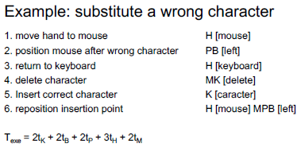

## Advantages of GOMS

* Helps to find usability problems.
* Saves time and resources.
* Easy to build a simple model.
* **Predictive**: predict the time it will take a user to perform the tasks under analysis, as long as the developer can come up with time estimates for the operators involved in each model.
* **Descriptive**: it is a representation of the way a user performs tasks on a system. The methods, sub-goals and selection rules provide the designer with a description of the process.
* **Prescriptive**: it can serve as a guide for developing training programs and help systems.

## Limitations

• Previews are only valid for experienced users, who do not make errors.

• Do not consider differences between users (statistical average for operator’s execution time).

• Do not consider the social impact nor the user satisfaction.

### Heuristic Evaluation

Executed by an expert and based on analysis and judgement.

Pode ser aplicada a Sketches, paper prototypes and unstable prototypes

Process:

* Evaluator exhaustively inspects the interface
* Compare the interface against heuristics
* Elaborate a list of usability problems: explains and justify each problem according to heuristics.
* Use several evaluators: Different evaluators find different problems -> Each new evaluator finds few new problems | 3-5 evaluators to best cost/benefice

# Usability heuristics – J. Nielsen

1. **Visibility of system status**

* “Feedback”
* Keep the user informed about the system state

1. **Match the real world**

* “Speak the user language”
* Use common words

1. **User control & Freedom**
   * “Clearly Marked Exits”
   * Users should not be trapped by the interface
2. **Consistency & Standards**

* Similar things should look and act similar

1. **Error prevention**

* Don’t give users the opportunity to make errors
* Selection is less error-prone than typing

1. **Recognition, Not Recall**

* All needed information should be visible

1. **Flexibility & Efficiency of use**

* Shortcuts for frequent operations

1. **Aesthetic and Minimalist Design**

* Simplicity
* Less is more
* Concise language

1. **Error reporting, diagnosis, and Recovery**

* Good error messages should be: precise, constructive, polite and hide technical detail

1. **Help & Documentation**

* In general, users don’t read user guides except when they have no other choice

## Formal process

#### Training

* + Meeting for design team and evaluators
  + Application, target users, scenarios, ...

#### Evaluation

* + Evaluators work separately
  + Produce a written report or oral comments recorded by the observer

#### Severity classification

* + - * All problems identified by all of the evaluators are compiled in a list
      * Evaluators classify each one of the problems
      * Calculate the average of the evaluator’s ratings.
      * **Factors:**
    - Frequency (common or rare)
    - Impact (easy or difficult to overcome)
    - Persistency (how often to overcome?)
* **Scale:**

1. Cosmetic: correction is not mandatory
2. Minor: correct, low priority
3. Major: correct, high priority
4. Catastrophic: correction is essential

#### Discussion of results

* + - * Design and evaluators team
      * Brainstorm à solutions

# Procedimento de avaliação

* Justify each problem with a heuristic
* List all the problems found
* Inspect the interface twice
* Go beyond the Nielsen’s 10 principles

**In the report:**

* Be polite
* Be specific
* Also include positive comments

## Pros e contras

**+** Cheaper

**+** Quick

**+** Identifies a lot of problems: minor and mayor

**-** Difficult to identify missing elements on a sketch

**-** Difficult to identify problems related to the problem domain

# Tog’s Principles

1. **Aesthetics:** should never trump usability.
   * 1. **Anticipation:** Anticipate the user’s needs.
     2. **Autonomy:** Give control to the user.
     3. **Color:** Color blindness. Color as vital interface element.
2. **Consistency:** Mainly, consistency with the user expectations.
3. **Defaults:** Easy to change, selected
4. **Discoverability:** If the user cannot find, it does not exist
5. **Efficiency of the User:** Focus on the user productivity, not the computer’s
6. **Explorable Interfaces:** Reversible actions – “Undo”
7. **Fitts’ Law:** Big buttons are faster
8. **Human-Interface Objects:** directories, files, recycle bin; Consistent, stable, self-meaningful
9. **Latency Reduction:** Multi-tasking
   * + Visual and audio feedback from buttons in 50 ms
     + ½ -2s display hourglass, animated hourglass
     + Progress bar, sign operations end (beep)
     + Messages indicating the system’s actions
     + Trap multiple clicks of the same button or object
10. **Learnabili**ty: no learning curve
11. **Metaphors:** Create images in the user’s mind.
12. **Protect the User's Work:** Make sure the users never lose their work
13. **Readability:** Contrast; Font size (visual deficiencies, elderly people)
14. **Simplicity:** Avoid the “illusion of simplicity”
15. **Track State:** Cookies
16. **Visible navigation**
    * + Make navigation visible
      + Reduce navigation needs
      + Clear and natural navigation

### Cognitive Walkthrough

Focus on learnability: users prefer to learn while exploring.

Evaluators execute a sequence of actions to achieve a goal, searching potential usability problems:

1. Prototype description (don't have to be complete, but must be detailed).
2. Task description (frequent task).
3. Complete list of the actions needed to complete the task with the given prototype.
4. Indications about the users and their experience.

### User testing

1. Select participants:
   * + - Representative users in terms of domain knowledge
2. Select tasks
   * + - Realistic
       - Not fragmented
       - Avoid long tasks

#### Field study

* + - * Qualitative observations (users in the real environment)

#### Controlled experiments

* + - * Quantitative observations (time, nº of errors).

## Treat the user with respect

The users:

* + - * performance anxiety
      * feels like an intelligence test
      * afraid to fail
      * feel observed

They need:

* + - * Time
      * Comfort
      * Consent
      * Privacy
      * Control

After the test:

* + - * Comfort
      * Information and consent
      * Privacy

## Formative evaluation

Qualitative observations (usability problems)

1. Select some appropriate users
2. Give each user some tasks
3. Watch users do the tasks

#### Roles

**User**

**Facilitator**

* + - * + Does the briefing
        + Give tasks
        + Encourages the user to think aloud (asking questions)
        + Controls the session

**Observers**

* + - * + Be quiet! (Invisible, as far as possible)
        + Take notes

#### Recording observations

* + - * Pen and paper notes
      * Audio recording
      * Video recording
      * Screen capture and logging

Note: Uses 5 users to find 85% problems with each of three design iterations.

### Controlled experiments

Users should be representative of the target user population

## Variables

Independent - manipulated to produce different conditions to allow comparison of results

Dependent - affected by the independent variables. Their resulting values are measured

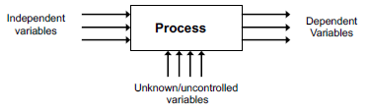

**Example**

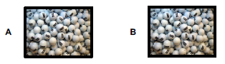

#### Internal validity

* + - * Manually counting is reliable for a few numbers of balls
      * Repeated counting improves reliability, but it is slow...

**Ordering effects (**tasks order should be random given to the user**);**

**Selection effects (**Randomly assign users to groups**);**

**Experimenter bias (**experimenter may prefer an interface over the other**)**

#### External validity

* + - * Weight the boxes instead of counting the balls
      * Ball A may have a different weight than ball B (Dependent variable - total weight)
      * Box A may have a different weight than box B

**Population (**random sample of users**);**

**Ecological (**lab conditions as realistic as possible**);**

**Training (**mimic how real interface would be encountered**);**

**Task (**Base tasks on task analysis**)**

Reliability

* + - * Does this result apply to all boxes in the world?

**Previous experience (**Novices and experts: separate**);**

**User differences (**Intelligence, visual acuity, memory**);**

**Tasks design;**

**Measurement errors (**Time on task includes coaching, distractions**);**

**Solutions (**Give all users the same training**)**

Note: Eliminate uncontrolled variation, and therefore increase reliability

# Methods

“Between-subjects” design

* + - Each group tests only one interface
    - Results compared between different groups (Eliminate ordering effect)

“Within-subjects” design

* + - Each user test all the interfaces (in random order)
    - Results compared within each user (Eliminates variation due to user differences; Ordering effect; Fatigue effect)

# Counterbalancing

Reduce ordering effects by systematically varying the order of conditions

**Latin square design**

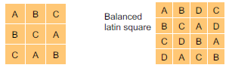

# Questionnaires

* Pre-defined questions – less flexible and faster than interviews.
* Can be used in various phases of the design process.
* Simple and cheap to execute, provides subjective information.

#### Types of questions:

* General
* Open-ended
* Scalar
* Multiple choice
* Ranked

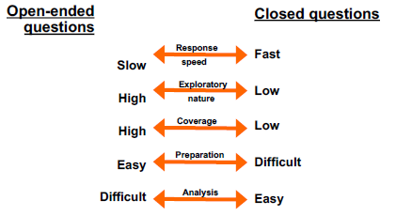

**Likert scales**  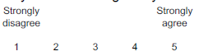

# Evaluation

#### Laboratory studies

* allow controlled experimentation and observation
* loses naturalness of the user’s environment

#### Field studies

* do not allow control over user activity
* Both studies should be made:
  + Lab studies dominating early stages
  + Field studies for new implementations

## Measurements

**Quantitative**

* numeric
* can be easily analysed using statistical techniques

**Qualitative**

* non-numeric
* difficult to analyse
* provide important detail which cannot be determined from numbers.

Numeric scales can be used to gather subjective data – Likert scales.