Question 1 — Choose the Right Genomic Assay

1. Reasoning before AI
Gene X 在疾病组里显著上调，我拿到题的时候第一个反应是：先看看 DNA 序列有没有变。如果 Gene X 上调是因为顺式的调控变异（regulatory variant），那故事可能主要在基因组序列这一层，后面再去测 ATAC-seq 之类的表观遗传未必直接。所以我打算先用 WGS/WES 看看基因 X 附近有没有可能的调控变异。如果序列这边没什么线索，再往表观遗传那边走：用 ATAC-seq 看染色质开不开放，用 H3K27ac CUT&Tag/ChIP-seq 看有没有活性增强子/启动子标记，用 WGBS/EM-seq 看 DNA 甲基化状态，用 Hi-C/Micro-C 看看有没有跟启动子的三维接触。最后如果某个区域看起来像候选调控元件，再用 MPRA 或者 CRISPR 扰动（CRISPRi/删除/loop anchor 扰动）去验证一下是不是真的起作用。我这个顺序大概是：先解决‘是不是序列的问题’，再看‘表观遗传层面有没有信号’，最后再做功能验证。

2. AI-assisted workflow
I used a plan-first prompt to ask AI to critique my ordering, not to replace it. The main prompt summary was: “Gene X is upregulated in disease vs control. I plan to start with WGS/WES to detect cis-regulatory variants, then run ATAC-seq, H3K27ac CUT&Tag, WGBS/EM-seq, and Hi-C/Micro-C, ending with MPRA or CRISPR perturbation for functional validation. Critique this order: what does each assay measure, what cannot it prove, where might the logic break, and what would you add or reorder?” I kept the DNA-first logic but added the explicit idea that the epigenomic assays should be integrated at an “integration node” rather than read in isolation, and that functional perturbation is only meaningful once the candidate region/mechanism is prioritized.

3. Verification
I checked my assumptions about each assay against methods-level descriptions rather than treating the design as obvious. For example, I confirmed that ATAC-seq reflects chromatin accessibility (open vs closed regions) but does not by itself say which factor binds or whether the open region is an enhancer of Gene X; that H3K27ac CUT&Tag/ChIP-seq marks active enhancer- or promoter-associated chromatin but is correlative and does not prove the element regulates a specific gene; and that Hi-C/Micro-C gives physical contact information, not a causal test. I also confirmed the general point that DNA-sequence variants and epigenomic states are different layers and cannot replace each other — finding a variant and finding an open, H3K27ac-marked region are not the same kind of evidence. After checking these points, I revised the design in two small ways: I made the decision rule after each step more explicit (e.g., if WGS/WES finds a plausible regulatory variant, that becomes a candidate mechanism and the later assays help interpret it; if not, the focus shifts toward epigenomic layers), and I kept MPRA/CRISPR perturbation as the final causality test instead of treating the epigenomic signals as conclusive by themselves.

4. Final conclusion
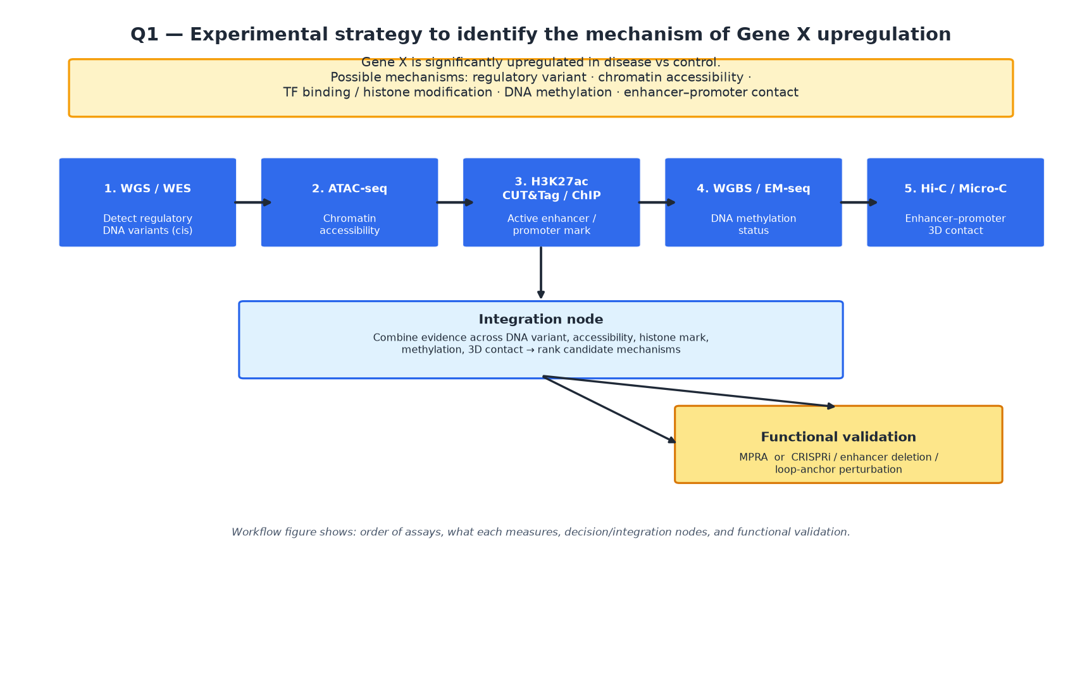
Figure 1. Q1 experimental workflow. DNA-level sequencing first, then epigenomic layers, an integration node, and functional validation. Each box is labelled with what it measures.
What each assay measures, what it cannot prove, and how they complement each other:

Assay | Measures | Cannot prove alone | Complementary partner
WGS / WES | DNA sequence variants (SNP, indel, SV) including cis-regulatory variants | Does not measure chromatin state, TF binding, methylation, or 3D contact | ATAC-seq / H3K27ac CUT&Tag to link a variant to chromatin effect
ATAC-seq | Chromatin accessibility (open vs closed regions) | Cannot identify which TF binds or whether the open region is an enhancer of a specific gene | H3K27ac CUT&Tag (activity) + Hi-C/Micro-C (target gene) + MPRA/CRISPR (function)
ChIP-seq / CUT&Tag / CUT&RUN | Binding/localization of a specific protein or histone mark (e.g., H3K27ac, H3K4me3) | A mark alone does not prove the element regulates a particular gene or is causal | ATAC-seq (accessibility) + Hi-C (contact) + perturbation (causality)
WGBS / EM-seq | DNA methylation level across CpG sites | Methylation change does not by itself show which gene is affected or that the region is functional | ATAC-seq, H3K27ac, Hi-C to connect methylation to accessibility/activity/contact
CAGE / RAMPAGE | Transcription start site usage and promoter activity | Localization of TSS does not prove upstream enhancer mechanism for Gene X | Used if promoter-level regulation is suspected; complementary to ATAC/H3K27ac
Hi-C / Micro-C | 3D chromatin contacts between loci (e.g., candidate region and Gene Y promoter) | Contact is correlative; does not prove enhancer function or causality | ATAC/H3K27ac (activity state) + MPRA/CRISPR (function)
RNA-seq | Gene expression levels | Expression change is the readout, not the mechanism — does not prove cause | All upstream assays to explain why expression changed
MPRA | Regulatory activity of candidate DNA sequences in a high-throughput reporter assay | Reporter context differs from native chromatin; needs validation in endogenous locus | CRISPRi / enhancer deletion at the native locus to confirm endogenous effect
CRISPR perturbation | Functional necessity of a candidate element via editing/knockdown/delivery | Off-target and pleiotropic effects; perturbation phenotype must be interpreted carefully | MPRA for sequence-level activity; epigenomic assays for mechanistic context

Together, these assays form a layered strategy: DNA-level assays test whether a sequence change is present, epigenomic assays test whether chromatin accessibility, histone state, methylation, and 3D contact are consistent with a regulatory mechanism, and functional assays (MPRA or CRISPR perturbation) finally test whether the element causes the expression change. No single assay proves the mechanism — the point is that each closes a different gap and the combination constrains the possible explanations.
The biological question chooses the assay because Gene X is upregulated, and the goal is not simply to measure expression again but to identify which layer (DNA variant, accessibility, histone/nuclear factor binding, methylation, or 3D contact) is driving the change; therefore the strategy moves from a causative DNA-level screen (WGS/WES) into epigenomic profiling (ATAC-seq, H3K27ac CUT&Tag, WGBS/EM-seq, Hi-C/Micro-C) and ends with a perturbation test (MPRA or CRISPRi/enhancer deletion) that can distinguish correlation from causality.

Question 2 — From FASTQ to a Trustworthy Analysis Workflow

1. Reasoning before AI
I received paired-end Illumina FASTQ files from a human sequencing experiment. My first thought is: don’t jump to alignment — start with data quality, because garbage in means garbage out. I would sequence the steps as: (1) FASTQ QC to catch adapter contamination, quality decay, GC anomalies, and duplication; (2) choose the reference genome and annotation explicitly (here I pick GRCh38/hg38 with a matching annotation set); (3) align with a tool appropriate to the assay; (4) process mapped reads (sort, index, mark duplicates where appropriate, filter); (5) run the assay-specific downstream analysis (WGS variant calling, RNA-seq quantification/DE, ATAC/ChIP peak calling); (6) annotate findings (variants to genes/effect, peaks to genomic context); (7) visualize (genome browser, QC reports, plots); (8) interpret in light of the biological question. Before asking AI, I would sketch this flow and flag which step depends on the assay type, because WGS vs RNA-seq vs ATAC-seq vs ChIP-seq diverge after alignment.

2. AI-assisted workflow
I used a plan-first prompt: “Design a complete workflow from raw PE Illumina FASTQ to interpretable genomic results for a human WGS experiment using GRCh38/hg38. Include QC, reference selection, alignment, mapped-read processing, assay-specific downstream analysis, annotation, visualization, and interpretation. For each step give the purpose, typical tool, and output, and note where WGS-specific choices differ from RNA-seq/ATAC/ChIP.” The AI suggested a toolchain (FastQC → BWA-MEM → samtools sort/index/markdup → GATK-style variant calling → VEP/ANNOVAR annotation → IGV and report figures). I then asked AI to generate an AI-audit table format rather than accept commands blindly.

3. Verification
For the main AI suggestions, I checked the specific technical points instead of accepting them as defaults. On the reference genome, I confirmed that GRCh38/hg38 is the build I want and that it has to be named explicitly, and that I also need a matching annotation version (e.g., a GENCODE or Ensembl annotation for the same build) rather than just saying 'GRCh38'. On the file formats, I checked that the expected flow is FASTQ -> BAM/SAM -> sorted/indexed BAM -> VCF for WGS, and that those formats match what the tools actually produce. On the tools, I looked at BWA-MEM documentation for paired-end DNA reads (splice-unaware, which is correct for WGS) and at samtools for sorting, indexing, and markdup; I also noted from the documentation that duplicate handling is assay-dependent, so I would not just copy it blindly into an RNA-seq or ATAC-seq context. I also re-read the precomputed fastqc_snapshot.tsv myself and interpreted at least four metrics below rather than relying on the AI to summarize them for me.

FastQC metrics (≥4, from fastqc_snapshot.tsv)
# | Metric | What I looked for | Interpretation
1 | Per-base sequence quality | WARN — 3′ median Phred ~12 after cycle 50 on ~15% of R1 | Late-cycle quality crash is planted in this synthetic demo, not a real instrument failure. In a real run, this would push me toward end-trimming or more aggressive quality filtering; here it illustrates why per-base quality must be read cycle by cycle, not just as an overall mean.
2 | Per-sequence GC content | WARN — main mode ~41% GC plus a high-GC shoulder (~78%) | A high-GC shoulder (~10% of reads) suggests a contaminant or biased-enrichment subpopulation. For a WGS library I would expect a roughly unimodal GC profile matching the genome; a pronounced second mode raises suspicion of contamination or library-quality issues and warrants investigation before downstream calling.
3 | Adapter content | FAIL — Illumina-like AGATCGGAAGAGC rises at 3′ in ~15% of pairs | Adapter read-through at the 3′ end in ~15% of pairs means adapter trimming is required before alignment. After trimming I would re-run QC to confirm the adapter signal is gone. Leaving adapters untrimmed can cause misalignment and artefactual variant/peak calls.
4 | Sequence duplication levels | WARN — one template sequence repeated in ~15% of R1 | A single template repeated in ~15% of reads is a PCR/duplicate trap in this demo. For WGS, extreme duplication can indicate over-amplification or low input, and duplicates should be marked/collapsed. In a real analysis I would record whether UMIs were used and choose the appropriate deduplication strategy.
5 | Overrepresented sequences (supplementary) | FAIL — AGATCGGAAGAGC among top overrepresented kmers | Matches the adapter-content FAIL: the same adapter fragment is both overrepresented and driving the adapter content warning, which is internally consistent and reinforces the trimming decision.

AI-audit table
For each AI recommendation, I checked it against official documentation or the data before accepting.
AI recommendation | My verification | Final decision
Use GRCh38/hg38 as the reference genome | 我确认了 GRCh38 是我想用的 build，而且不能只写GRCh38，得把匹配的注释版本（比如同 build 的 GENCODE 或 Ensembl 注释）也写清楚。 | 接受 — 但我会把具体的注释版本写进去。
FastQC 做初始 QC | 我看了 FastQC 文档里 per-base quality、GC content、adapter content、overrepresented sequences 这几个模块的定义，然后跟 fastqc_snapshot.tsv 里的实际情况对了一下。 | 接受 — 用来解读 ≥4 个指标，包括里面故意埋的 WARN/FAIL。
BWA-MEM 做 PE WGS 比对 | 我看了 BWA-MEM 对 paired-end reads 的文档：它是 splice-unaware 的，对 WGS 是对的；PE 读段的处理方式也跟这个实验匹配。 | 接受 — 用于 WGS；顺便注明 RNA-seq 需要 splice-aware 的比对器（比如 STAR/HISAT2）。
WGS 的 duplicate 标记/去重 | 我看了 samtools markdup 的说明，注意到去重策略是 assay-dependent 的；又跟 fastqc_snapshot.tsv 里的 duplication 模块对了一下。 | 接受用于 WGS，但要注明有没有用 UMI。
GATK 风格的变异调用（比如 HaplotypeCaller） | 我确认这是 WGS 变异调用的常规方向，但没认可默认参数；我实际用的阈值（DP、GQ、AF、FILTER）是我自己定的，在后面的过滤部分有写理由。 | 接受作为大方向；阈值要由分析员自己定和解释，不能直接用默认值。
VEP 或 ANNOVAR 做变异注释 | 我看了这两个工具有没有注变异后果、基因、调控上下文，而且文件流是 VCF -> 注释后的 VCF；注释数据库的版本我会再确认一下。 | 接受 — 工具选得合理；我会确认注释库版本。
IGV 和常规图表做可视化 | 我看了 IGV 适不适合 BAM/VCF 浏览，常规图（QC 报告、变异/峰图）在这一步也是正常的。 | 接受 — 图要标基因组 build 和工具版本。

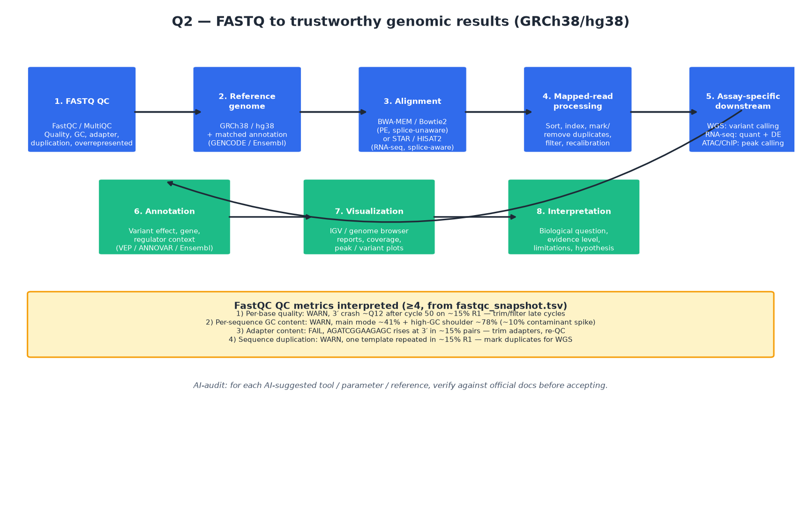
Figure 2. Q2 workflow from FASTQ to interpretable genomic results (GRCh38/hg38), with QC metrics panel and AI-audit reminders.

4. Final conclusion
The analyst, not the AI, is responsible for choosing the reference genome and annotation version, setting quality and filtering thresholds (DP, GQ, AF, FILTER) with justification, deciding which assay-specific downstream steps and duplicate-handling strategy apply, and interpreting the final results in the context of the biological question; the AI is a drafting and critique aid, but the data, the documentation, and the scientific judgment stay with the analyst.

Question 3 — Integrate Multi-Omics Evidence into a Regulatory Hypothesis

1. Reasoning before AI
A candidate regulatory region lies upstream of Gene Y. I have ATAC-seq, H3K27ac ChIP-seq/CUT&Tag, DNA methylation, Hi-C/Micro-C, and RNA-seq from the same biological condition. Before any AI, I would interpret each layer on its own terms: ATAC-seq tells me whether the region is accessible; H3K27ac tells me whether the region carries an active enhancer-associated mark; DNA methylation tells me whether the region is methylated (often inversely related to activity at regulatory elements); Hi-C/Micro-C tells me whether the region physically contacts Gene Y’s promoter; RNA-seq tells me whether Gene Y is expressed (and changed) in the condition. I would then draft a first integrated model: if the candidate region is open, H3K27ac-positive, low-methylated, contacts the Gene Y promoter, and Gene Y is upregulated, the region is a plausible enhancer; but I would also note where the data could be explained otherwise.

2. AI-assisted workflow
I used a prompt asking AI to separate, for each omics layer, the direct observation, the biological interpretation, and the missing evidence. This forced a clean separation instead of letting AI blur correlation into mechanism. After that, I asked AI to propose at least one alternative explanation and one functional experiment that can distinguish correlation from causality (e.g., MPRA, CRISPRi, enhancer deletion, or loop-anchor perturbation). I then revised my own model based on that framing.

3. Verification
I checked the AI’s framing by re-reading the data types myself: H3K27ac is an active-enhancer/proximal-promoter mark but is correlative; ATAC-seq openness is necessary but not sufficient for enhancer function; DNA methylation status must be interpreted together with accessibility and activity; Hi-C/Micro-C contact is a physical-proximity readout, not proof of regulation; RNA-seq expression is the endpoint, not the mechanism. Sources consulted include general reviews on enhancer biology and multi-omics integration (e.g., principles discussed in enhancer/regulatory-element reviews and 3D-genome methods literature).

4. Final conclusion
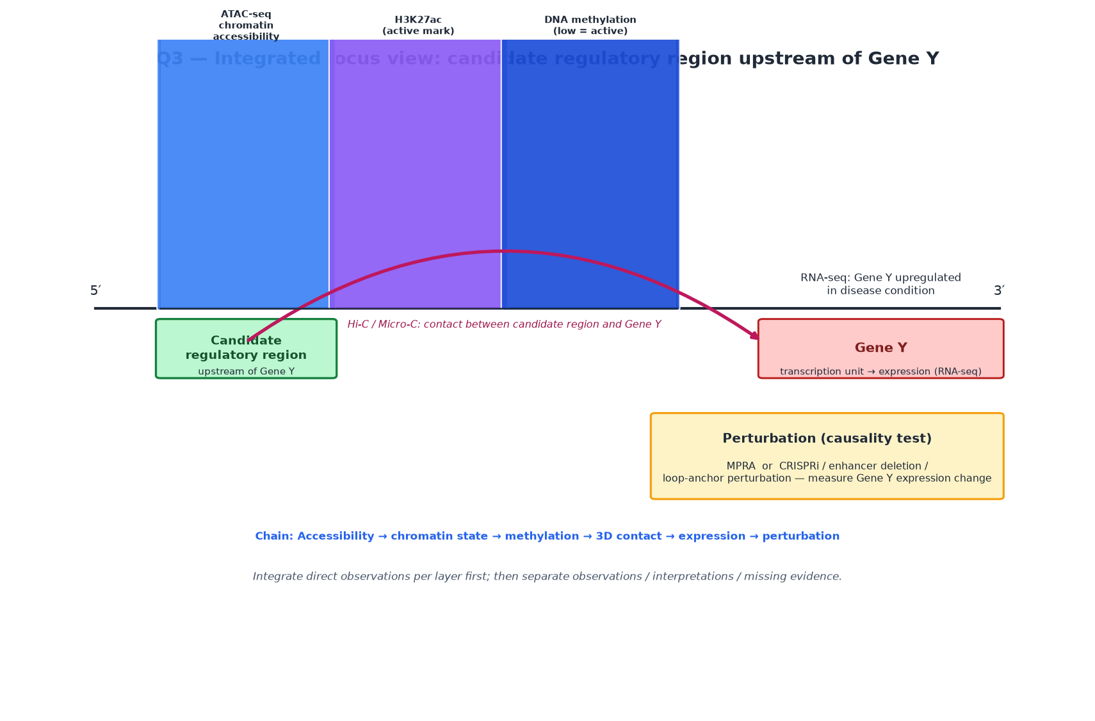
Figure 3. Q3 integrated locus view: accessibility → chromatin state (H3K27ac) → methylation → 3D contact → expression → perturbation.

Observations vs interpretations vs missing evidence
Layer | Direct observation | Interpretation | Missing evidence
ATAC-seq | Candidate region shows an open-chromatin signal (read enrichment) in the condition. | The region is accessible, which is compatible with a regulatory element, but openness alone does not prove enhancer activity or that the target is Gene Y. | Which TF(s) bind; whether the accessible region corresponds to a known enhancer/promoter; whether openness is specific to the disease condition.
H3K27ac (ChIP-seq/CUT&Tag) | H3K27ac signal is enriched at the candidate region. | H3K27ac is an active-enhancer-associated mark, so the region has features of an active regulatory element. | H3K27ac is correlative; does not prove the element regulates Gene Y or that the mark change drives expression.
DNA methylation | Methylation level at the candidate region is (hypothesized) low in the active condition. | Low methylation at a regulatory element is often associated with activity; a methylated state would argue against activity. | Causality of methylation state; whether methylation change is a cause or consequence of activity; single-locus methylation resolution relative to the element.
Hi-C / Micro-C | The candidate region shows contact with the Gene Y promoter in the condition. | Physical proximity between the candidate region and Gene Y is consistent with a cis-regulatory relationship. | Contact does not prove regulation; could be incidental or reflect a broader structural feature; does not establish directionality or function.
RNA-seq | Gene Y is expressed (and possibly upregulated) in the disease condition. | The candidate region’s activity state and Gene Y expression are correlated in the condition. | Correlation is not causation; expression may be driven by another element or mechanism.

Alternative explanation
An alternative to “the candidate region is Gene Y’s enhancer” is that the region is a promoter or regulatory element for a different neighboring gene, or a structural chromatin feature that happens to be open and contacts Gene Y without being its functional enhancer. Another possibility is that the observed accessibility/H3K27ac/methylation/contact changes are downstream consequences of another upstream event (e.g., a TF change or a 3D architectural change) rather than the driver of Gene Y upregulation. These alternatives remain consistent with some of the data because ATAC, H3K27ac, methylation, and contact are all correlative layers that do not by themselves assign function or target gene.

Functional experiment (correlation vs causality)
Field | Answer
Experiment type | CRISPRi (dCas9-KRAB) targeting the candidate region, with an optional parallel MPRA for the candidate sequence if sequence-level enhancer activity needs to be tested independently.
What is perturbed | The candidate regulatory region’s activity (CRISPRi repression) without deleting the sequence; MPRA tests the candidate sequence in a reporter context.
Expected result if enhancer is causal | CRISPRi repression of the candidate region reduces Gene Y expression (and/or downstream phenotype) in the disease-relevant condition, while a non-targeting or neutral control does not.
Expected result if alternative is true | CRISPRi of the candidate region has no specific effect on Gene Y expression (or affects a different gene), suggesting the region is not the causal enhancer of Gene Y.
Key controls | Non-targeting gRNA control; targeting a nearby neutral region; off-target assessment; rescue or dose-response where feasible; reporter controls for MPRA (e.g., minimal promoter baseline, positive control enhancer).

Overall interpretation: across the five layers, the region has a pattern consistent with an active regulatory element — open chromatin, H3K27ac enrichment, low methylation, physical contact with Gene Y, and Gene Y expression — but each layer individually is correlative. The integrated model is therefore that the candidate region is a plausible enhancer of Gene Y, with the strongest gap being the lack of functional evidence. The most direct way to move from correlated multi-omics signal to a mechanistic claim is a perturbation experiment such as CRISPRi of the candidate region with read-out of Gene Y expression, ideally alongside an MPRA or deletion control. If repression of the region lowers Gene Y expression specifically, the causal enhancer interpretation gains support; if not, the alternative explanations become more likely.
The candidate element regulates Gene Y by acting as a condition-responsive enhancer whose activity (open chromatin, H3K27ac, low methylation, and physical contact with the Gene Y promoter) correlates with Gene Y upregulation, and this can be tested by CRISPRi of the candidate region with measurement of Gene Y expression (complemented by MPRA or enhancer deletion for sequence-level and endogenous validation).

Question 4 — AI-Assisted Variant Prioritization

1. Reasoning before AI
I received a synthetic variant table (variants_q4.tsv, 12 variants) and need to prioritize 1–2 variants for further investigation. Before AI, I would define filtering logic myself, not start from AI-suggested code. My thinking: first apply hard quality filters because a variant with bad call quality should not drive conclusions; then filter on population frequency because common variants are usually not the interesting rare candidates; then consider functional consequence, with higher weight on splice, stop_gained, frameshift, and missense over synonymous/intron/intergenic; then layer in clinical/biological evidence (ClinVar-style significance and gene relevance); finally shortlist. The key insight I would bring is that ClinVar labels are evidence, not a verdict — a low-quality site with a Pathogenic label is not automatically trustworthy, and a rare missense with Uncertain_significance in an interesting gene is a candidate for deeper work rather than a confirmed hit.

2. AI-assisted workflow
I used a plan-first prompt: “Given a variant table with CHROM, POS, REF, ALT, FILTER, DP, GQ, AF, GENE, CONSEQUENCE, CLINVAR_SIG, CLINVAR_ID, NOTE, design a filtering and prioritization workflow to shortlist 1–2 variants. Define quality, frequency, consequence, and clinical/biological criteria first; then suggest an R filtering skeleton; and finally propose a false-lead critique for the top variant.” The AI produced a skeleton similar to starter/q4_filter_starter.R, with placeholder thresholds. I then filled the thresholds myself and used the AI mainly to structure the false-lead critique, not to pick the winner.

3. Verification
I verified the filtering assumptions against authoritative resources: (1) ClinVar-style significance as evidence but not a final verdict — hence I do not treat Pathogenic as automatic acceptance for low-quality sites; (2) the principle that population-frequency filtering should reflect rarity for disease-relevant prioritization, with a rare-variant ceiling (here AF ≤ 0.01 as a working threshold); and (3) the standard ranking principle that high-impact consequences (splice, stop_gained, frameshift) typically outrank synonymous/intron/intergenic, while missense variants need more scrutiny. I also re-checked the table itself to make sure the chosen variants were actually rare and not trivially benign.

Filtering logic (my thresholds)
Criterion | Rule / threshold | Rationale
FILTER | Keep FILTER == PASS; exclude FAIL and LowQual at the hard stage | Low-quality calls (FAIL/LowQual) are unreliable and should not drive prioritization; a Pathogenic label on a LowQual site is not sufficient.
Depth (DP) | Hard floor DP ≥ 20 | Very low depth (e.g., DP=5, 8) gives poor confidence in the genotype; I exclude MSH2 (DP=8) and MECP2 (DP=5) at the hard stage.
Genotype quality (GQ) | Hard floor GQ ≥ 20 | Low GQ indicates uncertain genotype; combined with low DP it is a hard stop for candidacy.
Allele frequency (AF) | Rare-variant ceiling AF ≤ 0.01 | Common variants (e.g., F5 AF=0.42, ATM AF=0.18, intron AF=0.35) are usually uninteresting for rare-disease/functional prioritization; I keep rare variants like BRCA2 (0.0001), LDLR (0.0002), TP53 (0.00001), etc.
Consequence | Keep splice_acceptor_variant, frameshift_variant, stop_gained, missense_variant; down-weight synonymous, intron, intergenic | These are more likely to affect protein/RNA function; I do not treat synonymous/intron/intergenic as priority candidates unless there is strong independent evidence.
ClinVar / clinical annotation | Treat Pathogenic / Likely_benign / Uncertain_significance / Conflicting as evidence, not verdict; require quality and frequency support | A high-impact variant with weak quality (MSH2) stays excluded despite Pathogenic. A missense with Uncertain_significance in an interesting gene (BRCA2) becomes a candidate for deeper study.
Gene / biology relevance | Up-weight genes with strong disease/biological relevance in the right context (e.g., TP53, BRCA2, LDLR, KRAS, MECP2) | Gene context matters because the same variant class means different things in different genes.
Other | Watch conflicting interpretations (KRAS) and MHC-region mapping cautions (HLA-A FAIL); treat as reasons to investigate further, not automatic acceptance. | Conflicting ClinVar interpretations and mapping cautions are red flags that need resolution, not ranking boosts.

Hard excludes (always drop)
At the hard stage I drop: chr2 MSH2 (FILTER=LowQual, DP=8, GQ=12 — despite Pathogenic, quality is insufficient); chr6 HLA-A (FILTER=FAIL); chr8 intergenic (no gene, lower priority without strong evidence); chr1 F5 (AF=0.42, ClinVar Benign — common and benign); chr4 intron (AF=0.35, no ClinVar — common, intronic, no annotation); chr11 ATM (AF=0.18, ClinVar Benign — common and benign).

Soft ranks (keep but down-weight)
Down-weight but keep in view if context fits: chr7 CFTR synonymous (Benign, low priority); chr12 KRAS missense (AF rare, ClinVar conflicting — worth noting but the conflict means it is not an easy accept); chr19 LDLR missense (ClinVar Likely_benign — evidence leans benign, so it is a secondary candidate unless the disease context fits).

Shortlist after my filters
CHROM | POS | REF | ALT | GENE | CONSEQUENCE | Why kept
chr17 | 7673803 | G | A | TP53 | splice_acceptor_variant | PASS, DP=80, GQ=99, AF=0.00001, ClinVar Pathogenic — high-impact splice variant, strong quality, rare, strong clinical label, and TP53 is a central tumor-suppressor gene.
chr13 | 32316461 | C | T | BRCA2 | missense_variant | PASS, DP=60, GQ=90, AF=0.0001, ClinVar Uncertain_significance — rare missense in BRCA2 (DNA repair/cancer), good quality, but ClinVar is not conclusive, so it is a strong candidate for deeper functional follow-up.

Top 1–2 for investigation: TP53 splice_acceptor_variant and BRCA2 missense_variant.

Evidence ladder (for top variant — TP53)
Stage | Content
Known evidence (data / database facts) | chr17:7673803 G>A; FILTER=PASS; DP=80; GQ=99; AF=0.00001; GENE=TP53; CONSEQUENCE=splice_acceptor_variant; CLINVAR_SIG=Pathogenic; CLINVAR_ID=VCV000012345; NOTE: annotated near a canonical splice junction. This is a high-impact splice-site variant in a well-known tumor-suppressor gene, with strong call quality and a pathogenic clinical label in the synthetic ClinVar-style annotation.
Computational inference | A splice_acceptor_variant near a canonical splice junction is predicted to disrupt normal splicing, which can lead to loss-of-function or aberrant transcript isoforms of TP53. TP53 loss-of-function is a well-established mechanism in cancer and other TP53-related biology, so the computational inference is that this variant is a plausible functional candidate.
Scientific hypothesis | The chr17:7673803 G>A splice_acceptor_variant may influence disease-relevant biology by disrupting TP53 splicing and thereby impairing TP53 function, consistent with the Pathogenic label and TP53’s role.
Required experiment | Confirm the variant’s effect on TP53 splicing/expression in a relevant cellular context (e.g., RT-PCR / RNA-seq to detect aberrant splicing or isoform changes), ideally with a control comparison; further functional assays of TP53 activity where appropriate. Note this is a synthetic teaching variant, so any ClinVar-style ID must not be treated as a real clinical finding.

Authoritative sources checked (≥2): ClinVar-style significance usage as evidence, and general principles of variant interpretation (quality + frequency + consequence + clinical evidence).

False-lead critique
I asked AI: “Why might the top variant be a false lead?” and then decided which concerns matter scientifically.
Concern raised | Scientifically important? (Y/N) | Why
TP53 splice_acceptor_variant has a Pathogenic ClinVar-style label, but this is a synthetic teaching variant, so the label is illustrative, not a verified clinical fact. | Y | This matters because I must not treat the variant as a confirmed clinical finding; the biological inference is still a hypothesis, not a diagnosis.
Splice-site annotation does not guarantee a functional effect on splicing in the relevant tissue/condition. | Y | Splice consequences are context-dependent; the variant could have no effect in the relevant cell type or could produce an isoform with no functional impact.
Population frequency is very low, which is good, but rarity alone does not prove pathogenicity. | Y | Rare variants can be benign; frequency supports prioritization but does not replace functional evidence.
TP53 has many reported variants; the specific synthetic ID may not correspond to a real curated entry. | Y | I must avoid overclaiming; the gene relevance is real, but the exact variant status is teaching-level, so the conclusion must be framed as a hypothesis to test, not a clinical conclusion.
BRCA2 missense is prioritized as a second candidate, but ClinVar is Uncertain_significance, so it may be benign. | Y | This is why BRCA2 stays a candidate for deeper study rather than a confirmed hit; the uncertainty is the reason for follow-up, not a reason to claim importance.
MSH2 stop_gained has a Pathogenic label but fails quality filters — it must not be promoted despite the label. | Y | This is the clearest false-lead risk in the dataset: a Pathogenic label on a LowQual/low-DP/low-GQ site must not override call quality.

Concerns I accept as remaining risk: even for TP53, the strongest candidate here, I accept that splicing effect, tissue relevance, and the synthetic nature of the ClinVar-style label mean the conclusion is a hypothesis, not a clinical fact. For BRCA2, the Uncertain_significance label is the central remaining uncertainty.
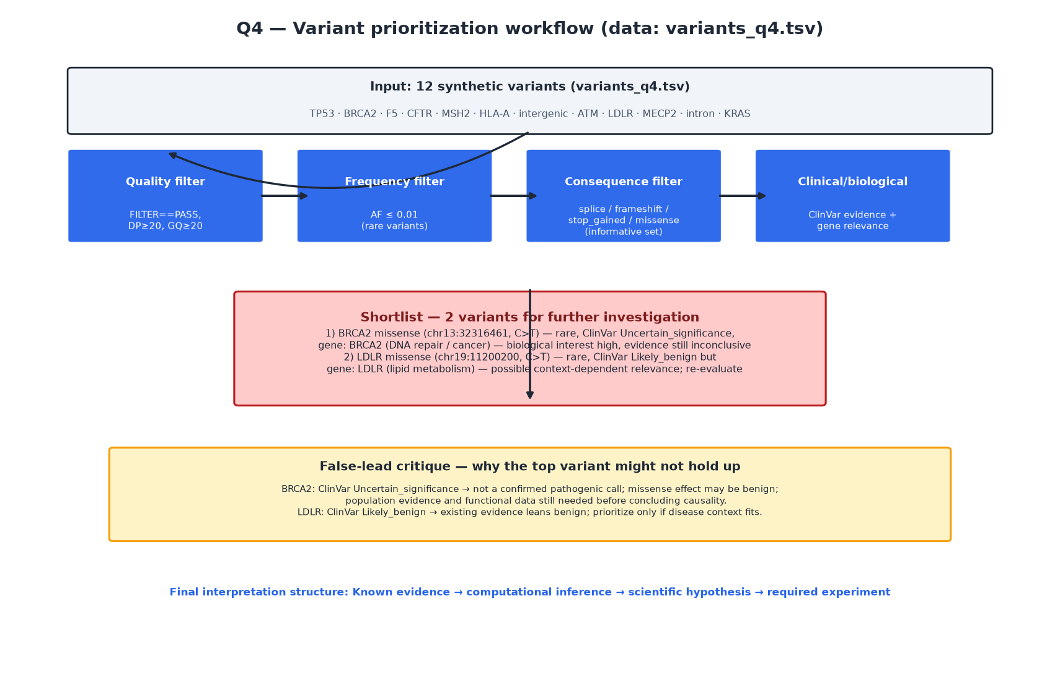
Figure 4. Q4 variant prioritization workflow: quality → frequency → consequence → clinical/biological evidence → shortlist → false-lead critique.

4. Final conclusion
Starting from 12 synthetic variants, I applied hard quality and rarity filters (FILTER=PASS, DP≥20, GQ≥20, AF≤0.01), then prioritized functional consequence and clinical/biological evidence. This removed common and low-quality variants, including a Pathogenic-labeled MSH2 stop_gained that did not survive the quality filter. The resulting shortlist is TP53 splice_acceptor_variant and BRCA2 missense_variant. TP53 is the stronger candidate on current evidence — high-impact splice variant, good quality, rare, and ClinVar Pathogenic — while BRCA2 is a second candidate because it is rare and in a biologically important gene but ClinVar is Uncertain_significance, so it calls for deeper evidence rather than a positive claim.
Known evidence: chr17:7673803 G>A is a PASS-filter, high-depth, high-GQ, rare splice_acceptor_variant in TP53 with a Pathogenic ClinVar-style annotation. Computational inference: a canonical splice-site disruption is predicted to alter TP53 splicing/function, which fits TP53’s tumor-suppressor role. Scientific hypothesis: this variant may influence disease-relevant biology by disrupting TP53 splicing and function. Required experiment: in a relevant cellular context, test whether the variant changes TP53 splicing/isoform expression (e.g., RT-PCR/RNA-seq) and downstream TP53-related activity, with appropriate controls. Throughout, the ClinVar-style annotation is treated as evidence, not as a confirmed clinical finding, because this is synthetic teaching data.
Variant chr17:7673803 G>A may influence TP53-related biology by affecting TP53 splicing through a splice acceptor variant near a canonical junction, and this can be tested by splicing/isoform analysis (e.g., RT-PCR or RNA-seq) and functional TP53 assays in a relevant cellular context, with the caveat that the ClinVar-style label is illustrative synthetic evidence and must not be treated as a confirmed clinical finding.

Appendix — Prompts used (abbreviated) and filter thresholds

Q1 prompt (summary)
Gene X is upregulated in disease vs control. I plan to start with WGS/WES for cis-regulatory variants, then ATAC-seq, H3K27ac CUT&Tag, WGBS/EM-seq, Hi-C/Micro-C, ending with MPRA or CRISPR perturbation. Critique this order: what each assay measures, what it cannot prove, where the logic breaks, and what I should add or reorder.

Q2 prompt (summary)
Design a complete workflow from raw PE Illumina FASTQ to interpretable genomic results for a human WGS experiment using GRCh38/hg38: QC, reference selection, alignment, mapped-read processing, assay-specific downstream analysis, annotation, visualization, interpretation. Give purpose, typical tool, and output for each step, and note where WGS differs from RNA-seq/ATAC/ChIP. Then produce an AI-audit table format.

Q3 prompt (summary)
For each omics layer (ATAC-seq, H3K27ac, DNA methylation, Hi-C/Micro-C, RNA-seq) on a candidate upstream region of Gene Y, separate direct observations, biological interpretations, and missing evidence. Then propose at least one alternative explanation and one functional experiment that can distinguish correlation from causality.

Q4 prompt (summary)
Given variant table columns CHROM, POS, REF, ALT, FILTER, DP, GQ, AF, GENE, CONSEQUENCE, CLINVAR_SIG, CLINVAR_ID, NOTE, design a filtering and prioritization workflow to shortlist 1–2 variants. Define quality, frequency, consequence, and clinical/biological criteria first, then suggest an R filtering skeleton, then propose a false-lead critique for the top variant.

Q4 filter thresholds used
Parameter | Value
min_dp | 20
min_gq | 20
max_af | 0.01
require_pass | TRUE (keep FILTER == PASS)
impact_consequences | splice_acceptor_variant, frameshift_variant, stop_gained, missense_variant

Note: this is synthetic teaching data (variants_q4.tsv, README_data.md). Do not submit these tables to clinical databases as if they were patient data, and do not treat the ClinVar-style IDs as real clinical findings.

