Module 9 Problem 1 Solution

- For the following problem, define an ERD for the initial requirements and then revise the ERD for the new requirements. Your solution should have an initial ERD, a revised ERD, and a list of design decisions for each ERD. In performing your analysis, you may want to follow the approach presented in module 9.
Design a database for managing the task assignments on a work order. A work order records the set of tasks requested by a customer at a specified location.
- A customer has a unique customer identifier, a name, a billing address (street, city, state, and zip), and a collection of submitted work orders.
- A work order has a unique work order number, a creation date, a date required, a completion date, a customer, an optional supervising employee, a work address (street, city, state, zip), and a set of tasks.
- Each task has a unique task identifier, a task name, an hourly rate, and estimated hours. Tasks are standardized across work orders so that the same task can be performed on many work orders.
- Each task on a work order has a status (not started, in progress, or completed), actual hours, and a completion date. The completion date is not entered until the status changes to complete.

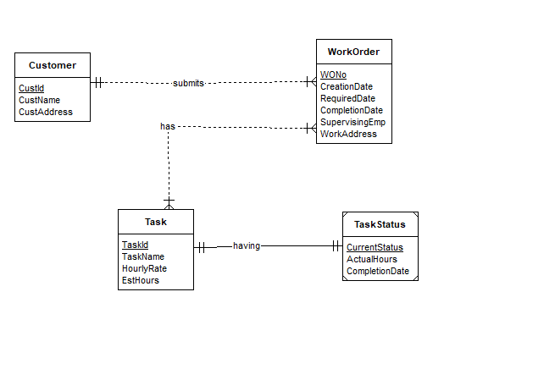
A Customer cam submits more than one work , each work having one or multiple tasks and every task associates a task status.

The Student Customer, WorkOrder, Task and TaskStatus entity types follow directly from the narrative. The narrative statement clearly indicates attributes and a primary key for each entity type. The M side of the 1-M relationships, has and submits, follows from the narrative withCustomer having more than one or one work order, The M-N relationships follows from WorkOrder and Task narrating that every work order may have multiple tasks and every task may belong to more than one or one work order.
The difficult part of the narrative involves the relationship between TaskStatus and Task. The problem narrative indicates stricltly following 1-1 relationship for an identifying entity relation to avoid violation of Identification Dependency Rule.

- After reviewing your initial design, the company decides to revise the requirements. Make a separate ERD to show your refinements. Refine your original ERD to support the following new requirements:
- The company wants to maintain a list of materials. The data about materials include a unique material identifier, a name, and an estimated cost. A material can appear on multiple work orders.
- Each work order uses a collection of materials. A material used on a work order includes the estimated quantity of the material and the actual quantity of the material used.
- The estimated number of hours for a task depends on the work order and task, not on the task alone. Each task of a work order includes an estimated number of hours.

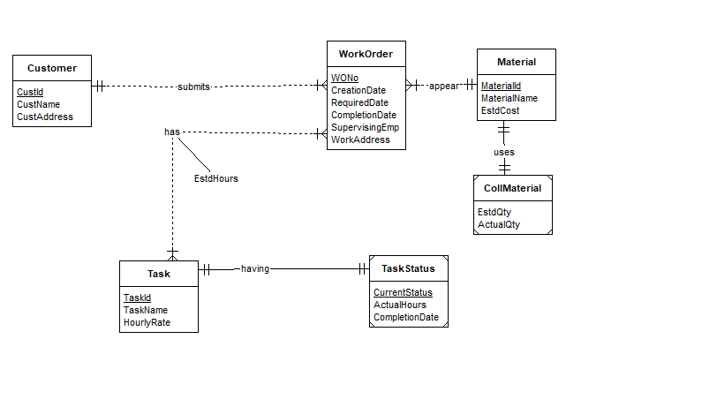
ERD for second part requirements.
Addition of Material entity having a Collection of Material Details.

The Student Customer, WorkOrder, Task , TaskStatus, Material and CollMaterial entity types follow directly from the narrative. The narrative statement clearly indicates attributes and a primary key for each entity type. The M side of the 1-M relationships, has and submits, and appear from the narrative with Customer and WorkOrder having more than one or one work order, The M-N relationships follows from WorkOrder and Task narrating that every work order may have multiple tasks and every task may belong to more than one or one work order.
The difficult part of the narrative involves the relationship between TaskStatus and Task and relationship between Material and CollMaterial. The problem narrative indicates stricltly following 1-1 relationship for an identifying entity relation to avoid violation of Identification Dependency Rule.

