# **ACTIVITY - IV**

Name: Hemanth sai kumar

RegNo: 12220407

## Question – 1

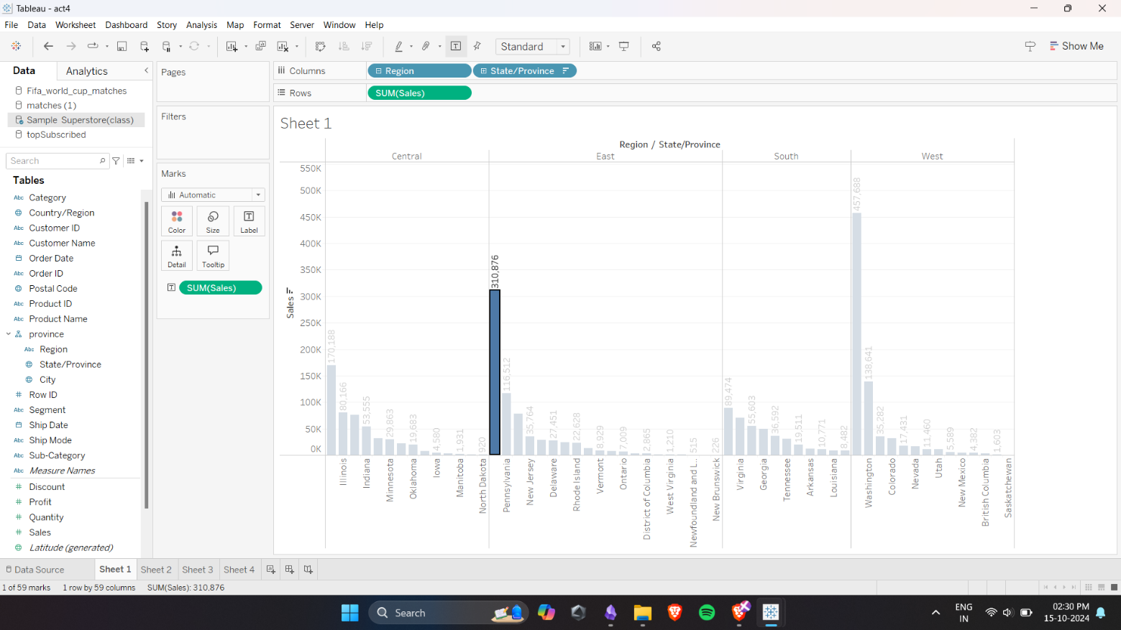

## Question 2

## Question 3

## Question 4

