FRAMES: FACULTY 201 RECORDS, ACADEMIC CREDENTIALS, AND ACCREDITATION EVIDENCE ANALYTICS SYSTEM FOR PACUCOA AREA II

A Capstone Project
Presented to the Faculty of the
Graduate School of Information Technology
Philippine Christian University

In Partial Fulfilment
of the Requirements for the Degree
Master in Information Technology

by
JOSEPH R. OPLE JR.

October 2026

APPROVAL SHEET

In partial fulfilment of the requirements for the degree of Master of Information Technology Major in Software Development. This Capstone Project entitled FRAMES: FACULTY 201 RECORDS, ACADEMIC CREDENTIALS, AND ACCREDITATION EVIDENCE ANALYTICS SYSTEM FOR PACUCOA AREA II has been prepared and submitted by JOSEPH R. OPLE JR. and who is recommended for oral examination.

Capstone Project Adviser

DEDICATION
To the faculty members, academic leaders, records administrators, and quality assurance teams of Colegio de Kidapawan, Inc., whose steadfast dedication to educational quality and continuous institutional improvement inspired the development of FRAMES.
To my mentors, family, and loved ones, for their unconditional support, wisdom, and guidance.

ACKNOWLEDGEMENT
The researcher expresses sincere gratitude to the administration, deans, academic chairs, and quality assurance officers of Colegio de Kidapawan, Inc. for providing the institutional context, domain access, and operational requirements necessary to formulate this capstone project proposal.
Special appreciation is extended to the capstone project adviser, panel evaluators, and faculty members of the Graduate School of Information Technology of Philippine Christian University for their scholarly guidance, rigorous feedback, and technical mentorship throughout the conceptualization of this study.
Gratitude is also offered to the Human Resource Office staff, academic department heads, and members of the PACUCOA Accreditation Task Force, whose daily operations and self-survey workflows provided the baseline for the system requirements.
Finally, deep appreciation is expressed to the researcher's family, friends, and colleagues for their constant encouragement, patience, and moral support throughout this academic journey.
Joseph R. Ople Jr.

TABLE OF CONTENTS
Title Page i
Approval Sheet ii
Dedication iii
Acknowledgement iv
Table of Contents v
List of Figures vii
List of Tables viii
Appendices ix
Abstract x
CHAPTER 1 – INTRODUCTION 1
Background of the Study 1
Objectives of the Study 3
General Objective 3
Specific Objectives 3
Statement of the Problem 4
Significance of the Study 6
Scope and Limitations of the Study 6
Limitations of the Study 8
CHAPTER 2 – THEORETICAL FRAMEWORK 9
Review of Related Studies 9
Foreign Related Studies 9
Local Related Studies 12
Synthesis of the Reviewed Literature and Studies 14
Research Gap 15
Conceptual Framework 16
Operational Definition of Terms 17
CHAPTER 3 – OPERATIONAL FRAMEWORK 19
Requirement Specification 19
Functional Requirement 20
Non-Functional Requirements 21
Time Feasibility 23
Hardware and Software Specification 24
Data and Process Modelling 25
Software Development Model 34
Ethical Considerations 36
Testing and Evaluation Procedure 37
Data Gathering Techniques 38
System Evaluation 38
Population and Sampling Techniques 39
Research Instrument and Validation 40
Statistical Treatment of Data 41
REFERENCES 43
APPENDICES 48
LIST OF FIGURES
Figure 1. Conceptual Framework of FRAMES 16
Figure 2. Three-Tier System Architecture of FRAMES 26
Figure 3. Context Diagram of FRAMES 27
Figure 4. Level 1 Data Flow Diagram of FRAMES 28
Figure 5. Entity Relationship Diagram of FRAMES 29
Figure 6. PACUCOA Area II Compliance Evaluation Flowchart 31
Figure 7. Use Case Diagram of FRAMES 32
Figure 8. Class Diagram of FRAMES 34
Figure 9. Agile Scrum Development Model 35
LIST OF TABLES
Table 1. Feature Comparison Matrix of Related Systems and FRAMES 14
Table 2. User Roles and Access Control Matrix 19
Table 3. Functional Requirements Specification 20
Table 4. Non-Functional Requirements Specification 21
Table 5. Configured PACUCOA Area II Evidence and Requirements Matrix 22
Table 6. Gantt Chart of Capstone Project Activities 23
Table 7. Hardware Specifications 24
Table 8. Software Specifications 24
Table 9. Use Case Descriptions for Key System Modules 32
Table 10. Agile Scrum Sprint Plan and Deliverables 35
Table 11. Compliance Rules Engine Test Cases 37
Table 12. ISO/IEC 25010 Quality Model Evaluation Criteria 39
Table 13. Distribution of Respondents 40
Table 14. Five-Point Likert Scale and Verbal Interpretation 40
APPENDICES
Appendix A – Non-Disclosure Agreement
Appendix B – ISO/IEC 25010 System Evaluation Questionnaire

ABSTRACT
FRAMES: Faculty 201 Records, Academic Credentials, and Accreditation Evidence Analytics System for PACUCOA Area II is a web-based platform designed to address the problems of managing faculty personnel files, academic credentials, and multi-source accreditation evidence for the Philippine Association of Colleges and Universities Commission on Accreditation (PACUCOA) Area II (Faculty) evaluation at Colegio de Kidapawan, Inc. The current manual process, characterized by paper filing, uncoordinated digital submissions, missing credential exhibits, untracked license expirations, and labor-intensive self-survey audits, delays accreditation readiness. FRAMES unifies digital faculty 201 files, verified academic credentials, and instructional, research, and extension evidence in a centralized repository. Its automated compliance rules engine evaluates each faculty member against requirements mapped to the six sub-areas of PACUCOA Area II as configured for this study: Academic Qualifications, Selection/Recruitment/Tenure, Faculty Development, Teaching Assignment/Performance, Research/Publications/Extension, and Working Conditions/Clearances, and classifies each requirement as Complied, Not Complied, or Incomplete. The system also provides role-based access control, a document validation workflow, 90/60/30-day credential expiration alerts, a dynamic compliance matrix, an executive dashboard, and PDF and Excel audit reports. FRAMES will be developed with Python/Django, PostgreSQL, and responsive web technologies following the Agile Scrum framework and will be evaluated against the ISO/IEC 25010 software quality model by IT experts and end users. The compliance metrics it produces support internal quality assurance and do not replace official external accreditation visits.
Keywords: Faculty 201 Files, Academic Credentials, PACUCOA Area II, Accreditation Evidence Analytics, Records Management System, ISO/IEC 25010

CHAPTER 1
INTRODUCTION
Background of the Study
Faculty records management, academic credential verification, and accreditation evidence management are foundational to quality assurance and regulatory compliance in Philippine higher education institutions (HEIs). Faculty 201 files serve as the official repository of each faculty member's personal records, employment contracts, service records, board licenses, and clearances. HEIs must also maintain academic credentials, including official transcripts of records (OTR), baccalaureate and graduate diplomas, documentation of vertical degree alignment, and Certificates of Authentication and Verification (CAV), to show compliance with the faculty qualification standards of the Commission on Higher Education (CHED) [1]. Beyond basic personnel filing, outcomes-based quality assurance requires institutions to collect, categorize, and verify evidence of instructional quality, research output, community extension, and faculty development [2].
In the Philippines, private HEIs frequently pursue voluntary accreditation through the Philippine Association of Colleges and Universities Commission on Accreditation (PACUCOA). For collegiate programs, PACUCOA evaluates institutions across several survey areas, among which Area II: Faculty assesses the teaching personnel of the program [3]. For the purposes of this study, the Area II requirements are organized into six sub-areas that reflect how the Area II evidence of Colegio de Kidapawan, Inc. is prepared:
II.A Academic Qualifications and Credentials – baccalaureate, master's, and doctoral degrees; vertical degree alignment; transcript validity; and professional board registrations;
II.B Selection, Recruitment, and Tenure – hiring policies, rank classification, appointment contracts, and security of tenure;
II.C Faculty Development Program – institutional support, study leaves, advanced degree completion, and participation in trainings;
II.D Teaching Assignment and Performance Evaluation – teaching load distribution, performance ratings, and syllabi and instructional materials;
II.E Research, Publications, and Extension Services – publications, completed research, and community involvement; and
II.F Salaries, Fringe Benefits, and Working Conditions – clearances, professional license validity, and faculty welfare documentation.
Despite the importance of Area II, many HEIs still manage faculty records through physical filing cabinets in human resource offices, uncoordinated desktop folders in deans' offices, and separate spreadsheets. This leads to misplaced credentials, lost accreditation exhibits, untracked expirations of professional licenses, and delayed retrieval of documents during self-surveys. Records laws and standards such as Republic Act No. 9470 [4] and ISO 15489 [5] require records to be complete, authentic, and retrievable, while the Data Privacy Act of 2012 [6] requires that personal information in these records be protected. During accreditation preparation, quality assurance committees spend many hours inspecting individual 201 files, cross-referencing transcripts, collecting performance ratings, and gathering syllabi to assemble Area II exhibits. This manual audit is labor-intensive, error-prone, and gives administrators no immediate view of departmental accreditation readiness.
At Colegio de Kidapawan, Inc., faculty 201 records, academic credentials, and PACUCOA accreditation evidence are managed largely through physical filing and manual spreadsheet tracking. When preparing for Area II evaluation, the accreditation task force must audit physical folders to determine whether every full-time and part-time faculty member has complete, valid, and vertically aligned credentials. Identifying missing transcripts, unverified teaching load assignments, expired Professional Regulation Commission (PRC) licenses, or incomplete research documentation requires extensive manual checking.
To address these problems, the researcher proposes FRAMES: Faculty 201 Records, Academic Credentials, and Accreditation Evidence Analytics System for PACUCOA Area II. FRAMES is a web-based platform that centralizes digital faculty 201 files, supports the verification of academic credentials, and organizes accreditation evidence mapped to the Area II sub-areas. By integrating role-based submission portals, an administrative validation workflow, credential expiration tracking, an automated compliance rules engine, a dynamic compliance matrix, and an executive analytics dashboard, FRAMES aims to turn Area II preparation from a periodic, reactive paper exercise into a continuous quality assurance process.
Objectives of the Study
General Objective
The general objective of this study is to design, develop, and evaluate FRAMES: Faculty 201 Records, Academic Credentials, and Accreditation Evidence Analytics System for PACUCOA Area II for Colegio de Kidapawan, Inc. to centralize faculty personnel files, automate the tracking of academic credentials and accreditation evidence, and provide real-time accreditation analytics for institutional quality assurance.
Specific Objectives
Specifically, the study aims to:
1. design and deploy a centralized digital repository that securely stores, categorizes, and retrieves faculty 201 files, academic credentials, and PACUCOA Area II evidence across all academic departments of Colegio de Kidapawan, Inc.;
2. establish a role-based document submission and validation workflow that enables faculty members to upload credentials and evidence while allowing HR administrators and the PACUCOA Area II Chair to approve, reject, or request re-submission with specific feedback;
3. develop an automated PACUCOA Area II compliance engine that evaluates faculty records against the configured Area II requirements and classifies each requirement as Complied, Not Complied, or Incomplete;
4. implement an expiration tracking and alert module that monitors time-sensitive documents, such as PRC licenses, NBI clearances, and employment contracts, and sends notifications 90, 60, and 30 days before expiry;
5. build an executive analytics dashboard and dynamic compliance matrix that show institutional, departmental, and sub-area compliance and generate downloadable audit reports in PDF and Excel formats; and
6. evaluate the software quality of FRAMES using the ISO/IEC 25010 model in terms of functional suitability, performance efficiency, compatibility, usability, reliability, security, maintainability, and portability.
Statement of the Problem
The management of faculty 201 files, academic credentials, and PACUCOA Area II evidence at Colegio de Kidapawan, Inc. is performed through physical folders and manual spreadsheets, which makes it difficult to determine at any given time whether each faculty member's Area II requirements are complete, valid, and current. This study seeks to answer the question: How can a web-based system centralize faculty records and automate the monitoring of PACUCOA Area II compliance at Colegio de Kidapawan, Inc.? Specifically, it seeks to answer the following questions:
1. What problems do the Human Resource Office and the PACUCOA Area II committee encounter in the current manual management of faculty 201 files, academic credentials, and accreditation evidence?
2. How can a centralized repository be designed to store, categorize, and retrieve faculty 201 files, credentials, and Area II evidence securely?
3. How can a role-based submission and validation workflow ensure that only reviewed and approved documents are counted as accreditation evidence?
4. How can an automated compliance engine accurately classify each Area II requirement as Complied, Not Complied, or Incomplete across sub-areas II.A to II.F?
5. How can the system track the expiry of time-sensitive credentials and clearances and notify the concerned users before they expire?
6. How can a compliance matrix and executive dashboard present faculty, departmental, and institutional Area II compliance for decision-making and audit reporting?
7. What is the level of software quality of FRAMES as evaluated by IT experts and end users in terms of: (a) functional suitability; (b) performance efficiency; (c) compatibility; (d) usability; (e) reliability; (f) security; (g) maintainability; and (h) portability?
Significance of the Study
The development of FRAMES will benefit the following stakeholders:
Colegio de Kidapawan, Inc. Administration. Executive leadership will gain real-time visibility of faculty qualification profiles, vertical degree alignment, and Area II accreditation readiness, supporting data-driven decisions and targeted allocation of faculty development resources.
PACUCOA Area II Committee and Quality Assurance Officers. The committee will no longer need to audit physical exhibits manually, because the system provides an automated compliance matrix, instant missing-document reports, and centralized retrieval of exhibits, shortening self-survey preparation.
HR and Records Administrators. The Human Resource Office will be able to keep 201 records in one place, digitize academic credentials, reduce physical folder clutter, follow a consistent validation workflow, and avoid overlooking expired licenses and clearances.
Faculty Members. Faculty will have a secure self-service portal to maintain their professional portfolios, submit credentials and evidence, track their personal compliance status, and receive timely re-submission requests and expiry reminders.
Future Researchers. The study will provide a design model and baseline for researchers developing educational records management systems, accreditation analytics engines, and compliance decision-support platforms in higher education.
Scope and Limitations of the Study
The study covers the design, development, and evaluation of FRAMES for Colegio de Kidapawan, Inc. Its scope includes the following:
Target institution and users. The system is designed for full-time and part-time faculty members, HR and records administrators, the PACUCOA Area II Chair and academic deans, and system administrators of Colegio de Kidapawan, Inc.
Centralized management. The system manages digital 201 personnel records, academic credentials, and accreditation evidence.
Role-based access control. Distinct permissions are enforced for the Faculty Member, HR/Records Administrator, PACUCOA Area II Chair, and System Administrator roles.
PACUCOA Area II mapping. Compliance is evaluated against requirements mapped to sub-areas II.A (Academic Qualifications), II.B (Selection, Recruitment, and Tenure), II.C (Faculty Development), II.D (Teaching Assignment and Performance), II.E (Research, Publications, and Extension), and II.F (Working Conditions and Clearances).
Administrative workflow. Reviewers may approve, reject, or request re-submission of each submitted document.
Automated features. The system provides credential expiration tracking with 90-, 60-, and 30-day alerts, an interactive compliance matrix, and an executive analytics dashboard.
Outputs. The system generates and exports compliance audit reports in PDF and Excel formats.
Technical stack. The system is a web application built with Python (Django), PostgreSQL, HTML5, CSS3, JavaScript, Bootstrap 5, Chart.js, and ReportLab.
Limitations of the Study
1. Focus area. The compliance engine is configured for PACUCOA Area II (Faculty) only and does not evaluate other accreditation areas such as Philosophy and Objectives, Instruction, or Library.
2. Document authenticity. FRAMES relies on review by authorized HR personnel and the Area II Chair; it does not use artificial intelligence or optical character recognition to detect forged documents or fraudulent transcripts.
3. Internal decision support. The compliance ratings produced by FRAMES are internal quality assurance benchmarks and do not constitute an official PACUCOA accreditation status or guarantee an accreditation outcome.
4. External integration. The initial release does not integrate with external databases such as those of CHED, PRC, or PACUCOA.
5. Initial digitization. Existing paper 201 files and credentials must be scanned and uploaded manually by faculty members or HR staff.
6. Accuracy of inputs. The accuracy of the analytics depends on the completeness of uploaded documents and on the requirement rules configured by the administrator, which must be updated when PACUCOA or institutional requirements change.
CHAPTER 2
REVIEW OF RELATED LITERATURE
This chapter presents the foreign and local studies reviewed in relation to FRAMES, the synthesis of these studies, the research gap that the project addresses, the conceptual framework of the study, and the operational definition of terms.
Foreign Related Studies
Khandait et al. [7] developed an Integrated Faculty Profile Management System for efficient academic data handling, noting that faculty academic data are often fragmented and error-prone. The web-based system provided staff profile creation, document uploads with verification, role-based data checking, and automatic report generation, and it was built with ASP.NET Core MVC and SQL Server on a three-tier architecture. The authors reported improved accuracy and accessibility of data, fewer manual errors, and reduced administrative workload, while noting dependence on the accuracy of user-provided data. The study is the closest foreign counterpart of FRAMES in terms of document upload and verification.
Bamel et al. [8] examined the usage, benefits, and barriers of human resource information systems in universities through a survey of 90 faculty members from seven state universities in India. They found that these systems were used mainly for administrative tasks rather than as a strategic resource. The study implies that a faculty records system delivers greater value when it moves from storage toward decision support, which FRAMES pursues through its compliance analytics.
Schreier et al. [9] argued that universities need dedicated information system support, not merely office files, to run a quality management system aligned with the European Standards and Guidelines for higher education. Keeping quality documents as separate files led to duplicated data and conflicting versions, so the authors proposed FINQUAS, an object-oriented framework on a relational database that can be adapted to different institutions. The study supports the decision of FRAMES to store Area II requirement rules and document metadata in a relational database so that they can be updated when accreditation standards change.
Abduldaem and Gravell [10] investigated the success factors of business intelligence and performance dashboards in higher education using a mixed-methods design and an adapted Balanced Scorecard. They noted that department-level dashboards support performance measurement and decision-making when designed around clear metrics. The study supports the executive dashboard of FRAMES, which presents compliance percentages by sub-area and department as clear metrics.
Kyobe, Molai, and Salie [11] investigated electronic records management and regulatory compliance at a South African university through a survey of academics, students, and technical staff. They found poor records practices, low awareness of the relevant laws, irregular backup and archiving, and a lack of user education. Asogwa [12] similarly found that three federal universities in Nigeria were not ready for electronic records management because of weak legislative and organizational frameworks and recommended training, hybrid records management, and periodic audits. Together, these studies show that compliance cannot depend on individual record-keeping habits, which supports the system-level controls, backups, and audit trail of FRAMES.
Mokhtar et al. [13] developed AQAMIS, an Academic Quality Assurance Metamodel Information System that converts a quality assurance metamodel into a user-friendly interface so that non-technical users such as auditors and quality assurance personnel can apply it. The study supports the approach of FRAMES in modeling Area II requirements as structured, configurable data that non-technical administrators can maintain.
Sukmana, Hilman, and Darmawan [14] examined the implementation of a web-based educational administration system and its effect on accreditation through a qualitative case study. They found that the system improved data integration, sped up administrative processes, raised data accuracy, enabled the structured preparation of accreditation documents, and improved readiness for assessments. The study provides recent evidence that web-based administrative systems directly support accreditation outcomes.
Changiz, Moeeny, and Jowshan [15] developed OFIS, an online faculty information system in which faculty members of a medical university in Iran enter information about their own academic activities to build an institutional knowledge base. Jansri and Sirichote [16] developed a human resource information system for Roi-Et Rajabhat University in Thailand after finding that personnel information was recorded manually on paper across six units, making retrieval and updating difficult. Both studies support the self-service submission and centralized personnel records design of FRAMES.
Mascariñas et al. [17] conducted a systematic review of 21 studies on human resource information systems in higher education following PRISMA 2020 guidelines and found that these systems improve human resource processes, communication, decision-making, and administrative efficiency, while noting limited empirical evidence and a narrow focus on specific functions. Okello [18] discussed the stages and challenges of digitizing academic records in universities in Uganda, and Evadini, Satriatama, and Handayani [19] developed a web-based visualization dashboard that replaced manually maintained spreadsheets with interactive charts for administrators. These studies support, respectively, the focus of FRAMES on an underexplored function, its plan for digitizing existing paper records, and its use of interactive charts.
Local Related Studies
Esguerra [20] developed an online faculty profiling system for the Lyceum of the Philippines University–Batangas, where faculty members could update their professional records and authorized personnel could retrieve centrally stored data for faculty evaluation and accreditation. The study expected the system to lessen the time spent filing and retrieving faculty profiles; however, it did not evaluate faculty records against formal accreditation criteria. Hernandez, Hernandez, and Bueno [21] designed a web-based decision support system on faculty profiling for Cavite State University using a full-text search algorithm. Evaluated with ISO/IEC 25010 by 100 participants, it obtained an overall mean of 4.39, interpreted as "Outstanding," confirming that centralized faculty data supports administrative decisions.
Abadiano [22] proposed a Human Resources Information System for the University of Cebu after finding that the manual human resource process was slow and that faculty and staff agreed on the need for an online system. Mindoro-Mesana, Mesana, and Mariño [23] developed an accreditation data warehouse for Romblon State University–Romblon Campus to organize scattered accreditation records for AACCUP accreditation and evaluated it with ISO/IEC 25010. While it improved the organization of accreditation documents, it functioned as a repository without per-faculty compliance evaluation.
Angala et al. [24] implemented a web-based document management system at Ilocos Sur Polytechnic State College–Tagudin Campus, and 40 respondents reported being generally very satisfied with how it handled the storing, tracking, and managing of files. Rabulan and Glina [25] developed a web-based file management system for the National Service Training Program office of Sorsogon State University–Bulan Campus using feature-driven development and ISO/IEC 25010. Balbas et al. [26] developed an electronic record management system for a municipal social welfare office after assessing existing practices against ISO 15489 and Republic Act No. 9470, and the system obtained a usability weighted mean of 4.34.
Gerodias [27] proposed a records management policy, file plan, and retention schedule for the Office of the Dean of the College of Social Sciences and Philosophy of the University of the Philippines Diliman, while Palcullo and Seelakate [28] found that even an ISO 9001-certified university library in Western Visayas continued to face records management challenges. Both studies emphasize that systems must be paired with clear records policies. Franco [29] developed a web-based faculty information system at De La Salle University that served as a central repository of faculty accreditation data with four user roles, confirming that direct faculty submission supports accreditation data collection.
Grepon et al. [30] developed a school management information system for a community college in Northern Mindanao using an Agile approach and evaluated it with ISO/IEC 25010, obtaining an overall mean of 4.04, interpreted as "Very Good." Patimo and Maribojoc [31] developed a university electronic records management system for Northwest Samar State University, whose respondents found it much faster to search records than with the manual process. Batoon, Maningo, and Francisco [32] developed Knight Tracker for the Graduate School of Colegio de San Juan de Letran Calamba, which automatically computed evaluation results and applied data aging to records, paralleling the expiration monitoring of FRAMES. Celis and Lagda [33] developed a research management system for the University of the East with submission and approval workflows, which obtained an ISO/IEC 25010 mean of 4.62 from 50 respondents who also requested enhanced dashboards and search tools.
Synthesis of the Reviewed Literature and Studies
The reviewed studies show that replacing manual, paper-based filing with centralized digital records improves document security, retrieval speed, and operational efficiency in higher education [20], [22], [24], [31], [16]. Local and foreign studies have developed faculty profiling and information systems [20], [21], [29], [7], [15], accreditation and quality assurance repositories [23], [9], [13], [14], document and records management systems [25], [26], [32], [33], and analytics dashboards [10], [19]. Many of these systems were evaluated with ISO/IEC 25010 and received favorable ratings [21], [23], [26], [30], [33]. The studies also show that records systems must be supported by policies, standards, and user awareness [27], [28], [11], [12], [18], and that personnel systems deliver the most value when they support decisions [8], [17].
Table 1 compares the main features of selected related systems with those of FRAMES.
Table 1. Feature Comparison Matrix of Related Systems and FRAMES
Feature | Esguerra [20] | Hernandez [21] | Mindoro-Mesana [23] | Angala [24] | Khandait [7] | FRAMES
Centralized web-based repository | ✓ | ✓ | ✓ | ✓ | ✓ | ✓
Faculty self-service upload | ✓ | – | – | ✓ | ✓ | ✓
Academic credential tracking | ✓ | ✓ | – | – | ✓ | ✓
Multi-source accreditation evidence | – | – | ✓ | – | – | ✓
Administrative validation workflow | – | – | – | – | ✓ | ✓
PACUCOA Area II sub-area mapping | – | – | – | – | – | ✓
Automated per-requirement compliance engine | – | – | – | – | – | ✓
Credential expiration tracking and alerts | – | – | – | – | – | ✓
Dynamic compliance matrix | – | – | – | – | – | ✓
ISO/IEC 25010 evaluation | – | ✓ | ✓ | – | – | ✓

Research Gap
Although the reviewed systems centralize faculty and institutional records, none of them combines faculty 201 file management with automated, requirement-level evaluation of accreditation compliance. Faculty profiling and information systems [20], [21], [29], [7] store and report faculty data but do not determine whether each required credential is complied with, incomplete, or missing. Accreditation repositories and administration systems [23], [14] organize documents but do not evaluate them per faculty member, and document management systems [24], [25], [26], [31] do not track credential expiry or compute compliance percentages. No reviewed study maps faculty records to the sub-areas of PACUCOA Area II, which is the accrediting framework used by many private HEIs in the Philippines.
FRAMES addresses this gap by integrating a centralized 201 file and credential repository, multi-source accreditation evidence, an administrative validation workflow, expiration tracking, and a configurable compliance rules engine mapped to the six Area II sub-areas, together with a dynamic compliance matrix and executive dashboard, in one system for Colegio de Kidapawan, Inc.
Conceptual Framework
The conceptual framework of the study follows the Input–Process–Output (IPO) model shown in Figure 1.
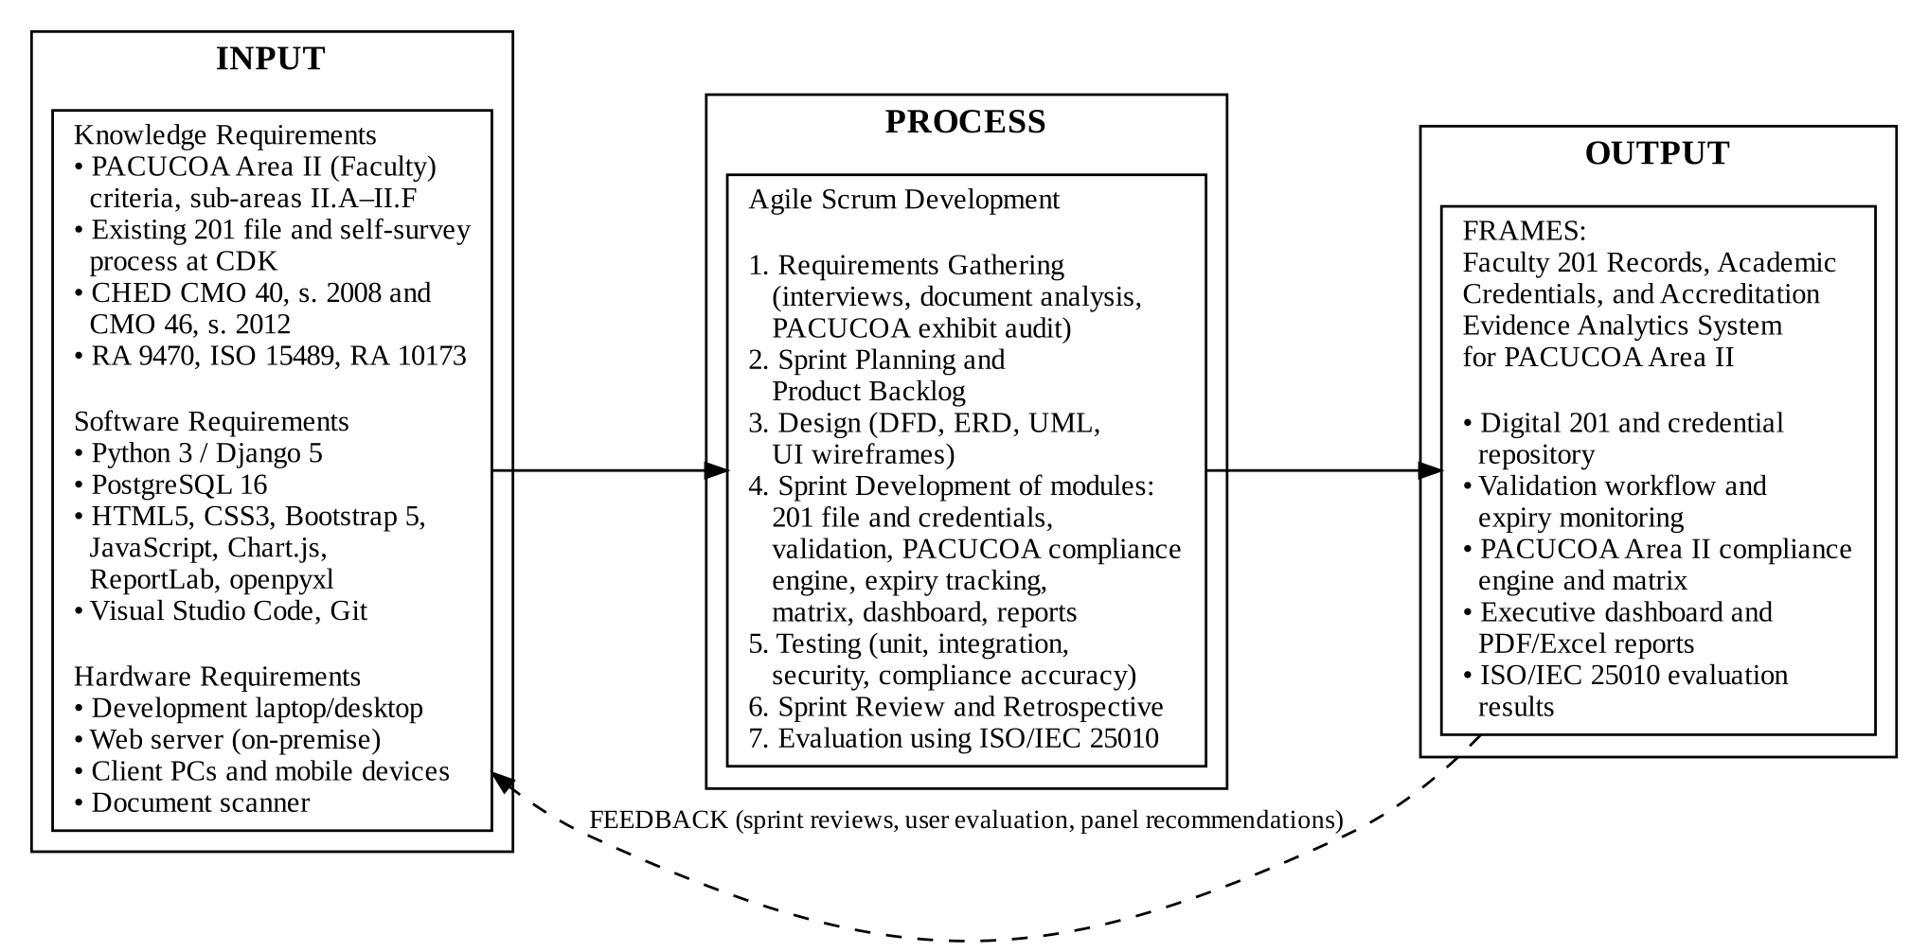
Figure 1. Conceptual Framework of FRAMES
The input consists of the knowledge, software, and hardware requirements of the project. The knowledge requirements include the PACUCOA Area II criteria and the sub-areas configured for this study, the existing 201 file and self-survey process of Colegio de Kidapawan, Inc., the CHED regulations on faculty qualifications and quality assurance, and the laws and standards on records and data privacy. The software requirements include Python, Django, PostgreSQL, and front-end and reporting libraries, while the hardware requirements include development workstations, a server, and client devices.
The process follows the Agile Scrum framework [34]: requirements gathering, product backlog construction and sprint planning, system modeling, iterative development of the 201 file, validation, compliance engine, expiry tracking, matrix, dashboard, and report modules, multi-level testing, and evaluation using ISO/IEC 25010 [35].
The output is FRAMES together with its ISO/IEC 25010 evaluation results. The success of the output will be judged by its system quality, information quality, and usefulness to its users, which are central dimensions of information system success [36]. The feedback loop represents sprint reviews, user evaluation results, and panel recommendations that are returned to the earlier stages to refine the system.
Operational Definition of Terms
The following terms are defined as they are used in this study:
201 File – The official personnel record of a faculty member, containing employment contracts, service records, board licenses, and clearances. In FRAMES, it is the encrypted digital set of uploaded personnel documents.
Academic Credentials – Educational records that certify a faculty member's qualifications, including diplomas, official transcripts of records, Certificates of Authentication and Verification, and PRC licenses.
Accreditation Evidence – Instructional, research, extension, and professional development documents submitted to support compliance with PACUCOA Area II, such as teaching load assignments, syllabi, performance ratings, publications, and extension certificates.
Applicable Requirement – A requirement that applies to a faculty member based on the configured rules, such as employment status, faculty type, or academic rank; conditional requirements that do not apply are excluded from computation.
Compliance Engine – The component of FRAMES that evaluates validated documents against the configured Area II rules, assigns a compliance status to each requirement, and computes compliance percentages.
Compliance Status – The status assigned to each requirement: Complied (uploaded, approved, and unexpired), Incomplete (uploaded but pending validation or returned for re-submission), or Not Complied (not submitted, or expired).
Expiring Credential – An approved document whose expiry date falls within 90 days; FRAMES sends alerts at 90, 60, and 30 days before expiry.
PACUCOA – The Philippine Association of Colleges and Universities Commission on Accreditation, a private accrediting agency that evaluates programs of private HEIs in the Philippines.
PACUCOA Area II (Faculty) – The accreditation area that assesses faculty qualifications, recruitment and tenure, development, teaching performance, research and extension, and working conditions; in this study it is organized into sub-areas II.A to II.F.
PACUCOA Compliance Matrix – A grid generated by FRAMES that lists faculty members in rows and Area II requirements in columns, color-coding each cell by compliance status.
Validation – The review of a submitted document by the HR/Records Administrator or Area II Chair, resulting in an Approved, Rejected, or Re-submission decision.
CHAPTER 3
OPERATIONAL FRAMEWORK
This chapter presents the requirement specification, time feasibility, hardware and software specification, data and process modelling, software development model, ethical considerations, testing and evaluation procedure, data gathering techniques, system evaluation, population and sampling techniques, research instrument and validation, and statistical treatment of data.
Requirement Specification
Following Sommerville [37], the requirements of FRAMES are classified into functional requirements, which describe the services the system must provide, and non-functional requirements, which describe its quality attributes and constraints. Access to these services is governed by role-based access control [38], with the four user roles described in Table 2.
Table 2. User Roles and Access Control Matrix
User Role | System Permissions and Operational Scope
Faculty Member | Accesses personal profile; uploads and re-submits 201 files, academic credentials, and evidence; views personal compliance status, reviewer remarks, and expiration notifications.
HR / Records Administrator | Manages faculty profiles; validates submitted 201 files and credentials; approves, rejects, or requests re-submission; tracks license expirations; generates HR compliance reports.
PACUCOA Area II Chair | Reviews verified credentials and accreditation evidence; inspects departmental and program compliance dashboards; generates Area II compliance matrices and audit summaries.
System Administrator | Manages user accounts, roles, database configuration, audit logs, automated backups, and the PACUCOA Area II requirement rules.

Functional Requirement
Table 3 lists the functional requirements of FRAMES. The dashboard and report requirements follow the principle that the most important indicators should be visible at a glance on a single screen [39].
Table 3. Functional Requirements Specification
Code | Module | Functional Requirement
FR-01 | User Management | The system shall support secure authentication with hashed passwords and role-based access control.
FR-02 | Profile Management | The system shall store faculty profiles, including employee number, academic rank, employment status, faculty type, highest degree, department, and date hired.
FR-03 | 201 and Credential Upload | The system shall allow faculty members to upload files in PDF, JPG, or PNG format of up to 10 MB per file for each applicable requirement.
FR-04 | Document Versioning | The system shall keep previous versions of re-submitted documents as a complete document history.
FR-05 | Validation Workflow | The system shall allow the HR Administrator and Area II Chair to review pending uploads, record an Approved, Rejected, or Re-submission decision, and log feedback.
FR-06 | PACUCOA Rule Configuration | The system shall allow the System Administrator to configure Area II requirements, sub-area assignments, applicability rules, mandatory flags, and expiration flags.
FR-07 | Compliance Engine | The system shall automatically classify each applicable requirement as Complied, Not Complied, or Incomplete and re-evaluate it whenever a document or rule changes.
FR-08 | Expiration Tracking | The system shall check expiry dates daily, flag documents expiring within 90 days, and send alerts at 90, 60, and 30 days before expiry.
FR-09 | Compliance Matrix | The system shall generate a color-coded PACUCOA Area II compliance matrix of faculty members against requirements, filterable by department and sub-area.
FR-10 | Executive Dashboard | The system shall show overall and sub-area compliance percentages, departmental breakdowns, missing evidence lists, and expiring credential queues.
FR-11 | Report Generation | The system shall generate faculty compliance summaries, missing-document reports, and Area II audit summaries in PDF and Excel formats.
FR-12 | Audit Logging | The system shall log user actions, uploads, validation decisions, and rule changes with timestamps and IP addresses.

Non-Functional Requirements
The non-functional requirements of FRAMES are aligned with the quality characteristics of ISO/IEC 25010, as shown in Table 4.
Table 4. Non-Functional Requirements Specification
Quality Characteristic | Requirement
Functional Suitability | Compliance classification shall match the configured Area II rules in 100% of the prepared test cases.
Performance Efficiency | Pages and dashboards shall load in under 2.5 seconds and database queries shall execute in under 1 second under normal campus load.
Compatibility | The system shall run on Google Chrome, Mozilla Firefox, Microsoft Edge, and Safari, with a responsive layout for desktop and mobile devices.
Usability | Navigation shall be consistent, with clear status labels and feedback messages, following established usability heuristics [40].
Reliability | The system shall target 99.5% availability, with scheduled daily database backups and recovery without loss of validated records.
Security | Connections shall use HTTPS/TLS; passwords shall be stored with salted hashing; records shall be protected by role; and the system shall be tested against the OWASP Top 10 risks [41].
Maintainability | The modular Django application [42] shall allow Area II requirement rules to be changed through the interface without modifying source code.
Portability | The system shall be deployable on Ubuntu Server or Windows Server using documented installation steps.

Table 5 presents the initial Area II evidence and requirements matrix to be configured in FRAMES. The list will be validated with the Human Resource Office and the PACUCOA Area II committee during requirements gathering against the survey instrument used by the institution, and can be changed by the System Administrator without modifying the program.
Table 5. Configured PACUCOA Area II Evidence and Requirements Matrix
Sub-Area | Evidence / Document Item | Documentary Basis | Expiry Tracking | Mandatory
II.A | Bachelor's diploma and transcript of records | CHED / Area II.A | No | Yes
II.A | Master's diploma and transcript (vertical alignment) | CHED / Area II.A | No | Yes
II.A | Doctoral diploma and transcript (graduate faculty) | CHED / Area II.A | No | Conditional
II.A | CAV / degree equivalency (foreign degrees) | CHED / Area II.A | No | Conditional
II.A | PRC license / certificate of registration | PRC / Area II.A | Yes | Conditional
II.B | Appointment contract / terms of employment | Area II.B | Yes | Yes
II.B | Updated curriculum vitae / personal data sheet | Area II.B | No | Yes
II.B | Service record / certificate of employment | Area II.B | No | Yes
II.B | Certificate of academic rank and promotion | Area II.B | No | Yes
II.C | Annual faculty development participation plan | Area II.C | Yes | Yes
II.C | Seminar and training certificates (past 3 years) | Area II.C | No | Yes
II.C | Study leave contract / scholarship agreement | Area II.C | Yes | Conditional
II.D | Official teaching load assignment form | Area II.D | Yes | Yes
II.D | Summarized performance ratings (student/peer/dean) | Area II.D | Yes | Yes
II.D | Sample course syllabi and instructional materials | Area II.D | Yes | Yes
II.E | Refereed publications / books authored | Area II.E | No | Yes
II.E | Completed institutional or funded research reports | Area II.E | No | Yes
II.E | Community extension certificates and reports | Area II.E | No | Yes
II.F | NBI / police clearance | Area II.F | Yes | Yes
II.F | Annual medical / health clearance | Area II.F | Yes | Yes

Time Feasibility
The project will be completed over two academic terms. Table 6 presents the Gantt chart of activities, which may be adjusted to the academic calendar of the Graduate School.
Table 6. Gantt Chart of Capstone Project Activities (2026–2027)
Activity | Sep  2026 | Oct  2026 | Nov  2026 | Dec  2026 | Jan  2027 | Feb  2027 | Mar  2027 | Apr  2027
Proposal defense and approval | X
Requirements gathering and PACUCOA audit |  | X
System design and database modeling |  | X | X
Sprint 1–2: authentication and 201 module |  |  | X | X
Sprint 3–4: validation and compliance engine |  |  |  | X | X
Sprint 5–6: dashboard, matrix, and reports |  |  |  |  | X | X
System testing and security hardening |  |  |  |  |  | X
User acceptance evaluation (ISO/IEC 25010) |  |  |  |  |  |  | X
Manuscript revisions and final defense |  |  |  |  |  |  |  | X

Hardware and Software Specification
Tables 7 and 8 present the hardware and software that will be used to develop and deploy FRAMES.
A. Hardware Specifications
Table 7. Hardware Specifications
Component | Development Workstation | Production Server (Recommended) | Client Device (Minimum)
Processor | Intel Core i7 (12th Gen) / AMD Ryzen 7 | Intel Xeon E-2300 series, 8 cores | Dual-core 2.0 GHz or smartphone
Memory | 16 GB DDR4 | 32 GB DDR4 ECC | 4 GB
Storage | 512 GB NVMe SSD | 1 TB NVMe SSD (RAID 1) | 32 GB
Network | High-speed Internet / LAN | 1 Gbps LAN, static IP | Campus Wi-Fi or mobile data

B. Software Specifications
Table 8. Software Specifications
Software Layer | Technology / Tool | Purpose
Operating System | Ubuntu Server 22.04 LTS / Windows 11 | Deployment server and development OS
Programming Language | Python 3.12 | Back-end logic
Web Framework | Django 5 | Web logic, ORM, authentication, administration
Database | PostgreSQL 16 | Relational database management
Database Driver | psycopg 3 | PostgreSQL adapter used by Django
Front End | HTML5, CSS3, JavaScript (ES6+), Bootstrap 5 | Responsive user interface
Visualization | Chart.js | Dashboard charts
Reporting | ReportLab and openpyxl | PDF and Excel report generation
Web Server | Nginx and Gunicorn | Reverse proxy and WSGI application server
Version Control | Git and GitHub | Source code management

Data and Process Modelling
This section presents the system architecture, context diagram, data flow diagram, entity relationship diagram, compliance evaluation flowchart, use case diagram, and class diagram of FRAMES. The context and data flow diagrams follow the structured analysis conventions of Dennis, Wixom, and Roth [43].
FRAMES follows the three-tier architecture shown in Figure 2. The presentation tier is the web browser of each user. The application tier is the Django server, which contains the authentication and role-based access control layer and the modules for digital 201 files and credentials, document validation, the PACUCOA Area II compliance engine, expiration tracking, the compliance matrix, dashboard and reports, and the audit trail. The data tier consists of the PostgreSQL database and encrypted file storage for uploaded documents.
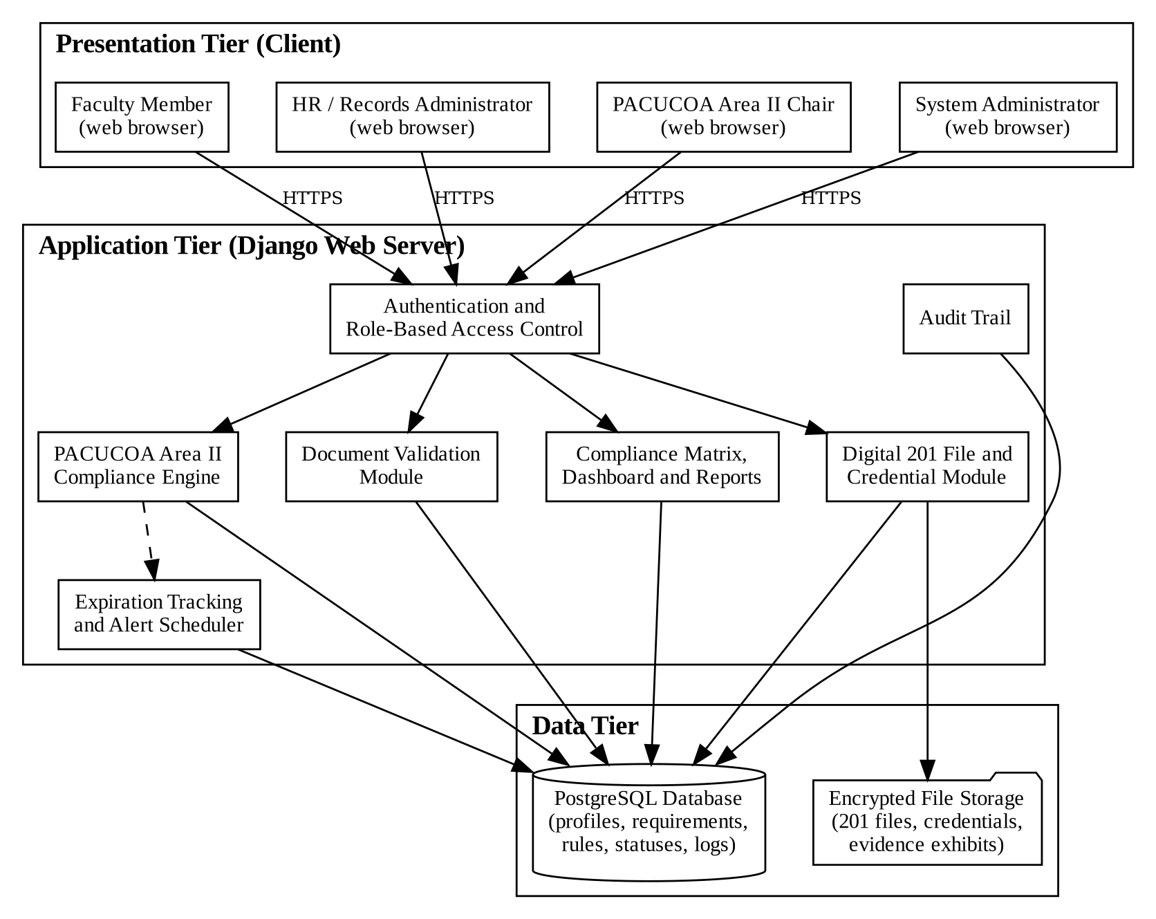
Figure 2. Three-Tier System Architecture of FRAMES
Figure 3 presents the context diagram, which shows FRAMES as a single process and the data exchanged with its four external entities.
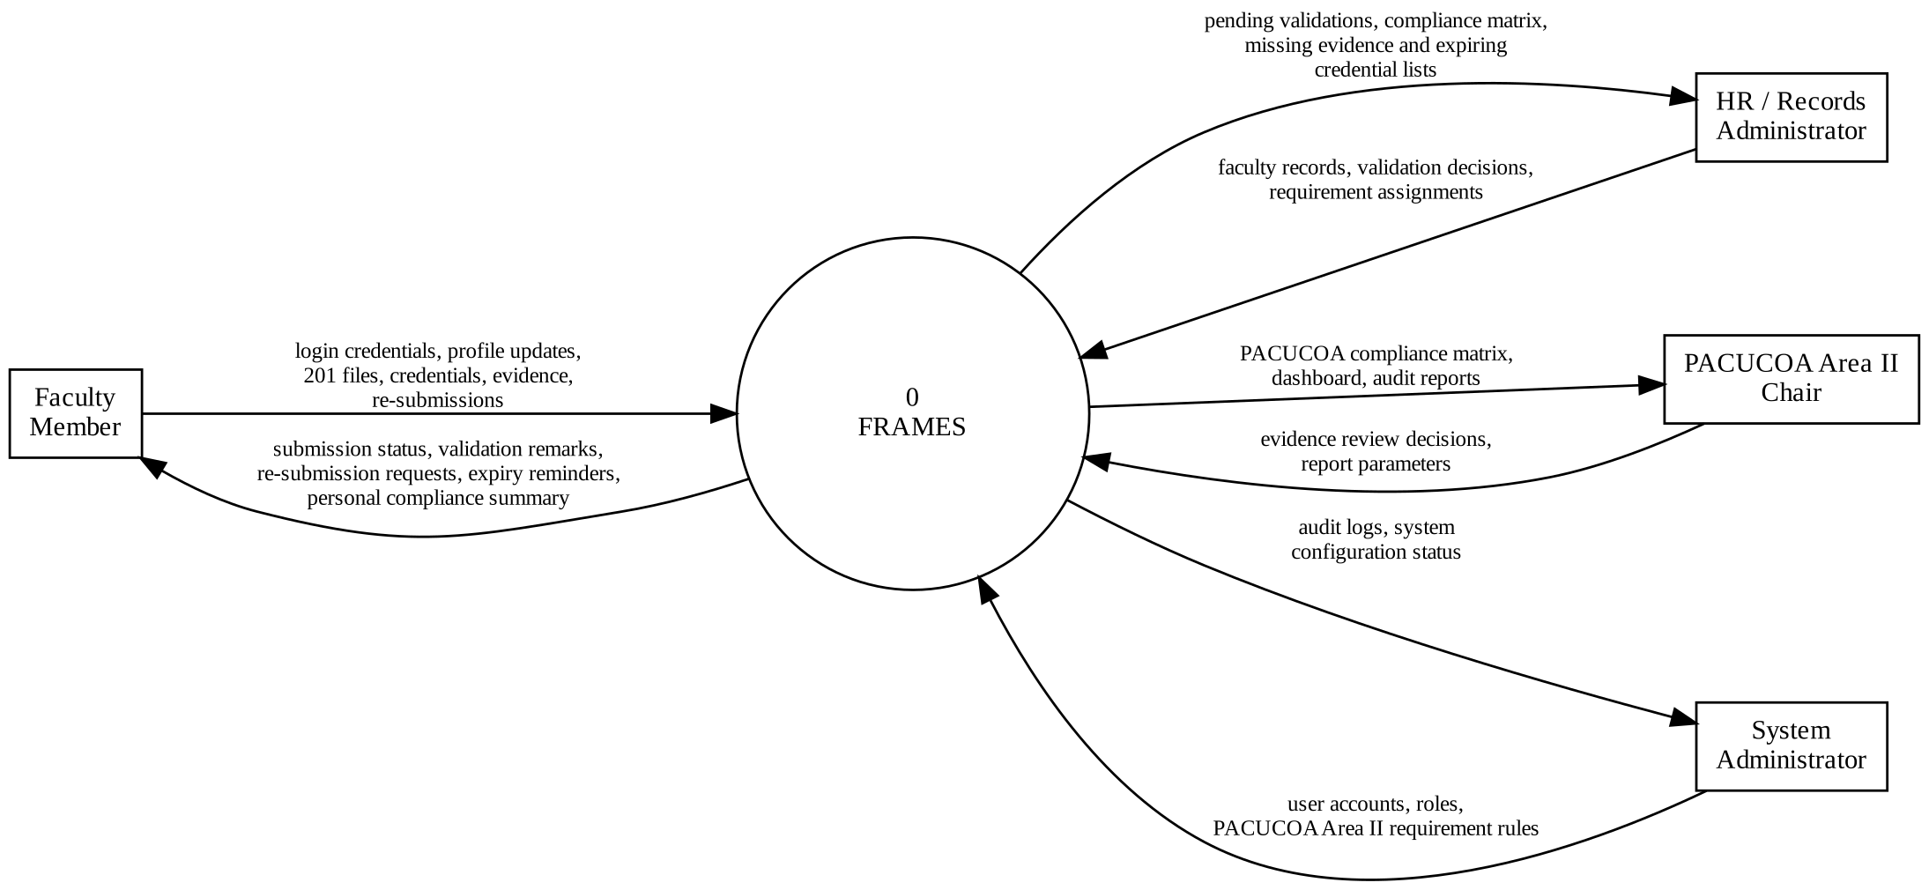
Figure 3. Context Diagram of FRAMES
Figure 4 presents the Level 1 data flow diagram, which breaks FRAMES into seven processes: managing users and authentication, managing faculty profiles, uploading 201 files, credentials, and evidence, validating documents, evaluating Area II compliance, generating the matrix, dashboard, and reports, and tracking expirations and sending alerts.
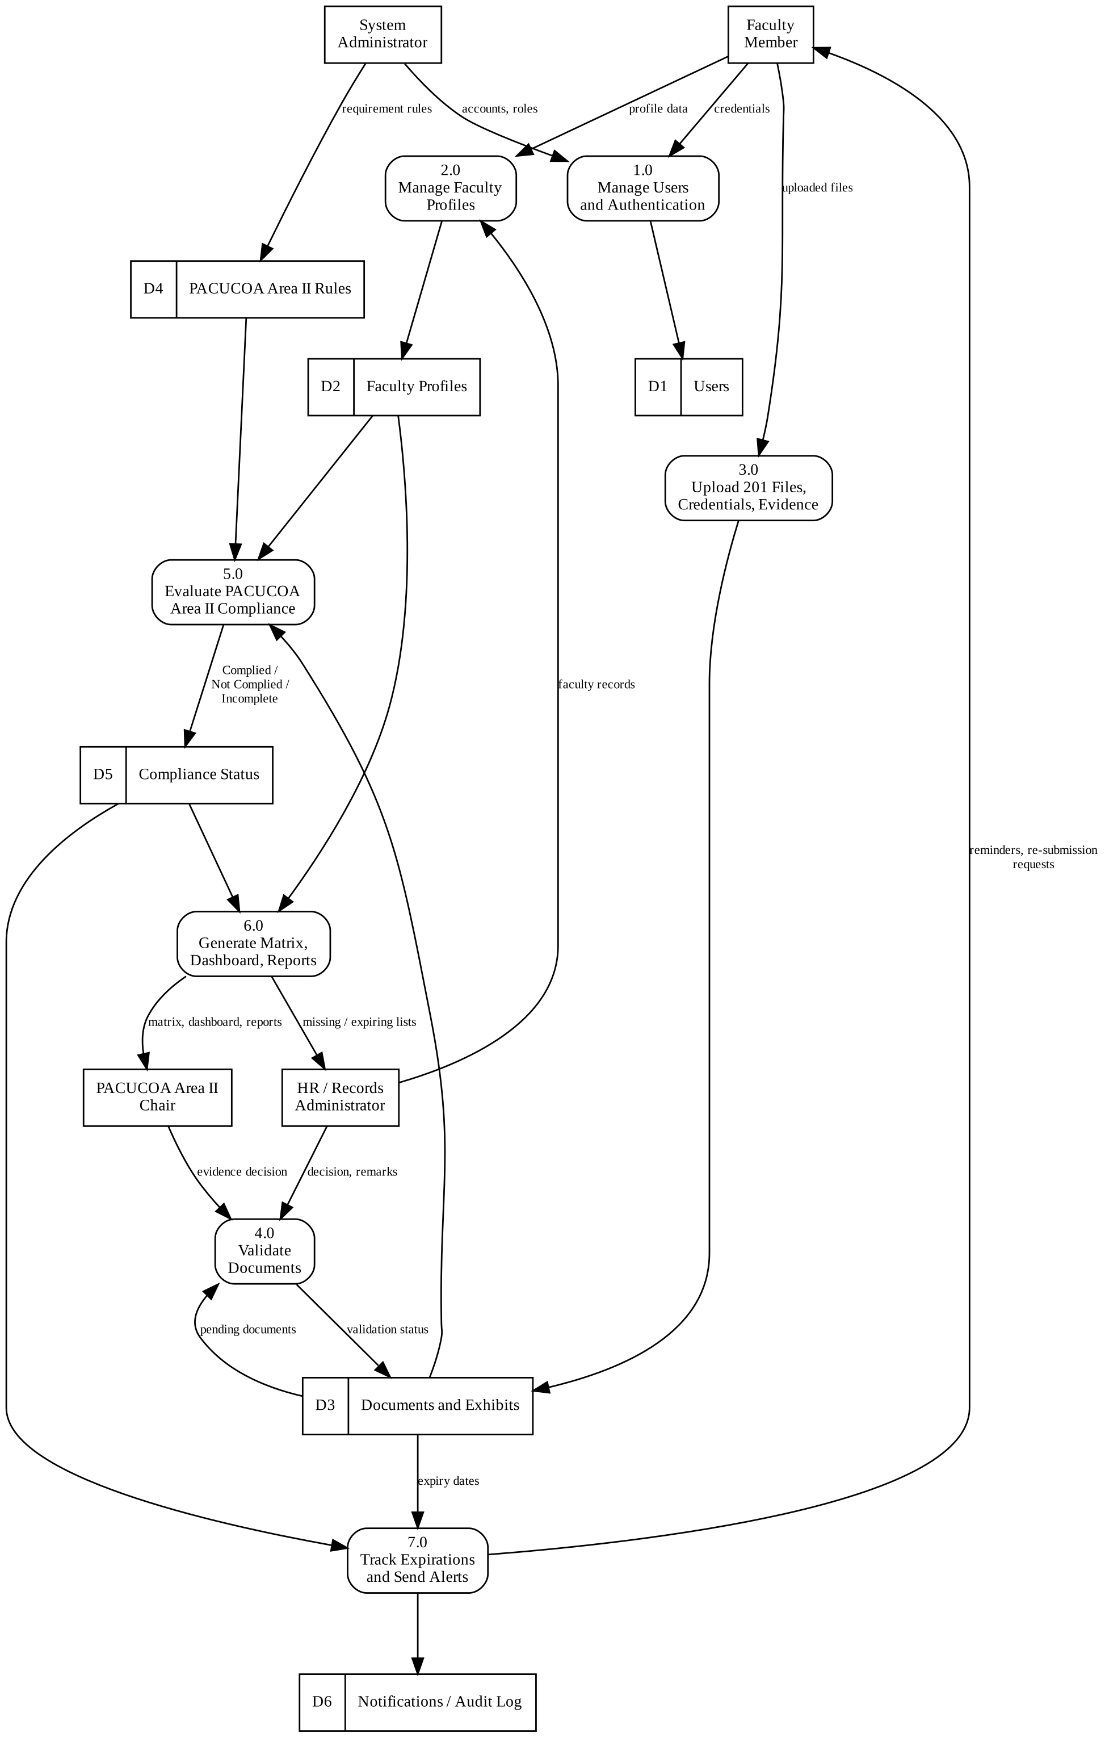
Figure 4. Level 1 Data Flow Diagram of FRAMES
Figure 5 presents the entity relationship diagram, drawn in crow's foot notation [44]. Each requirement belongs to one of the six PACUCOA Area II sub-areas. A faculty member submits many documents, each fulfilling one requirement and reviewed in one or more validation records. The compliance status table stores the current status of every applicable requirement of every faculty member, which allows the matrix and dashboard to load quickly.
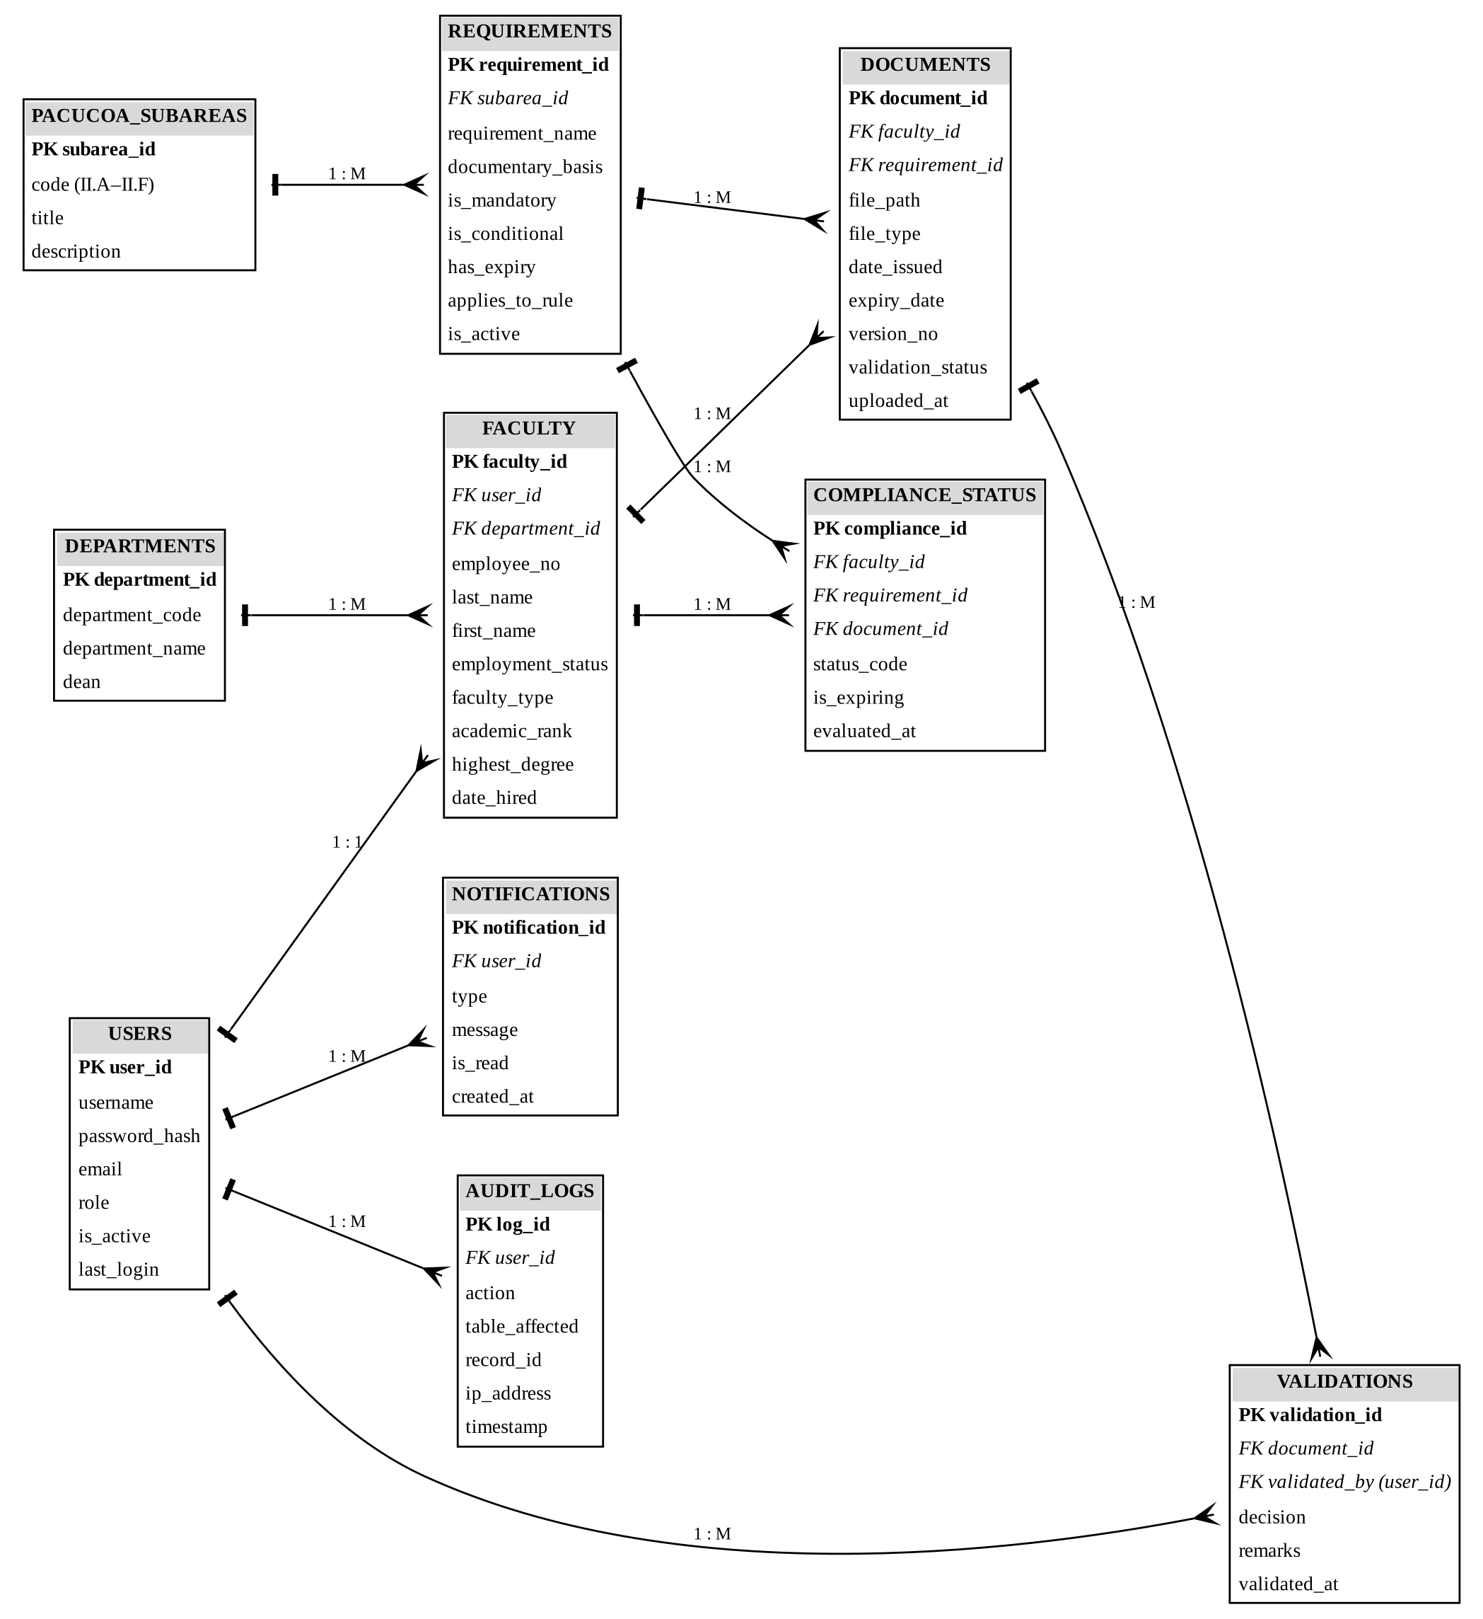
Figure 5. Entity Relationship Diagram of FRAMES
Figure 6 presents the logic of the compliance engine. A requirement with no uploaded document is Not Complied. A document that is pending validation or returned for re-submission makes the requirement Incomplete. An approved document without an expiry date, or with an expiry date that has not passed, makes the requirement Complied; if it expires within 90 days it is also flagged as expiring and alerts are queued. An approved document whose expiry date has passed makes the requirement Not Complied. The engine then computes the compliance percentage of each sub-area and the overall Area II compliance of the faculty member.
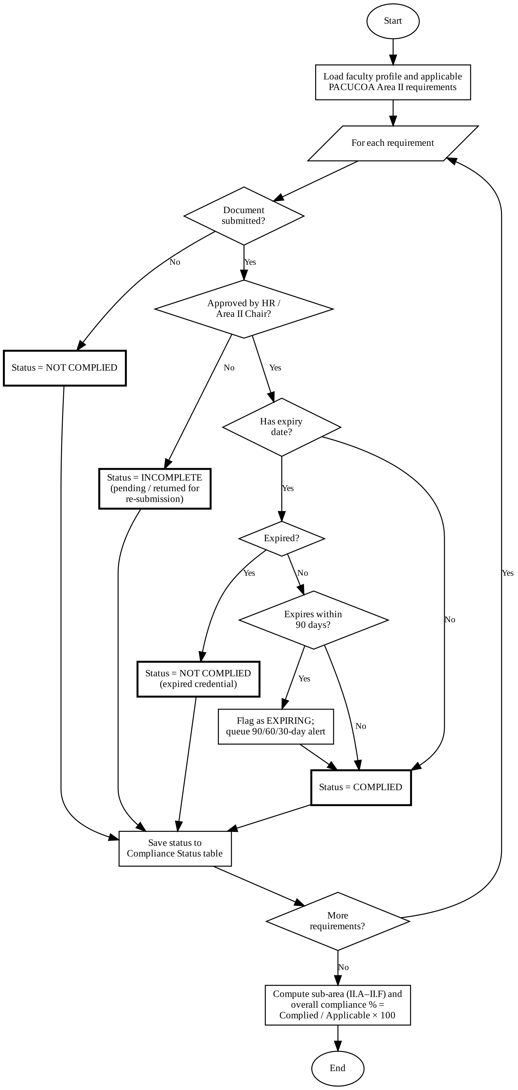
Figure 6. PACUCOA Area II Compliance Evaluation Flowchart
The object-oriented models of FRAMES follow the Unified Modeling Language 2.5.1 specification [45]. Figure 7 presents the use case diagram and Table 9 describes the key use cases.
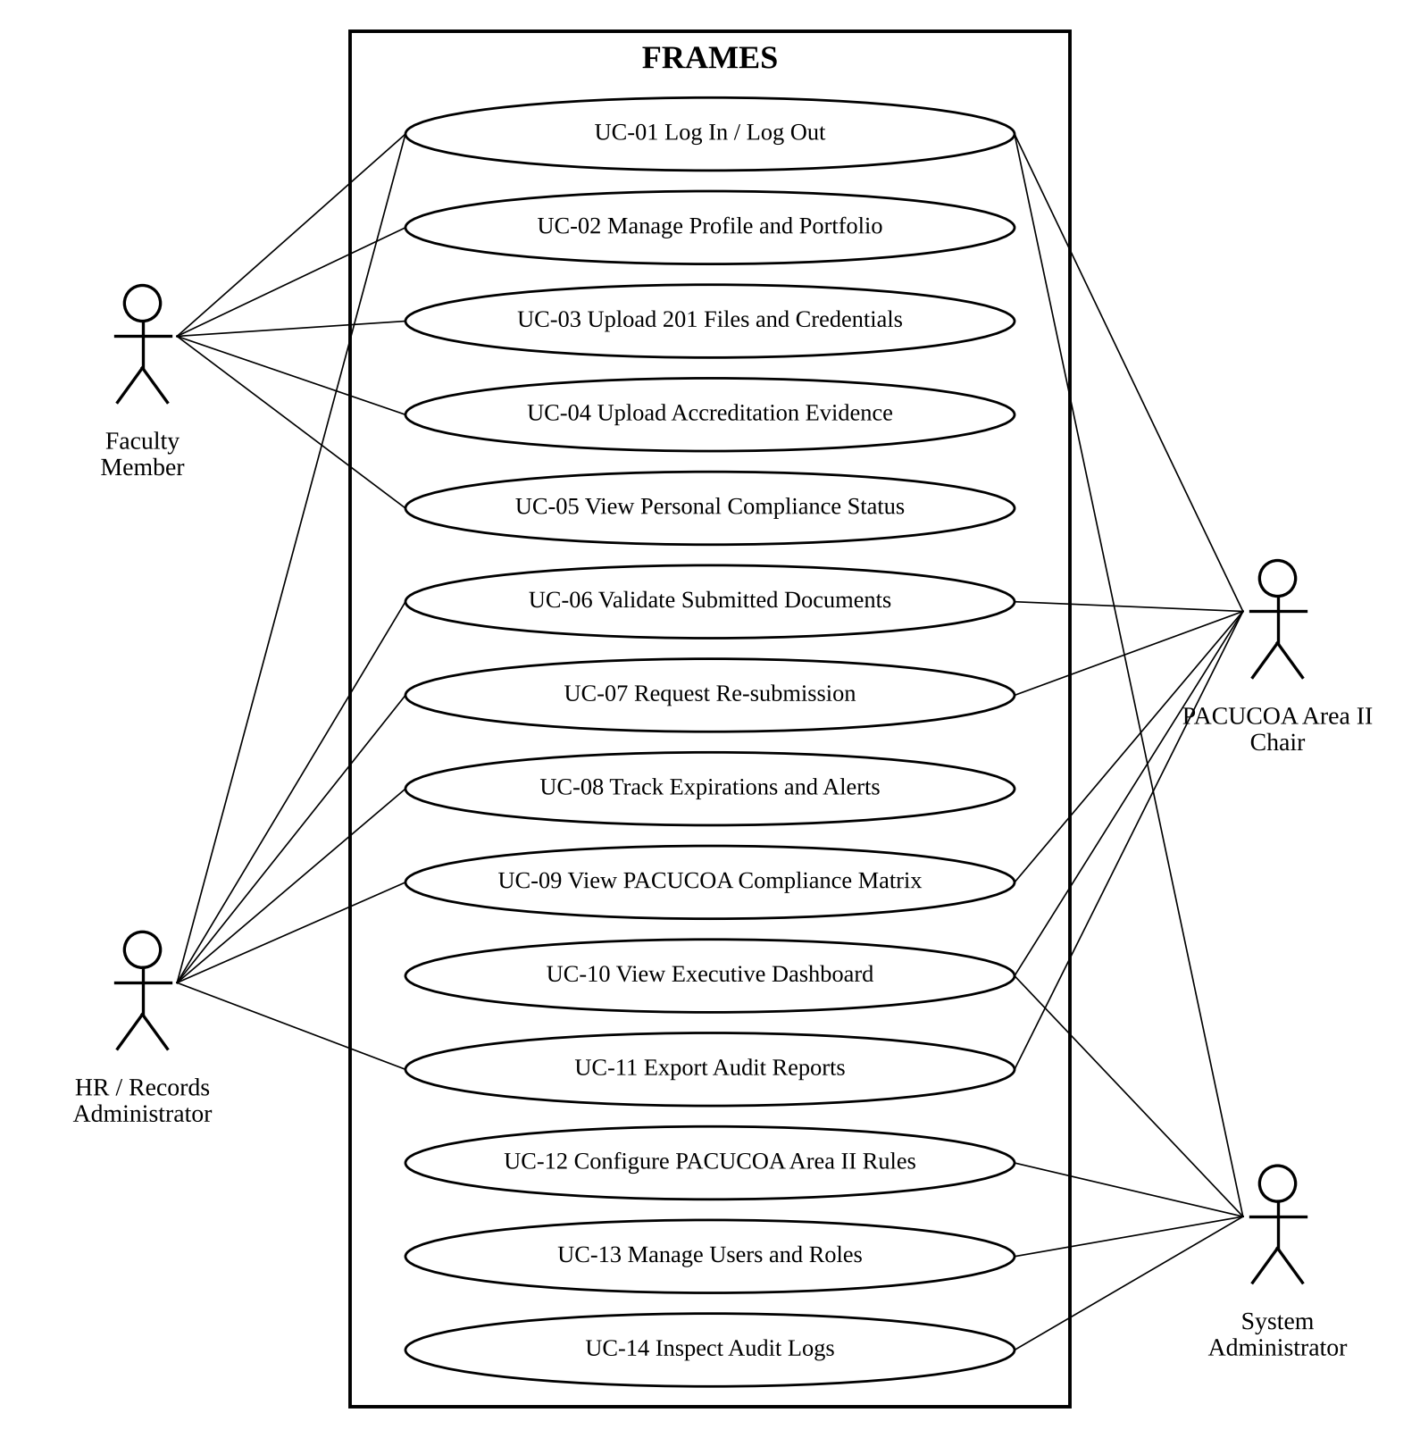
Figure 7. Use Case Diagram of FRAMES
Table 9. Use Case Descriptions for Key System Modules
ID | Use Case | Primary Actor | Description
UC-03 | Upload 201 Files and Credentials | Faculty Member | Selects an Area II requirement, attaches the file, enters issue and expiry dates, and submits. The document becomes Pending and the requirement becomes Incomplete.
UC-06 | Validate Submitted Documents | HR Admin / Area II Chair | Inspects the document against the requirement and approves, rejects, or requests re-submission with remarks. The compliance status is updated immediately.
UC-08 | Track Expirations and Alerts | HR Admin / System | The system checks expiry dates daily, sends alerts at 90, 60, and 30 days, and marks expired credentials as Not Complied.
UC-09 | View PACUCOA Compliance Matrix | Area II Chair | Displays a color-coded matrix of faculty members against Area II requirements, filterable by department and sub-area.
UC-12 | Configure PACUCOA Area II Rules | System Administrator | Defines requirements, sub-area assignments, mandatory and conditional flags, and expiry settings without code changes.

Figure 8 presents the class diagram. The ComplianceEngine class evaluates the applicable requirements of each faculty member and produces ComplianceStatus objects, which the ReportGenerator class reads to build the compliance matrix, dashboard data, and exported reports.
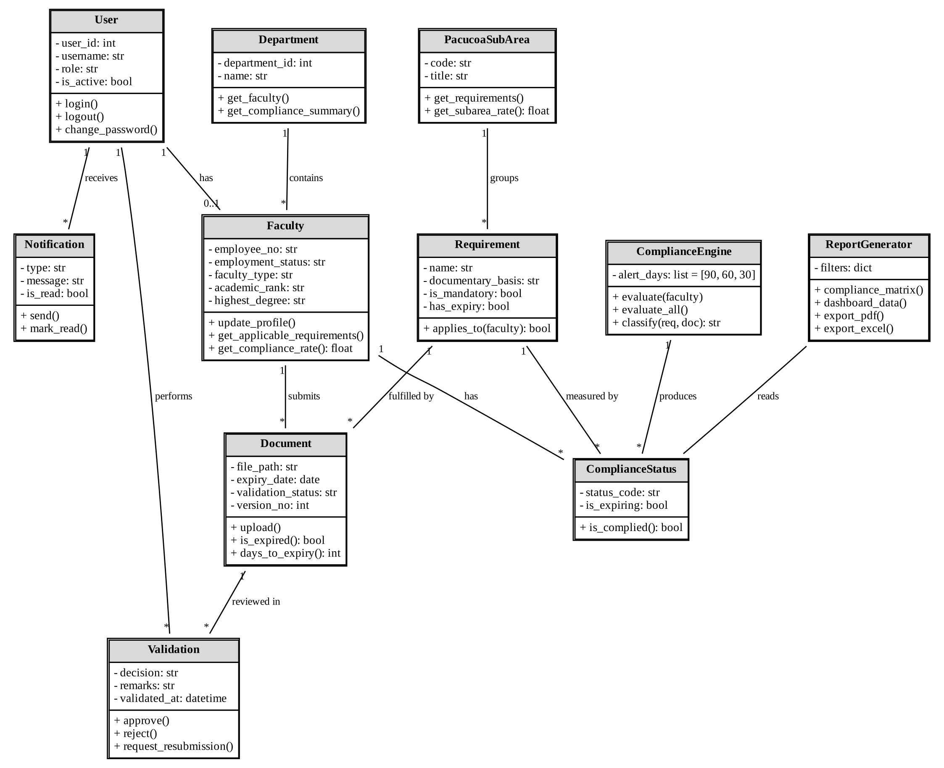
Figure 8. Class Diagram of FRAMES
Software Development Model
Agile Methodology
FRAMES will be developed using the Agile Scrum framework [34], shown in Figure 9. Scrum was chosen because the exact Area II rules and report formats needed by the institution are expected to be refined as users see working versions of the system. This follows the Agile Manifesto, which values working software and responding to change over following a fixed plan [46], and the incremental delivery of software described by Pressman and Maxim [47].
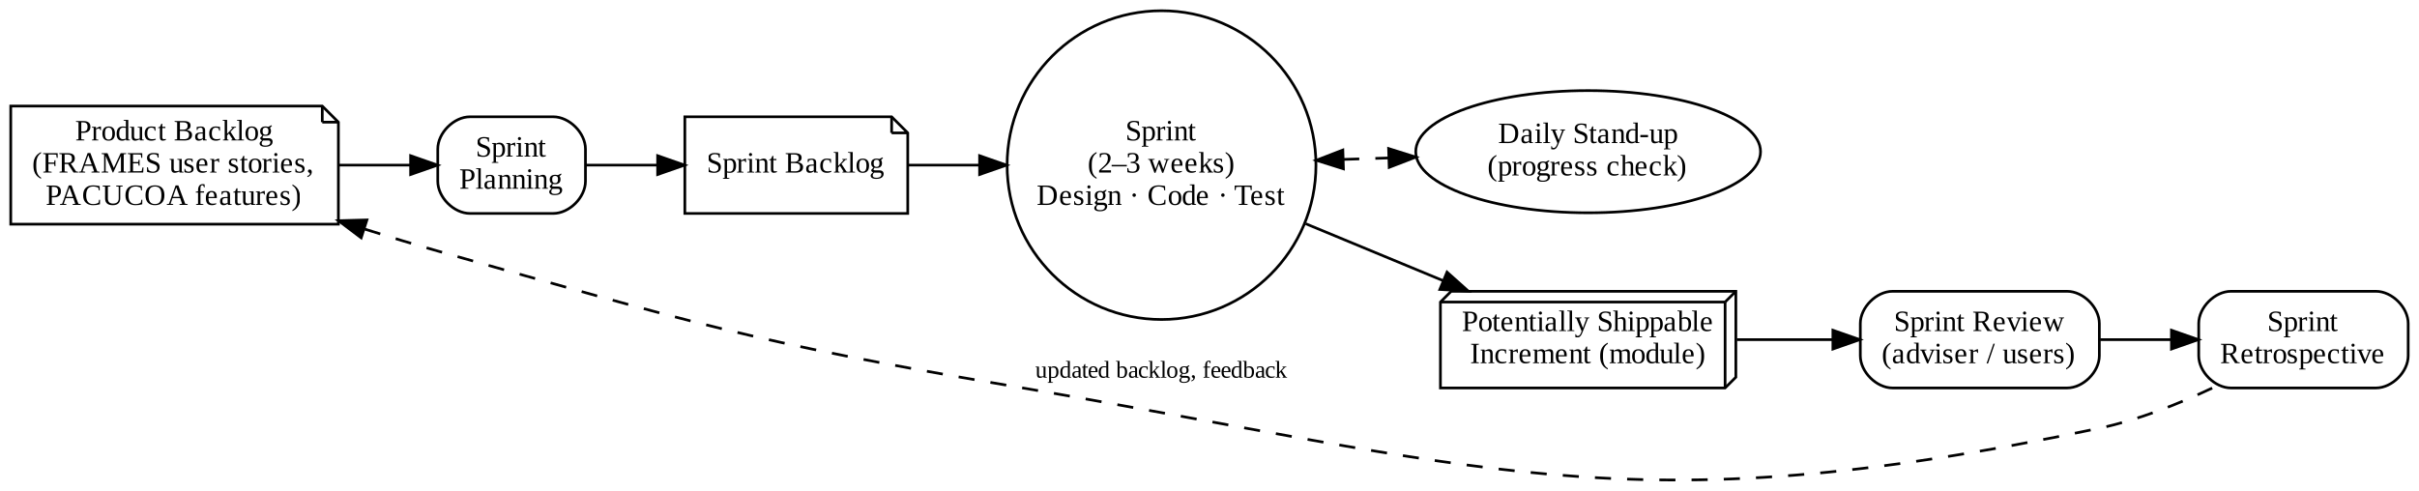
Figure 9. Agile Scrum Development Model
The requirements in Tables 3 to 5 are written as user stories in the product backlog. In each two- to three-week sprint, the researcher selects stories in sprint planning, designs, codes, and tests them, and produces a working increment that is demonstrated to the adviser and selected users in the sprint review. Table 10 presents the planned sprints.
Table 10. Agile Scrum Sprint Plan and Deliverables
Sprint | Deliverables | Timeline
Sprint 1 | System setup, database migrations, authentication, and role-based access control | Weeks 1–3
Sprint 2 | Faculty profile portal, 201 file upload, and academic credential repository | Weeks 4–6
Sprint 3 | Validation workflow, document review portal, and feedback messaging | Weeks 7–9
Sprint 4 | PACUCOA Area II compliance engine and expiration tracking scheduler | Weeks 10–12
Sprint 5 | Compliance matrix and executive analytics dashboard | Weeks 13–15
Sprint 6 | PDF and Excel reports, audit logging, security hardening, and deployment | Weeks 16–18

Continuous Improvement
Continuous improvement is built into the process through the sprint retrospective, in which the researcher reviews what worked and what should change in the next sprint, and through backlog refinement, in which feedback from sprint reviews is added and reprioritized. After the user acceptance evaluation, the comments and lowest-rated items from the ISO/IEC 25010 questionnaire will be converted into backlog items and addressed before final deployment. After deployment, the System Administrator will update the Area II rules whenever PACUCOA or institutional requirements change, without changes to the program code.
Ethical Considerations
Because FRAMES processes confidential faculty personnel records and academic credentials, the researcher will observe the following ethical considerations:
1. Institutional permission. Written permission will be secured from the President and the HR Director of Colegio de Kidapawan, Inc. before data gathering and system testing.
2. Data privacy. In compliance with Republic Act No. 10173 and Republic Act No. 9470, personal and employment information will be collected and processed only for accreditation and quality assurance purposes.
3. Data security. Stored documents will be encrypted at rest, all traffic will use HTTPS/TLS, and access will be limited by role, consistent with the information security controls of ISO/IEC 27001 [48].
4. Anonymization and consent. Development and testing will use anonymized or sample records. Evaluation participants will sign informed consent forms stating that participation is voluntary and that they may withdraw at any time.
5. Confidentiality. Questionnaire responses will be reported only in aggregate, and the researcher will sign the non-disclosure agreement in Appendix A.
Testing and Evaluation Procedure
FRAMES will undergo unit testing of the compliance engine logic using automated Django test cases, integration testing of the data flow between Django, PostgreSQL, and the reporting libraries, system testing against the requirements in Tables 3 and 4, security testing against the OWASP Top 10 risks, and compliance accuracy testing in which the statuses produced by FRAMES are compared with statuses determined manually by the HR Administrator. Table 11 lists the test cases of the compliance engine.
Table 11. Compliance Rules Engine Test Cases
Test Case | Condition | Expected Classification
TC-01 | Mandatory requirement; no document uploaded | Not Complied
TC-02 | Document uploaded; validation pending | Incomplete
TC-03 | Document returned for re-submission | Incomplete
TC-04 | Document approved; requirement has no expiry | Complied
TC-05 | Document approved; expiry more than 90 days away | Complied
TC-06 | Document approved; expiry within 90 days | Complied (flagged; alert queued)
TC-07 | Document approved; expiry date has passed | Not Complied (expired)
TC-08 | Conditional requirement not applicable (e.g., doctoral degree for undergraduate faculty) | Excluded from computation

System Preparation
Before the evaluation, FRAMES will be deployed on a staging server in the campus network. The System Administrator will configure the Area II requirements in Table 5, create accounts for each respondent group, and load anonymized sample faculty records and documents that cover all compliance scenarios in Table 11. The researcher will prepare a short user guide and task scenarios for each role and conduct a brief orientation before the evaluation.
Data Gathering Techniques
The researcher will use the following techniques:
1. Interview. Semi-structured interviews with HR personnel, deans, and the PACUCOA Area II committee to understand the current 201 file and self-survey process and the reports needed.
2. Document analysis. Review of the Area II survey instrument used by the institution, existing requirement checklists, sample 201 files, and CHED issuances to define the requirement rules.
3. Observation. Observation of how documents are currently submitted, filed, and checked to identify delays in the manual process.
4. Survey questionnaire. An ISO/IEC 25010-based questionnaire administered after hands-on use of the system.
System Evaluation
User acceptance of an information system depends largely on its perceived usefulness and perceived ease of use [49]. To measure the quality of FRAMES, respondents will perform role-based task scenarios on the staging server, such as uploading and validating documents, viewing the compliance matrix, and exporting reports, and will then rate the system using the ISO/IEC 25010 questionnaire. Usability is understood as the extent to which intended users can achieve their goals with effectiveness, efficiency, and satisfaction [50]. Table 12 shows which characteristics each respondent group will evaluate.
Table 12. ISO/IEC 25010 Quality Model Evaluation Criteria
Quality Characteristic | Sub-Characteristics Evaluated | Evaluator Group
Functional Suitability | Completeness, correctness, appropriateness | All respondents
Performance Efficiency | Time behavior, resource utilization, capacity | All respondents
Compatibility | Co-existence, interoperability | IT experts and administrators
Usability | Recognizability, learnability, operability, user error protection | All respondents
Reliability | Maturity, availability, fault tolerance, recoverability | IT experts and administrators
Security | Confidentiality, integrity, accountability, authenticity | IT experts and administrators
Maintainability | Modularity, reusability, analysability, modifiability | IT experts only
Portability | Adaptability, installability, replaceability | IT experts only

Population and Sampling Techniques
The population consists of the HR and records administrators, PACUCOA Area II chairs and deans, faculty members of Colegio de Kidapawan, Inc., and external IT experts. Total enumeration will be used for the HR administrators and Area II chairs and deans because of their small number and direct involvement with the system. Faculty members will be selected through stratified random sampling, with departments as strata and the sample allocated in proportion to the number of faculty members in each department. IT experts will be selected through purposive sampling based on their experience in software development or systems administration. Table 13 presents the distribution of respondents.
Table 13. Distribution of Respondents
Respondent Group | Population (N) | Sample (n) | Sampling Technique
HR and Records Administrators | 3 | 3 | Total enumeration
PACUCOA Area II Chairs / Deans | 7 | 7 | Total enumeration
Full-Time and Part-Time Faculty | 45 | 35 | Stratified random sampling
External IT Experts | 5 | 5 | Purposive sampling
Total | 60 | 50

Research Instrument and Validation
The research instrument is a structured questionnaire based on the ISO/IEC 25010 quality characteristics in Table 12 (Appendix B). Each item is rated on the five-point Likert scale [51] in Table 14. Before administration, the questionnaire will be reviewed for content validity by three experts, consisting of an IT faculty member, a quality assurance officer, and a software developer, who will check that each item is clear and relevant to its characteristic. The revised instrument will be pilot-tested with ten faculty members who are not part of the sample, and its internal consistency will be measured with Cronbach's alpha [52], where a coefficient of at least 0.70 will be considered acceptable.
Table 14. Five-Point Likert Scale and Verbal Interpretation
Scale | Mean Range | Verbal Interpretation | Meaning
5 | 4.21 – 5.00 | Excellent | Exceeds quality expectations
4 | 3.41 – 4.20 | Very Good | Meets quality expectations
3 | 2.61 – 3.40 | Good | Acceptable; minor improvements needed
2 | 1.81 – 2.60 | Fair | Below expectations; substantial improvement needed
1 | 1.00 – 1.80 | Poor | Fails to meet baseline requirements

Statistical Treatment of Data
The following statistical tools will be used:
1. Weighted Mean. Used to compute the average rating for each ISO/IEC 25010 characteristic and for the system as a whole:
WM = Σ(f × w) / N
where WM is the weighted mean, f is the number of respondents who chose a scale value, w is the scale value (1 to 5), and N is the total number of respondents. The result is interpreted using Table 14.
2. Percentage. Used to describe the distribution of respondents and test results:
P = (f / N) × 100
where P is the percentage, f is the frequency, and N is the total number of cases.
3. Compliance Engine Accuracy. Used in compliance accuracy testing:
A = (C_correct / C_total) × 100
where A is the accuracy rate, C_correct is the number of requirements classified the same way by FRAMES and by manual review, and C_total is the number of requirements tested.
4. PACUCOA Area II Compliance Rating. Computed by FRAMES for each faculty member, sub-area, department, and the institution:
CR = (Σ Complied requirements / Σ Applicable requirements) × 100
where CR is the compliance rating. Requirements that do not apply to a faculty member are excluded from both the numerator and the denominator.
REFERENCES
[1] Commission on Higher Education, Manual of Regulations for Private Higher Education (CHED Memorandum Order No. 40, Series of 2008). Quezon City, Philippines: CHED, 2008.
[2] Commission on Higher Education, Policy-Standard to Enhance Quality Assurance (QA) in Philippine Higher Education through an Outcomes-Based and Typology-Based QA (CHED Memorandum Order No. 46, Series of 2012). Quezon City, Philippines: CHED, 2012.
[3] Philippine Association of Colleges and Universities Commission on Accreditation, "Programs that PACUCOA accredits." [Online]. Available: https://pacucoa.com/copy-of-pacucoa-accreditation
[4] National Archives of the Philippines Act of 2007, Republic Act No. 9470, Philippines, 2007.
[5] Information and Documentation – Records Management – Part 1: Concepts and Principles, ISO 15489-1:2016, International Organization for Standardization, Geneva, Switzerland, 2016.
[6] Data Privacy Act of 2012, Republic Act No. 10173, Philippines, 2012.
[7] A. Khandait, S. Katkar, S. Khanorkar, C. Logade, R. Ninawe, and A. Moon, "An integrated faculty profile management system for efficient academic data handling," International Journal for Research in Applied Science and Engineering Technology, 2026, doi: 10.22214/ijraset.2026.80454.
[8] N. Bamel, U. K. Bamel, V. Sahay, and M. Thite, "Usage, benefits and barriers of human resource information system in universities," VINE Journal of Information and Knowledge Management Systems, vol. 44, no. 4, 2014, doi: 10.1108/VINE-04-2013-0024.
[9] U. Schreier, M. Reusch, M. Hüffmeyer, and D. Belzer, "Information system support for quality management applying European standards and guidelines for higher education," in Proc. 6th Int. Conf. Computer Supported Education (CSEDU), 2014, pp. 309–316, doi: 10.5220/0004846403090316.
[10] A. Abduldaem and A. Gravell, "Success factors of business intelligence and performance dashboards to improve performance in higher education," in Proc. 23rd Int. Conf. Enterprise Information Systems (ICEIS), vol. 2, 2021, pp. 392–402, doi: 10.5220/0010499503920402.
[11] M. E. Kyobe, P. Molai, and T. Salie, "Investigating electronic records management and compliance with regulatory requirements in a South African university," South African Journal of Information Management, vol. 11, no. 1, Art. no. a396, 2009, doi: 10.4102/sajim.v11i1.396.
[12] B. E. Asogwa, "The readiness of universities in managing electronic records: A study of three federal universities in Nigeria," The Electronic Library, vol. 31, no. 6, pp. 792–807, 2013, doi: 10.1108/EL-04-2012-0037.
[13] R. Mokhtar, S. H. Othman, N. H. Jaafar, M. M. Malom, and R. Ramlan, "Visualization of academic quality assurance metamodel through the creation of academic quality assurance metamodel information system," Journal of Soft Computing and Data Mining, vol. 3, no. 2, pp. 60–70, 2022.
[14] N. Sukmana, C. Hilman, and E. D. Darmawan, "Implementation of a web-based educational administration system to enhance accreditation at university," Scaffolding: Jurnal Pendidikan Islam dan Multikulturalisme, vol. 8, no. 2, 2026, doi: 10.37680/scaffolding.v8i2.9450.
[15] T. Changiz, A. Moeeny, and R. Jowshan, "OFIS: Online faculty information system," Campus-Wide Information Systems, vol. 21, no. 2, pp. 95–100, 2004, doi: 10.1108/10650740410529529.
[16] K. Jansri and P. Sirichote, "Development of human resource information system of Roi-Et Rajabhat University," Journal of Information Science Research and Practice, vol. 35, no. 4, pp. 55–73, 2017.
[17] R. D. Mascariñas, J. F. Solatorio, E. M. Rafols, J. Ramos, E. L. Mordeno, N. Aung, J. C. Rarugal, and L. Velasco, "Human resource information systems in higher education institutions: A systematic review," International Journal of Computing and Digital Systems, vol. 17, no. 1, pp. 1–14, 2024.
[18] A. Okello, "Digitization of academic records at institutions of higher learning," M.A. dissertation, Makerere University, Kampala, Uganda, 2022.
[19] S. Evadini, D. A. Satriatama, and N. S. Handayani, "Development of a web-based e-report visualization dashboard evaluated using the System Usability Scale (SUS)," Journal of Applied Multimedia and Networking, vol. 10, no. 1, pp. 20–30, 2026, doi: 10.30871/jamn.v10i1.13438.
[20] M. A. Esguerra, "Development of an online faculty profiling system for Lyceum of the Philippines University-Batangas," University of the Philippines Open University, Los Baños, Laguna, 2011. [Online]. Available: https://repository.upou.edu.ph/handle/20.500.13073/419
[21] R. G. Hernandez, R. L. Hernandez, and N. F. Bueno, "Decision support system on faculty profiling using full-text search algorithm: A tool for evaluating faculty performances," Journal Européen des Systèmes Automatisés, vol. 58, no. 4, pp. 689–700, 2025, doi: 10.18280/jesa.580403.
[22] M. N. Abadiano, "Human resources information system for the University of Cebu," IAMURE International Journal of Business and Management, vol. 3, no. 1, 2012.
[23] J. M. M. Mindoro-Mesana, J. P. M. Mesana, and L. M. Mariño, "Design and development of Romblon State University Romblon Campus accreditation data warehouse," Romblon State University Research Journal, vol. 4, no. 2, pp. 17–24, 2022.
[24] D. T. Angala, B. C. O. Casugay, H. M. Q. Estillore, J. B. Lebantino, S. O. Marcha, and G. R. Villanueva Jr., "Development and implementation of document management system for Ilocos Sur Polytechnic State College, Tagudin Campus," Ilocos Sur Polytechnic State College, vol. 3, special issue, Jun. 2023, doi: 10.56901/HPCB6748.
[25] R. G. Rabulan and J. P. L. Glina, "Web-based file management system for the Office of National Service Training Program," Indonesian Journal of Educational Research and Technology, vol. 5, no. 2, pp. 191–200, 2025, doi: 10.17509/ijert.v5i2.85144.
[26] E. J. M. Balbas, M. R. O. Danao, L. A. Difuntorum, D. C. E. Jacla, A. D. Llavore, and A. J. B. Rivera, "eRMS: Electronic record management system for Municipal Social Welfare and Development Office of Tubao, La Union," undergraduate thesis, Don Mariano Marcos Memorial State University–South La Union Campus, Agoo, La Union, 2022.
[27] S. T. Gerodias, "Office of the Dean, College of Social Sciences and Philosophy records management policy: A project proposal," M.L.I.S. thesis, School of Library and Information Studies, University of the Philippines Diliman, Quezon City, 2018.
[28] V. E. V. Palcullo and P. Seelakate, "Strengthening records management in higher education: A case of university library practices in the Philippines," 2025. [Online]. Available: https://repository.cpu.edu.ph/handle/20.500.12852/3622
[29] G. R. L. Franco, "Design and implementation of a web-based faculty information system," in Proc. IEEE Region 10 Conf. (TENCON), Macao, China, 2015, doi: 10.1109/TENCON.2015.7372976.
[30] B. G. S. Grepon, N. T. Baran, K. M. V. C. Gumonan, A. L. M. Martinez, and M. L. E. Lacsa, "Designing and implementing e-school systems: An information systems approach to school management of a community college in Northern Mindanao, Philippines," International Journal of Computing Sciences Research, 2021, doi: 10.25147/ijcsr.2017.001.1.74.
[31] D. M. Patimo and R. P. Maribojoc, "University electronic records management system for Northwest Samar State University, Calbayog City," Logic: Jurnal Rancang Bangun dan Teknologi, vol. 21, no. 1, pp. 1–7, 2021, doi: 10.31940/logic.v21i1.2145.
[32] P. A. Batoon, L. M. Maningo, and J. Francisco, "Knight Tracker: A web based records management system and evaluation process with data aging for the Graduate School of Colegio de San Juan de Letran Calamba," Ani: Letran Calamba Research Report, vol. 19, no. 1, 2023.
[33] J. R. Celis and E. Lagda, "Development and evaluation of UE – Research Management System," UE Research Journal, vol. 28, no. 2, 2025.
[34] K. Schwaber and J. Sutherland, The Scrum Guide, Nov. 2020. [Online]. Available: https://scrumguides.org
[35] Systems and Software Engineering – Systems and Software Quality Requirements and Evaluation (SQuaRE) – System and Software Quality Models, ISO/IEC 25010:2011, International Organization for Standardization, Geneva, Switzerland, 2011.
[36] W. H. DeLone and E. R. McLean, "The DeLone and McLean model of information systems success: A ten-year update," Journal of Management Information Systems, vol. 19, no. 4, pp. 9–30, 2003, doi: 10.1080/07421222.2003.11045748.
[37] I. Sommerville, Software Engineering, 10th ed. Boston, MA, USA: Pearson, 2016.
[38] R. S. Sandhu, E. J. Coyne, H. L. Feinstein, and C. E. Youman, "Role-based access control models," Computer, vol. 29, no. 2, pp. 38–47, 1996, doi: 10.1109/2.485845.
[39] S. Few, Information Dashboard Design: Displaying Data for At-a-Glance Monitoring, 2nd ed. Burlingame, CA, USA: Analytics Press, 2013.
[40] J. Nielsen, Usability Engineering. San Francisco, CA, USA: Morgan Kaufmann, 1993.
[41] OWASP Foundation, OWASP Top 10: 2021, 2021. [Online]. Available: https://owasp.org/Top10/
[42] Django Software Foundation, Django Documentation (Version 5). [Online]. Available: https://docs.djangoproject.com
[43] A. Dennis, B. H. Wixom, and R. M. Roth, Systems Analysis and Design, 7th ed. Hoboken, NJ, USA: Wiley, 2018.
[44] R. Elmasri and S. B. Navathe, Fundamentals of Database Systems, 7th ed. Boston, MA, USA: Pearson, 2016.
[45] Object Management Group, OMG Unified Modeling Language (OMG UML), Version 2.5.1, Dec. 2017. [Online]. Available: https://www.omg.org/spec/UML/2.5.1
[46] K. Beck et al., Manifesto for Agile Software Development, 2001. [Online]. Available: https://agilemanifesto.org
[47] R. S. Pressman and B. R. Maxim, Software Engineering: A Practitioner's Approach, 9th ed. New York, NY, USA: McGraw-Hill Education, 2020.
[48] Information Security, Cybersecurity and Privacy Protection – Information Security Management Systems – Requirements, ISO/IEC 27001:2022, International Organization for Standardization, Geneva, Switzerland, 2022.
[49] F. D. Davis, "Perceived usefulness, perceived ease of use, and user acceptance of information technology," MIS Quarterly, vol. 13, no. 3, pp. 319–340, 1989, doi: 10.2307/249008.
[50] Ergonomics of Human-System Interaction – Part 11: Usability: Definitions and Concepts, ISO 9241-11:2018, International Organization for Standardization, Geneva, Switzerland, 2018.
[51] R. Likert, "A technique for the measurement of attitudes," Archives of Psychology, vol. 22, no. 140, pp. 1–55, 1932.
[52] L. J. Cronbach, "Coefficient alpha and the internal structure of tests," Psychometrika, vol. 16, no. 3, pp. 297–334, 1951, doi: 10.1007/BF02310555.
APPENDICES
Appendix A
NON–DISCLOSURE AGREEMENT
This Non-Disclosure Agreement is entered into on [date] by and between Colegio de Kidapawan, Inc., hereinafter referred to as the "Institution," and JOSEPH R. OPLE JR., a graduate student of the Master in Information Technology program of Philippine Christian University, hereinafter referred to as the "Researcher," in connection with the capstone project entitled FRAMES: FACULTY 201 RECORDS, ACADEMIC CREDENTIALS, AND ACCREDITATION EVIDENCE ANALYTICS SYSTEM FOR PACUCOA AREA II.
1. Confidential Information. Confidential information includes all faculty personnel records, 201 files, academic credentials, employment and performance data, accreditation documents, and any other information of the Institution that the Researcher obtains during the study, whether in physical or electronic form.
2. Obligations of the Researcher. The Researcher shall use the confidential information solely for the design, development, testing, and evaluation of FRAMES; shall not disclose it to any third party without the written consent of the Institution; shall process personal information in accordance with Republic Act No. 10173 (Data Privacy Act of 2012); and shall protect it with reasonable organizational, physical, and technical security measures.
3. Use of Data in the Manuscript. Any data reported in the capstone manuscript, presentations, or publications shall be aggregated or anonymized so that no individual faculty member can be identified.
4. Return and Disposal. Upon completion of the study, or upon request of the Institution, the Researcher shall return or securely delete all confidential information and copies in his possession, except the deployed system and data that remain under the Institution's control.
5. Duration. The obligations under this Agreement shall remain in effect during the study and for a period of [number] years after its completion.
IN WITNESS WHEREOF, the parties have signed this Agreement on the date first written above.
For the Institution | Researcher
______________________________  [Name and Position]  Colegio de Kidapawan, Inc. | ______________________________  JOSEPH R. OPLE JR.  MIT Student, Philippine Christian University

Appendix B
ISO/IEC 25010 SYSTEM EVALUATION QUESTIONNAIRE
Respondent group: ☐ HR / Records Administrator ☐ PACUCOA Area II Chair / Dean ☐ Faculty Member ☐ IT Expert
Instructions: After using FRAMES, please rate each statement by checking the column that best matches your assessment: 5 – Excellent, 4 – Very Good, 3 – Good, 2 – Fair, 1 – Poor. Characteristics marked (A) are answered by IT experts and administrators only; characteristics marked (E) are answered by IT experts only.
Indicator | 5 | 4 | 3 | 2 | 1
Functional Suitability
1. The system provides all the functions needed to manage 201 files, credentials, and Area II evidence.
2. The system correctly classifies requirements as Complied, Not Complied, or Incomplete.
3. The functions help me complete Area II preparation tasks.
Performance Efficiency
4. Pages, the dashboard, and the compliance matrix load quickly.
5. Uploading and downloading documents is fast.
6. The system remains responsive when many users are working.
Compatibility (A)
7. The system works well on different browsers and devices.
8. Exported PDF and Excel reports open correctly in other applications.
Usability
9. The functions of the system are easy to recognize.
10. The system is easy to learn.
11. The system is easy to operate and navigate.
12. The system prevents and clearly explains input errors.
Reliability (A)
13. The system operates without errors or crashes.
14. The system is available whenever I need it.
15. Data is preserved after an error or interruption.
Security (A)
16. Users can access only the functions and records allowed by their role.
17. Faculty records and documents are protected from unauthorized changes.
18. User actions are recorded in the audit log.
Maintainability (E)
19. The system is organized into modules that can be changed independently.
20. Area II requirement rules can be modified without changing the program code.
Portability (E)
21. The system can be installed on a new server with the documented steps.
22. The system can adapt to different operating environments.

Comments and suggestions:
______________________________________________________________________________
______________________________________________________________________________
______________________________________________________________________________

