**Personas**

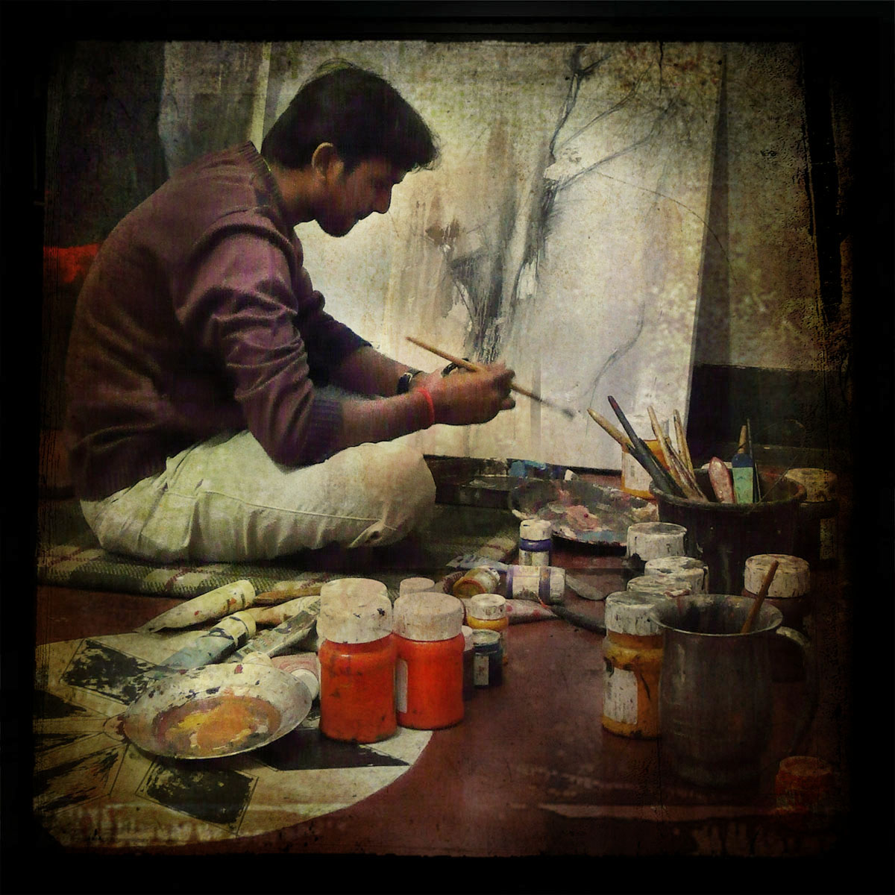

This website is a collection of musings, writings, interests and art of Kendyl LeMahieu.

The purpose of this site is for the author to share her works, which include: blog posts, videos, short stories, novels, poetry, paintings and diy projects. Included in the sharing of these works, visitors to the site can purchase physical copies of selected submissions. Due to this, the site allows for its author to expand on her market for her works.

**K**

**E**

**N**

**D**

**Y**

**L**

**M.**

**L**

**E**

**M**

**A**

**H**

**I**

**E**

**U**

**Art teachers & enthusiasts**



**Avid Readers**



**Other Writers**

**Comparables**

**Zoella:** [**http://www.zoella.co.uk**](http://www.zoella.co.uk)

**SprinkleofGlitter:** [**http://sprinkleofglitter.blogspot.com**](http://sprinkleofglitter.blogspot.com)

**Hannah Maggs:** [**http://www.hannahmaggs.co.uk**](http://www.hannahmaggs.co.uk)