**4.5 Building Projects with Gradle**

This section will guide you to:

* Build projects with Gradle in jenkins

This lab has three sub-sections, namely:

4.5.1 Configuring Gradle plugin for Jenkins

4.5.2 Creating a Gradle project

4.5.3 Building a project with Gradle in Jenkins

**Step 4.5.1:** Configuring Gradle plugin for Jenkins

* Go to Jenkins dashboard.
* Click on *Manage Jenkins* and select *Manage Plugins*.

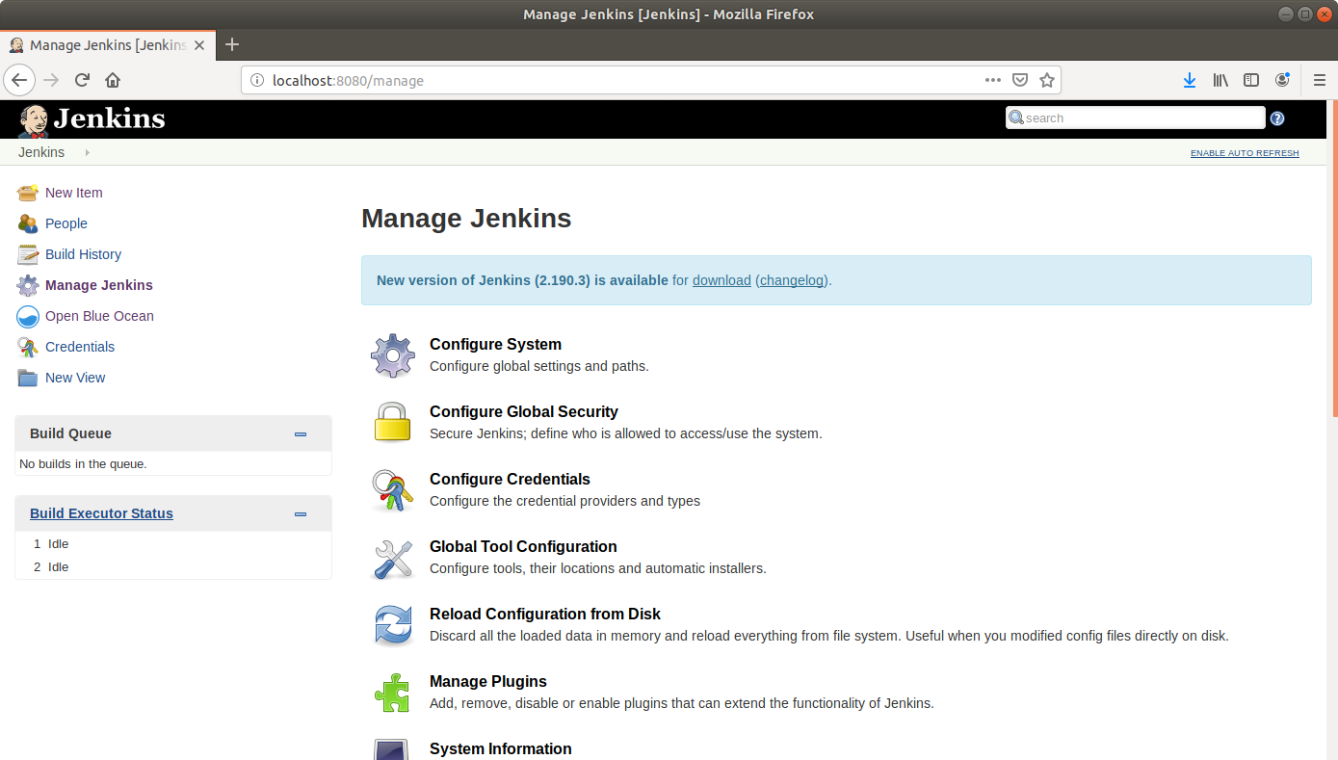

* Under the *Available* tab, select *Gradle*.

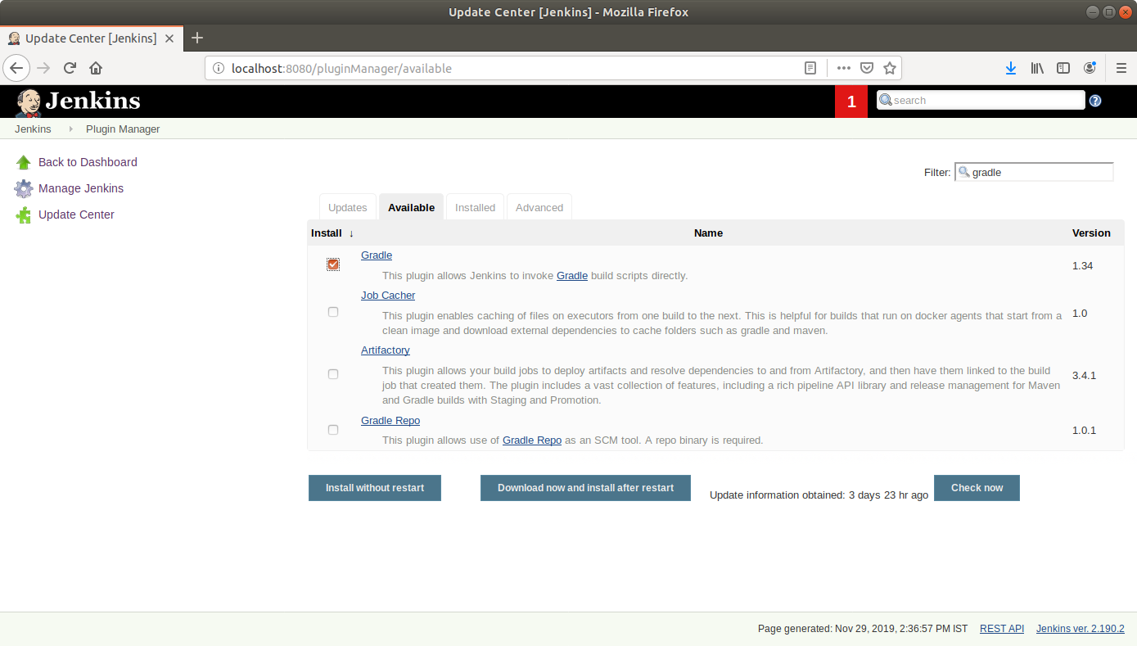

* Click on *Install without restart* and the plugin will be installed.

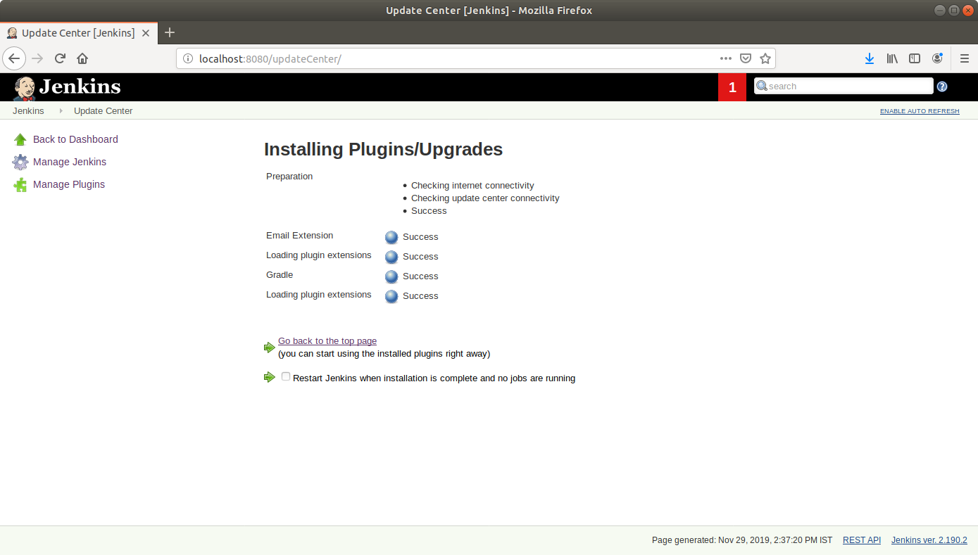

* Click on *Manage Jenkins* and select *Global Tool Configuration.*
* Scroll down to the *Gradle* section and click on *Add Gradle*.

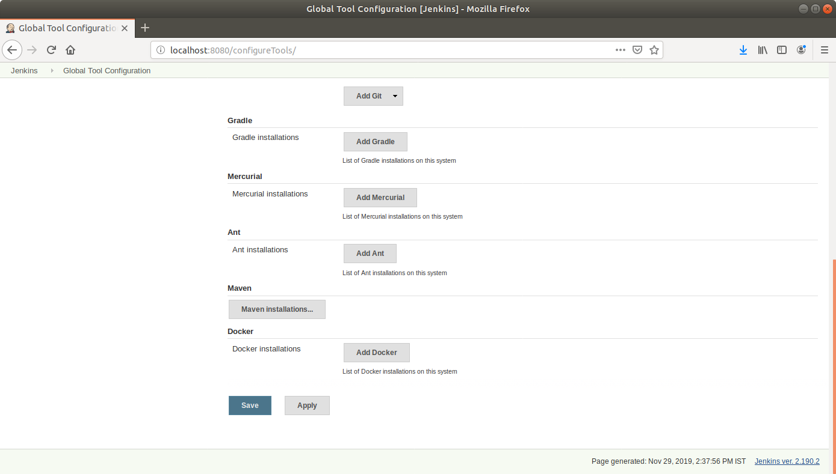

* Check the *Install automatically* box and specify a name for the installation.

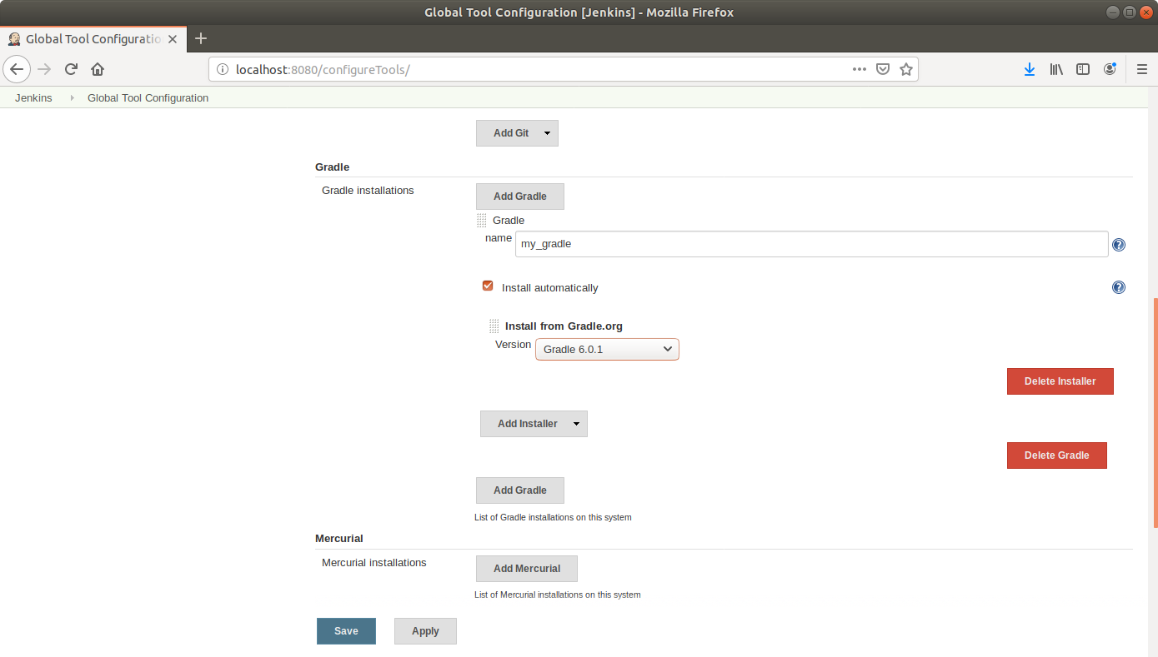

* Click *Save*.

**Step 4.5.2:** Creating a Gradle project

* Open the terminal.
* If you don’t have gradle installed, run **sudo apt-get install gradle** command
* Create a new directory and navigate into it with **cd**.
* Run **gradle init** to create a sample gradle project.

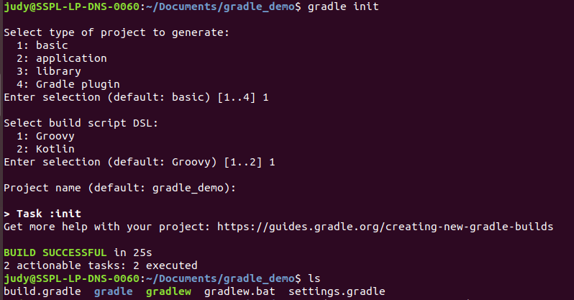

* Go to github.com and create a new repository.

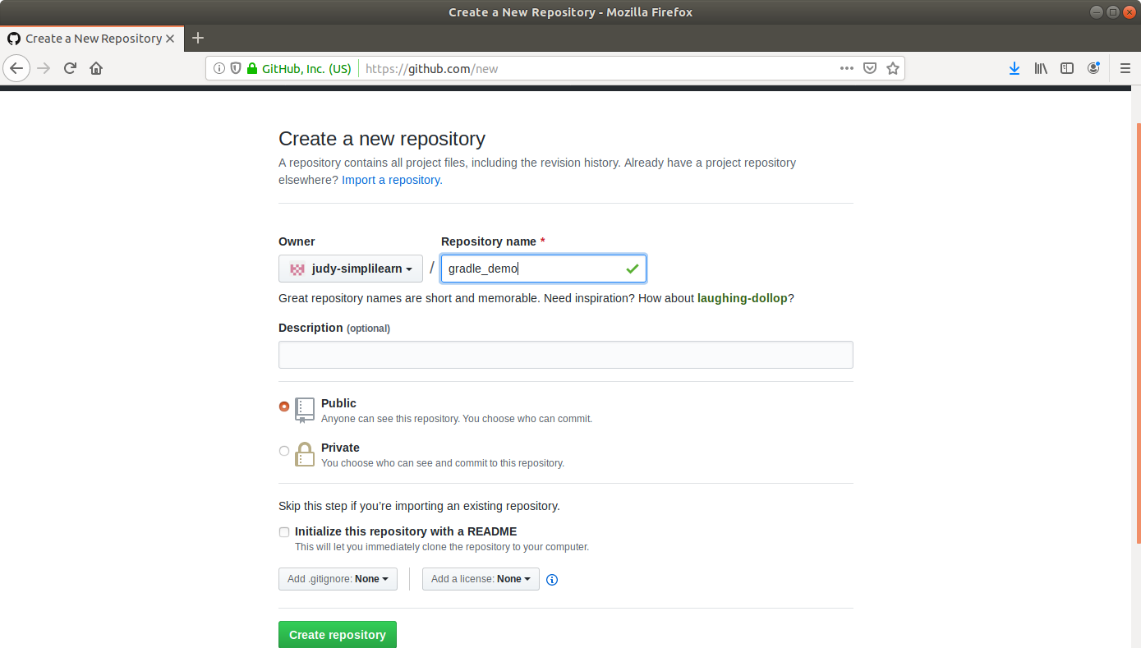

* Push the gradle project to the repository as shown below:

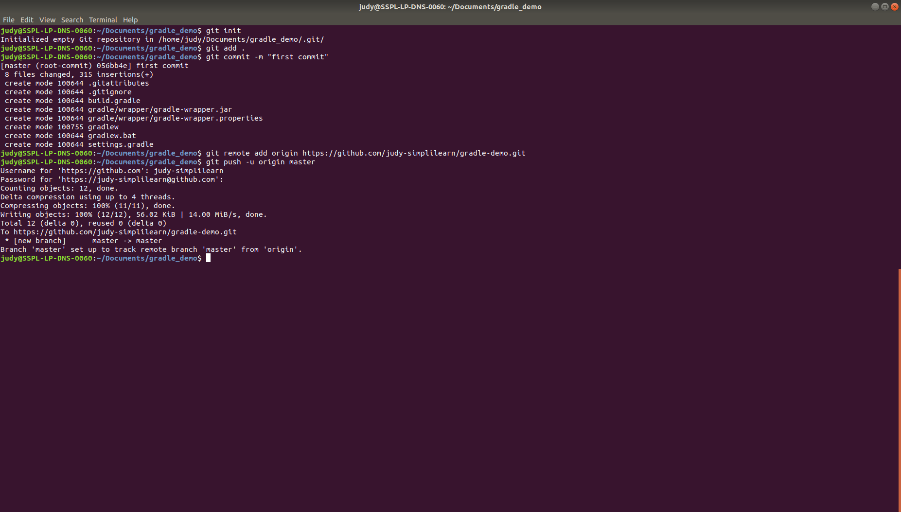

**Step 4.5.3:** Building a project with Gradle in Jenkins

* Go to Jenkins dashboard.
* Click on *New Item*.
* Enter a name for your build job.
* Select *Freestyle project* as the build job type.

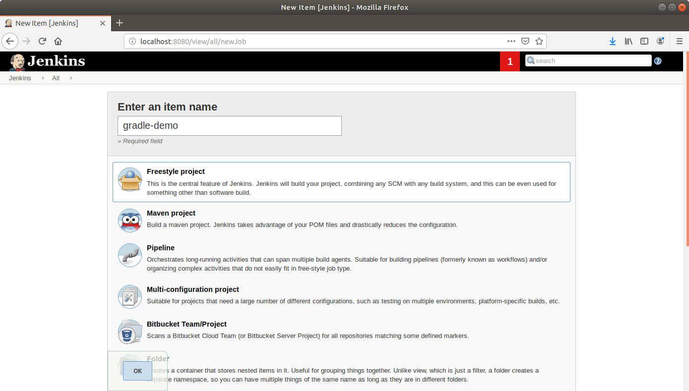

* Click OK.
* Scroll down to the Source Code Management section and select *Git*.
* Enter the link to the repository in the field that appears.

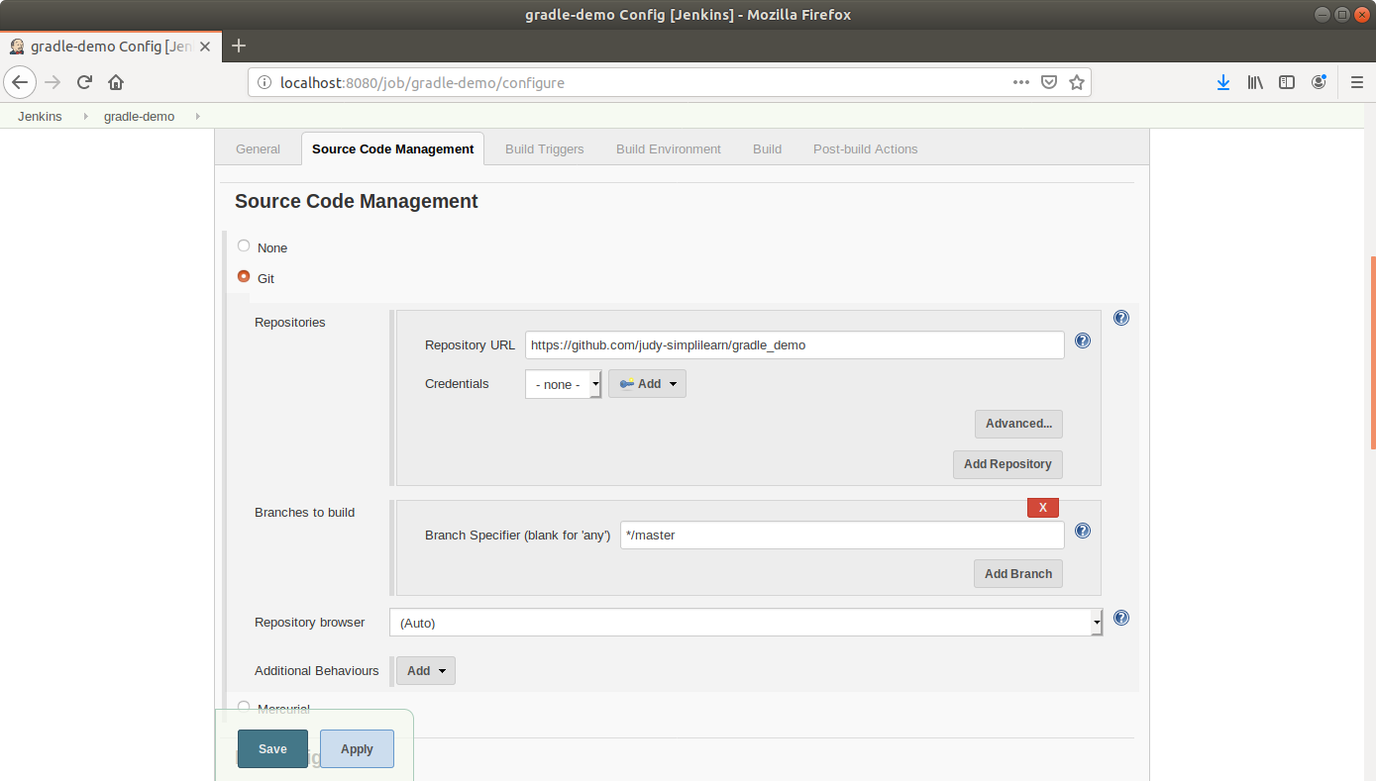

* Scroll down to the *Build* section and click on *Add build step*.
* Select *Invoke Gradle Script* from the drop down that appears.
* Fill up the form as shown below:

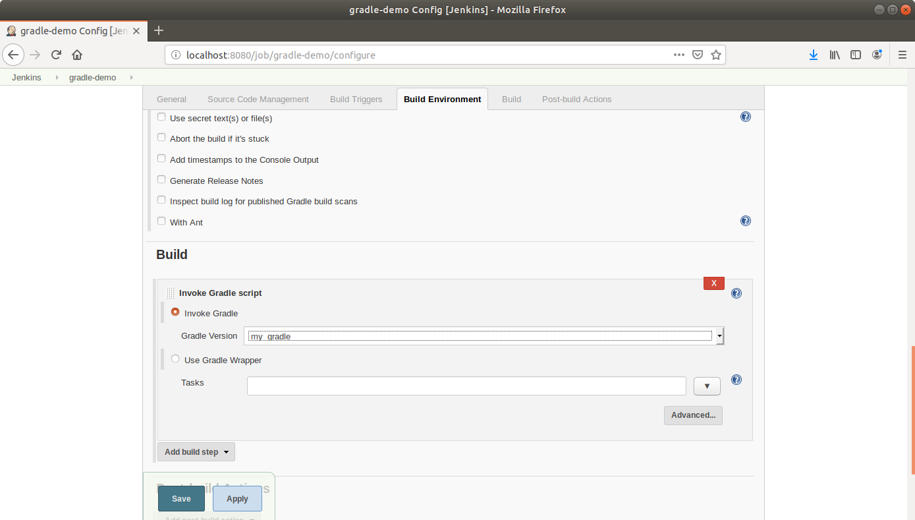

* Scroll down to the *Post-build Actions* tab and click on the *Add post-build action* button.
* From the drop down, select *Email notification* and fill the recipient address in the textbox that appears.
* Click Save.
* Click *Build Now* in the project window to make sure that the build works. Jenkins will now build your project.
* Click on the *Build History* to view the build results.
* Click on the *Console Output* to view the build logs.