**4.9 Enabling Security**

This section will guide you to:

* Enable security in jenkins

This lab has three sub-sections, namely:

4.9.1 Enabling security Jenkins

4.9.2 Setting up an account

**Step 4.9.1:** Enabling security Jenkins

* Go to Jenkins dashboard.
* Click on *Manage Jenkins* and select *Configure Global Security*.

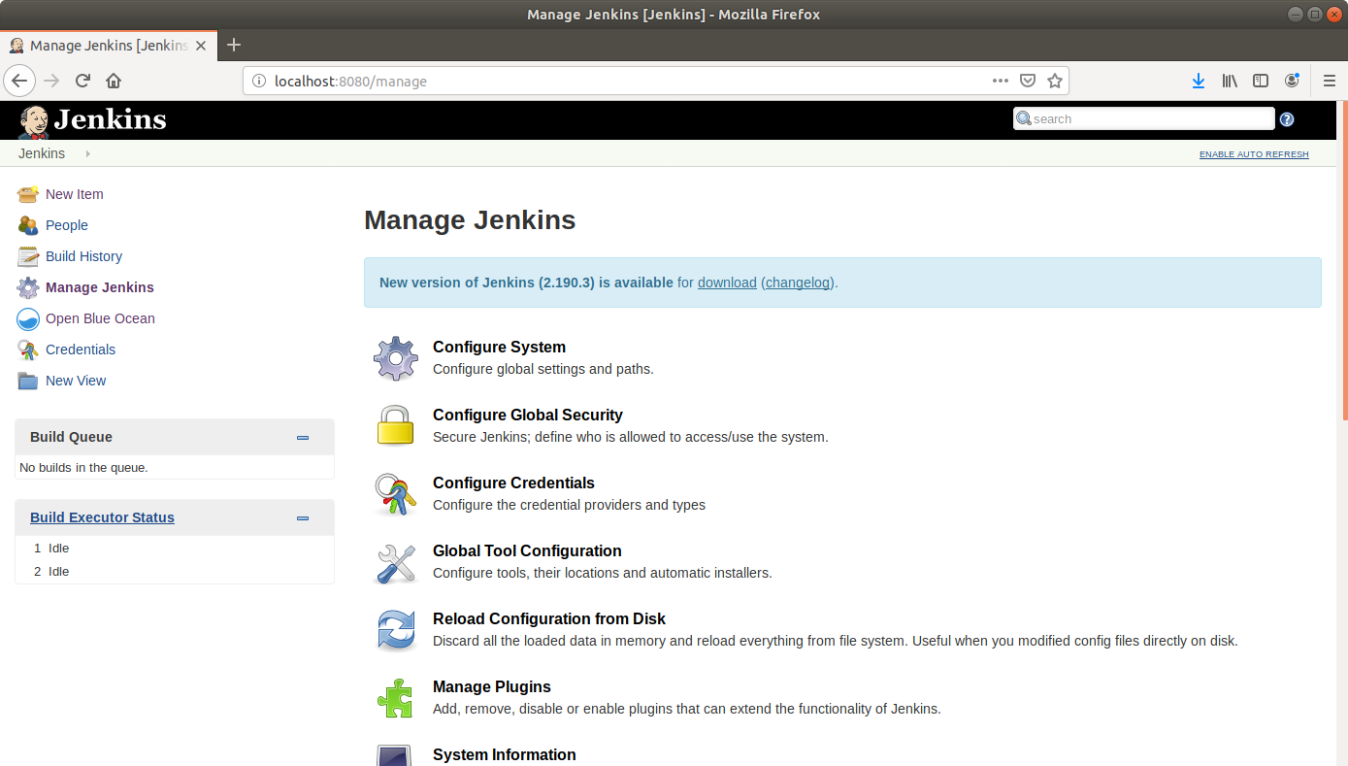

* Check the box that says *Enable security*.

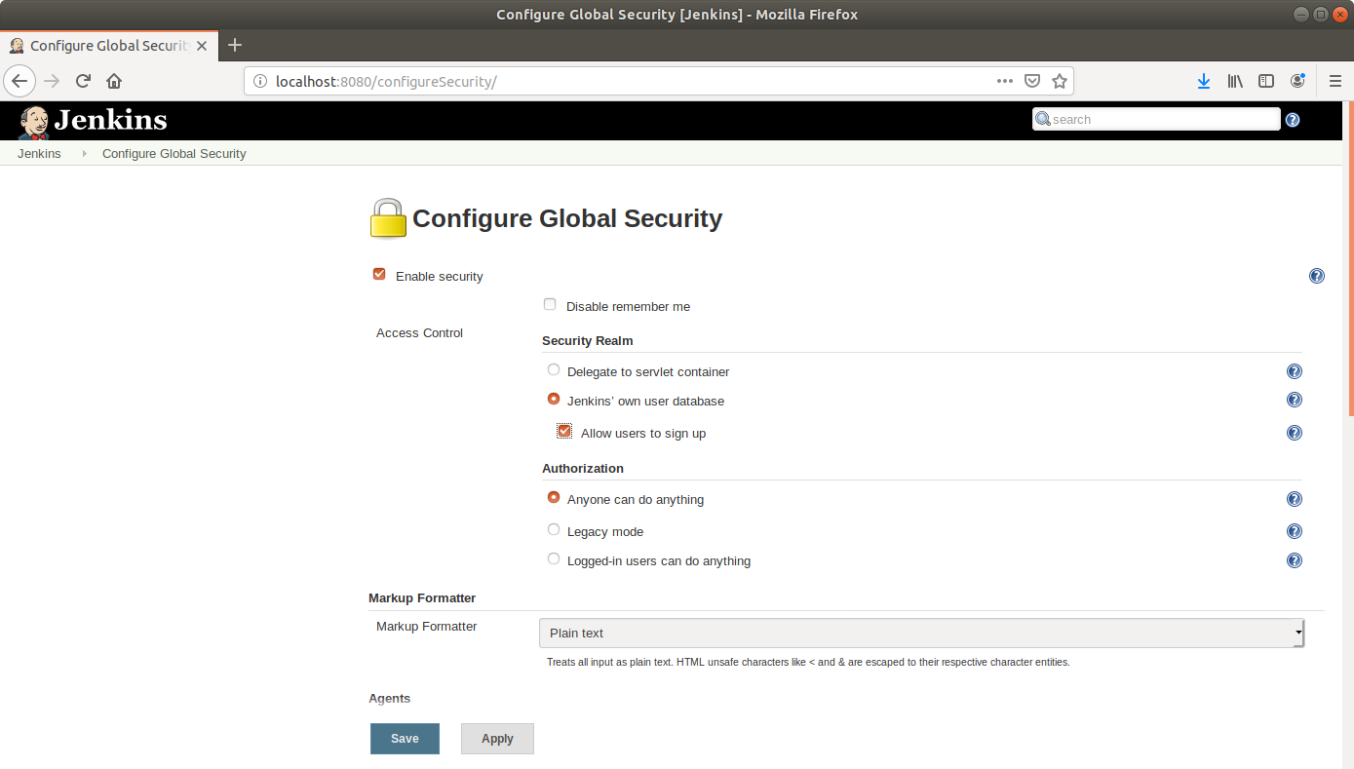

* Under *Security Realm*, choose *Jenkins’ own user database* and check the box that says *Allow users to sign up*.
* Under *Authorization*, select *Logged-in users can do anything*.
* Click Save.

**Step 4.9.2:** Setting up an account

* Navigate to the Jenkins Dashboard.
* Click on Sign up at the top right corner.

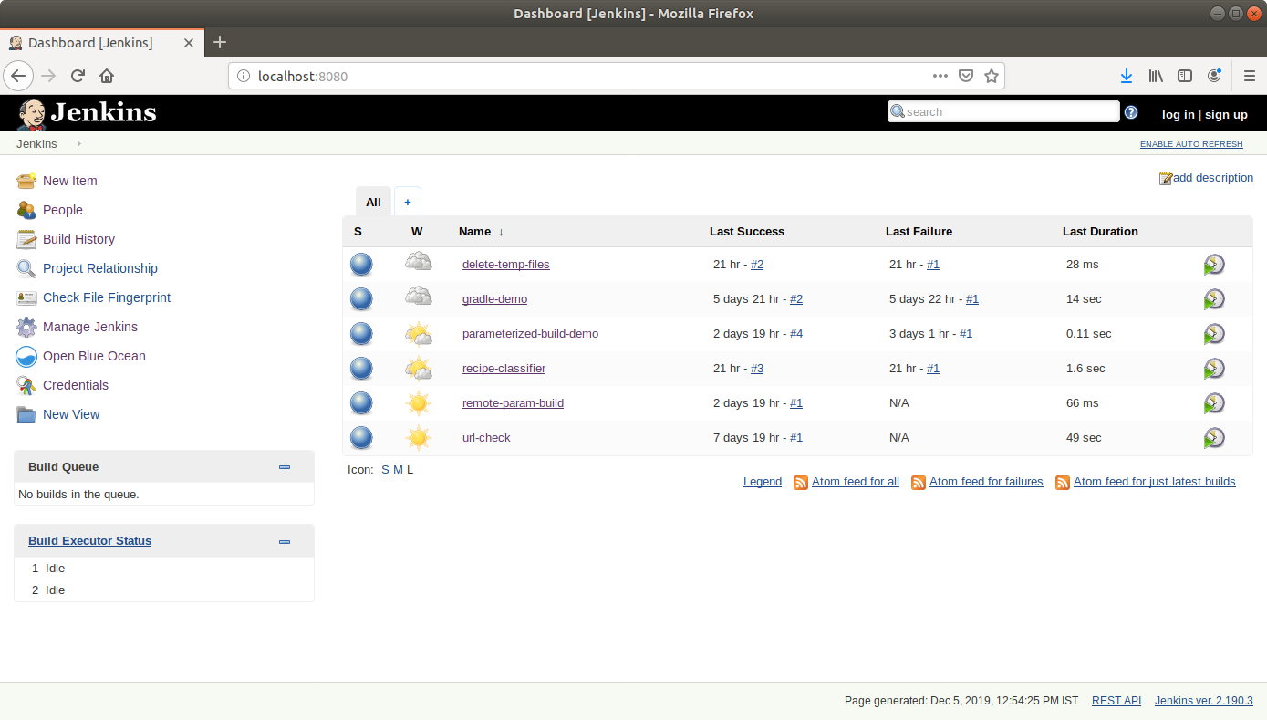

* Fill the required fields in the sign up form.

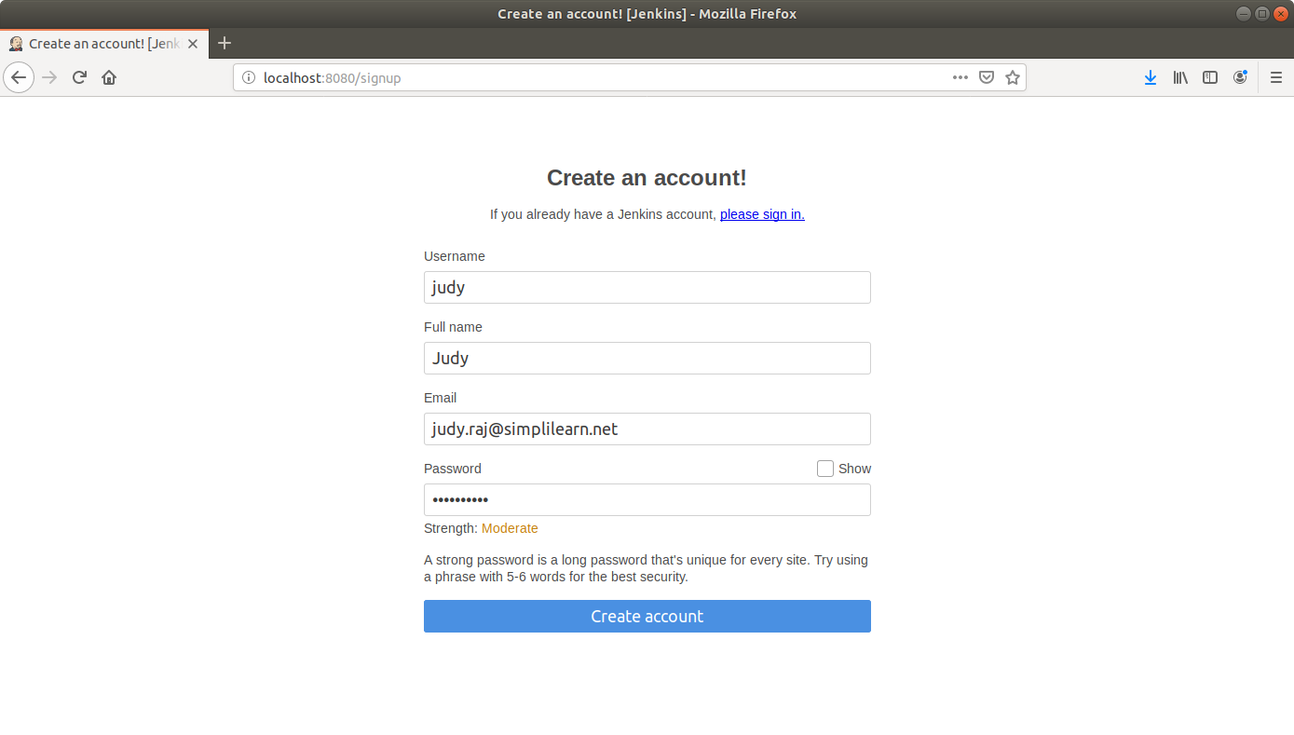

* Click *Create account*.
* You can now log in with your credentials.