**5.1 Building Pipelines In Jenkins**

This section will guide you to:

* Build multibranch pipelines in jenkins

This lab has two sub-sections, namely:

5.1.1 Configuring Pipeline plugin for Jenkins

5.1.2 Creating a Pipeline

**Step 5.1.1:** Configuring Pipeline plugin for Jenkins

* Go to Jenkins dashboard.
* Click on *Manage Jenkins* and select *Manage Plugins*.

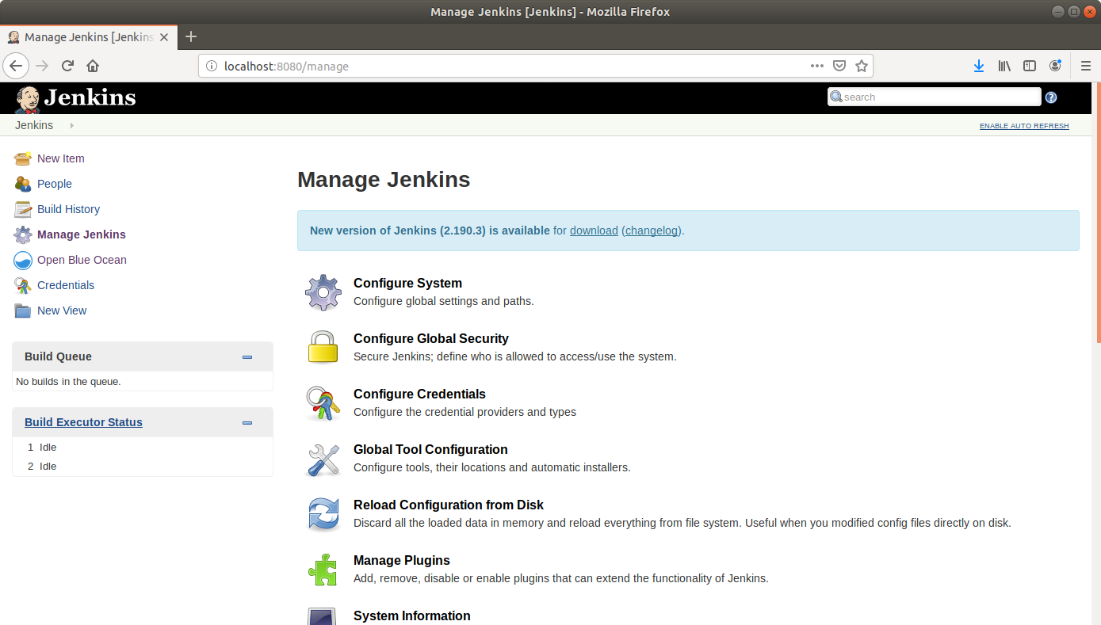

* Under the *Available* tab, select *Pipeline*.

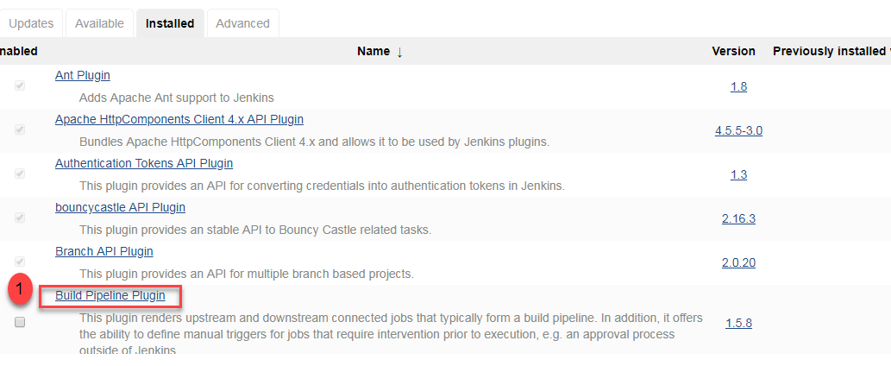

* Click on *Install without restart* and the plugin will be installed.
* Click *Save*.

**Step 5.1.2:** Creating a Pipeline

* Go to Jenkins dashboard.
* Click on *New Item*.
* Enter a name for your build job.
* Select Pipelineas the build job type.

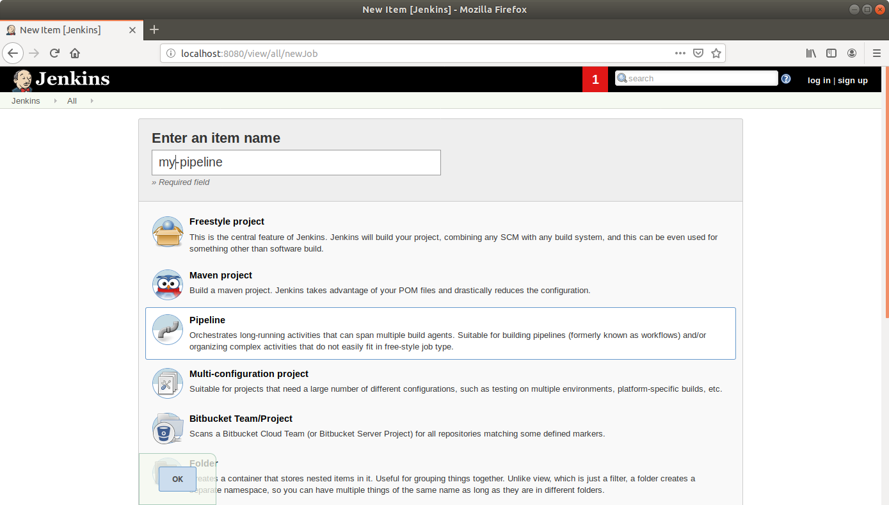

* Click OK.
* Scroll down to the Pipeline section and enter the script below:

pipeline {

agent any

stages {

stage('First Stage') {

steps {

echo 'Hello World'

}

}

stage('Second Stage') {

steps {

echo 'Hello Again'

echo 'A third time Hello'

}

}

}

}

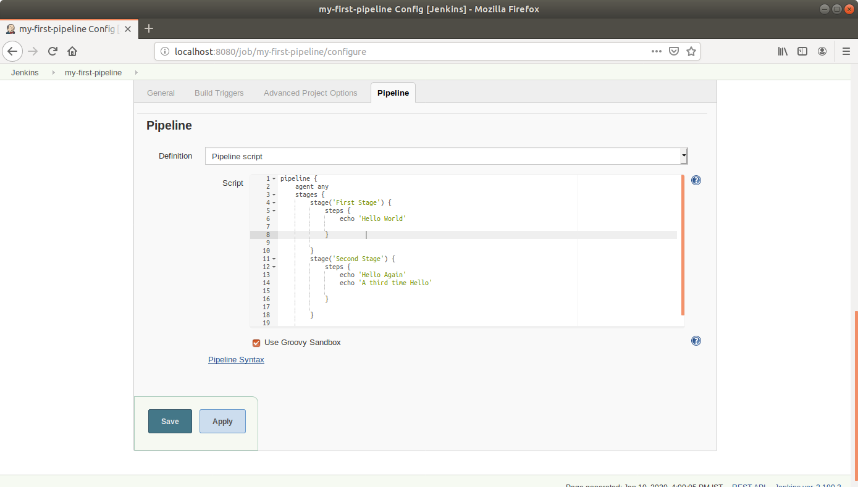

* Click Save.
* Click *Build Now* in the project window to make sure that the build works. Jenkins will now build your project.
* Click on the *Build History* to view the build results.

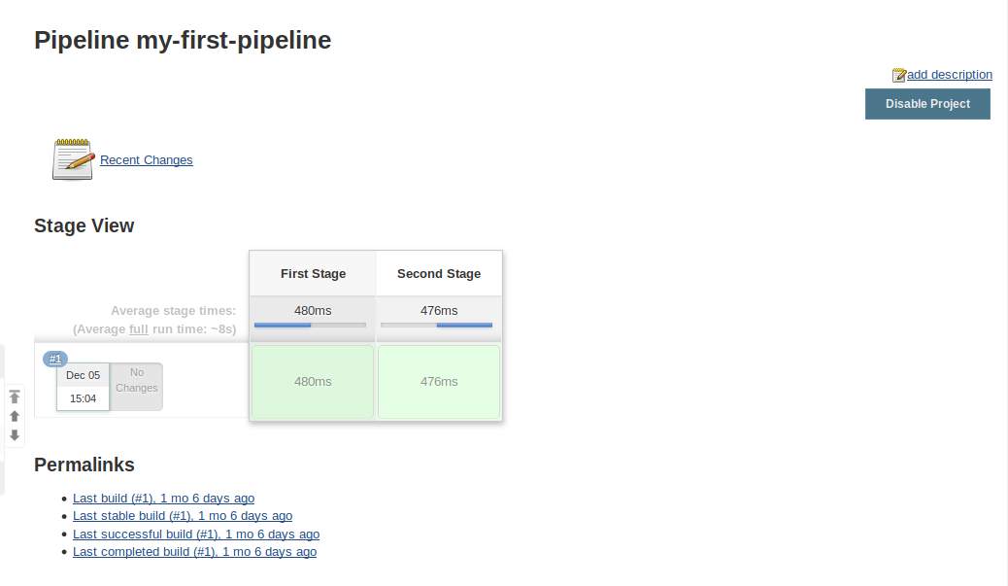

* Click on the *Logs* to view the build logs in each stage.

