**3.4 Building a Maven Project**

This section will guide you to:

* Build a Maven project in Jenkins

This lab has four sub-sections, namely:

3.4.1 Configuring git on Jenkins

3.4.2 Forking a sample repository

3.4.3 Creating a Jenkins build job to build a Maven project

3.4.4 Building the Maven project

**Step 3.4.1:** Configuring git on Jenkins

* Go to *Manage Jenkins* from the Jenkins dashboard and select *Global Tool Configuration.*
* Scroll down to the *Git* section and click on *Add git*.

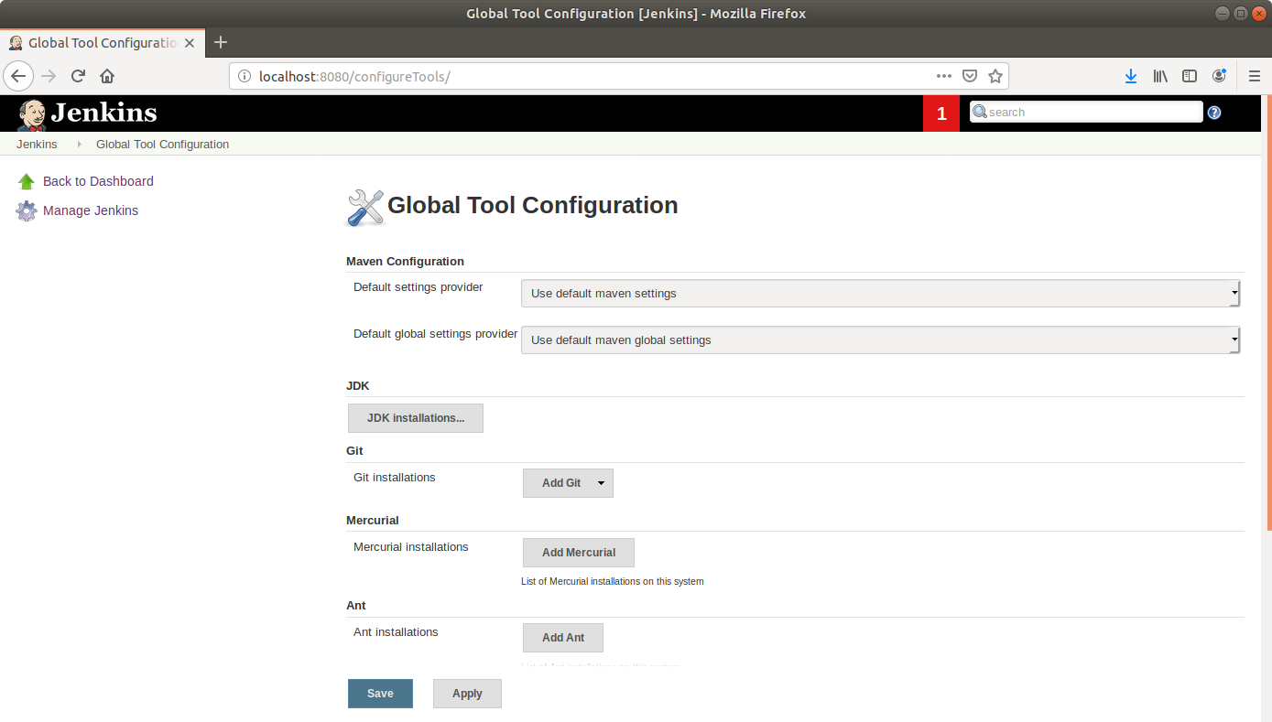

* Enter a name to refer the git installation.
* Enter the path to git at the *Path to git executable field* and click Save.

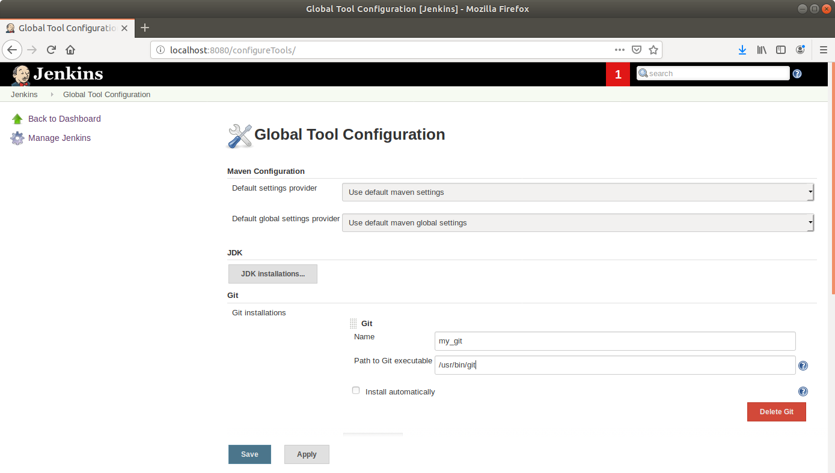

**Step 3.4.2:** Forking a sample repository

* Log on to your Github account.
* Navigate to <https://github.com/jenkins-docs/simple-java-maven-app> and click on *Fork*.

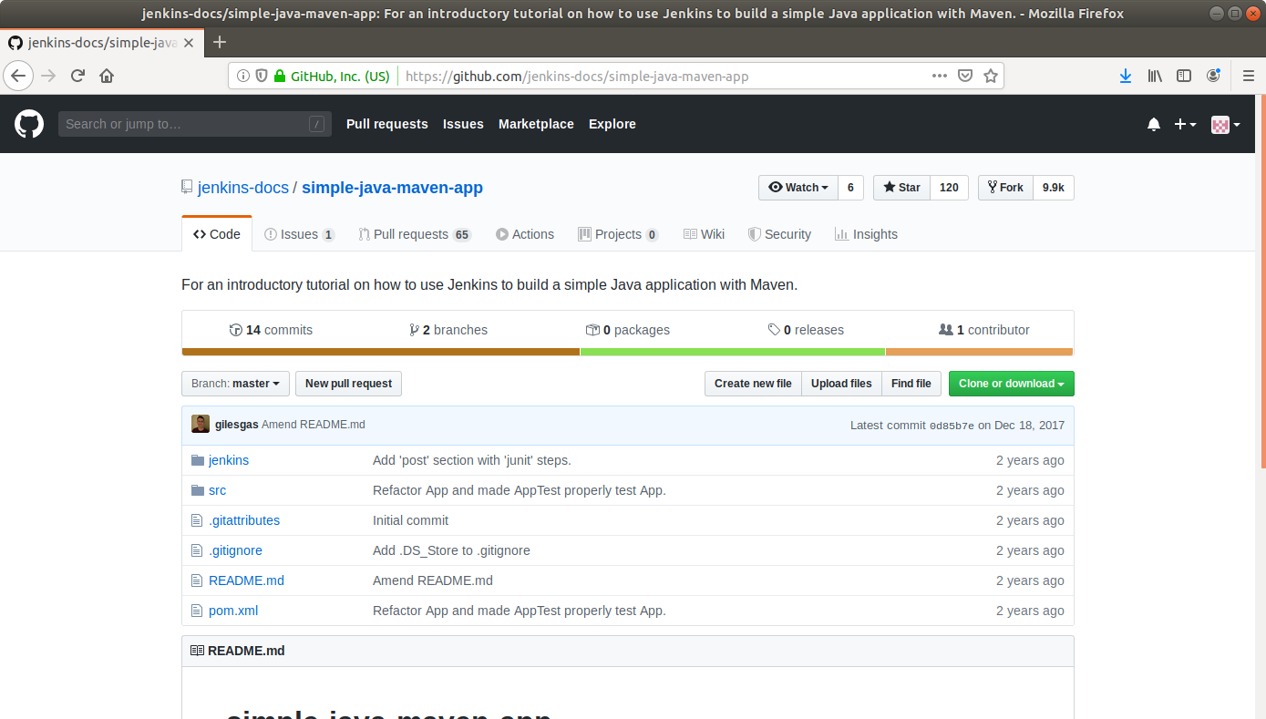

* Open the terminal.
* Run ***git clone [Forked_REPO URL]*** to clone the repo locally.

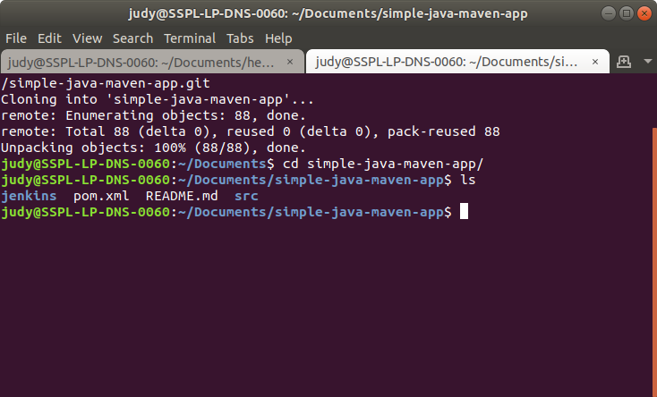

**3.4.3:** Creating a Jenkins build job to build a Maven project

* Select *Maven Project* as the build job type.

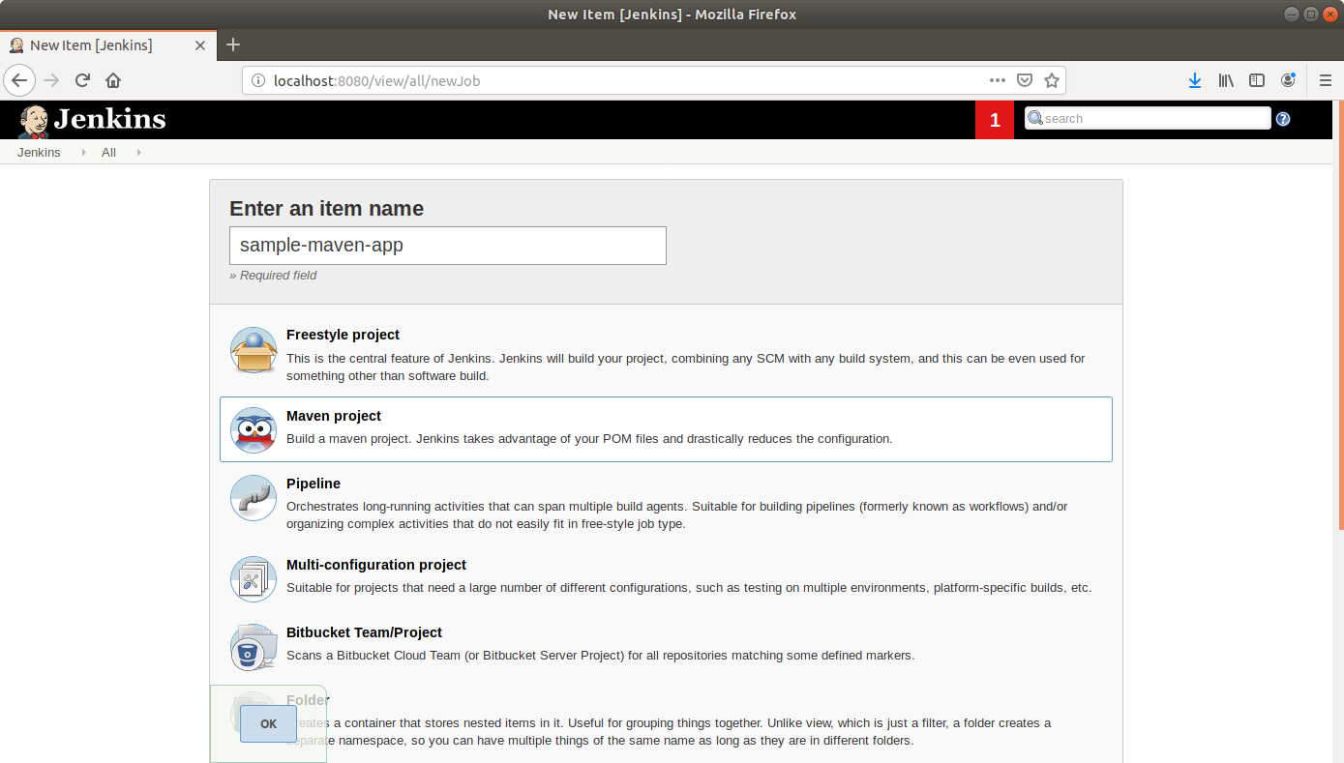

* Click *OK*.
* Leave the defaults as they are and scroll down to the *Source Code Management* section.
* Select *Git*.
* Enter the local path to the app directory in the Repository URL field.

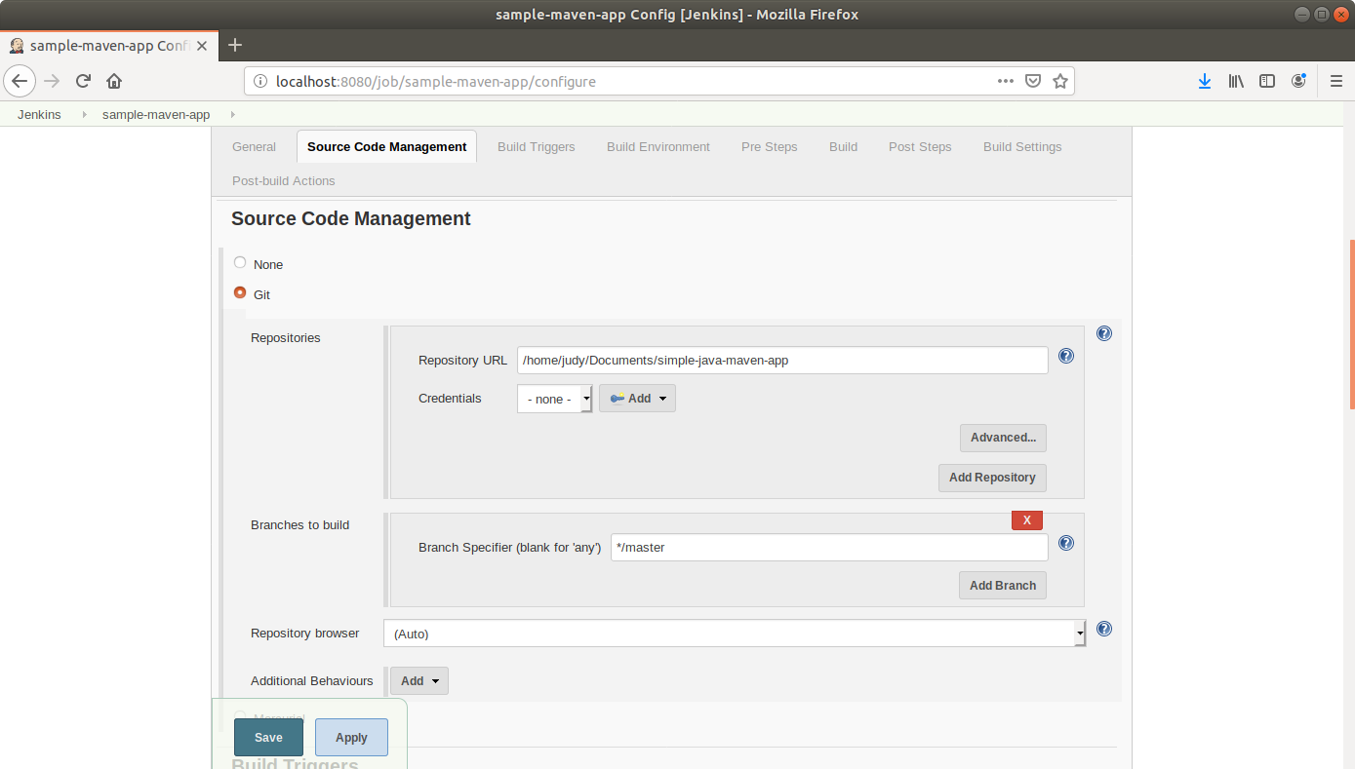

* Click *Save*.

**Step 3.4.4:** Building the Maven project

* Click on the project name in the Jenkins dashboard.
* Click *Build Now* in the project window. Jenkins will now build your project.

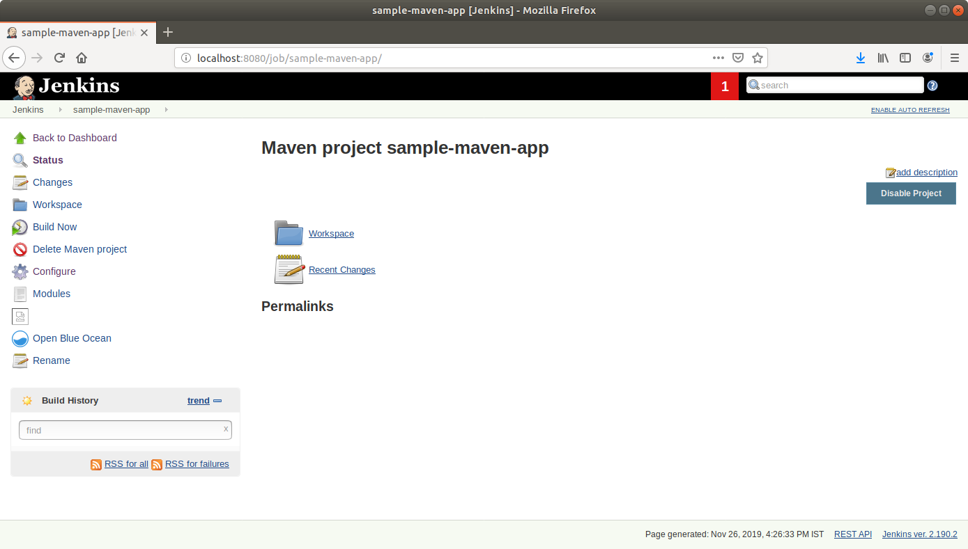

* Click on the *Build History* to view the build results.
* Click on the *Console Output* to view the build logs.

