**4.2 Scheduled Builds**

This section will guide you to:

* Schedule a freestyle build job in Jenkins that runs twice a day

This lab has two sub-sections, namely:

4.2.1 Creating a scheduled build in Jenkins

4.2.2 Testing a scheduled build

**Step 4.2.1:** Creating a scheduled build in Jenkins

* Navigate to the folder with the temporary files to be deleted and save the path.

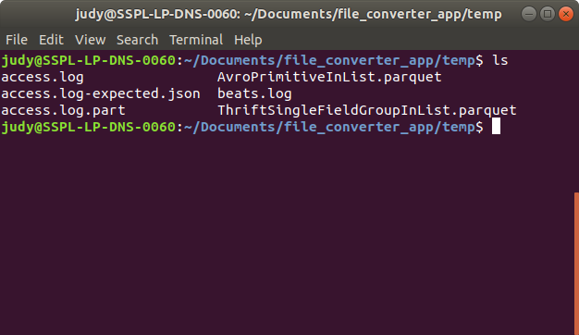

* Go to Jenkins dashboard.
* Click on *New Item*.
* Enter a name for your Maven project.
* Select *Freestyle project* as the build job type.

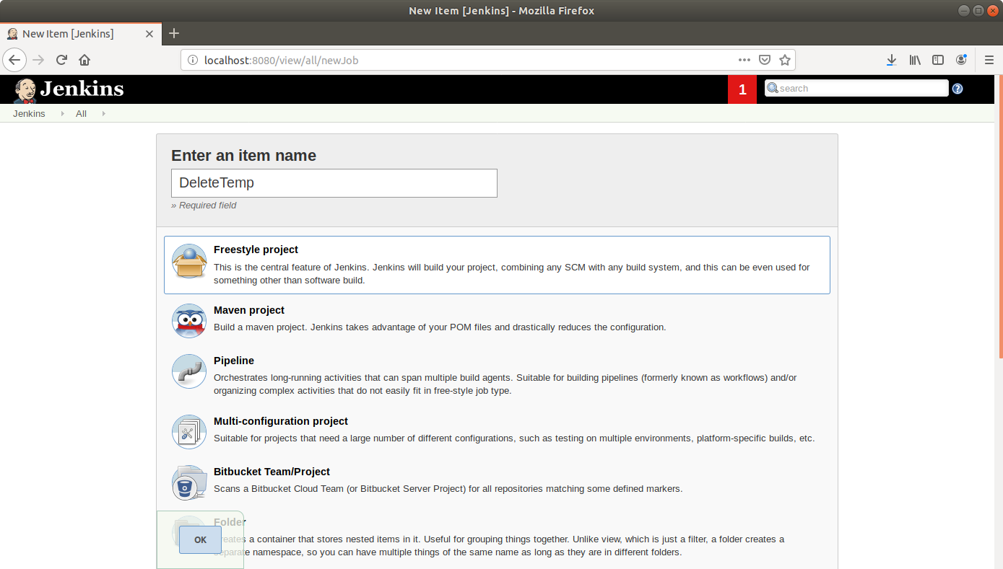

* Click OK.
* Enter job details like description and select the **Discard old builds** option.

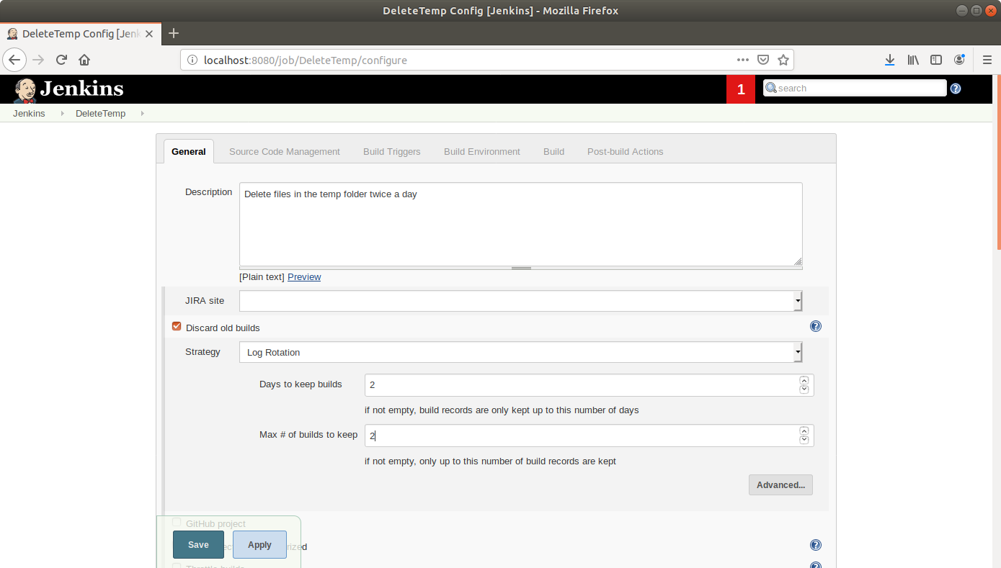

* Scroll down to the *Build Triggers* section and select the *Build periodically* option.
* In the box that appears, enter the cron syntax to schedule a build every day at 11 in the morning and at night .

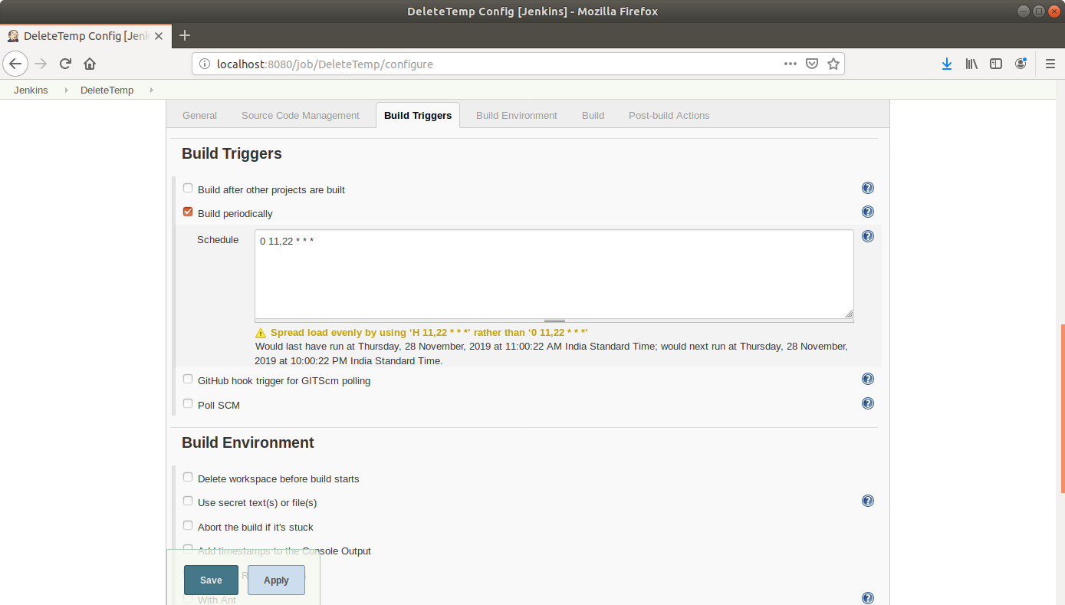

* Scroll down to the *Build* section and click on *Add build step*.
* Select *Execute Shell* from the drop down that appears.
* Enter the command to delete the files in the temp folder in the textbox that appears.

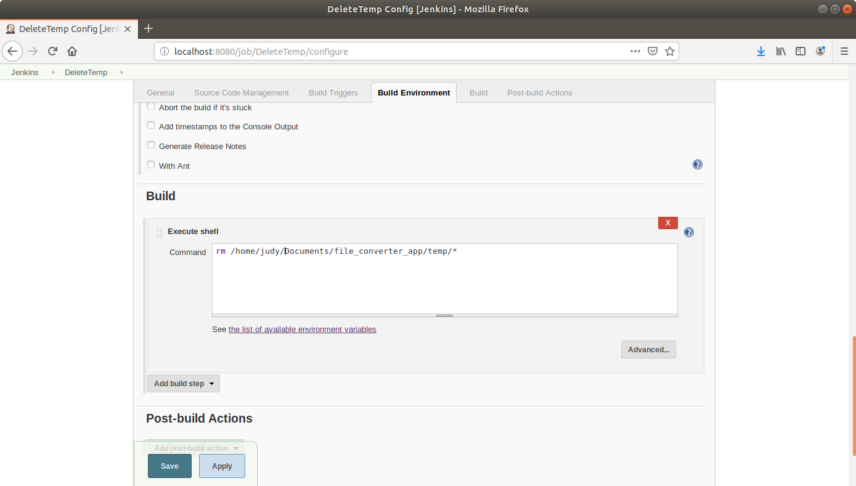

* Click Save.

**Step 4.2.2:** Testing a scheduled build

* Click on the project name in the Jenkins dashboard.
* Click *Build Now* in the project window to make sure the build works. Jenkins will now build your project.
* Click on the *Build History* to view the build results.
* Click on the *Console Output* to view the build logs.

