**4.3 Polling SCM**

This section will guide you to:

* Schedule a freestyle build job in Jenkins that polls the SCM every night

This lab has two sub-sections, namely:

4.3.1 Scheduling a build job to poll an SCM and run Maven build steps

4.3.2 Testing a scheduled build

**Step 4.3.1:** Scheduling a build job to poll an SCM and run Maven build steps

* Go to Jenkins dashboard.
* Click on *New Item*.
* Enter a name for your Maven project.
* Select *Freestyle project* as the build job type.

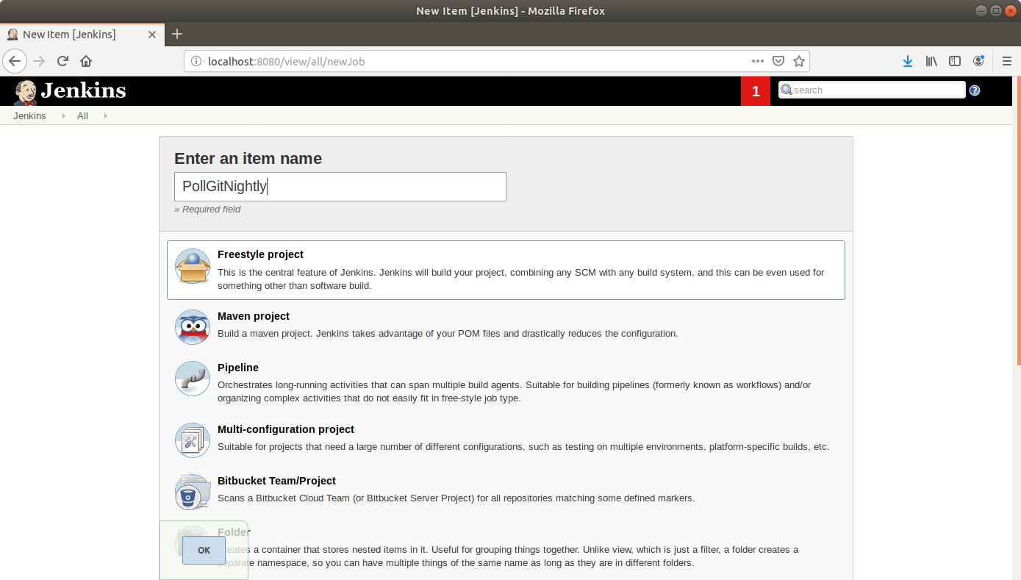

* Click OK.
* Enter job details like description.

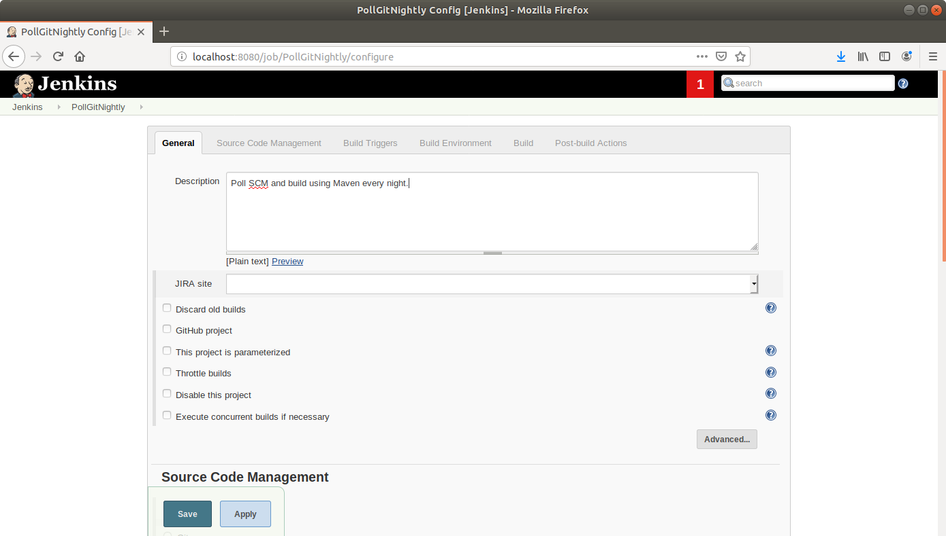

* Scroll down to the Source Code Management section and select *Git*.
* Enter the link to the repository in the field that appears.

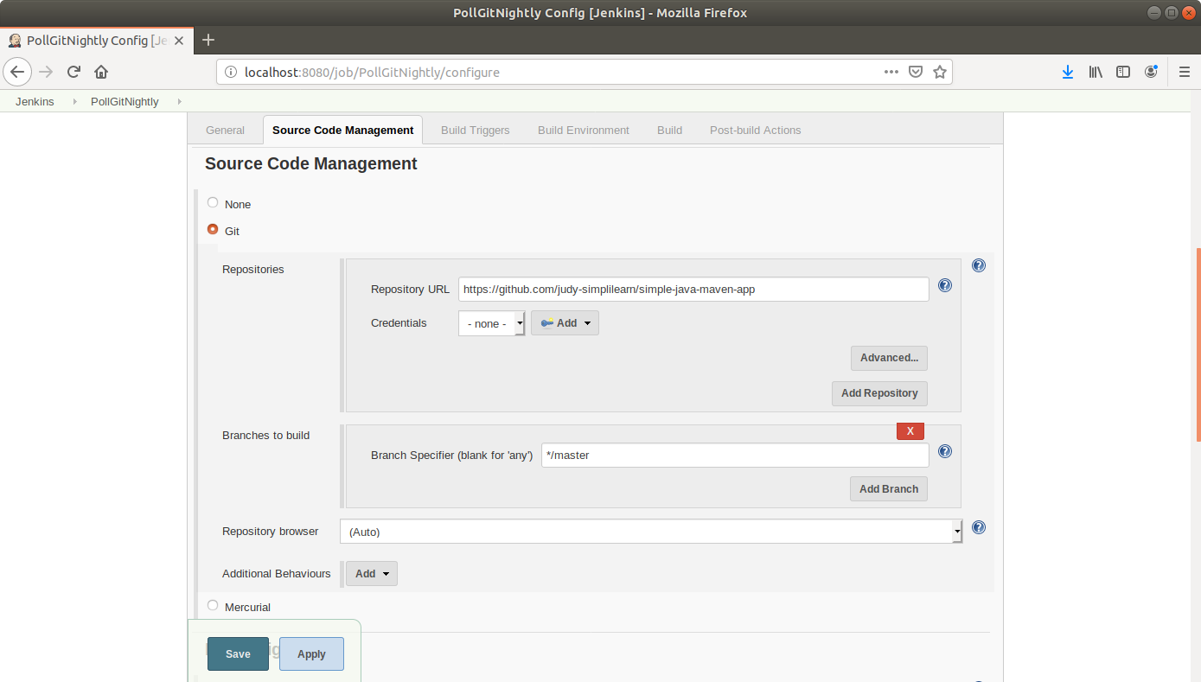

* Scroll down to the *Build Triggers* section and select the *Poll SCM* option.
* In the box that appears, enter the cron syntax to schedule a build every night at 12.

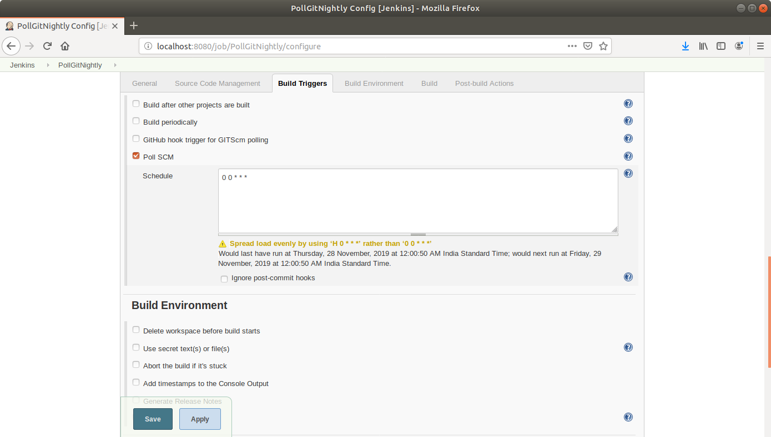

* Scroll down to the *Build* section and click on *Add build step*.
* Select *Execute Shell* from the drop down that appears.
* Enter the Maven command in the textbox that appears.

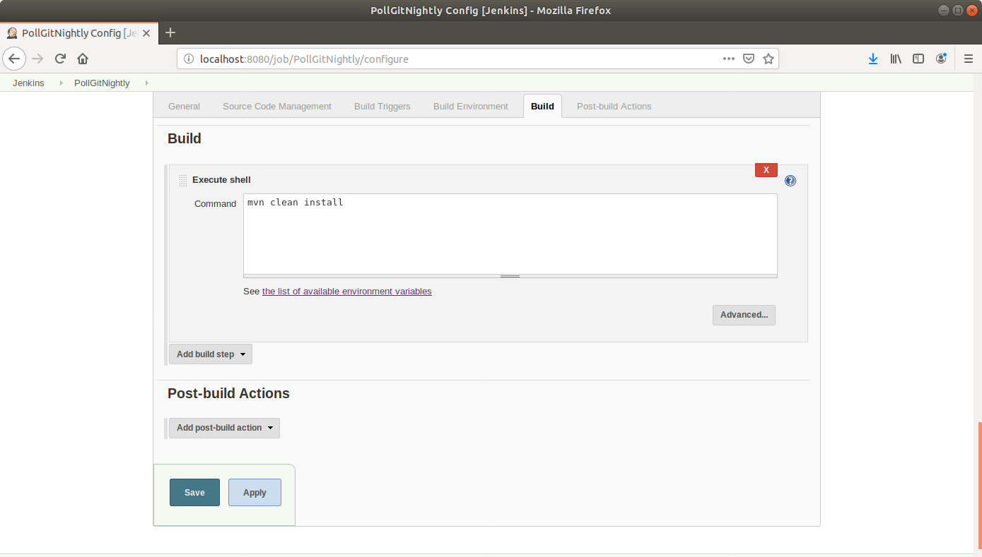

* Click Save.

**Step 4.3.2:** Testing a scheduled build

* Click on the project name in the Jenkins dashboard.
* Click *Build Now* in the project window to make sure the build works. Jenkins will now build your project.
* Click on the *Build History* to view the build results.
* Click on the *Console Output* to view the build logs.

