**4.4 Post-Build Actions**

This section will guide you to:

* Configure post-build actions

This lab has two sub-sections, namely:

4.4.1 Configuring SMTP settings to enable email alerts in Jenkins

4.4.2 Defining post-build actions in a build and testing the SMTP settings

**Step 4.4.1:** Configure SMTP settings to enable email alerts in Jenkins

* Go to Jenkins dashboard.
* Click on *Manage Jenkins* in the Jenkins dashboard and select *Configure System*.

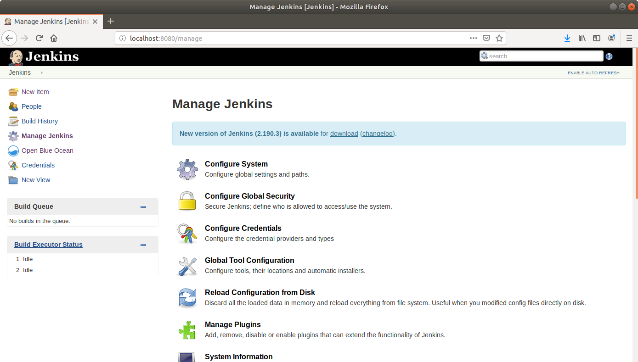

* Scroll down to the end of the page to the *Email Notification* section.
* Click on the *Advanced* button to reveal advanced settings.
* Fill the fields with appropriate values as shown below:

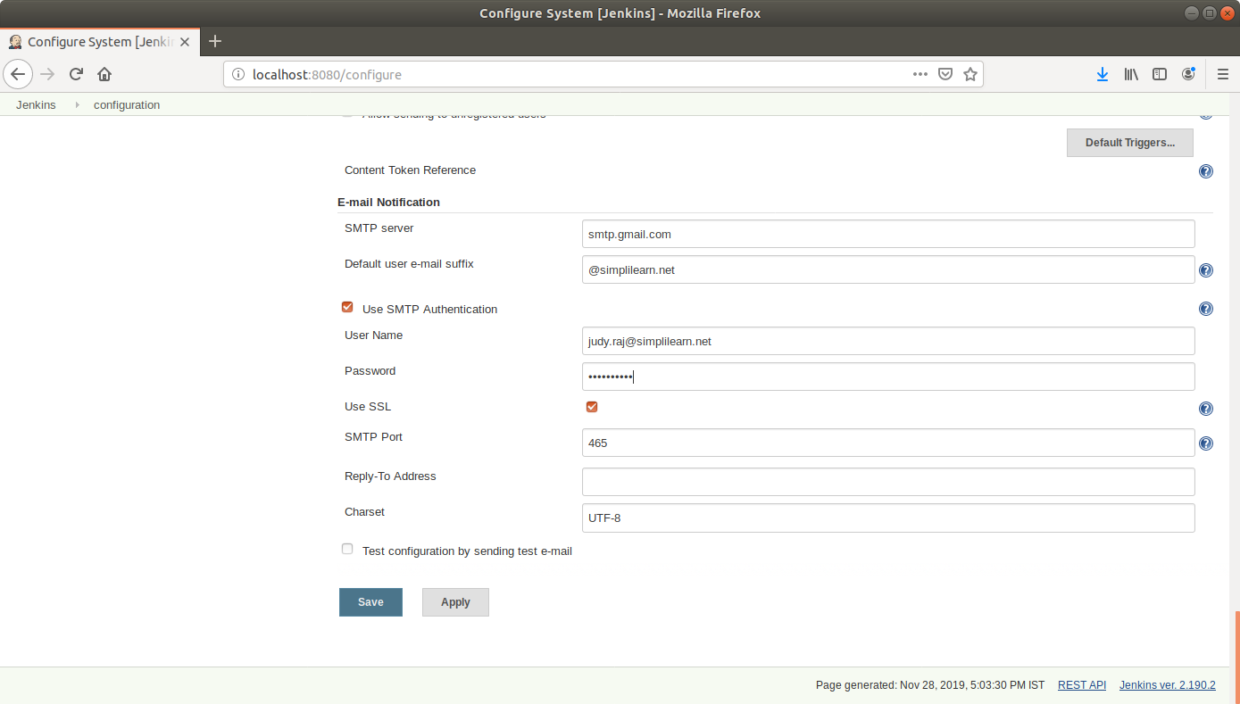

* Select the *Test configuration by sending test e-mail* and enter a recipient email to test the configuration.
* Click *Save*.

**Step 4.4.2:** Defining post-build actions in a build and testing the SMTP settings

* Go to Jenkins dashboard.
* Click on *New Item*.
* Enter a name for your build job.
* Select *Freestyle project* as the build job type.

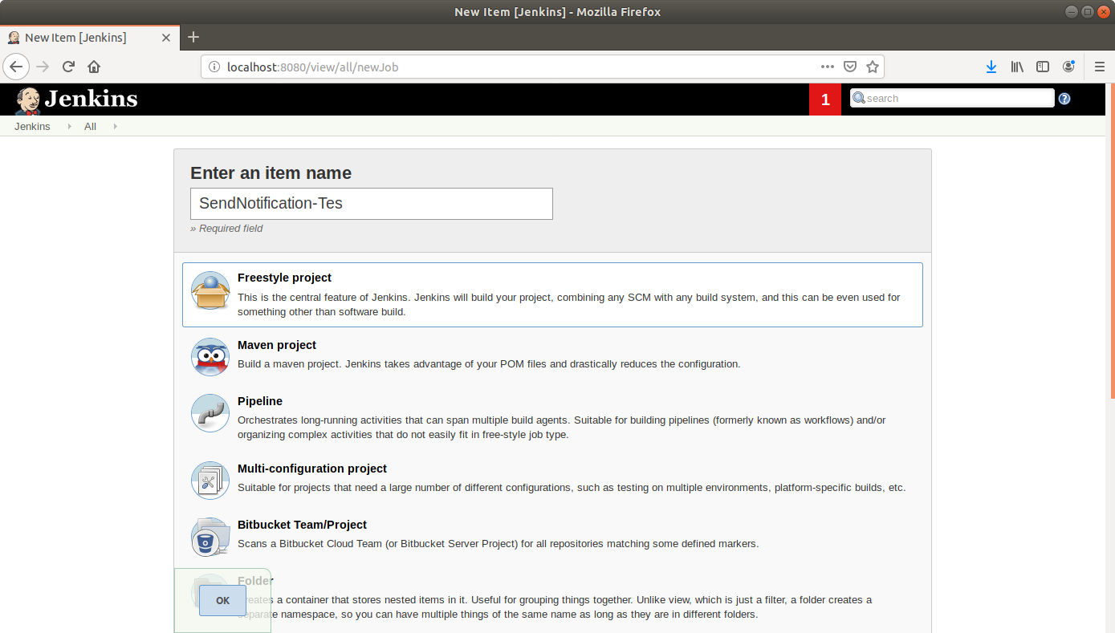

* Click OK.
* Scroll down to the Source Code Management section and select *Git*.
* Enter the link to the repository in the field that appears.

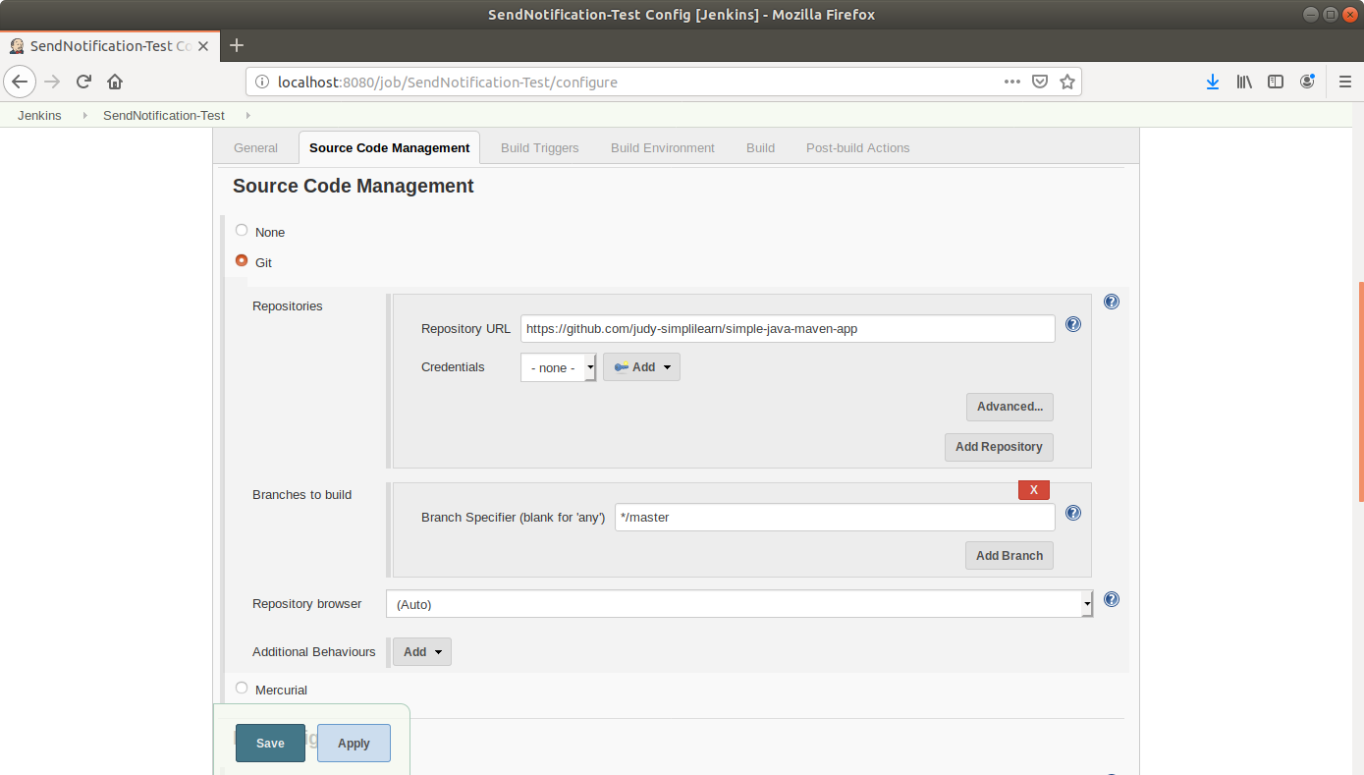

* Scroll down to the *Build* section and click on *Add build step*.
* Select *Execute Shell* from the drop down that appears.
* Enter the Maven command in the textbox that appears.

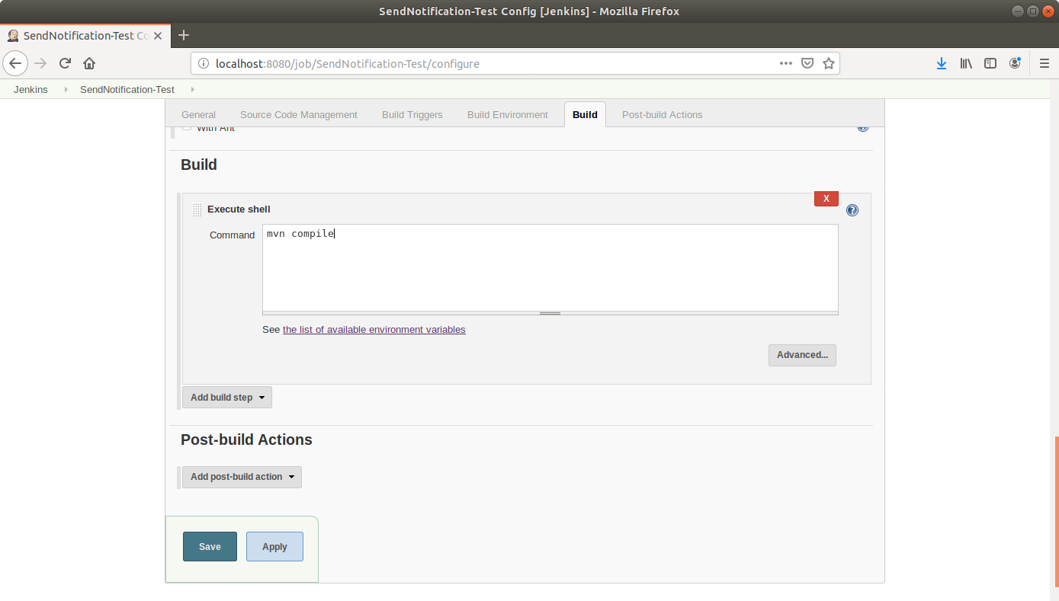

* Scroll down to the *Post-build Actions* tab and click on the *Add post-build action* button.
* From the drop down, select *Email notification* and fill the recipient address in the textbox that appears.

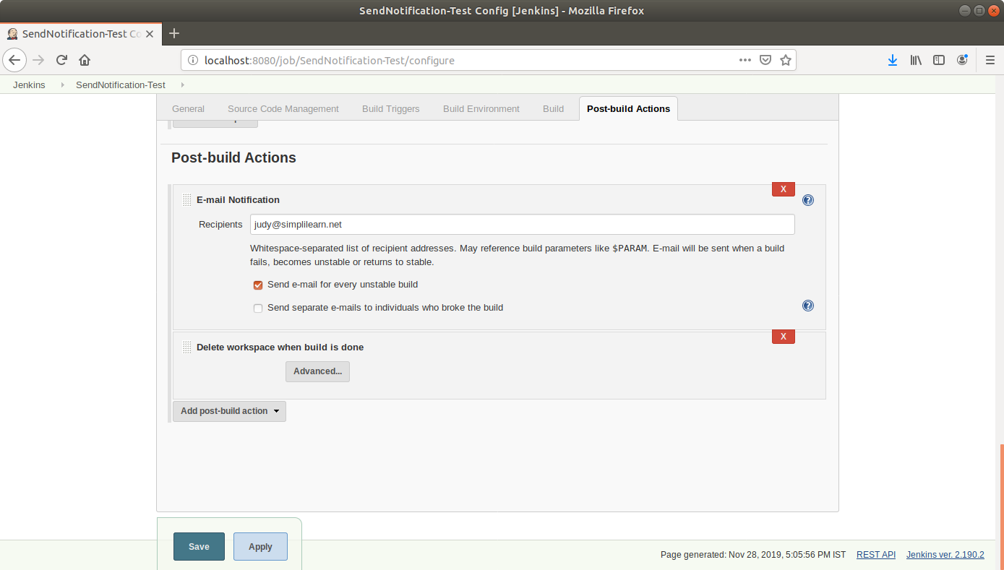

* Click on the *Add post-build action* button.
* From the drop down, select *Delete workspace when build is done*.
* Click Save.
* Introduce an error in the Maven project to be built and commit to Git. An extra build tag is added in the pom.xml below.

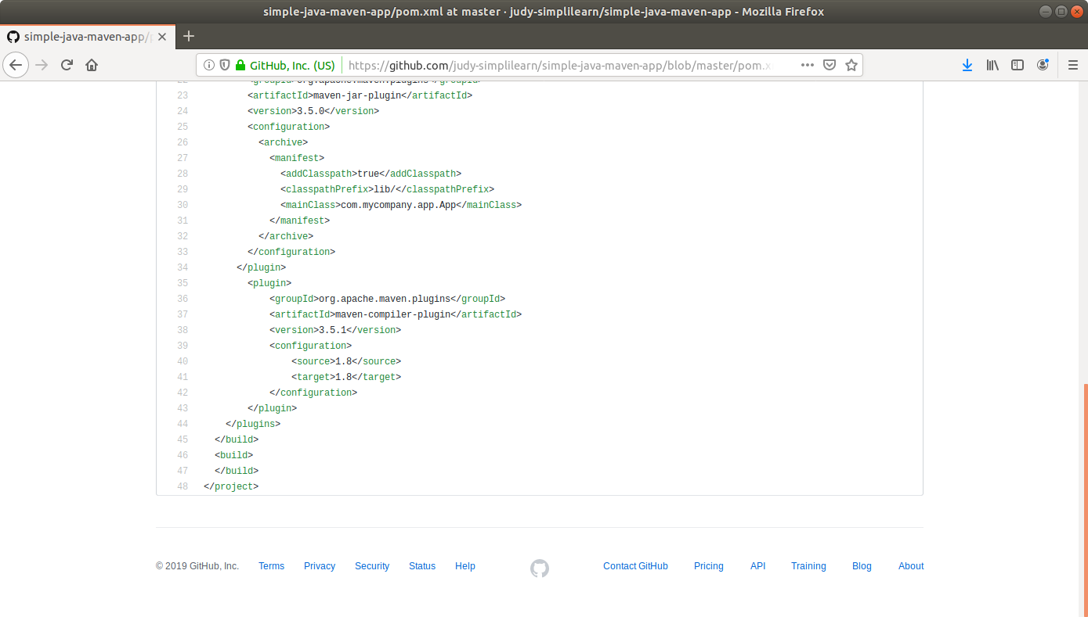

* Click *Build Now* in the project window to make sure that the build works. Jenkins will now build your project.
* Click on the *Build History* to view the build results.
* Click on the *Console Output* to view the build logs.

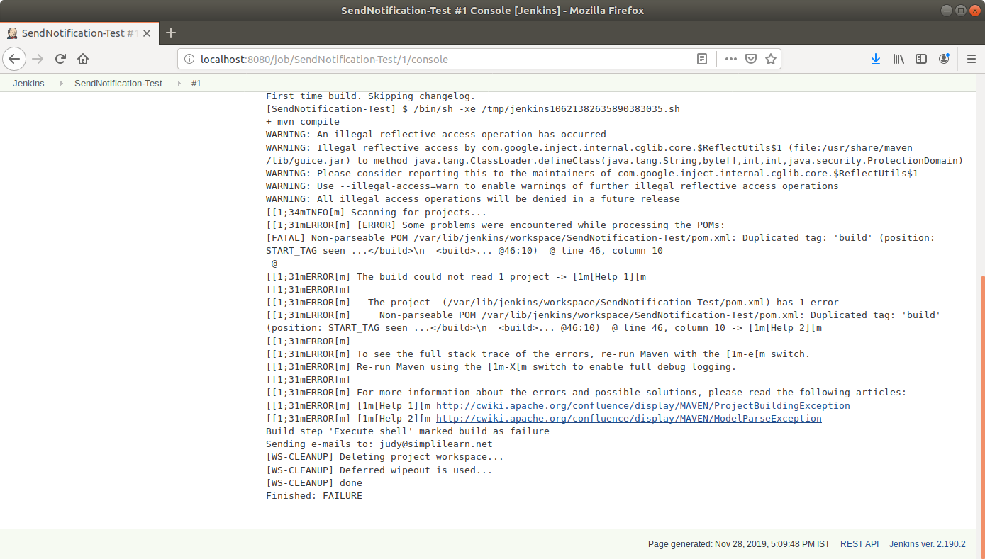

* Check the email to see the notification.

