**4.7 Building From Tags**

This section will guide you to:

* Configure a build job in Jenkins to build from a Git tag

This lab has three sub-sections, namely:

4.7.1 Adding the Git parameter plugin to Jenkins

4.7.2 Creating a tag in Git

4.7.3 Building a project from a Git tag in Jenkins

**Step 4.7.1:** Adding the Git parameter plugin to Jenkins

* Go to Jenkins dashboard.
* Click on *Manage Jenkins* in the Jenkins dashboard and select *Manage Plugins*.

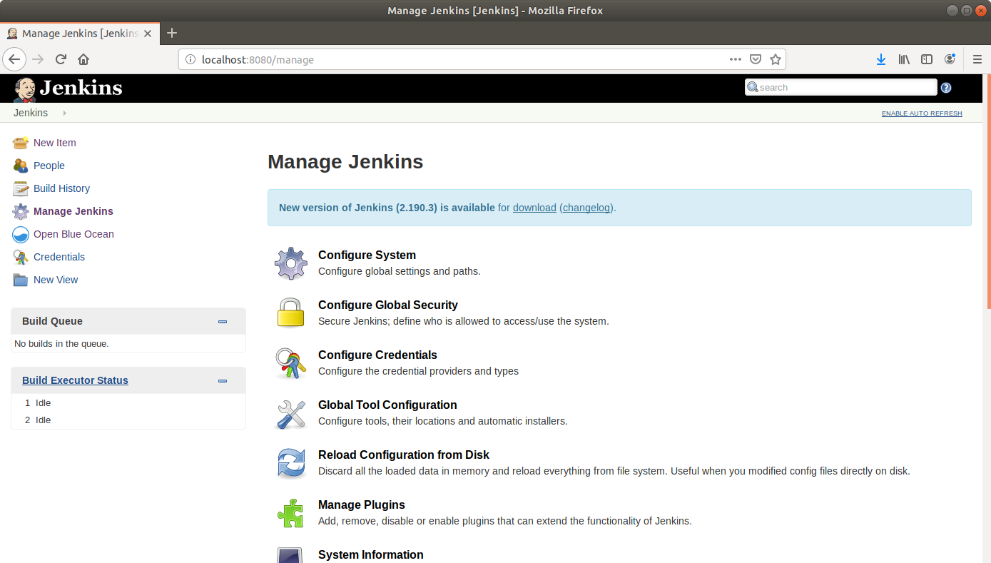

* Under the *Available* tab, select *Git Parameter*.

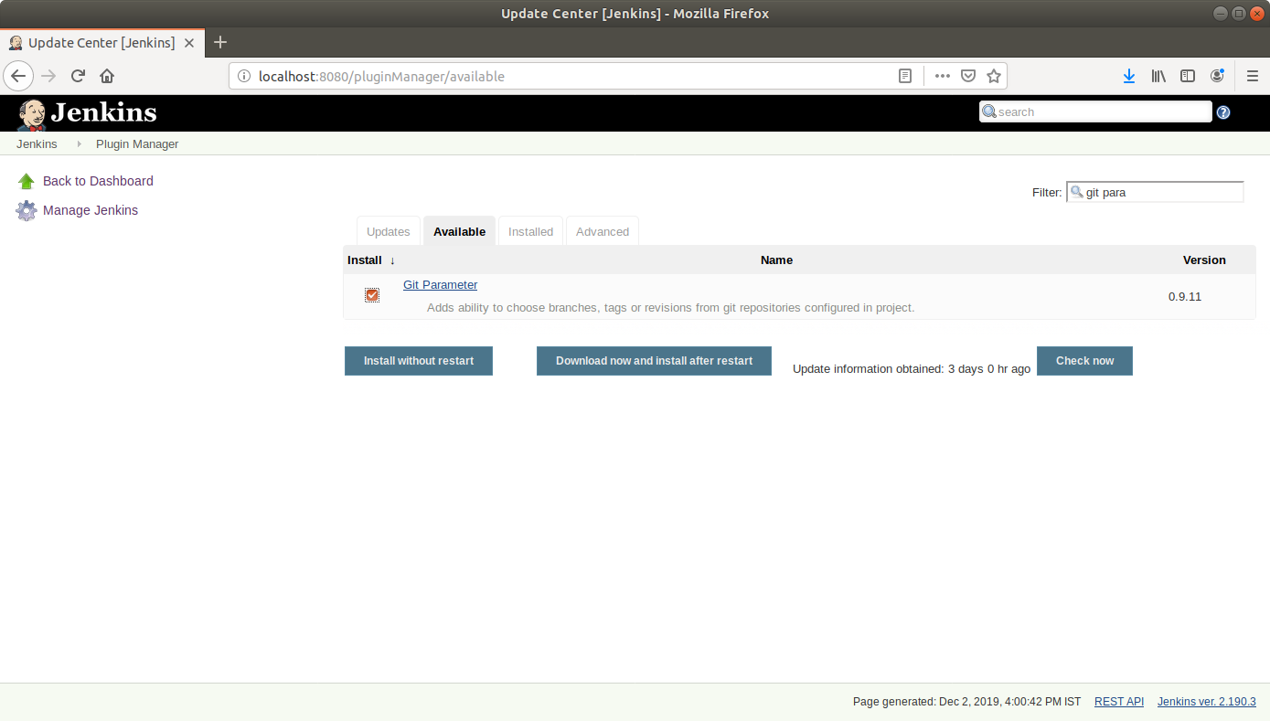

* Click on *Install without restart* and the plugin will be installed.

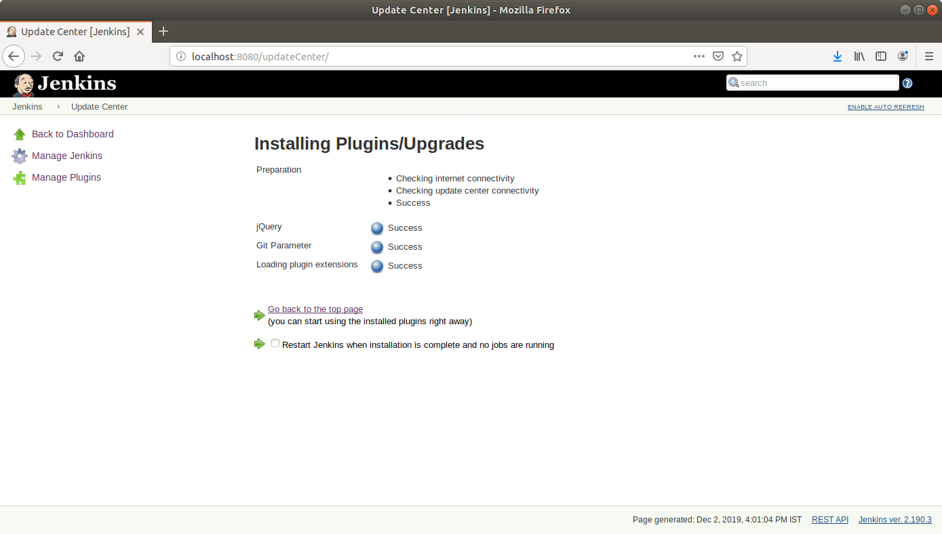

**Step 4.7.2:** Creating a tag in Git

* Go to github.com and open a repository.
* Click on the releases tab.

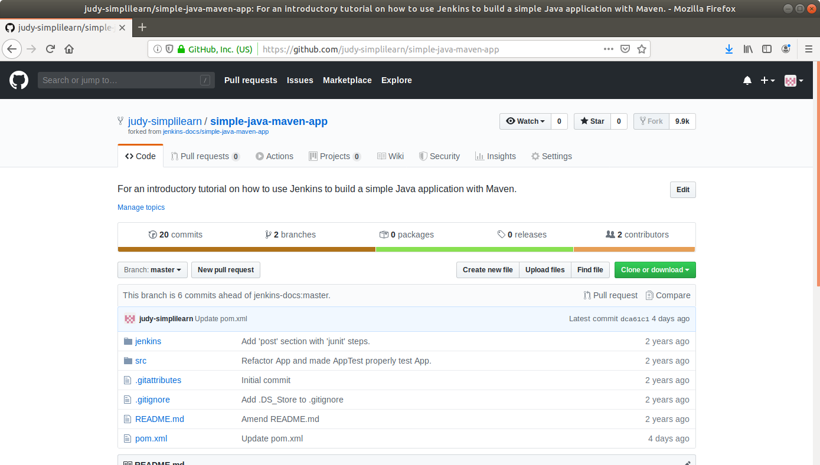

* Click on the *Create a new release* button*.*

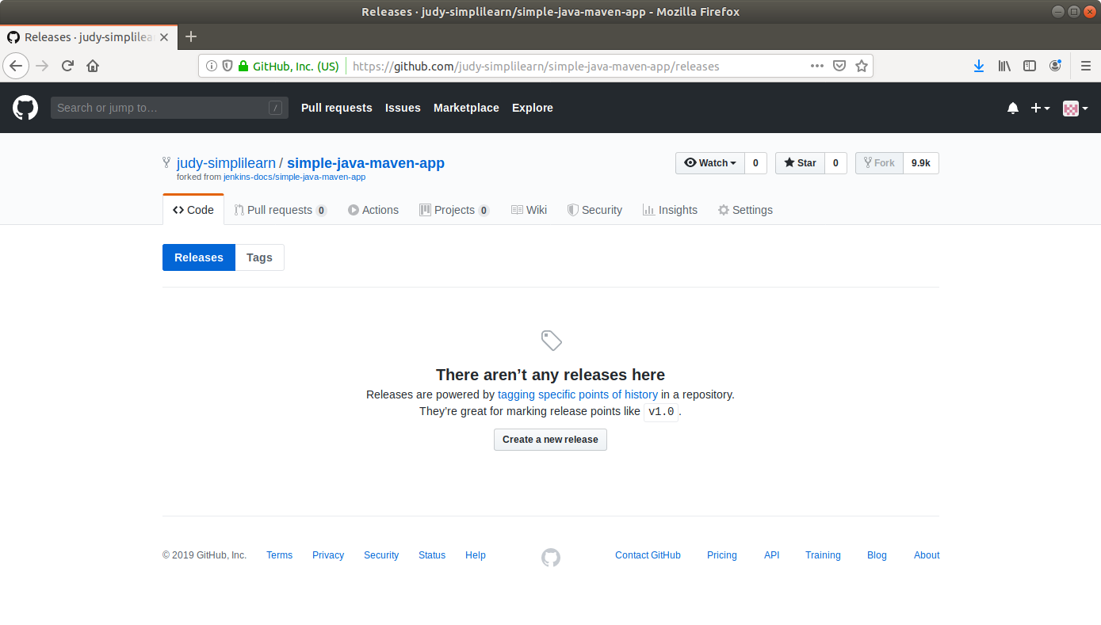

* Enter a tag name and fill out the other form fields.

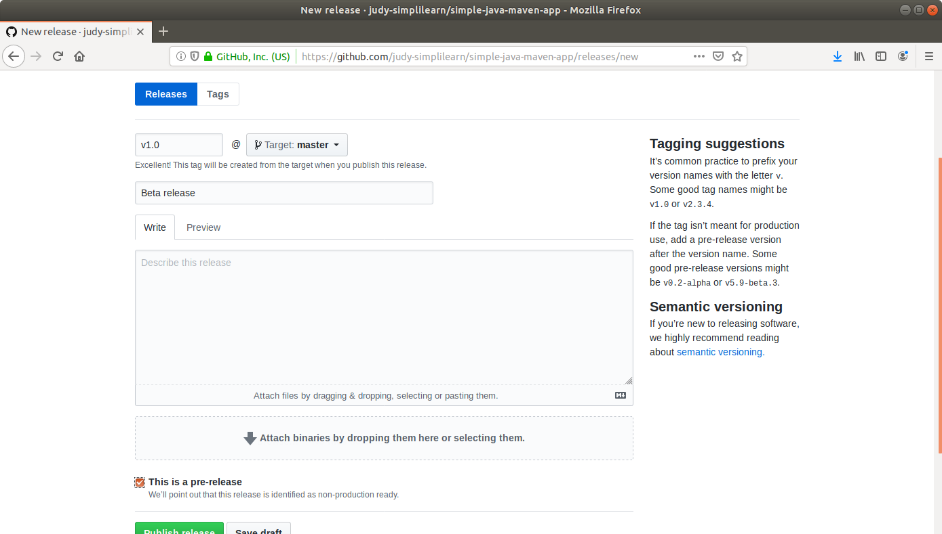

* Click *Publish release* at the bottom.

**Step 4.7.3:** Building a project from a Git tag in Jenkins

* Go to Jenkins dashboard.
* Click on *New Item* in the Jenkins dashboard.
* Enter a name for your build job.
* Select *Freestyle project* as the build job type.

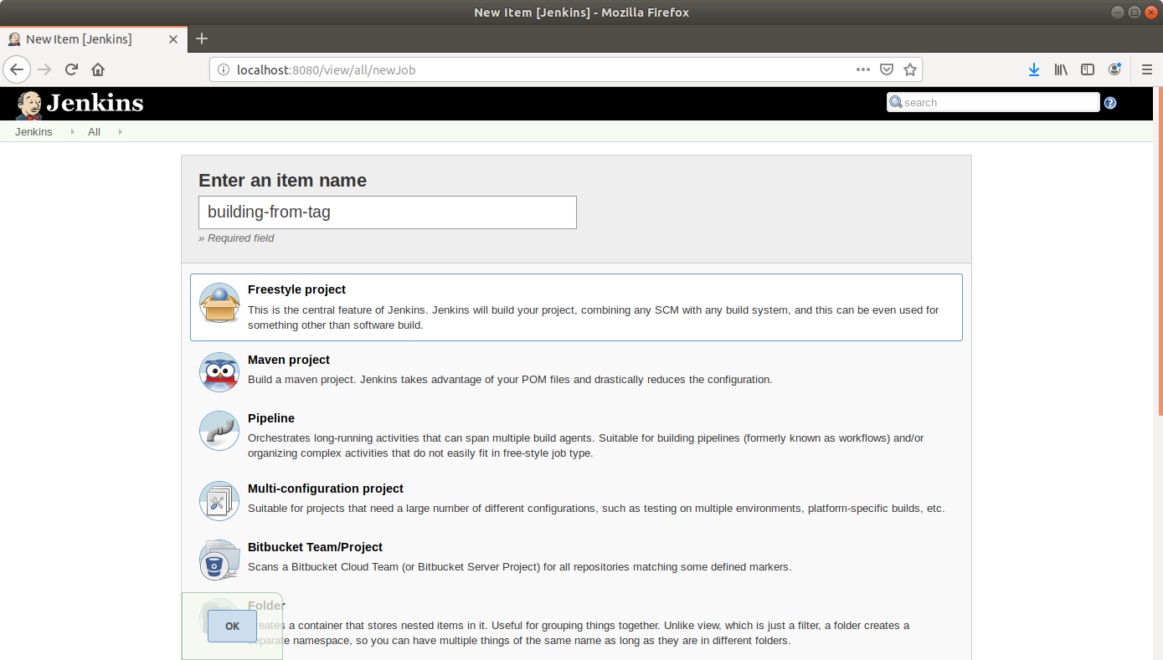

* Click OK.
* On the configuration page, select the checkbox next to text that states, *This project is parameterized*.
* Click on the *Add parameter* button that appears.

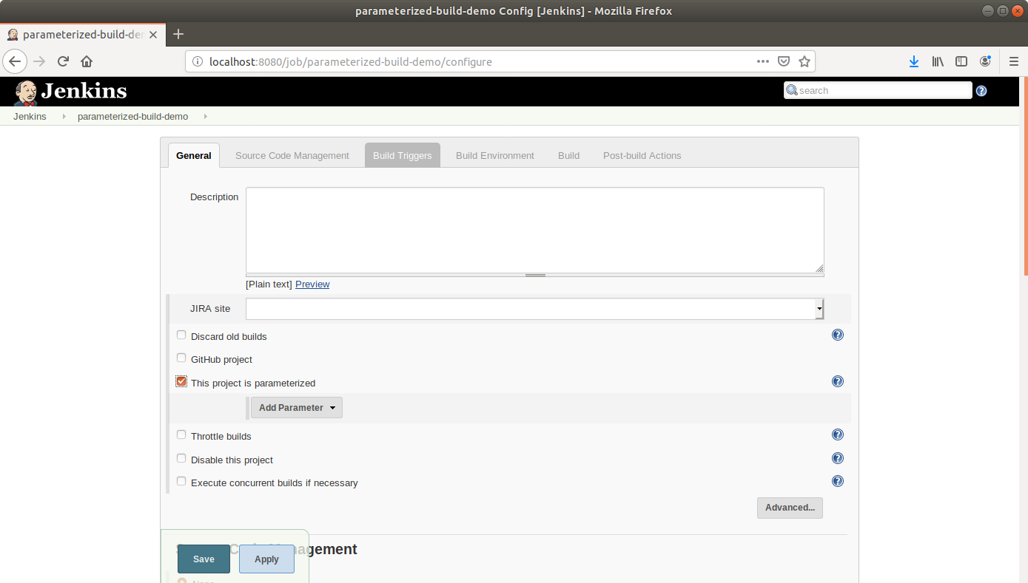

* From the drop-down menu that appears, select *Git parameter*.
* Name the Git parameter tag, and choose parameter type *Tag*.

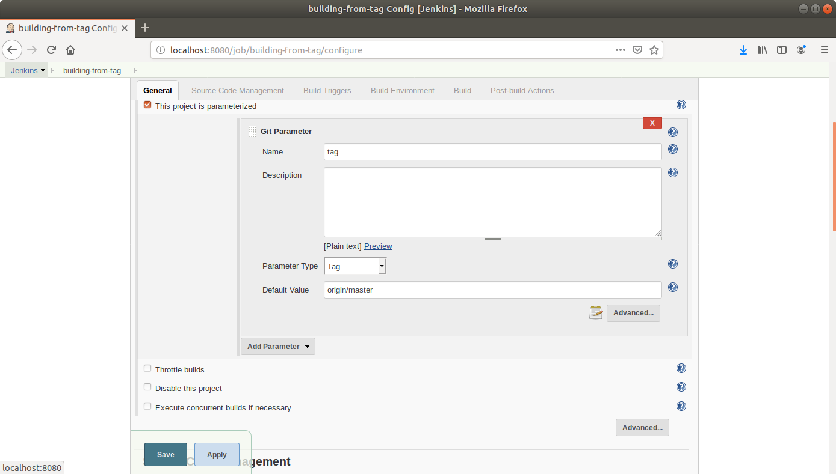

* Add a default value.
* Scroll down to the Source Code Management section and select *Git*.
* Enter the link to the repository in the field that appears.

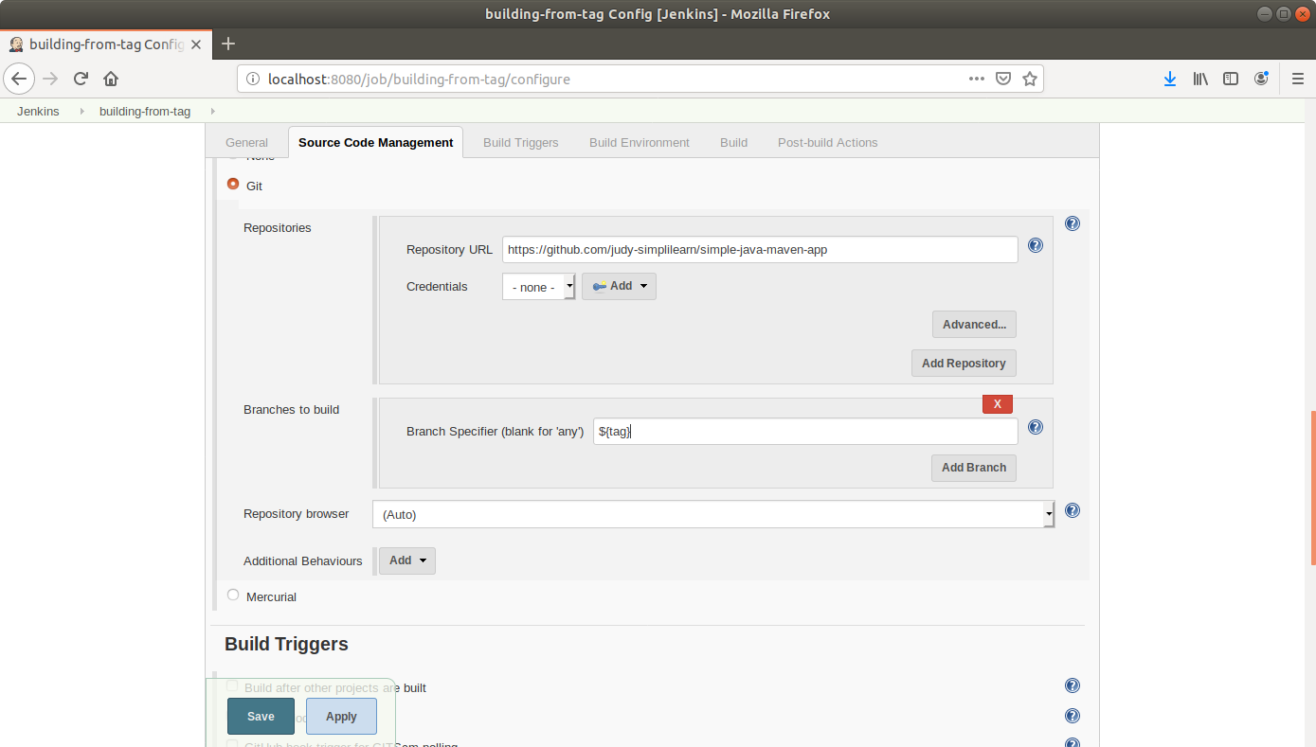

* In the *Branches to Build* field, enter the variable name as, **${tag}**.
* Click Save.
* Click *Build With Parameters* in the project window to make sure the build works.
* In the page that appears, accept the defaults if correct or enter the tag value, and click the *Build* button. Jenkins will now build your project.

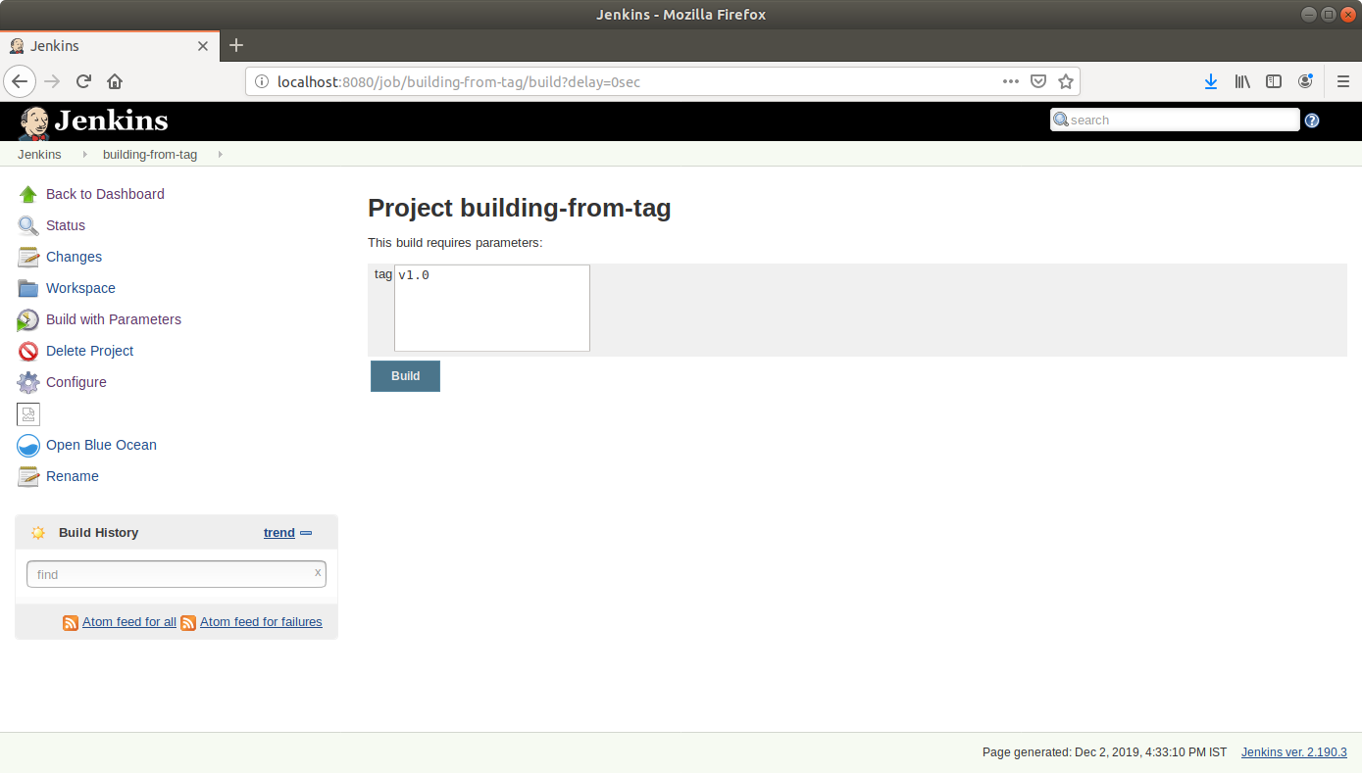

* Click on the *Build History* to view the build results.
* Click on the *Console Output* to view the build logs.

