**4.1 Freestyle Build Jobs**

This section will guide you to:

* Create a freestyle build job in Jenkins

This lab has four sub-sections, namely:

4.1.1 Creating a Git repository

4.1.2 Adding a Java program to the repository

4.1.3 Creating a freestyle build job in Jenkins

4.1.4 Building the Java program with Jenkins

**Step 4.1.1:** Creating a Git repository

* Log on to your Github account.
* Click on the plus icon next to the profile picture and select *New repository* from the drop down menu.

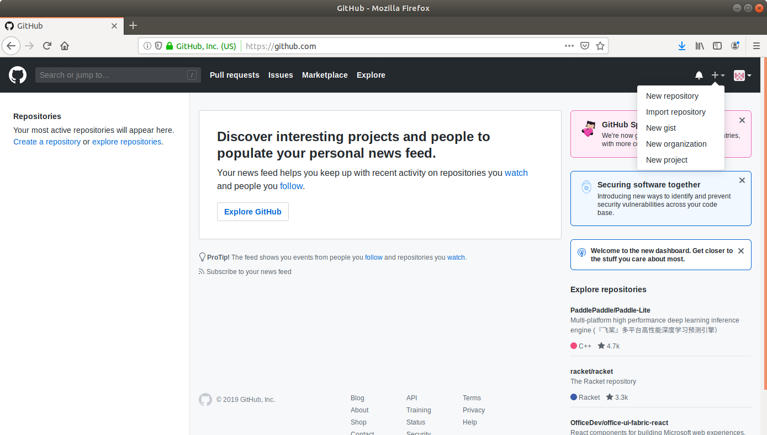

* Fill the fields in the create repository form appropriately.

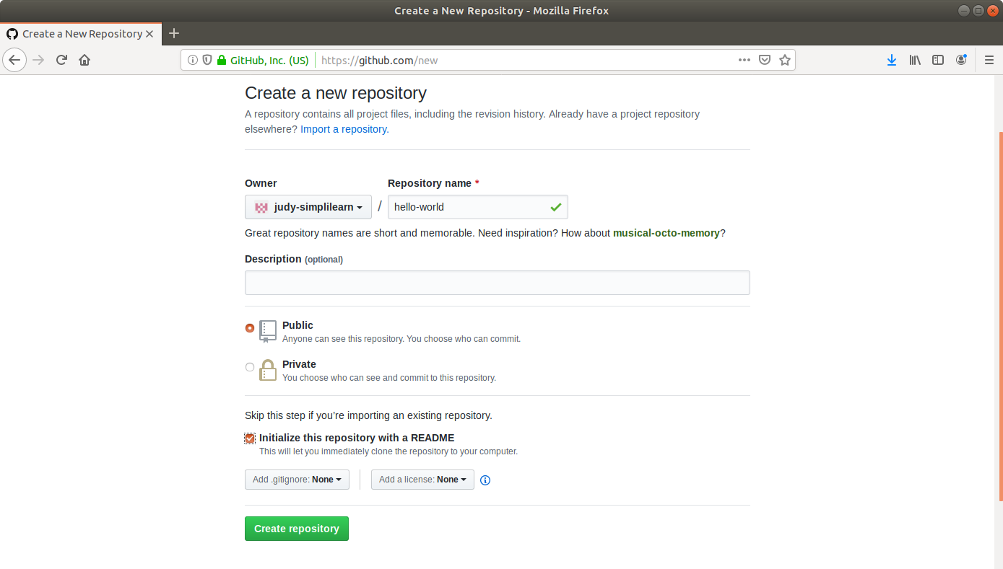

* Click on the **Create Repository** button.

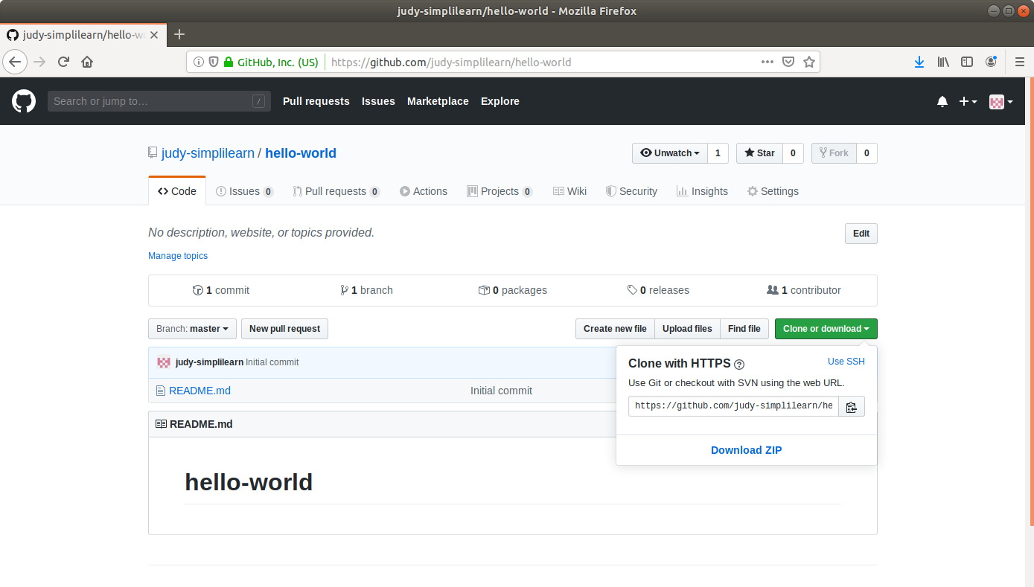

* Click on *Clone or Download* to copy the repository URL.

**Step 4.1.2:** Adding a Java program to the repository

* Open the terminal.
* Run **mkdir hello-world** to create a directory.
* Navigate to the *hello-world* directory.
* Run nano HelloWorld.java to open the java file in a text editor.
* Paste the code below into the file:

**public class HelloWorld {**

**public static void main(String[] args) {**

**System.out.println("Hello, World");**

**}**

}

* Save the file and exit the text editor.
* Run **git init**
* Run **git add .**
* Run **git commit -m “Add new files” .**
* Run **git remote add origin [Repository_URL].**
* Run **git push -u origin master.**

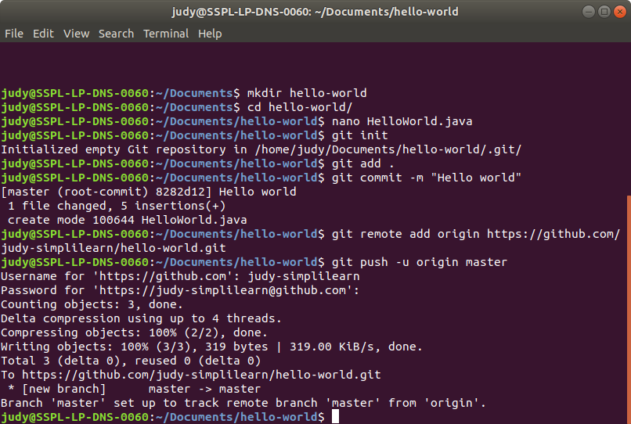

**Step 4.1.3:** Creating a freestyle build job in Jenkins

* Click on *New Item* in the Jenkins dashboard.
* Enter a name for your Maven project.
* Select *Freestyle project* as the build job type.

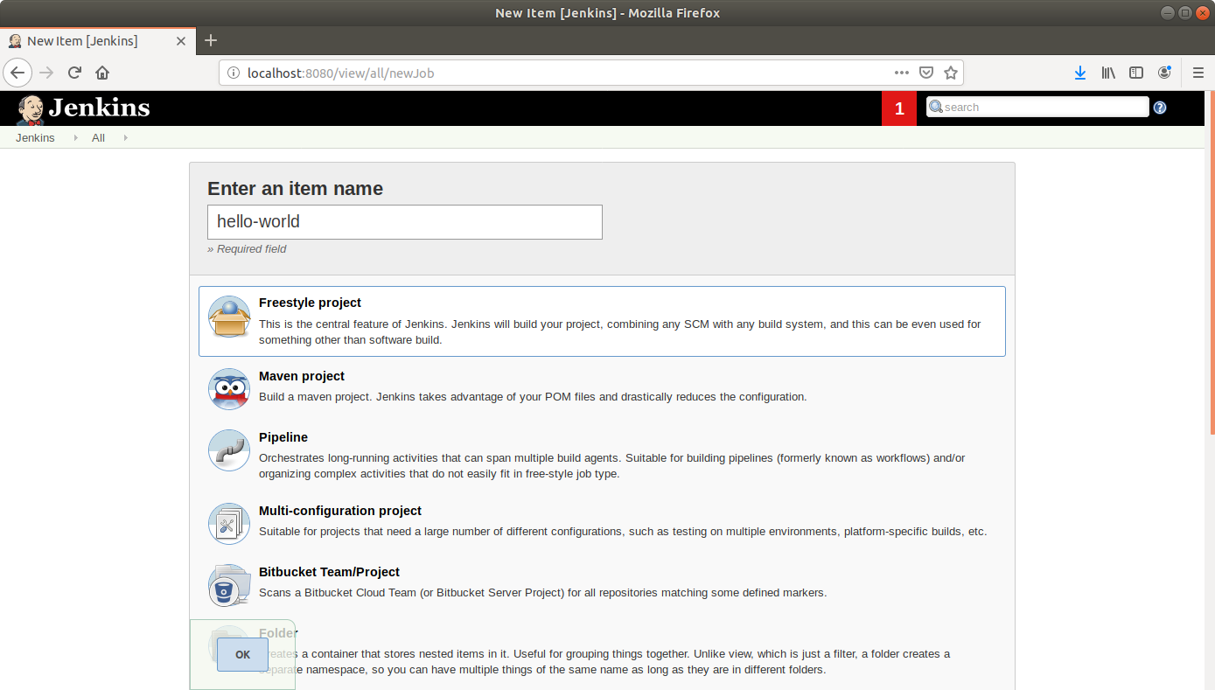

* Click OK.
* Scroll down to the *Source Code Management* section and select *Git*.
* Enter the repository URL.

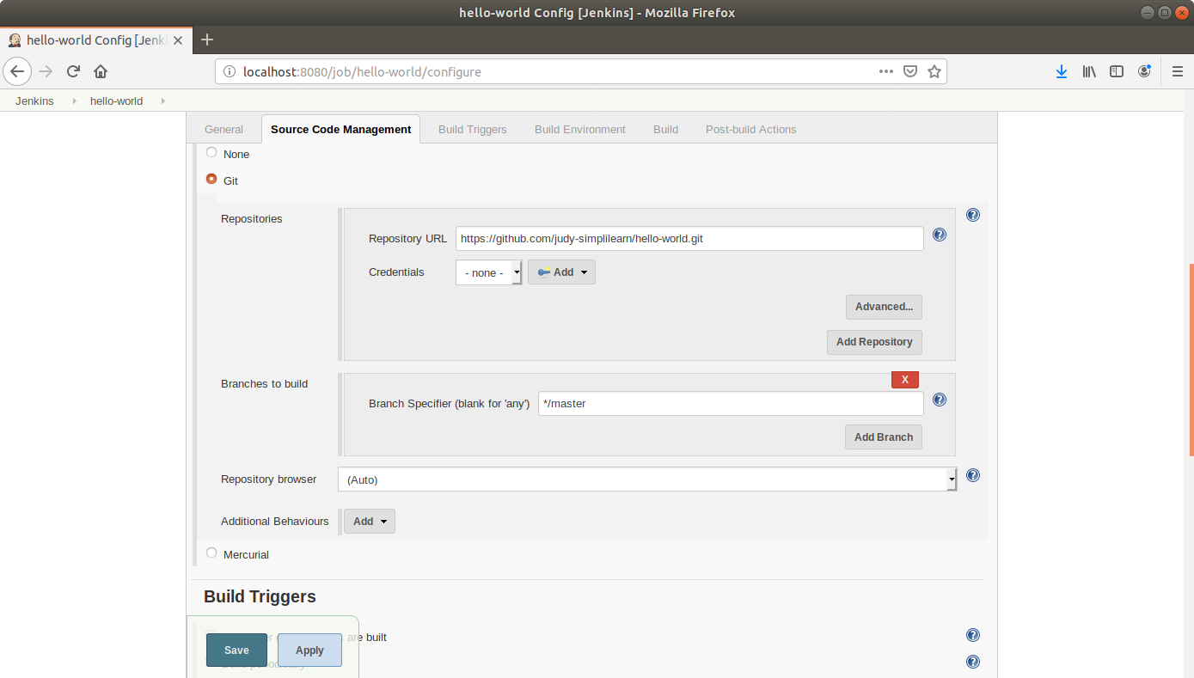

* Click Save.

**Step 4.1.4:** Building the Java program with Jenkins

* Click on the project name in the Jenkins dashboard.

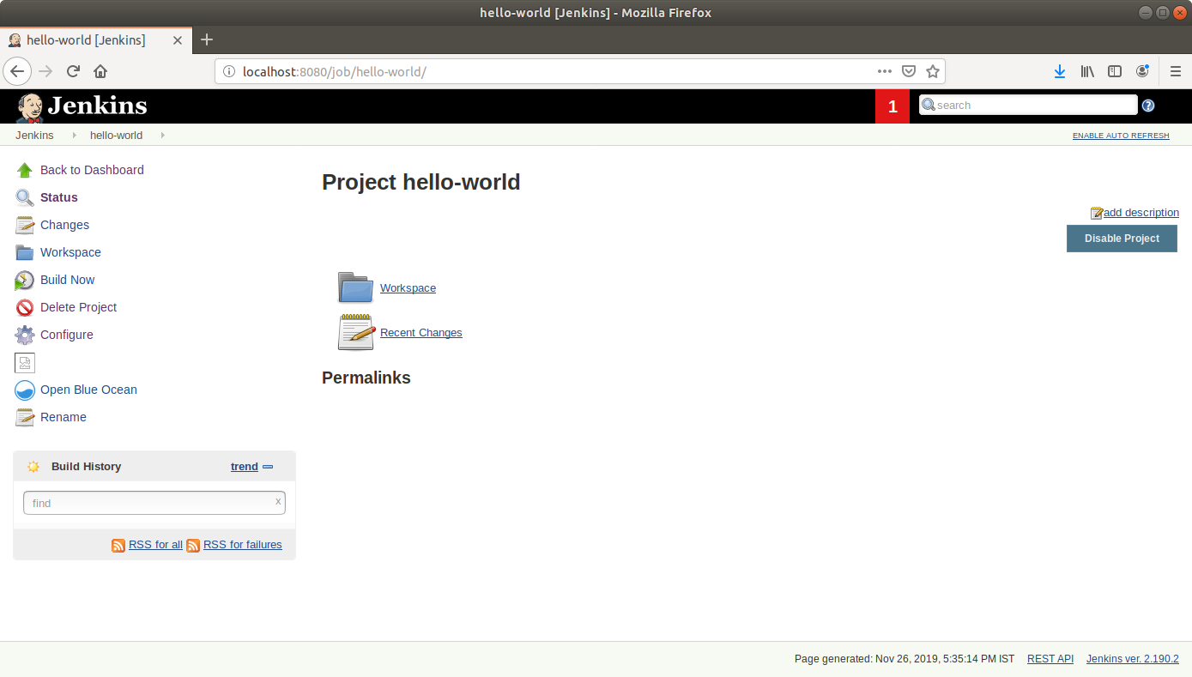

* Click *Build Now* in the project window. Jenkins will now build your project.
* Click on the *Build History* to view the build results.
* Click on the *Console Output* to view the build logs.

