**4.6 Parameterized Builds**

This section will guide you to:

* Configure parameterized builds in Jenkins

This lab has two sub-sections, namely:

4.6.1 Configuring a parameterized build in Jenkins

4.6.2 Building a project with parameters in Jenkins

**Step 4.6.1:** Creating a parameterized build

* Go to Jenkins dashboard.
* Click on *New Item*.
* Enter a name for your build job.
* Select *Freestyle project* as the build job type.

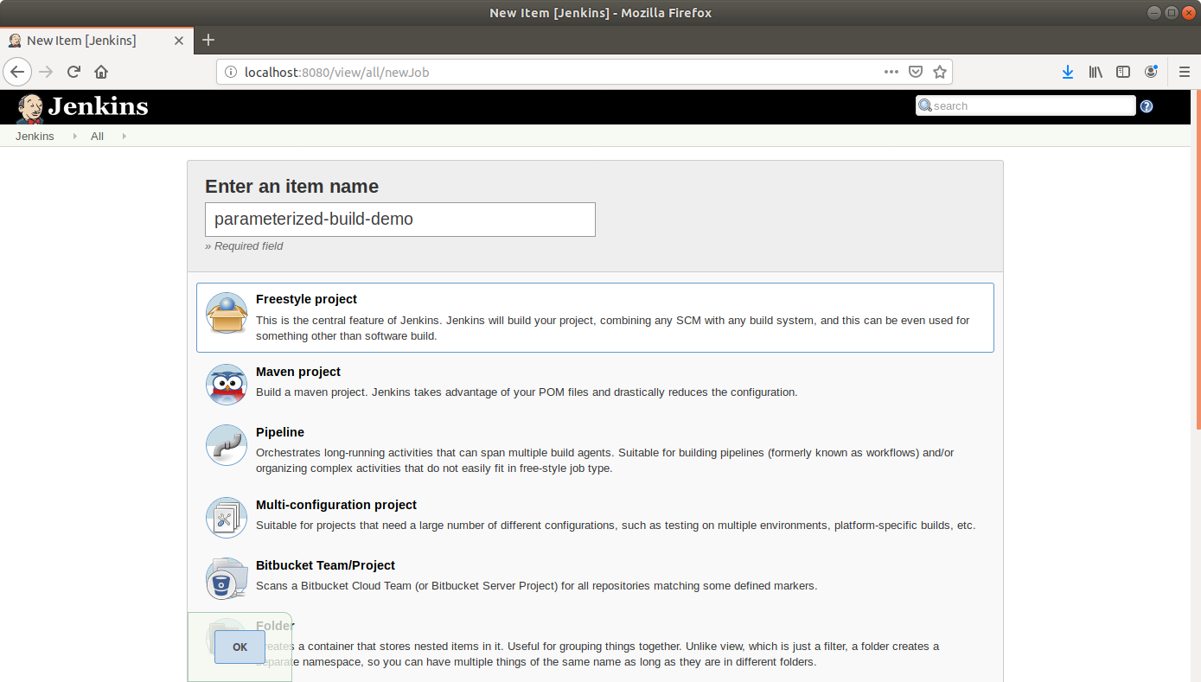

* Click OK.
* On the configuration page, select the checkbox next to text that states, *This project is parameterized*.
* Click on the *Add parameter* button.

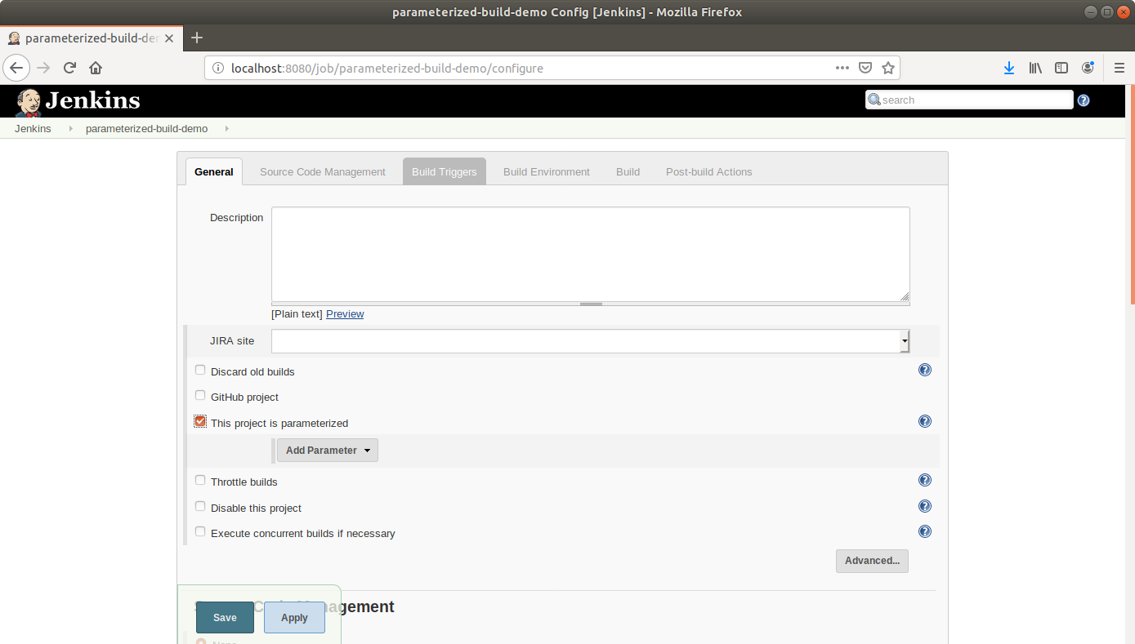

* From the drop-down menu, select *Boolean parameter*.
* Name the Boolean parameter *generate_javadoc* and enable the *Default Value* checkbox.

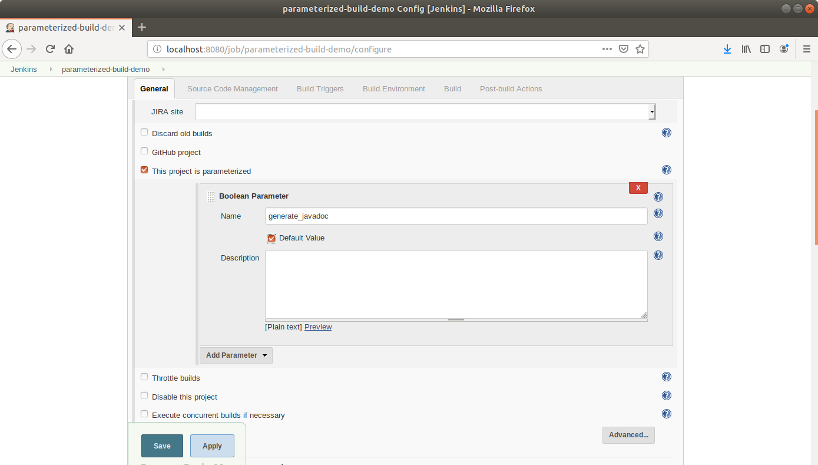

* Click the *Add Parameter* drop-down list again and choose a string parameter. Name this Jenkins build parameter *javadoc_location* and give it a default value.

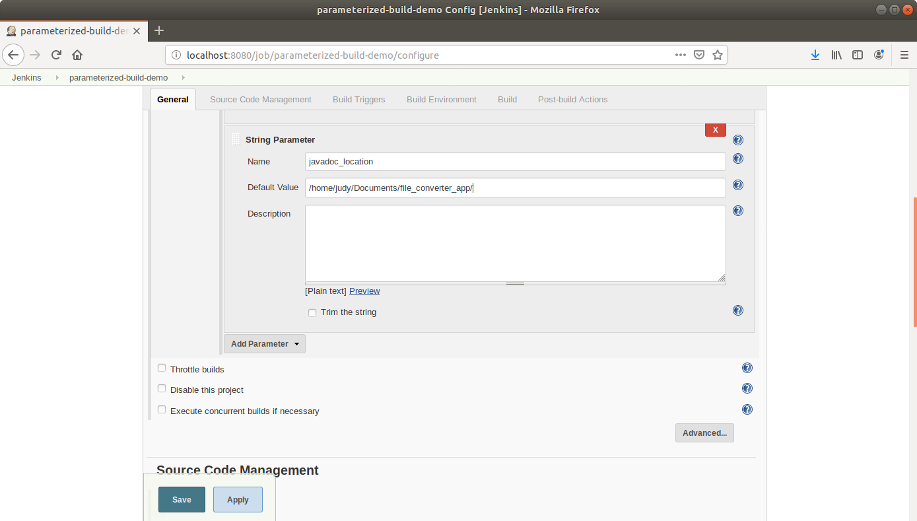

* Scroll down to the *Build* section and click on *Add build step*.
* Select *Execute Shell Command* from the drop down that appears.

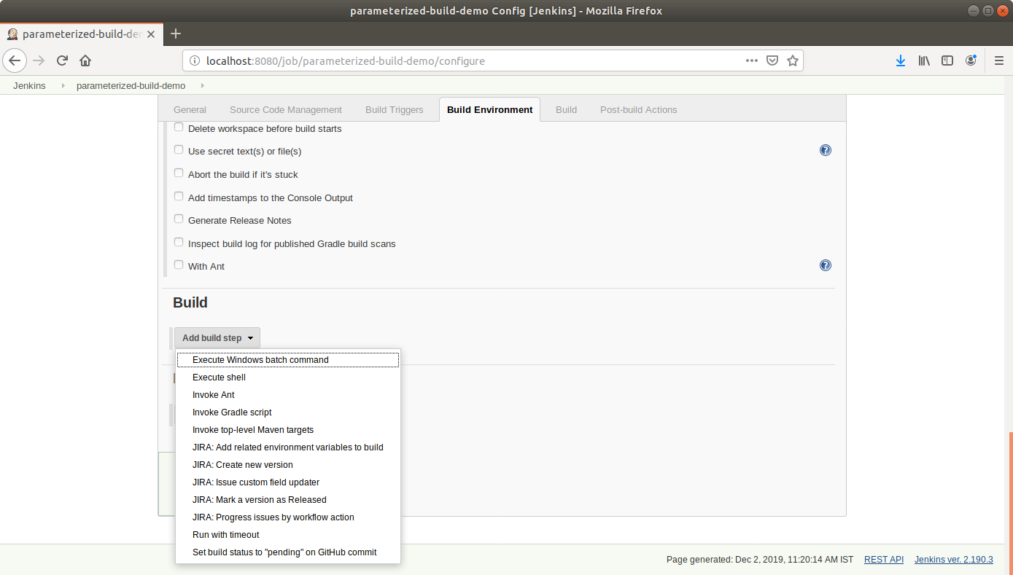

* In the text input area , enter the following text:

**echo $generate_javadoc**

**echo $javadoc_location**

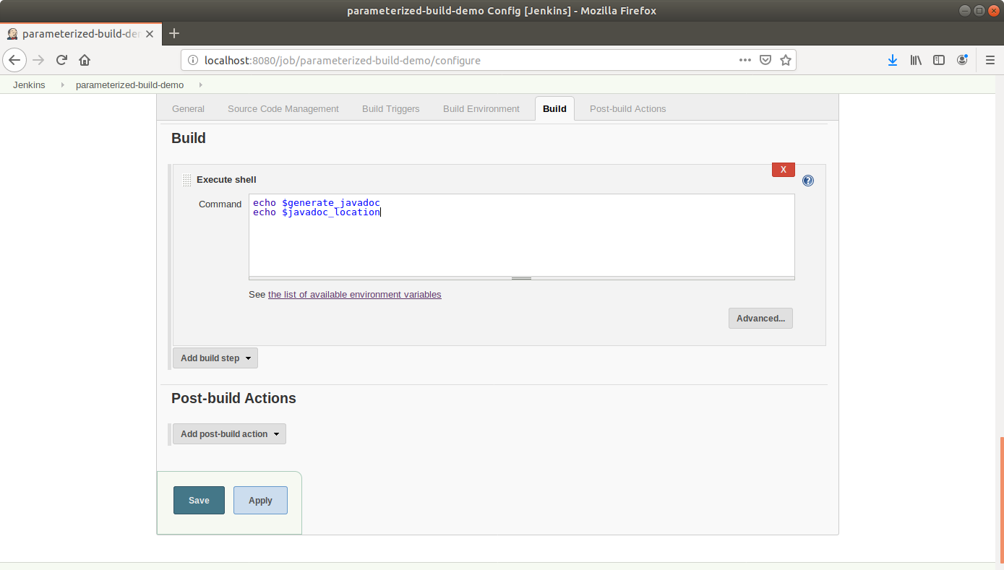

* Click Save.

**Step 4.6.2:** Building a project with parameters in Jenkins

* Click *Build With Parameters* in the project window to make sure the build works.

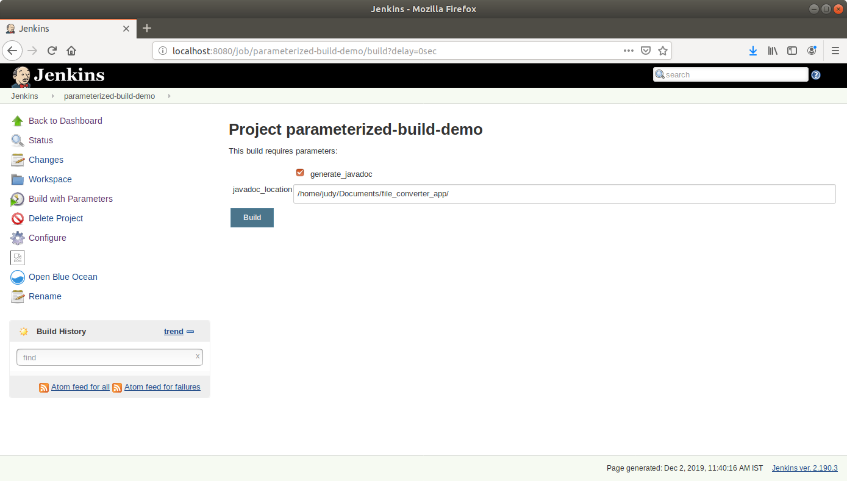

* In the page that appears, accept the defaults and click the *Build* button. Jenkins will now build your project.
* Click on the *Build History* to view the build results.
* Click on the *Console Output* to view the build logs.

