**4.8 Remote Triggering Parameterized Builds**

This section will guide you to:

* Trigger parameterized builds in Jenkins remotely

This lab has two sub-sections, namely:

4.8.1 Configuring a parameterized build in Jenkins

4.8.2 Triggering a parameterized build remotely

**Step 4.8.1:** Configuring a parameterized build in Jenkins

* Go to Jenkins dashboard.
* Click on *New Item* in the Jenkins dashboard.
* Enter a name for your build job.
* Select *Freestyle project* as the build job type.

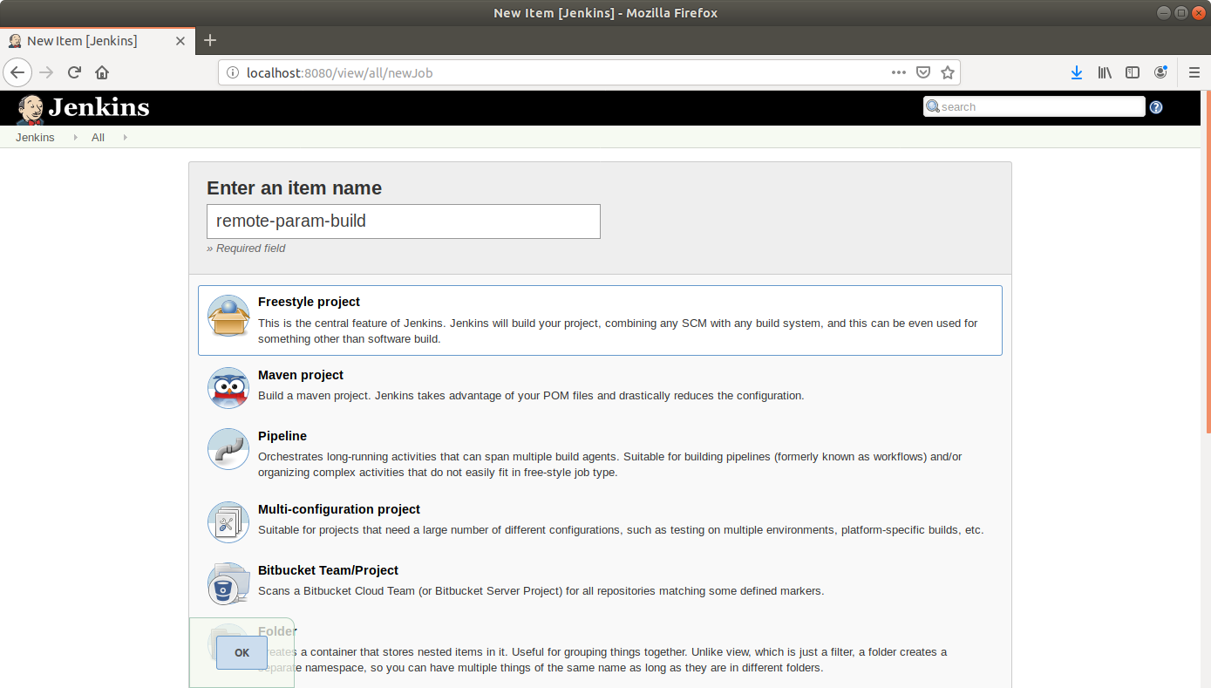

* Click OK.
* On the configuration page, select the checkbox next to text that states, *This project is parameterized*.
* Click on the *Add parameter* button that appears.

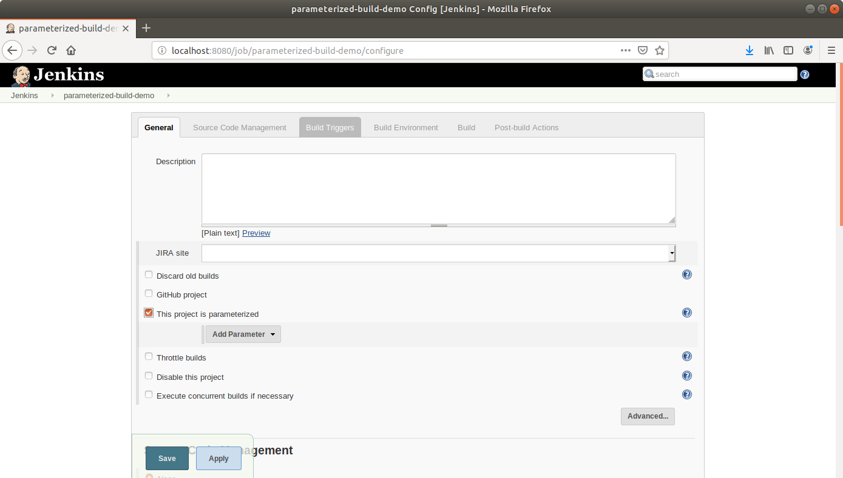

* From the drop-down menu that appears, select *String parameter*.
* Name the parameter *my_param*, and enter the *Default Value*.

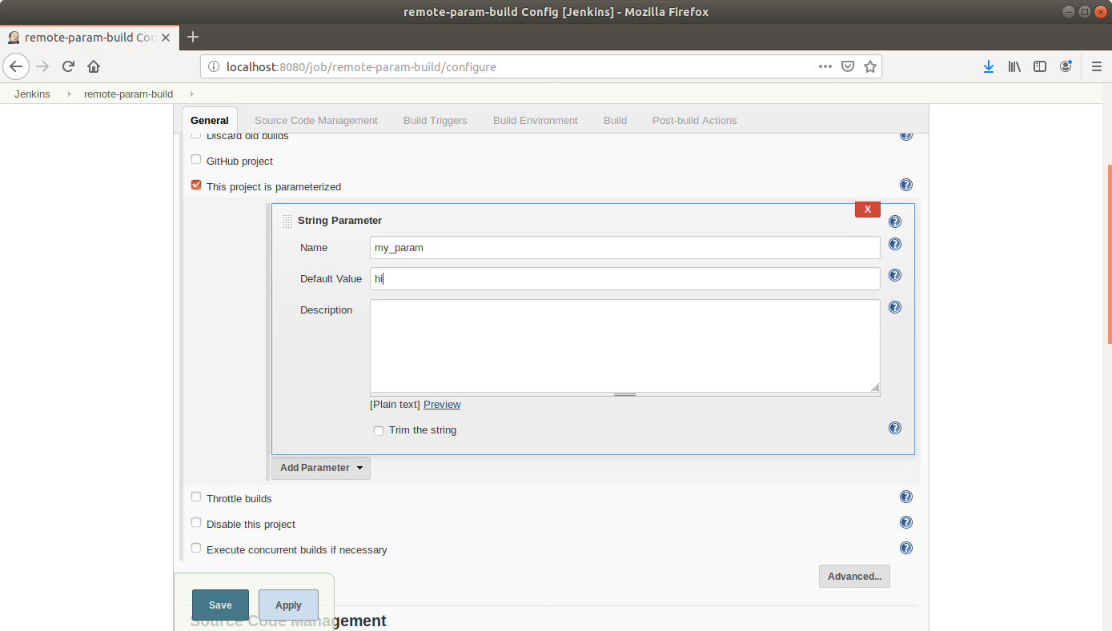

* Scroll down to the *Build* section and click on *Add build step*.
* Select *Execute Shell Command* from the drop down that appears.

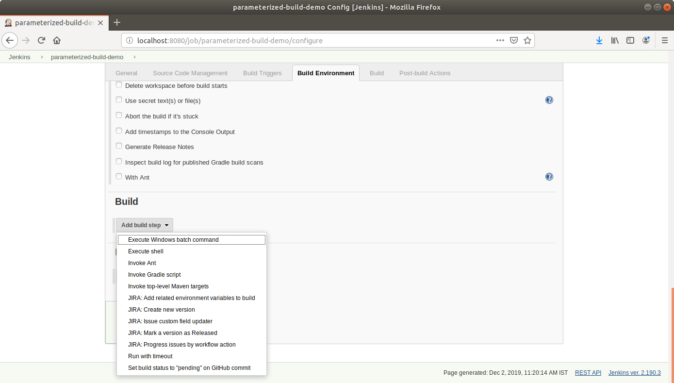

* In the text input area that appears, enter the following text:

**echo $my_param**

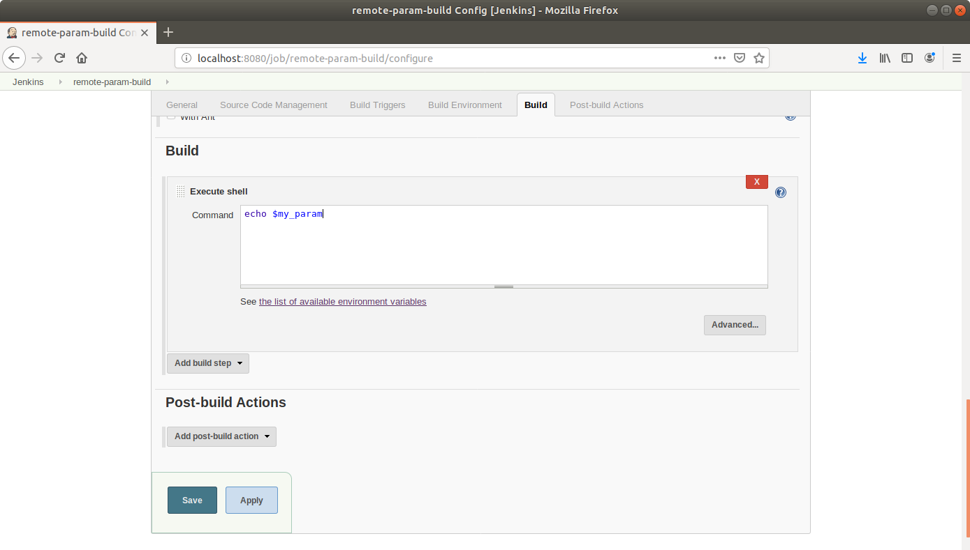

* Click Save.

**Step 4.8.2:** Triggering a parameterized build remotely

* Copy the url to the job from the project window.

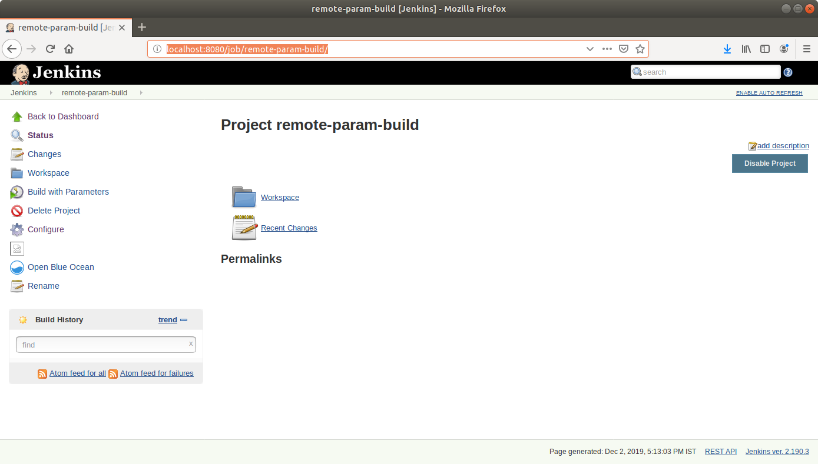

* Open the terminal.
* Suffix the parameter and its value to the url copied in the previous step and send a *GET* request using *Curl*.

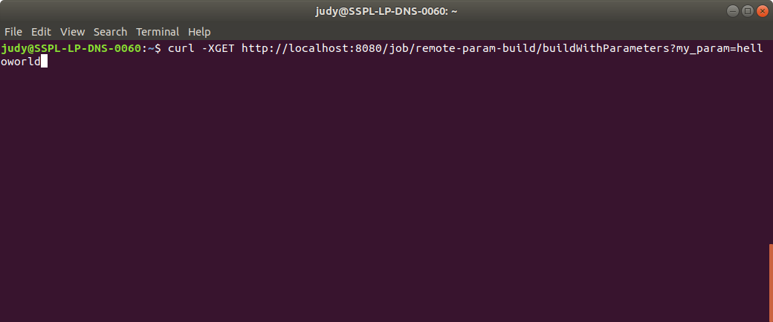

* Open the job in the Jenkins UI.
* Click on the *Build History* to view the build results.
* Click on the *Console Output* to view the build logs.
* The parameter value will be displayed in the console output.

