Link get:

[https://9pay.vn](https://9pay.vn)

Link get: <https://9pay.vn/dich-vu/chuyen-nhan-tien>



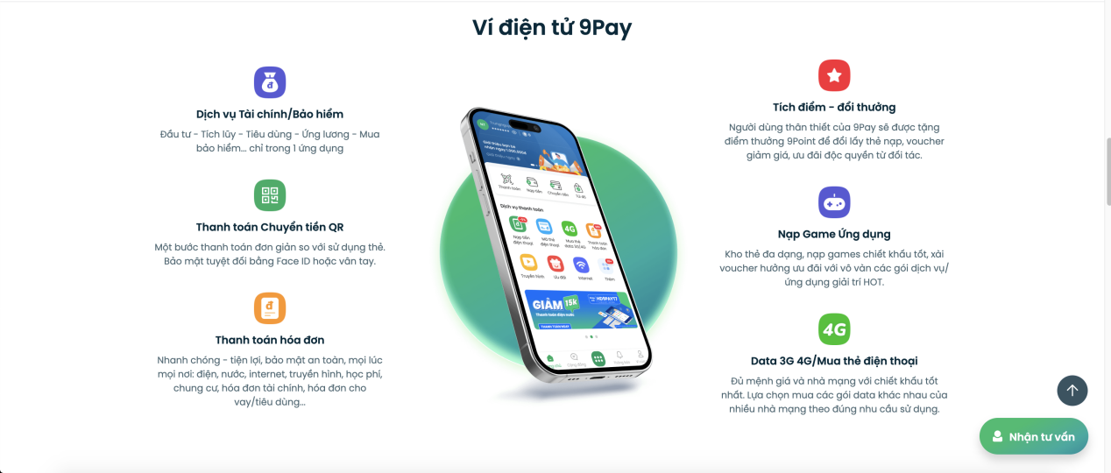

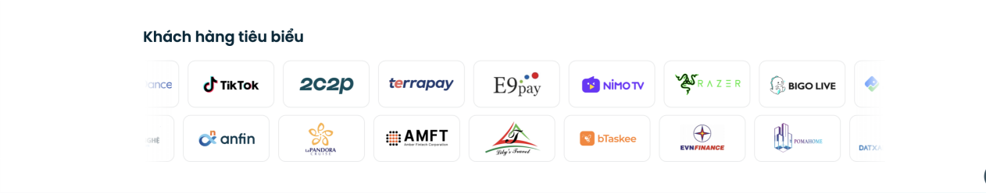



**Link get: <https://loatingting.com/>**

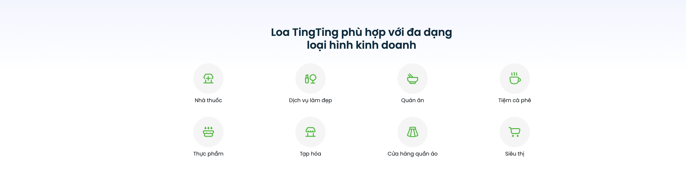

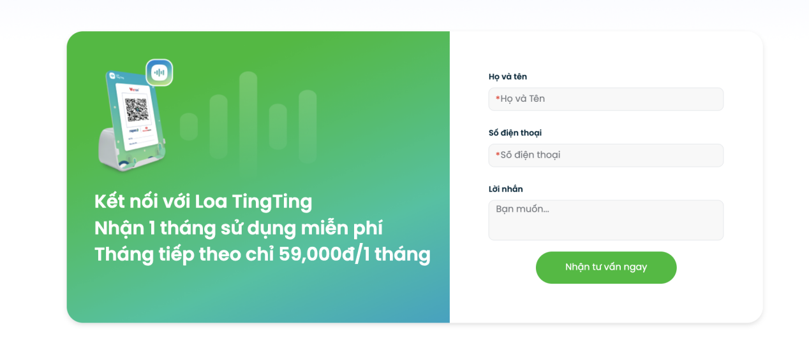

**Link get: <https://loatingting.com/>**

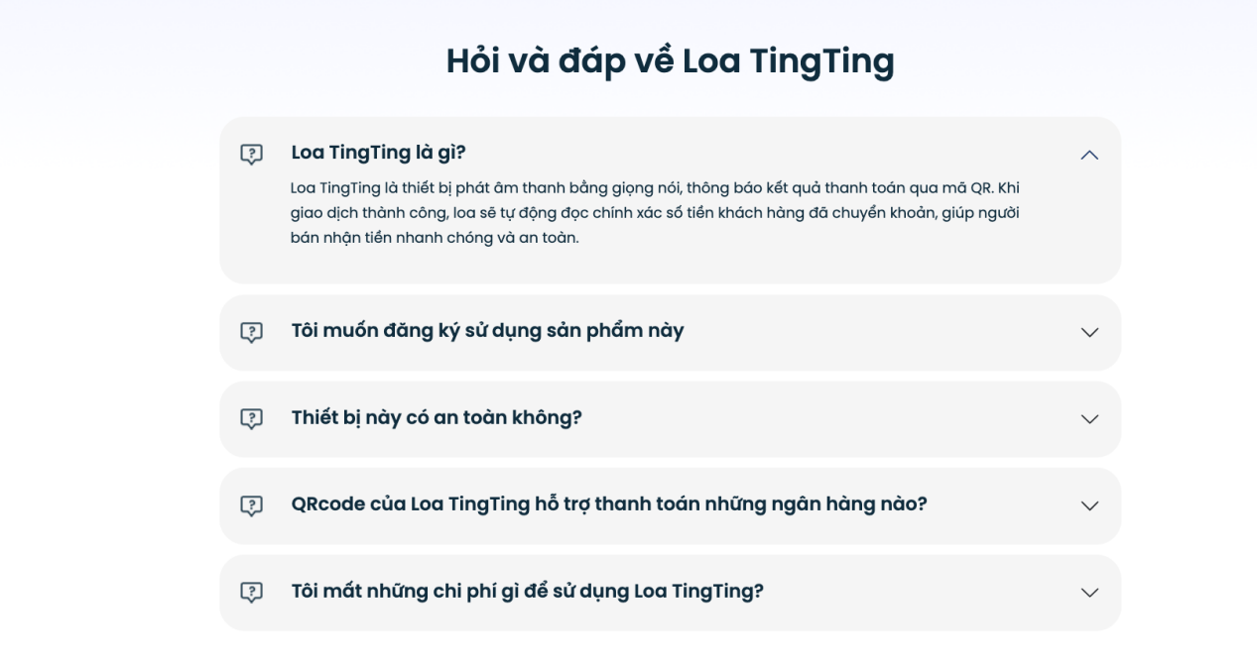

Link get: <https://9pay.vn> 