***How to install the R-package “crmPack” for CRMs in R***Version 1.0 (December 2014)

1. First, you have to install JAGS (“Just Another Gibbs Sampler”).   
   Click on the following link to visit the JAGS webpage:  
   <http://sourceforge.net/projects/mcmc-jags/files/JAGS/>
2. Download the JAGS installation program suitable for your computer by clicking on the top link in the JAGS webpage:  
   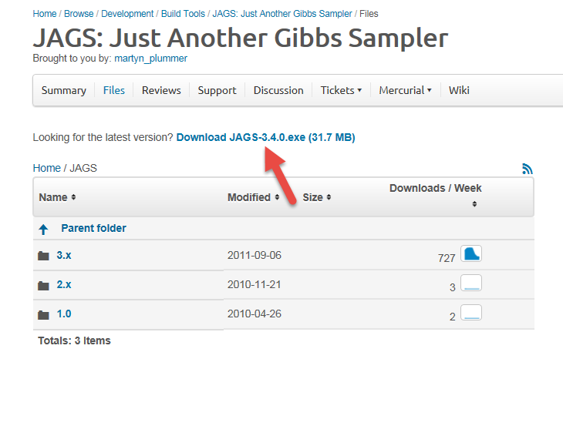
3. Run the JAGS installation program by executing the downloaded file, and clicking through and confirming all installation setup steps.   
   (Note that this requires you to have administrative rights on your machine.)
4. Download the R-package zip-file from the following link:  
   <https://stash.intranet.roche.com/stash/plugins/servlet/archive/projects/RSTAT/repos/crmpack?at=refs%2Fheads%2Fmaster>  
   Save the zip-file crmPack-master.zip to your downloads directory.
5. In your file manager, go to your downloads directory.
   1. Right click on the “crmPack-master.zip” and then “Extract all”:  
      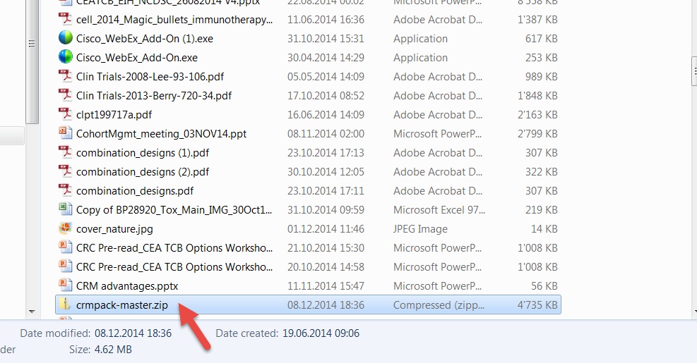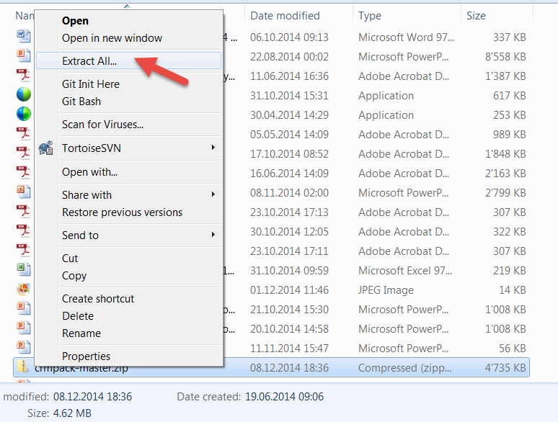  
      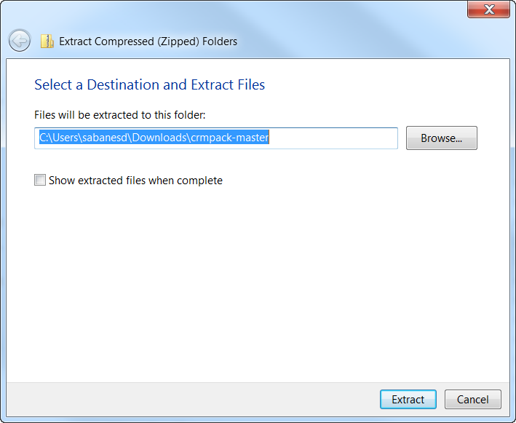  
      Here the directory path is already selected, please copy it to the clipboard. We will need it later.
   2. Only copying the directory path to your clipbord, click “Extract”. You obtain the folder phase1b-master:  
      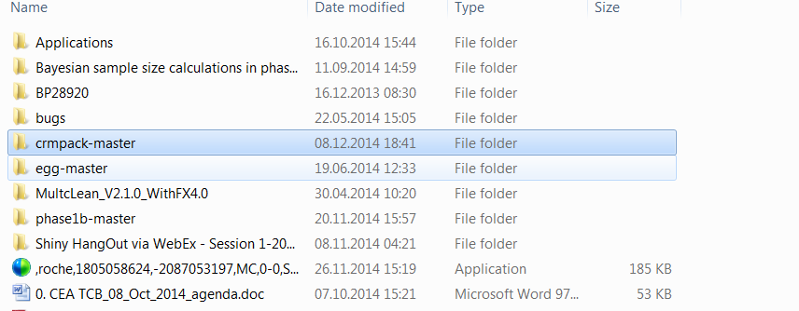
6. Open R-Studio.   
   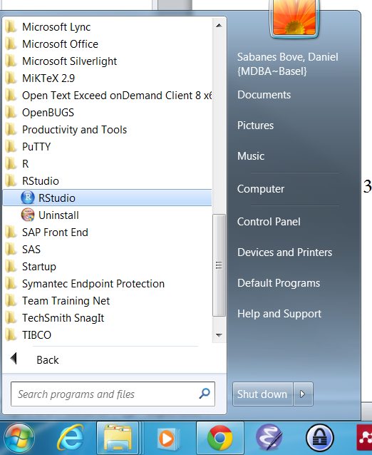
   1. Copy the following line into the R console:  
      install.packages("xxx", repos=NULL, type="source")  
      and replace xxx by the directory name from the clipboard (see Step 4 a). Please replace the backslashes \ by forward slashes / . Otherwise it will not work!   
      It should look like this:  
      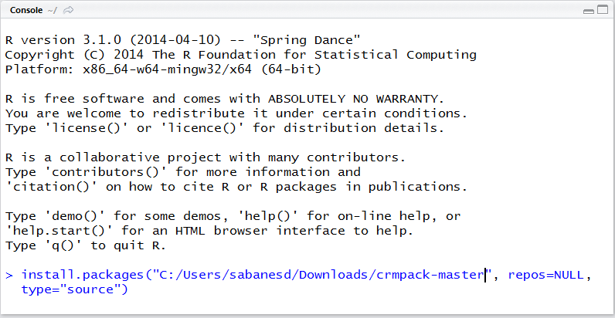

Click Enter.

* 1. The successful installation looks like this:  
     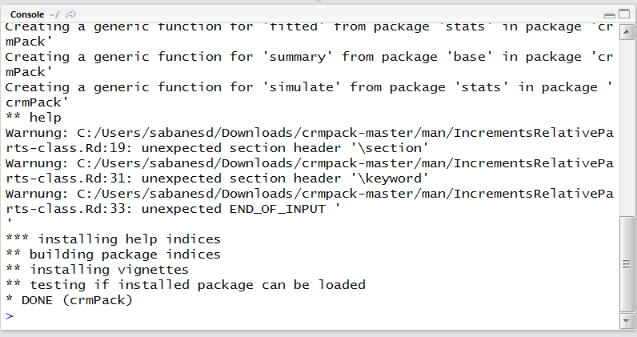

1. Before you can use the R-package, you have to load it into your R session, by typing the command  
   library("crmPack")  
   Note that you have to do *this* *again* for each *new R session*.   
   On the other hand, you only have to do the *installation* process *once* on your machine.