Assignment 5: Prolog (Due : Dec. 10th)

In this Assignment, you will be writing Prolog code to answer the following database queries.

The company is organized into DEPARTMENTs. Each department has a name, unique number and an employee who manages the department. We keep track of the start date of the department manager.
We store each EMPLOYEE’s social security number, address, salary, sex, birthdate, and the department the employee works for. We also keep track of the direct supervisor of each employee.
The company database schema diagram is given below, where primary keys are underlined, and foreign keys are indicated by pointed arrows.

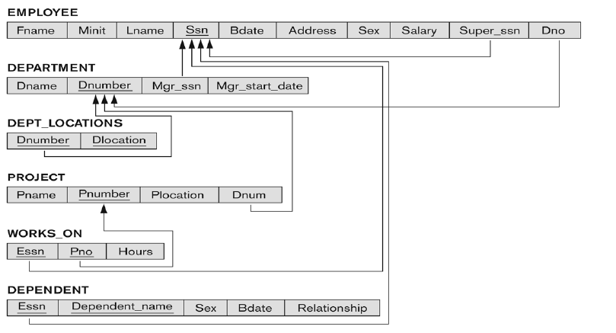
- The csv files corresponding to the tables for EMPLOYEE, DEPARTMENT, PROJECT and WORKS_ON are given to you. Create them as prolog facts in corresponding files such as employee.pl, department.pl and so on.
- Specify and execute the following queries using Prolog by loading the database created from Part A.
  - Retrieve the names of employees in department 5 who work more than 10 hours per week on the 'ProductX' project.
  - For each department, retrieve the department name, and the department manager (name) who manages the department.
  - Get the names of employees who work on either project 1 or project 2.
  - Get the names of employees who work on both projects 1 and 2.
  - Get the names of employees who don’t work on any project
  - Find the names of employees that are directly supervised by 'Franklin Wong'

Submission: Submit your source code, and test case reports to d2l.mu.edu by the due date.

