Project 3 Report

Group 8

Game of Thrones Project (Whodat: GOT)

Group Members: Gage Godfrey, Cameron Smith, and Carlee Berry

For our final mobile programming project, we have decided to implement a “Whodat” Android application. The goal of this project is to create an application which acts as a viewing assistant for new viewers of the TV show, Game of Thrones. Oftentimes, someone will watch Game of Thrones and be unfamiliar with the backstory of a character they’ve seen. They’ll know the face of the character they’ve seen, but they may not remember what that character’s name is or what they’ve been doing throughout the series. That’s where Whodat: GOT comes in. By simply selecting the season and episode they’re watching, the user will be shown a list of every relevant character in the season. From there, the user can simply select the face of the character they want to know more about. They’ll then be given a small bit of spoiler free information about the character, including their affiliation (very important in the Game of Thrones series) and a brief, spoiler free summary of the character they selected. It’s important that this information be spoiler free, as in the Game of Thrones series the roles and affiliations of each character change dramatically.

Most of the information on the Game of Thrones series and characters comes from our database designer’s (Cameron Smith) interpretation of the show, as he’s seen it many times over. Any auxiliary information, and all the portraits, come from the Game of Thrones wiki page (cited below). We feel that “Whodat: GOT” is a much needed app for any casual Game of Thrones enthusiast. While the diehard fans of the show tend to binge watch the show and thus would know the full backstory of any character they see, the more casual consumer would likely watch episodes days or even weeks apart. Given that there are so many characters in Game of Thrones and there is so much depth to each one, it can be easy to get lost in all of the information. Our app hopes to simplify Game of Thrones to an easily digestible level. This would attract more viewers to the show and even allow people to start from the middle of the series after a long break, without the risk of getting lost in a sea of house names and characters.

The main alternative to this app that we’ve found on the Google Play Store is an app called “A Game of Thrones Guide.” It functions similarly to our app, and admittedly has a prettier interface, and at the time of writing this report, far more information. However, the advantages of “A Game of Thrones Guide” end there. Firstly, despite the name, “A Game of Thrones Guide” is based on the “A Song of Ice and Fire,” book series, rather than the TV show. As the books and the movie are markedly different, this causes a lot of unnecessary confusion among users. This app is also not entirely free. Rather than simply allowing the user to select the season and episode they want to choose to eliminate spoilers, spoilers are hidden behind paywalls, clearly a completely ludicrous concept. Instead, you are encouraged to buy “InfoPacks,” which unlock more characters, places, and information. The InfoPack associated with the Game of Thrones book costs two dollars, and the ones associated with the other books in the series cost 99 cents each, or you can buy them all for five bucks. Alternatively, our app is, and will remain, free. The information you are given by downloading the free app is incredibly limited, and many important characters aren’t even included. Instead, You also don’t have the instant recognition of character portraits, so the user must rely on hearing the name of the character they wish to know more about.

As mentioned previously, upon opening our application the user will be selected with a screen allowing them to choose both the episode and season that they are currently watching.

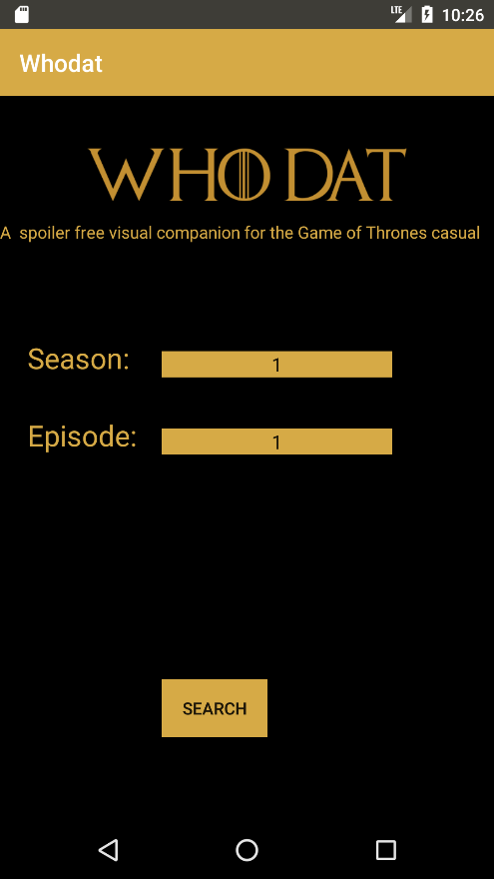

Upon selecting their parameters, the app takes the season and displays a list of important characters from that season, their names alongside their portraits.

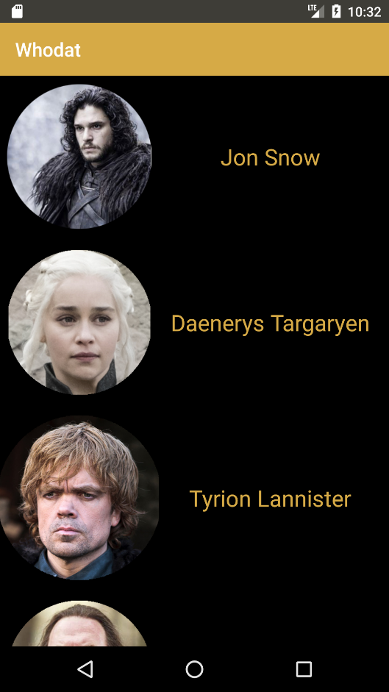

After this, the user is expected to select one of the portraits shown. Upon tapping on the character they want, in this case, Jon Snow…

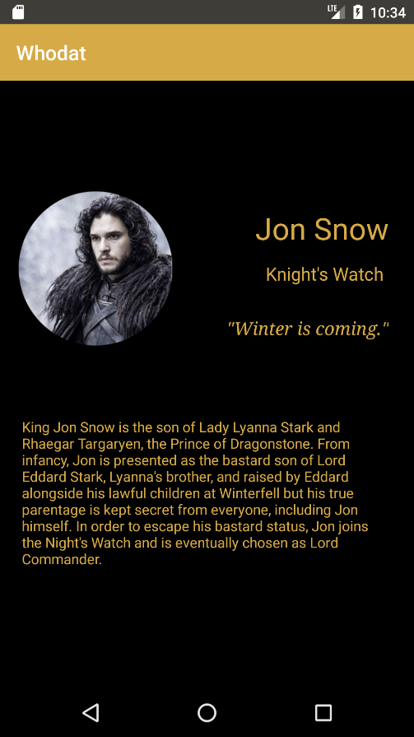

…they are greeted with the portrait of the character they chose before, the character’s affiliation, a brief quote, and a spoiler free summary of the character. This is done through the matching of “Relevance codes.” In essence, our app is designed to search our database for a relevance code attached to that character. For example, since Jon Snow is relevant in every season, his relevance code is “1234567”. The app then compares this to the season that the user submitted and displays the appropriate amount of information (so as to avoid spoilers, of course). The user is of course free to go back and select another character if they choose. The main android component we made use of in the making of this app was the SQLiteOpenHelper, to help with database manipulation. We also used a RecycleView to display the list of characters, and a couple of other java classes to aid in displaying and manipulating the information. The RecycleView was suggested by our professor, and it allowed us to display a set of imagebuttons and character information programmatically and conveniently. We did not feel the need to implement any APIs into the app.

As the app currently stands, the database is incomplete. We never quite got SQLite database reads to work correctly, so as a result we’ve implemented all of the information thus far programmatically, in order to give test users a sense of how the app is intended to operate. We’ve attempted to make up for this shortcoming by littering our code with comments and documentation on how the app is intended to work. We’ve also implemented only a few characters, and only from season one. Though we’ve long since decided on an algorithm for checking season relevance, as it turns out, creating a huge database filled with very calculated and spoiler filtered details was extremely time-consuming, and out of the scope of a weeklong project. We don’t believe the goal was overly ambitious, however, and we expect to implement newer seasons very soon.

As far as long term features go, we plan to take the formula we’ve used to create this application and use it to create other applications of a similar nature. A popular request we’ve received is to adapt this app for series like “Harry Potter,” “Final Fantasy,” and “The Walking Dead,” among many other media franchises. Another idea we’ve been toying around with is to take a hint from our competition and incorporate not just people but locations and important items as well. These of course would be implemented in a similar fashion as the characters were and thus would be an easy and welcome addition to the app.

The goal in creating “Whodat: GOT” was to take a very complex and intricate TV show and attempt to aid in its digestion by the casual Game of Thrones enthusiast. Despite our fallbacks, we feel we’re well on our way to accomplishing that goal. We have a good system set up, a friendly user interface, and convenient way to communicate complex information to even the most sporadic of Game of Thrones fans. With a little more work, we hope that this app will serve an essential tool for both new fans and veterans of the series who might need a little help catching up.

Sources: “Game of Thrones Wiki.” Game of Thrones Wiki, gameofthrones.wikia.com/wiki/Game_of_Thrones_Wiki.