*Republic of the Philippines*

**EULOGIO “AMANG” RODRIGUEZ**

**INSTITUTE OF SCIENCE AND TECHNOLOGY**

*Nagtahan, Sampaloc, Manila*

COLLEGE OF ARTS AND SCIENCES - ITE DEPARTMENT

**< DATE > Name <Signature/Date>**

**July 23,2021 Marinella Castuera** 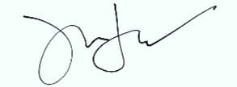

**Final Project in Application Development and Emerging Technologies Title:**

**Attendance AIDE Educational Tour**

**Rationale: (Background of the final project understudy)**

The rationale of this project is to educate students how to use AIDE Application at their own comfort, and to help create a system that can be made through the use of cellphone . This project is generally for the students, can be teacher and individuals. It is an integrated development environment (IDE) for developing real Android apps directly on your Android device. Follow interactive coding lessons and step-by-step become an expert app developer. Visually design apps, write code with the feature rich editor with code completion, real-time error checking, refactoring and smart code navigation, run your app with a single click and use the Java debugger to find bugs.

AIDE features interactive lessons with step-by-step instructions to learn Android app development and Java programming skills. Follow the lessons, become an expert and apply what you've learned in your own app projects and will turn your Android tablet with keyboard into a real development box. AIDE will turn your Android Phone into a small development computer to browse and touch your code on the go.

**Beneficiaries: (bulleted format)**

**<include the target users>**

* **Students**
* **Individuals**
* **Can be Professors**

**Features of the application development: (bulleted format)**

* **Splash Scree**
* **Show/Hide Talks**
* **Previous/Next Button**
* **Start Button**

**Technology:**

**<Frontend/ Backend>**

* **xml**
* **Java**
* **AIDE**

**User’s Manual:**

**Spalsh Screen**

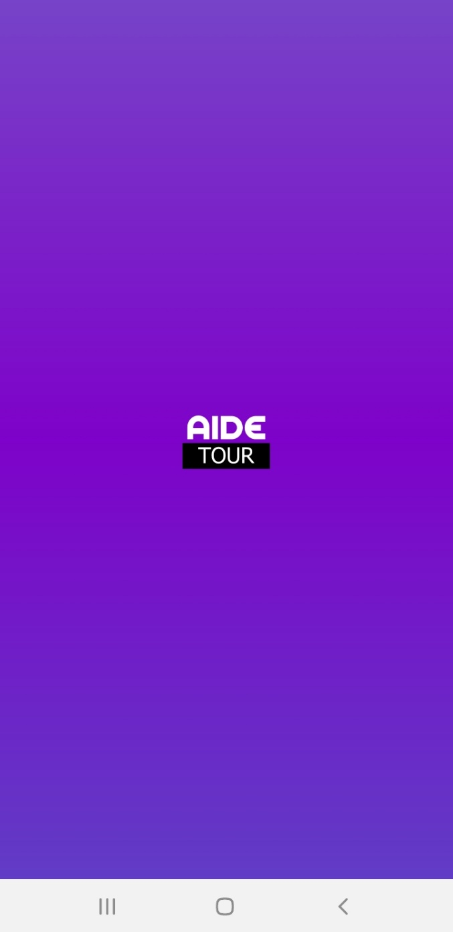

**Start Activity**

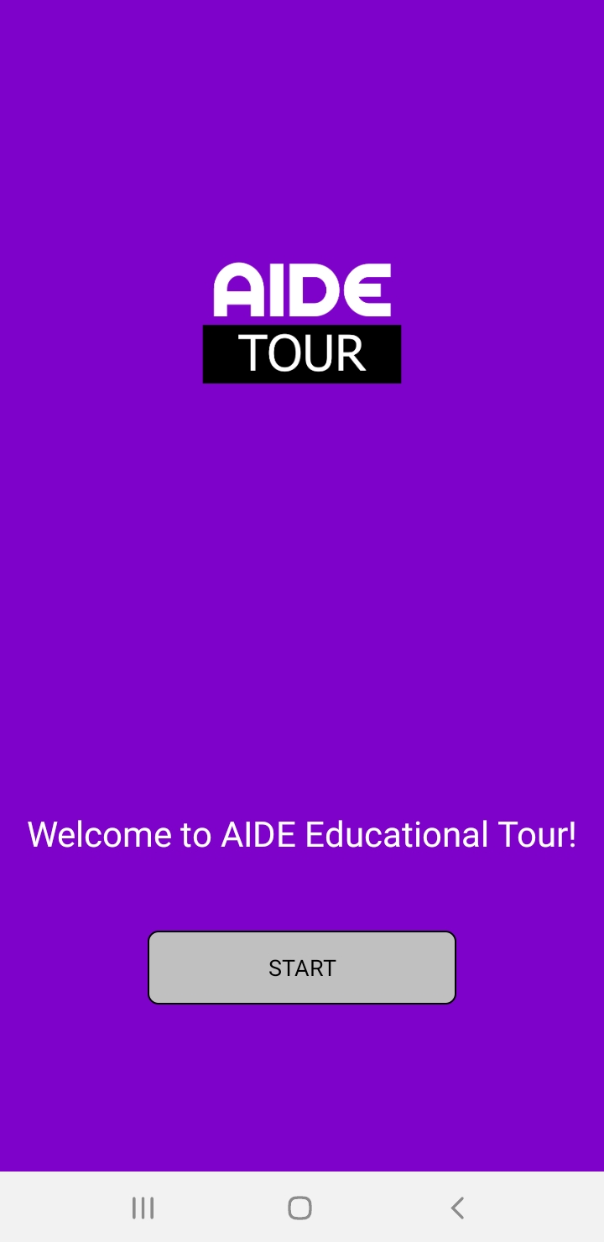

**Main Activity**

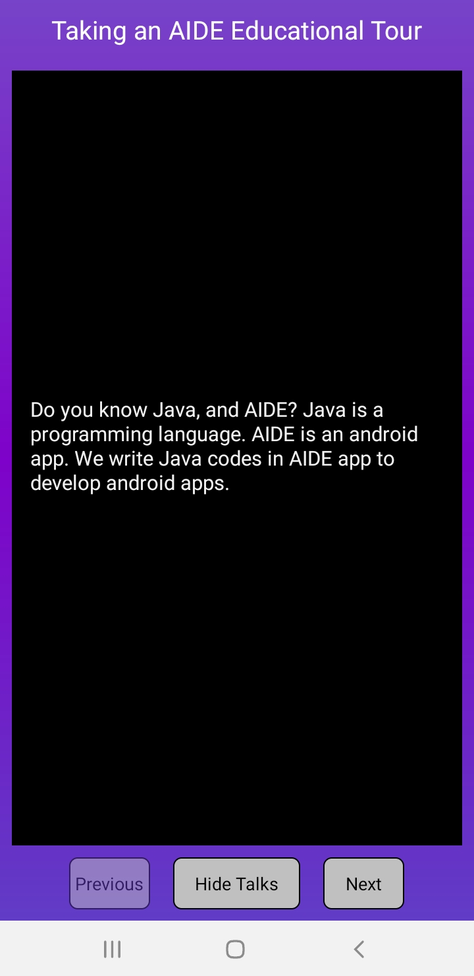

**Code UI**

**Main.xml**

<?xml version="1.0" encoding="utf-8"?>

<LinearLayout

xmlns:android="http://schemas.android.com/apk/res/android"

android:layout_width="match_parent"

android:layout_height="match_parent"

android:gravity="center"

android:orientation="vertical"

android:background="@drawable/splash_bg">

<TextView

android:layout_height="wrap_content"

android:layout_width="wrap_content"

android:text="Taking an AIDE Educational Tour"

android:textSize="20sp"

android:textColor="#FFFFFF"

android:padding="10dp"/>

<RelativeLayout

android:layout_height="wrap_content"

android:layout_width="match_parent"

android:layout_weight="1.0"

android:layout_margin="10dp"

android:background="#000000"

android:padding="3dp">

<LinearLayout

android:layout_height="wrap_content"

android:layout_width="wrap_content"

android:orientation="vertical"

android:id="@+id/codeView"/>

<TextView

android:layout_height="wrap_content"

android:layout_width="wrap_content"

android:text="Text"

android:id="@+id/talksTv"

android:layout_alignParentBottom="true"

android:textColor="#FEFEFE"

android:textSize="16sp"

android:layout_margin="5dp"

android:padding="8dp"/>

</RelativeLayout>

<LinearLayout

android:layout_height="55dp"

android:layout_width="wrap_content"

android:orientation="horizontal">

<Button

android:layout_height="wrap_content"

android:layout_width="wrap_content"

android:text="Previous"

android:onClick="previous"

android:id="@+id/previousBtn"/>

<Button

android:layout_height="wrap_content"

android:layout_width="wrap_content"

android:text="Hide Talks"

android:layout_marginRight="20dp"

android:layout_marginLeft="20dp"

android:id="@+id/talksBtn"

android:onClick="talks"/>

<Button

android:layout_height="wrap_content"

android:layout_width="wrap_content"

android:text="Next"

android:onClick="next"

android:id="@+id/nextBtn"/>

</LinearLayout>

</LinearLayout> <?xml version="1.0" encoding="utf-8"?>

<LinearLayout

xmlns:android="http://schemas.android.com/apk/res/android"

android:layout_width="match_parent"

android:layout_height="match_parent"

android:gravity="center"

android:orientation="vertical"

android:background="@drawable/splash_bg">

<TextView

android:layout_height="wrap_content"

android:layout_width="wrap_content"

android:text="Taking an AIDE Educational Tour"

android:textSize="20sp"

android:textColor="#FFFFFF"

android:padding="10dp"/>

<RelativeLayout

android:layout_height="wrap_content"

android:layout_width="match_parent"

android:layout_weight="1.0"

android:layout_margin="10dp"

android:background="#000000"

android:padding="3dp">

<LinearLayout

android:layout_height="wrap_content"

android:layout_width="wrap_content"

android:orientation="vertical"

android:id="@+id/codeView"/>

<TextView

android:layout_height="wrap_content"

android:layout_width="wrap_content"

android:text="Text"

android:id="@+id/talksTv"

android:layout_alignParentBottom="true"

android:textColor="#FEFEFE"

android:textSize="16sp"

android:layout_margin="5dp"

android:padding="8dp"/>

</RelativeLayout>

<LinearLayout

android:layout_height="55dp"

android:layout_width="wrap_content"

android:orientation="horizontal">

<Button

android:layout_height="wrap_content"

android:layout_width="wrap_content"

android:text="Previous"

android:onClick="previous"

android:id="@+id/previousBtn"/>

<Button

android:layout_height="wrap_content"

android:layout_width="wrap_content"

android:text="Hide Talks"

android:layout_marginRight="20dp"

android:layout_marginLeft="20dp"

android:id="@+id/talksBtn"

android:onClick="talks"/>

<Button

android:layout_height="wrap_content"

android:layout_width="wrap_content"

android:text="Next"

android:onClick="next"

android:id="@+id/nextBtn"/>

</LinearLayout>

</LinearLayout>

**Splash.xml**

<LinearLayout

xmlns:android="http://schemas.android.com/apk/res/android"

android:layout_width="match_parent"

android:layout_height="match_parent"

android:gravity="center"

android:background="@drawable/splash_bg">

<ImageView

android:layout_height="100dp"

android:layout_width="100dp"

android:background="@drawable/logo"/>

</LinearLayout>

**MainActivity.java**

package mkk.EducationalTour;

import android.app.*;

import android.graphics.*;

import android.os.*;

import android.view.*;

import android.widget.*;

import com.mkk.aidecodeformatter.AIDECodeFormatter.*;

import java.io.*;

import android.widget.AbsListView.*;

import android.view.animation.*;

import android.content.*;

import com.mkk.aidecodeformatter.AIDECodeFormatter;

public class MainActivity extends Activity

{

LinearLayout codeView;

TextView talksTv;

Button previousBtn, talksBtn, nextBtn;

AIDECodeFormatter mCodeHighlighter;

int currentLesson = 1;

int LAST_LESSON = 14;

SharedPreferences mSharedPreferences;

@Override

protected void onCreate(Bundle savedInstanceState)

{

super.onCreate(savedInstanceState);

setContentView(R.layout.main);

codeView = from(R.id.codeView);

talksTv = from(R.id.talksTv);

previousBtn = from(R.id.previousBtn);

talksBtn = from(R.id.talksBtn);

nextBtn = from(R.id.nextBtn);

talksTv.setBackgroundColor(Color.argb(200,0,0,0));

mCodeHighlighter = new AIDECodeFormatter(this);

mSharedPreferences = getSharedPreferences("Data",MODE_PRIVATE);

currentLesson = mSharedPreferences.getInt("lesson",1);

createLesson();

}

public void previous(View v) {

if(currentLesson > 1) {

currentLesson--;

createLesson();

}

}

public void talks(View v) {

if(talksTv.getVisibility() == View.INVISIBLE) {

talksTv.setVisibility(View.VISIBLE);

talksBtn.setText("Hide Talks");

} else {

talksTv.setVisibility(View.INVISIBLE);

talksBtn.setText("Show Talks");

}

}

public void next(View v) {

if(currentLesson < LAST_LESSON) {

currentLesson++;

createLesson();

}

}

AlphaAnimation aa = new AlphaAnimation(0,1);

private void createLesson() {

aa.setDuration(1500);

talksTv.setAnimation(aa);

aa.start();

if(currentLesson == 1) {

previousBtn.setAlpha(0.5f);

} else {

previousBtn.setAlpha(1f);

}

if(currentLesson == LAST_LESSON) {

nextBtn.setAlpha(0.5f);

} else {

nextBtn.setAlpha(1f);

}

createTalks();

createCodes();

}

private void createTalks() {

try

{

talksTv.setText(readFileContents("talks/lesson" + currentLesson));

}

catch (IOException e)

{

talksTv.setText(e.getMessage());

}

}

// 0 for .java file, 1 for .xml file, 2 for (AndroidManifest.xml) non-extension

int attempt = 0;

private void createCodes() {

RelativeLayout.LayoutParams lp = (RelativeLayout.LayoutParams)talksTv.getLayoutParams();

lp.addRule(RelativeLayout.CENTER_HORIZONTAL);

InputStream is = null;

String codefile = " ";

// In every lesson we attempt to open code snippets file three times for code hightlighting.

// First attempt tries to read the "lesson(number).java".

// If successful, do java code highlighting.

// If failed, go on second attempt for file with ".xml", and so on ...

// If all three attempts failed, we know the lesson refers or contains no codes file to highlight.

try {

if(attempt == 0) {

codefile = "codes/lesson" + currentLesson + ".java";

is = getAssets().open(codefile);

mCodeHighlighter.formatJava(codeView,codefile);

} else if(attempt == 1) {

codefile = "codes/lesson" + currentLesson + ".xml";

is = getAssets().open(codefile);

mCodeHighlighter.formatXML(codeView, codefile);

} else if(attempt == 2) {

codefile = "codes/lesson" + currentLesson;

is = getAssets().open(codefile);

mCodeHighlighter.formatAndroidManifest(codeView, codefile);

}

attempt = 0;

lp.removeRule(RelativeLayout.CENTER_IN_PARENT);

lp.addRule(RelativeLayout.ALIGN_PARENT_BOTTOM);

talksTv.setLayoutParams(lp);

} catch (IOException ioe) {

attempt++;

if(attempt < 3) {

createCodes();

} else {

lp.removeRule(RelativeLayout.ALIGN_PARENT_BOTTOM);

lp.addRule(RelativeLayout.CENTER_IN_PARENT);

talksTv.setLayoutParams(lp);

attempt = 0;

codeView.removeAllViews();

}

}

}

private String readFileContents(String filename) throws IOException {

StringBuilder sb = new StringBuilder();

BufferedReader br = new BufferedReader(new InputStreamReader(getAssets().open(filename)));

String line;

while( (line = br.readLine()) != null) {

sb.append(line + System.lineSeparator());

}

return sb.toString();

}

// Do you know we don't need "casting" in newer AIDE versions anymore.

private <T extends View> T from(int id) {

return (T) findViewById(id);

}

@Override

protected void onDestroy()

{

// TODO: Implement this method

mSharedPreferences.edit()

.putInt("lesson",currentLesson)

.commit();

super.onDestroy();

}

}

**Spalsh.java**

package mkk.EducationalTour;

import android.app.*;

import android.content.*;

import android.os.*;

public class SplashActivity extends Activity

{

@Override

protected void onCreate(Bundle savedInstanceState)

{

super.onCreate(savedInstanceState);

setContentView(R.layout.splash);

new Handler().postDelayed(mRunnable,4000);

}

private void wizz() {

startActivity(new Intent(this,MainActivity.class));

finish();

}

Runnable mRunnable = new Runnable(){

@Override

public void run()

{

// TODO: Implement this method

wizz();

}

};

}

**Approved by: <Signature/Date>**

**_________________**

**Jefferson A. Costales, MIT, IBM-CDA, MCTS, ZCE, OCE, NC3, CLSYB**

**APDEV Professor**