**Chapter 3**

**Research Methodology**

In this chapter will discuss about the methodology that will be using in the development of Clinic Management System. This chapter also presents the research design, population, locale of the study and data collection method. The fundamental for this project is to develop a management system that can be implemented and integrated in clinics.

**Research Design**

The defenders have utilized the Descriptive Research Method wherein the examination is centered around current circumstances. It is a technique wherein a development whose fundamental explanation is a scientific information on the subtleties of human action with the end goal of progress. As the investigation covers about the patient data, arrangement of the specialist, the clinical history of the patient, the information's and data required in the examination should be exact, precise and refreshed to the said study

**Respondents of the Study**

The researchers will conduct a structured interview with the study's participants. This group of responders is particularly interested in doctors and clinic personnel since they are vital to the study's success.

The respondents of the proposed system were Dr. Peggy Ochoa, the School Nurses and the patient of EARIST Clinic.

**Statistical Treatment**

Response to the questionnaire by clinic personnel were statistically analyzed with the data requirements of the study. Likewise, responses of clinic personnel were statistically analyzed with the data instruments of the study. Statistics such a frequency count, mean, percent and rank are considered in order to know if there is a correlation between the independent and dependent variables.

**Data Collection Methods**

In this step, the researchers analyzed the problem encountered by the Clinic Staff of EARIST. Hence, the researchers conducted the following method of collecting data.

**Internet Research**

The researchers used the internet to acquire some related information to understand their studies and to get reliable concepts and techniques connected to the study.

**Client Interview**

The researchers conducted an interview to the Clinic EARIST to learn and analyze what should be included in the system and how they will enhance it. The developers conducted the interview with the one who assist in the clinic and get the information needed in improving the system.

**Observation**

The researchers use all of their senses to observe people in ordinary situations or indeed happening conditions.

**Questionnaire**

The researchers provide a series of questionnaires were prepared by the researchers to determine the acceptance of the respondents and used to collect information from individuals to assess the effectiveness of the system.

**Locale of the Study**

One of the Institute’s in Metro Manila is the Eulogio Amang Rodriguez Institute of Science and Technology. It is located at Nagtahan, Sampaloc, Manila. The Clinic in the said Institute has been operating since that the school was build and currently keeping and managing their records since then. The client of the researchers is “EARIST Manila Clinic”. The school clinic has a moderate amount of staff and nurses.

**Population of the Study**

The number of inhabitants in the investigation incorporated the program implementers, personnel associated with the EARIST Clinic, Metro Manila understudies selected and the specialists. The scientists will utilize Stratified Random Sampling wherein the analysts separate the whole populace into various subgroups or layers, then, at that point arbitrarily chooses the last subjects relatively from the various layers. The respondents of the examination will have a two center staffs and ten understudies in each evaluation and segment. They were picked in light of the fact that they would be the person who will utilize the framework

**Table 1: Respondents of the Study**

|  |  |  |
| --- | --- | --- |
| Respondents | Population | No. of Respondents |
| Clinic Staff | 2 | 2 |
| Doctor | 1 | 1 |
| Students | 20 | 20 |
| Total | 23 | 23 |

**Software Methodology**

In this section the researchers will use a System Development Life Cycle (SDLC) Waterfall Model which ensure that all the requirements are met in developing a Clinic Information Record System. In this study, SDLC had the following phases: requirements gathering and analysis, design, development, testing and evaluation, and deployment.

See Figure 3.1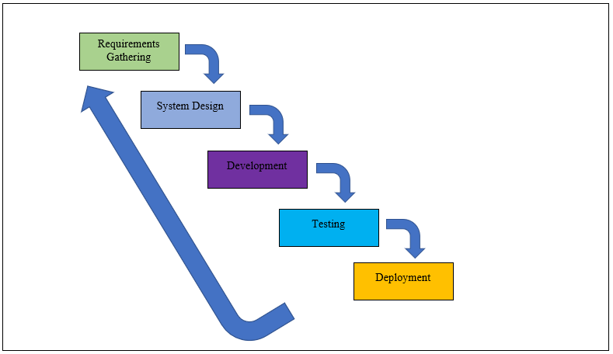

Figure 3.1 Waterfall Model of SDLC

**Requirements Gathering and Analysis Phase**

In this phase, the researchers gathered all the information essential in the newly developed Clinic Information Record System. All the requirements needed for the system are captured in this phase. The researchers prepared a letter of intent addressed to the nurse in charge in the clinic of Eulogio Amang Rodriguez Institute of Science and Technology (See Appendix C). The researchers prepared nine (9) guide questions prior to the interview to the nurse that is in charge (See Appendix D) and eleven (11) guide questions to the staff in the school clinic (See Appendix C). After which the researchers asked for sample of the current student medical form (See Appendix E). The sampling size was tabulated (See table 3.1). The purpose of the interview was to determine the problems they have encountered.

The problems that had been identified in the interview will be addressed by the implementation of the system.

**Research Ethics**

The researchers utilized the six-principle set out in the Economic and Social Research Council (ESRC) Framework for Research. (1) The researchers ensured the quality and integrity of the research. (2) Proper permission and consent of the participants were asked before participating in the research. Questionnaires had a clear statement about what the research involved, and what the participants’ part were in the research. (3) The researchers respected the anonymity and confidentiality of the respondents and future users of the system. All of the data and information during the conducting of the research are gathered and kept confidential and secured. The participants had the option to be anonymous. (4) All of the participants participated willingly and voluntarily and the participants in the research project did not receive any monetary amount of value. (5) The researchers of the research did not seek any harm or damage to any of the participants or to the future users of the system. (6) Lastly, the research was independent and impartial. The research was not being funded by any organization or group.

**Design Phase**

In this phase, the researchers provided a comprehensive design of the system for the user to understand the whole concept of the system. In the design phase, it was sectioned into three parts: conceptual design, database design, and the user interface design.

1. Conceptual Design:

The researchers were able to answer the following questions:

* What are the reports that the system needs to generate?
* What are the needed functions of the system?
* Who will perform such functions?

To further illustrate the requirements of the system, the following system models were used answering all the questions stated above:

The *Context Diagram*, this will help give an overview on how the proposed system works. It identifies the flows of information between the system and external entities. The entire software system is shown as a single process.

*Use-Case Diagram*, to give graphic overview of the users’ involvement in the system, different functions needed by those users’ and how these different functions interact. The Use-Case Diagram would help in tracking the roles that each user used. In this phase, functional requirements were identified based on the information gathered from the requirements gathering phase.

1. Database Design:

*Physical Database Design,* to give a better understanding to the researchers’ system and the concept, it gave the users a hint to the system. Also, the researchers used the Entity Relationship Diagram (ERD); the researchers showed diagrams in a graphical representation of the system that would describe the relation between the people, object, places, concept and events within the proposed system.

*Logical Database Design.* The logical database design was transformed as a conceptual schema of the application domain into a schema for the data model underlying a particular DBMS. It also helped in determining what data and information were needed to be kept tracked of.

1. User Interface Design:

User interface design were used so that the users interact with visual representations on digital control panels, design interface of software or computerized devices focusing on the looks or styles. This includes the basic interface designs, input controls, navigational components, informational components, and containers. There are two categories, the Administrator, and the User. The proposed system has four main forms: medicine inventory form, appointment form, patient information form, and the data grid for the monthly and annual report.

**Development Phase**

The next process is the development phase. The Clinic Information Record System have combined the three-tier architecture design for its development. This was composed of three layers; the presentation layer, the application layer, and the database layer (see Figure 3.2). The first layer is the presentation tier which was implemented using Bootstrap Framework, HTML 5, CSS, JavaScript. The application tier used PHP and jQuery scripting language to implement the functionalities needed in the system. The database layer used MySQL database as the repository for the data. In recognition of the data confidentiality and security of data, role-based authentication was required from each user.

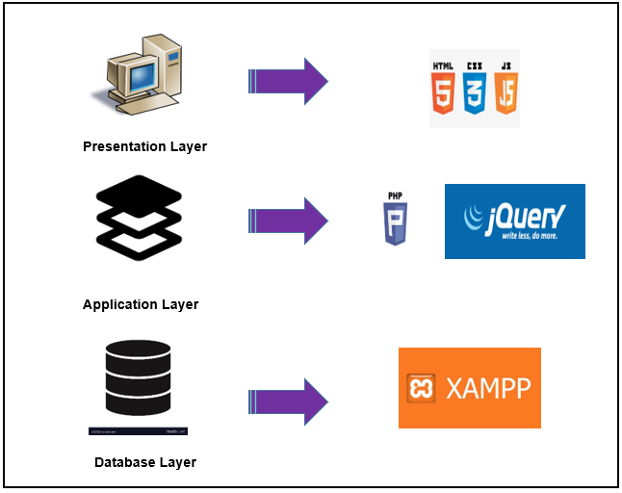Figure 3.2 Architectural Design

**Testing Phase**

In this phase, in order to determine the reliability of the system, it would be tested and evaluated wherein, the researchers would ask permission from (20) twenty random individual who would act as users and (2) two random individuals that would also act as the administrator. Each user would test the functionalities of the system which helps the researchers to determine and verify different bugs and errors. After that, the acting users and administrators would be asked to verify the system’s overall functionalities and if all the functionalities were met. The researchers would guide and instruct the users regarding the proper usage of each functionalities of the system.

The initial testing is very necessary in order to meet the users’ expectation. The system is open for any necessary changes, adjustments and enhancements to be able to address any particular problem. Testing the Functionality, the researchers would perform a specific task that examine if all the outputs were accomplished as what was anticipated. The system would be evaluated if the stated features in the objectives was performed as designed.

**Evaluation Phase**

The researchers conducted a functionality and usability evaluation to find out how functional, time efficient and usable the system would be. The evaluation process is done after testing the functionality of the proposed system. After doing the tasks, each participant is asked to answer the questionnaire that were used to the functionality and usability evaluation. After which, the Usability Test wherein the researchers prepared a questionnaire which is a System Usability Scale that served as a foundation for the system’s evaluation later and would help in determining the satisfaction rating and feedback of the participants to the overall system functionalities and features.

In the assessment phase, after the gathering of data and feedbacks from the Systems Usability Scale questionnaire was answered by the participants, an evaluation would be done to measure the system’s functionality and overall performance, if it is consistent and accurate. The assessment would reflect to the objectives of the system.

**Deployment**

Deployment phase, the final phase of the software development life cycle (SDLC) and puts the proposed system into production. After the researchers’ test and evaluate the functionalities of the proposed system, and if the proposed system passes each testing phase, it would then go live to Eulogio Amang Rodriguez Institute of Science and Technology specifically in the school clinic department. This means that the newly developed system is ready to be used in a real environment by all end users of the product.