AI GOVERNANCE, REMEDIATION & IMPLEMENTATION

From AI Policies to Demonstrable Control

J.S. Held turns the findings into action. Organizations are rapidly adopting artificial intelligence, but many struggle to translate governance frameworks into operational controls. J.S. Held helps clients establish governance structures, remediate identified gaps, and implement sustainable AI oversight programs that align with business objectives, regulatory expectations, and emerging industry standards..

How J.S. Held Helps

Governance & Oversight
Establish the foundation for responsible AI through governance structures, accountability mechanisms, and executive oversight.

- AI governance frameworks and operating models
- Board and executive reporting
- Policies, standards, and procedures
- Roles, responsibilities, and accountability structures
- AI asset inventories and model registries
- Governance committees and escalation protocols

Risk, Compliance & Remediation
Identify and address gaps that may expose the organization to regulatory, operational, legal, or reputational risk.

- AI risk assessments and gap analyses
- Remediation roadmaps and corrective action plans
- Privacy and data governance controls
- Regulatory readiness and compliance support
- Internal audit and control evaluations
- Control design, testing, and documentation

Implementation & Operationalization
Transform governance requirements into practical, sustainable business processes.

- Governance program implementation
- Control deployment and monitoring
- Third-party and vendor oversight
- Evidence and documentation management
- Reporting and dashboard development
- Governance workflow design and execution
Model & Technical Governance
Support the responsible development, deployment, and monitoring of AI-enabled technologies.
- Model risk management
- Validation and testing support
- Bias and fairness assessments
- Explainability and transparency documentation
- Security and resilience controls
- Audit trails, traceability, and monitoring

Aligned to Leading Frameworks and Regulatory Expectations

Our approach can be aligned to recognized standards and guidance, including:

- NIST AI Risk Management Framework (AI RMF)
- ISO/IEC 42001
- EU AI Act
- GDPR
- OECD AI Principles
- Industry-specific regulatory and supervisory requirements

OUR APPROACH

Assess

Evaluate existing governance practices, controls, risks, and operational capabilities.

Prioritize

Focus resources on the most significant risks, gaps, and compliance obligations.

Implement

Deploy governance frameworks, controls, processes, and accountability structures.

Validate

Test effectiveness through evidence, monitoring, independent review, and performance measurement.

Sustain

Maintain ongoing governance through oversight, reporting, continuous improvement, and program maturity enhancement.

Illustrative Deliverables

Governance | Remediation | Implementation
AI Governance Framework | Gap Assessment & Remediation Roadmap | Implemented Control Environment
Governance Charter | Risk Register | Monitoring & Reporting Dashboards
AI Policies & Standards | Corrective Action Plans | Governance Workflows
Executive Reporting Structure | Compliance Documentation | Evidence Management Repository
AI Inventory & Registry | Testing & Validation Results | Ongoing Oversight Program

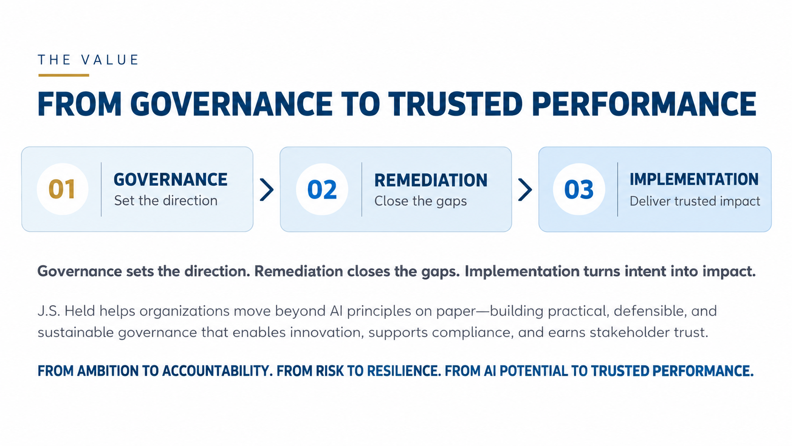

CONTACT
To discuss converting AI governance findings into accountable action and measurable improvement, please contact:

James E. Malackowski, CPA, CLP
Chief Intellectual Property Officer, J.S. Held
Senior Managing Director, Ocean Tomo, a part of J.S. Held James.Malackowski@jsheld.com

JP Brennan
Senior Managing Director, J.S. Held JP.Brennan@jsheld.com

Ken Feinstein
Senior Managing Director, J.S. Held Ken.Feinstein@jsheld.com

Mike Gaudet
Senior Managing Director, J.S. Held Mike.Gaudet@jsheld.com

John A. Hudson
Senior Managing Director, Ocean Tomo, a part of J.S. Held JA.Hudson@jsheld.com




www.jsheld.com J.S. Held LLC J.S. Held LLC

J.S. Held, its affiliates and subsidiaries are not certified public accounting firm(s) and do not provide audit, attest, or any other public accounting services. J.S. Held is not a law firm and does not provide legal advice. Securities offered through PM Securities, LLC, d/b/a Phoenix IB or Ocean Tomo Investments, a part of J.S. Held, member FINRA/SIPC. All rights reserved.

