|  |  |
| --- | --- |
| Cairo University  Faculty of Engineering | Microwave Engineering (ELC3050)  EECE – 3rd Year  project – Winter 2022 |

**Project ELC3050**

|  |  |  |  |  |
| --- | --- | --- | --- | --- |
| NAME | *Omar Amr Mahmoud Hafz* |  |  |  |
| GROUP | ***A*** |  |  |  |
| SEC | ***3*** |  |  |  |
| BENCH NUM. | ***3*** |  |  |  |
| STUDENT ID | ***9202967*** |  |  |  |
| EMAIL | ***eng.omar.amr@gmail.com*** |  |  |  |
| DATE | ***06-01-2022*** |  |  |  |

Supervised by: **Dr. Mohamed A. Nasr**

***ELC3050***

1. 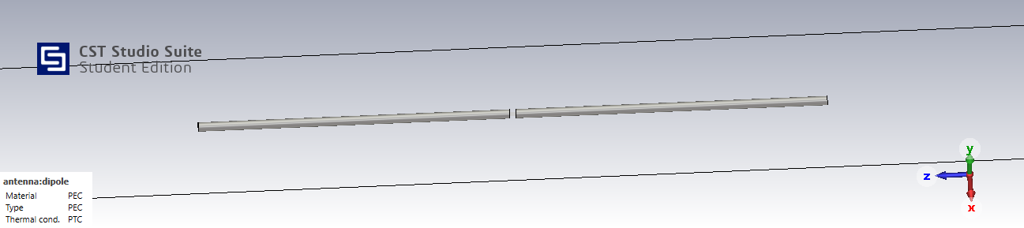The schematic of the dipole antenna:

**The used parameters in design:**

****Radiation pattern (3D-plot):**

1. The reflection coefficient in dB:
2. Before adjustment:

1. Chart, diagram

   Description automatically generatedChart, diagram

   Description automatically generatedAfter adjustment:
$$Fractional Bandwidth = \frac{f_{2}-f_{1}}{f_{c}}=\frac{21.646-18.676}{20}*100\%=14.85\%$$

2. Radiation Pattern Plotting:
3. E-plane:

E-plane

1. Chart, radar chart

   Description automatically generatedH-plane:

H-plane

1. Chart, radar chart

   Description automatically generatedFNBW, HPBW and maximum gain:

From the above radiation patterns, we get the following values:

$FNBW=180°$ ${HPBW}_{(3dB)}=78.5°$ ${Gain}_{(max)}=2.13dBi$

Hand Analysis:

1. Maximum Gain calculation:

Generally, for a for a finite length dipole antenna, the electric field is given by ∶

Solving the above integration numerically, we get: $W_{\text{rad }}=\frac{{\left(ωμI_{o}\right)}^{2}}{2η(2πk)^{2}}*7.6581$

$$∴The directivity is given by:$$

$$D=\frac{4πU}{W_{rad}}=1.64\frac{\cos^{2}⁡\left(\frac{π}{2}cos⁡(θ)\right)}{\sin^{2}⁡(θ)}$$

$∴The maximum directivity is at θ=90° :$ $D_{max}=1.64=2.15 dBi$

$G=η_{eff}*D$ $η_{eff}=\frac{w_{\text{rad }}}{w_{\text{rad }}+w_{\text{Loss }}}$

Since we are using PEC, therefore, there are no losses hence: $η_{eff}=1$

$${∴G}_{max}=D_{max}=2.15 dBi$$

1. **FNBW calculaiton:**

The angle $(θ$) ajdacent to the main lobe at which the gain (or directivity or intensity) is equal to zero. Put $D=0$:

$∴\cos^{2}⁡\left(\frac{π}{2}cos⁡(θ)\right)=0$ $∴cos⁡\left(\frac{π}{2}cos⁡(θ)\right)=0$ $∴\frac{π}{2}cos⁡(θ)=(2n+1)\frac{π}{2}$

$∴θ=\cos^{-1}⁡(2n+1)$ $(at n = 0):$ $θ=0^{∘}$

$(at n = -1):$ $θ={180}^{∘}$

*Notice that $n∈\{ 0,1\}$ $$∴FNBW=180°$$*

1. **HPBW calculation:**

The angle $(θ$) at which the gain (or directivity or intensity) is equal to half it’s maximum value. Put $D=1/2$:

$\frac{\cos^{2}⁡\left(\frac{π}{2}cos⁡(θ)\right)}{\sin^{2}⁡(θ)}=1/2$ $∴cos⁡\left(\frac{π}{2}cos⁡(θ)\right)=\frac{1}{\sqrt{2}}sin⁡(θ)$

solving the equation numerically, we get: or

|  |  |  |
| --- | --- | --- |
|  | **Simulated values** | **Analytically calculated values** |
| $$FNBW$$ | $$180°$$ | $$180°$$ |
| $${HPBW}_{(3dB)}$$ | $$78.5°$$ | $$78.078°$$ |
| $${Gain}_{(max)}$$ | $$2.13dBi$$ | $$2.15 dBi$$ |

We notice that there is a small difference between the calculated and the simulated values, due to adjusting (slightly) the antenna length for resonance (the new length is 0.4578ʎ). Also, the assumptions that were made to ease the analytical solution, such as uniform volumetric current distribution and the neglection of the antenna thickness.

1. Copper dipole antenna:

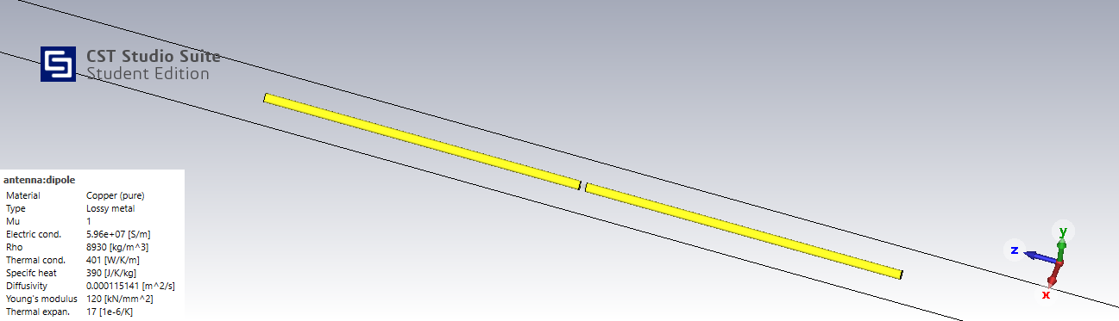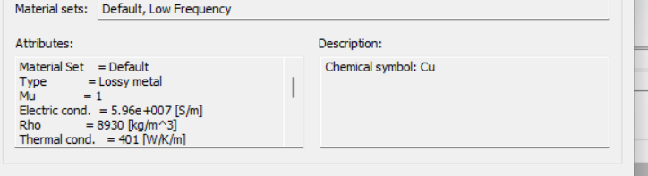

Electric conductivity of copper (pure) is $σ=5.96×10^{7} S/m$, $f=20GHz$

$R_{loss}= \frac{1}{2}R_{hf} = \frac{l}{2p}R_{s}$ (eqn 2-90b) (p is the perimeter of wire cross-section)

$R_{s}=\sqrt{\frac{πfμ}{σ}}=0.0364 Ω$ $l=6.86625 mm$ $p=2π*0.050535 mm$

$R_{loss}= \frac{1}{2}R_{hf} = \frac{l}{2p}R_{s}=0.3936Ω$ ${∵W}_{\text{rad }}=\frac{{\left(ωμI_{o}\right)}^{2}}{2η(2πk)^{2}}*7.6581={\frac{1}{2}\left(I_{o}\right)}^{2}*R_{rad}$

$$∴R_{rad}=7.6581*\frac{{\left(ωμ\right)}^{2}}{η(2πk)^{2}}=73.14 Ω$$

$${∴η}_{\text{rad }}=\frac{R_{\text{rad }}}{R_{\text{rad }}+R_{L}}=99.46\%$$

**Simulation:**

when the material is PEC, , hence, :

when the material is copper, $R_{loss}≠0$, hence, $R_{total}=R_{rad}+R_{loss}$:

$$∴R_{loss}=R_{total}-R_{rad}=73.51155-72.93056=0.58099Ω$$

$${∴η}_{\text{rad }}=\frac{R_{\text{rad }}}{R_{total}}=99.3\%$$

Or directly calculating the efficiency:

From the graph: $η_{\text{rad }}=99.355\%$

The radiation efficiency calculated by the simulator is slightly different from the calculated value, this is due to the simplifications in the analytical calculations like neglecting the effects of feeding gap dimensions. Also, due to neglecting the effect of nearfield impedance ( $Z_{total}=R_{rad}+R_{loss}+{jX}_{a})$, hence, the value of the analytically calculated efficiency is smaller than the simulated value.