**Folder Organisation:**

Assets: contains all uploaded files, including documents and pictures, it has these folders:

* “templates” folder is meant for the web page design, like Icons and background pictures, and pictures, and etc.
* “data” contains additional info for the elements of the application, more likely it has complex data that can’t be stored easily in regular database, it completes it

Frags: contains reusable pieces of codes as functions, it has:

* “Classes” folder is for the classes definition.

CSS, : has customized CSS code

Node_modules : is the library root folder

**Conception**

Use case diagram: first impression:

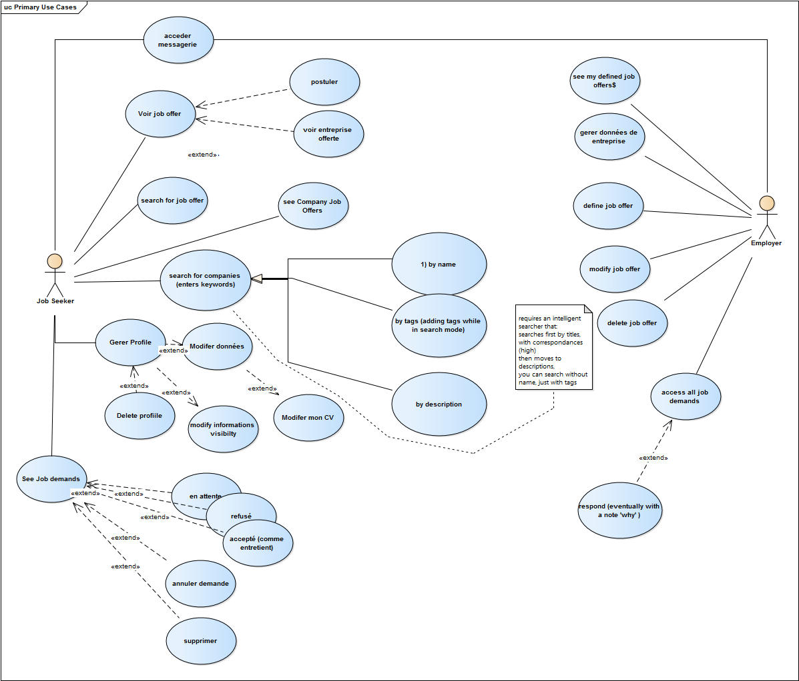

class diagram: first impression:

