***Problem description***

Humans have a social nature. Social nature means that we interact with each other in positive, friendly ways, and it also means that we know how to manipulate others in a very negative way. **Sarcasm**, which is both positively funny and negatively nasty, plays an important part in human social interaction.

But sometimes it is difficult to detect whether someone is making fun of us with some irony. So to make it easy we built something which helps you in detecting sarcastic text, but before getting into much more detail,

Let’s define sarcasm:-

**Sarcasm** is “a sharp, bitter, or cutting expression or remark”. The use of irony to mock or convey contempt. So now it’s time to charge up and start the journey of sarcasm detection.

Let’s start by defining the problem:-

***1-Problem description:-***

We have given the **Dataset** and our goal is to predict whether a given text is sarcastic or not. This **News Headlines Dataset** for Sarcasm Detection.

***2-Model design :-***

Using keras, we use embedding which is a vector (arrow) points to direction,

Embedding should define vector “arrow" for each word,

Embedding dimension is dim of arrows (vector) to use,

We use two hidden layer first one has 24 neurons using activation function relu and the second one has a neuron using activation function sigmoid, and we use optimizer adam then fit model using 30 epochs

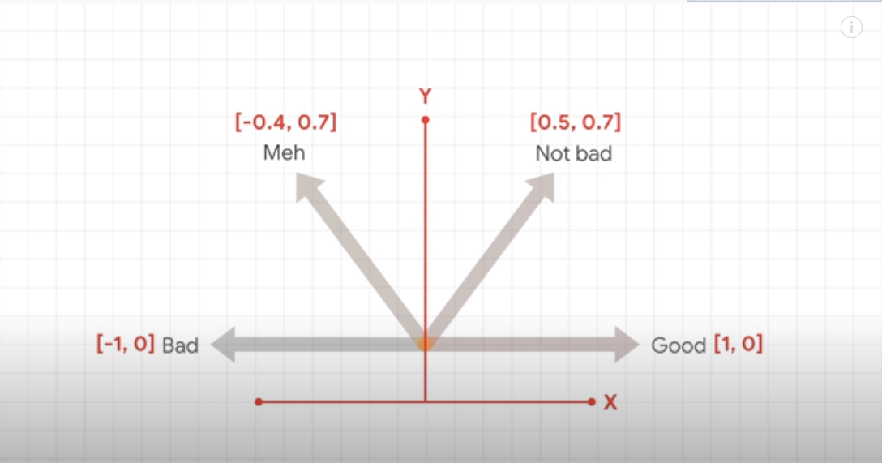

***3-Experimental results:-***

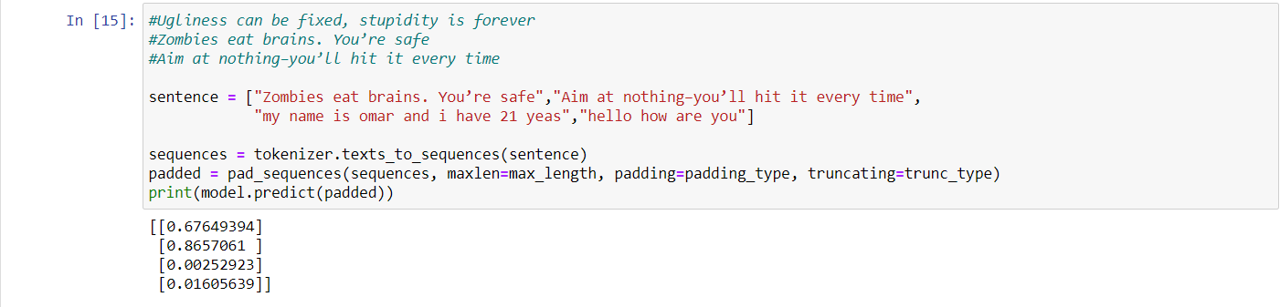

***4-Model performance:-***

We fit our model on training data and we get:

Loss: 0.2127

Accuracy: 0.9129

Validation loss: 0.4460

Validation accuracy: 0.8293