Assignment 4 — MySQL
Mohamed Emad Eldin Asaad | 01097191995

Part 1 — ERD Diagram (Musicana Records)
Requirements summary:
- Each MUSICIAN has an ID (PK), Name, Address (Street, City) and Phone.
- Each INSTRUMENT has a unique Name (PK) and a Musical Key.
- Each ALBUM has a unique Title, a Copyright Date, and an AlbumID (PK).
- Each SONG has a unique Title (PK) and an Author.
- Musicians and Instruments: many-to-many (PLAYS).
- Albums and Songs: one-to-many — a song belongs to exactly one album (CONTAINS).
- Musicians and Songs: many-to-many (PERFORMS).
- Albums and Producers: one-to-many — one musician produces many albums, each album has exactly one producer (PRODUCES).
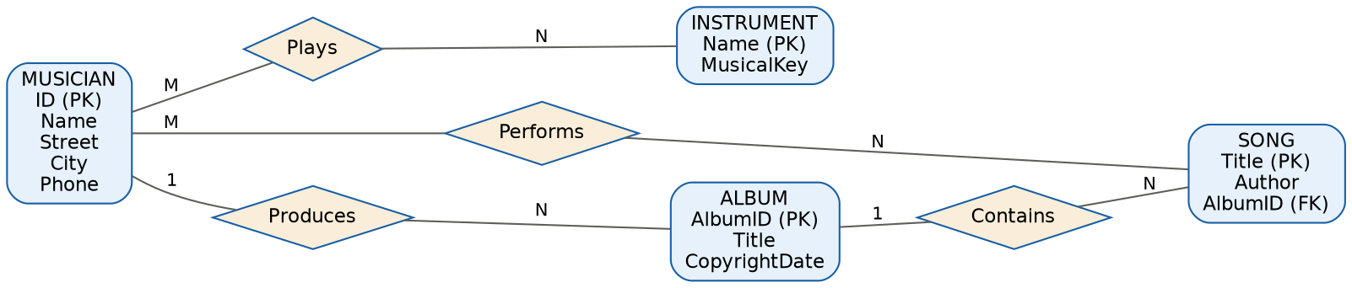

Entities and Attributes
Entity | Attributes | Key
Musician | ID, Name, Street, City, Phone | ID (PK)
Instrument | Name, MusicalKey | Name (PK)
Album | AlbumID, Title, CopyrightDate | AlbumID (PK)
Song | Title, Author, AlbumID (FK) | Title (PK)

Relationships
Relationship | Participants | Cardinality
Plays | Musician ↔ Instrument | M : N
Performs | Musician ↔ Song | M : N
Contains | Album → Song | 1 : N
Produces | Musician (Producer) → Album | 1 : N

Part 2 — Schema Mapping (User–Own–Product ERD)
The ERD shows a User entity related to a Product entity through a 1:N relationship named "Own" (one user owns many products).
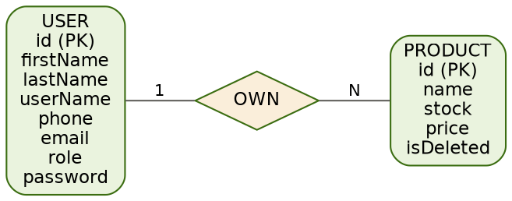

Mapping Rule Applied
Because the relationship "Own" is 1:N (one User owns many Products), no separate relationship table is needed. Instead, the foreign key is placed on the "many" side (Product), referencing the primary key of the "one" side (User).

Resulting Relational Schema
Table | Columns
User | id (PK), firstName, lastName, userName, phone (UNIQUE), email (UNIQUE), role, password
Product | id (PK), name, stock, price, isDeleted, userId (FK → User.id)

SQL DDL equivalent:
CREATE TABLE User (
id INT AUTO_INCREMENT PRIMARY KEY,
firstName VARCHAR(50) NOT NULL,
lastName VARCHAR(50) NOT NULL,
userName VARCHAR(50) NOT NULL,
phone VARCHAR(20) UNIQUE,
email VARCHAR(100) UNIQUE NOT NULL,
role VARCHAR(30) NOT NULL,
password VARCHAR(255) NOT NULL
);

CREATE TABLE Product (
id INT AUTO_INCREMENT PRIMARY KEY,
name VARCHAR(100) NOT NULL,
stock INT DEFAULT 0,
price DECIMAL(10,2) NOT NULL,
isDeleted BOOLEAN DEFAULT FALSE,
userId INT NOT NULL,
FOREIGN KEY (userId) REFERENCES User(id)
);

Part 3 & Bonus
The full RESTful API (Node.js + Express.js + MySQL) implementing all 16 required endpoints, the database initialization script, and the LeetCode bonus solution are delivered as separate files alongside this document:
- retail-api/ — complete Express + mysql2/promise project (see README.md inside for setup & endpoint list)
- bonus.txt — SQL solution for "Customers Who Visited but Did Not Make Any Transactions"

