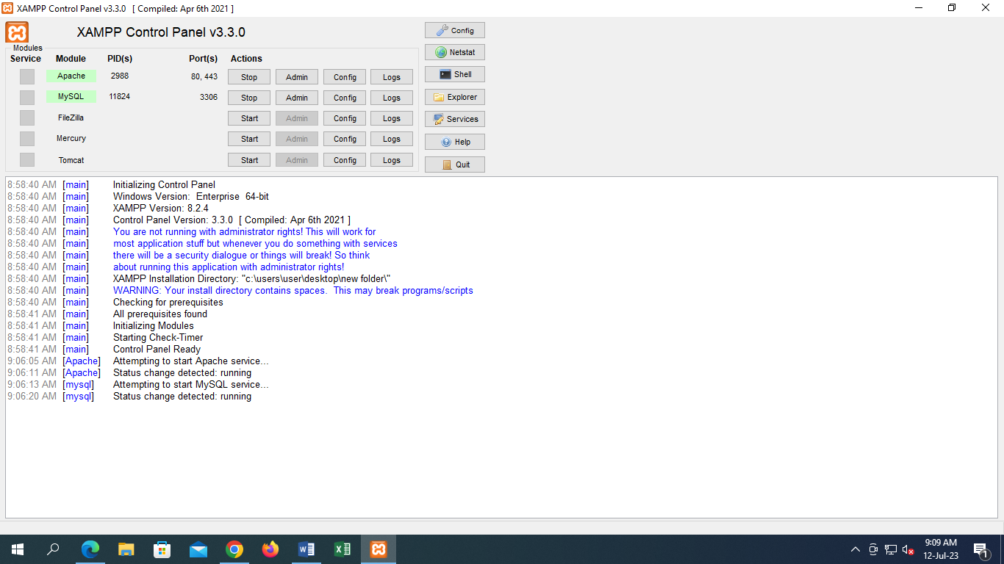

1. Start Apache and click admin
2. Start MySQL and click admin
3. Database creation- go to SQL

syntax- create database mehedi_334 then click go

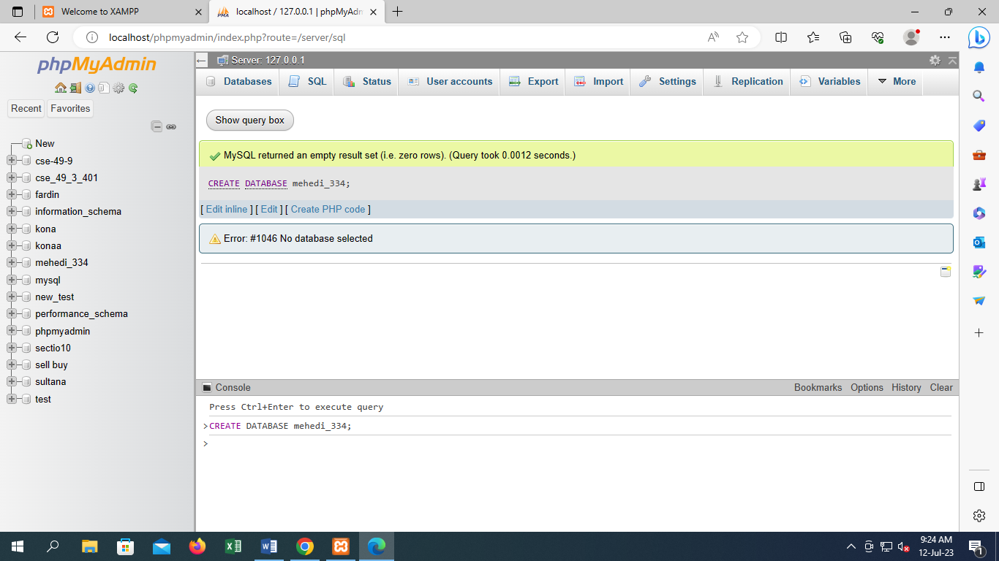

Data Type:

1. Int ( upto 6 to 10 digit)
2. Float ( suppose input 3.50 than it will be cgpa floa(3.2) 3means 3 digit and .2 means float value if 3.500 than float(4.3 )
3. Char (upto 255)
4. Variable character( varchar( upto 1 to 255))

Table creation:

Create table table _name(col_1 datatype(size),……….,col_n datatype(size));

Example:

Create table student(Name varchar(30),ST-ID int(2),NID int(3),Intake int(2),Section int(2),CGPA float(3.2));

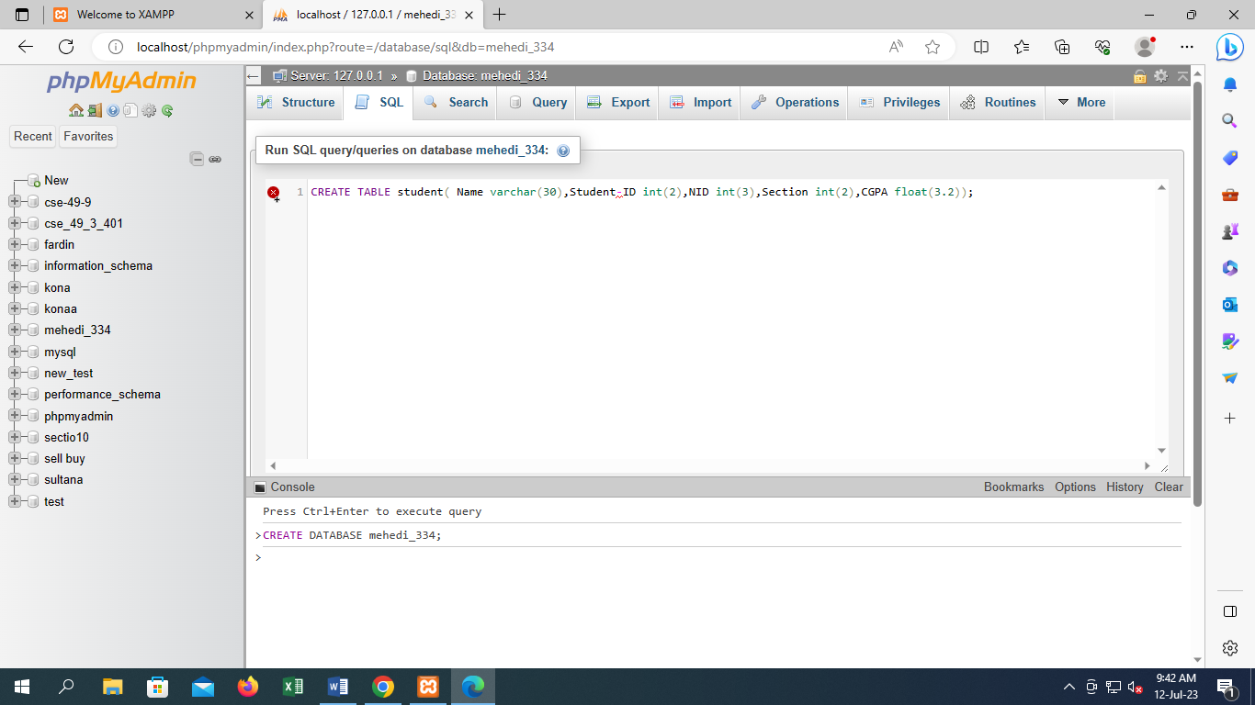

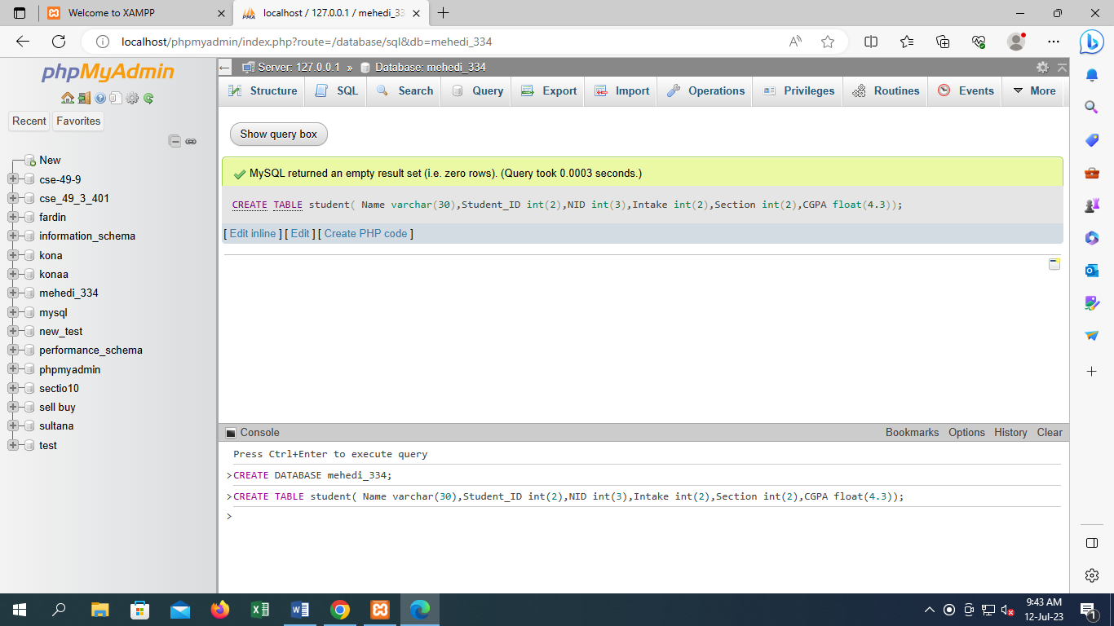

Than click structure then browse

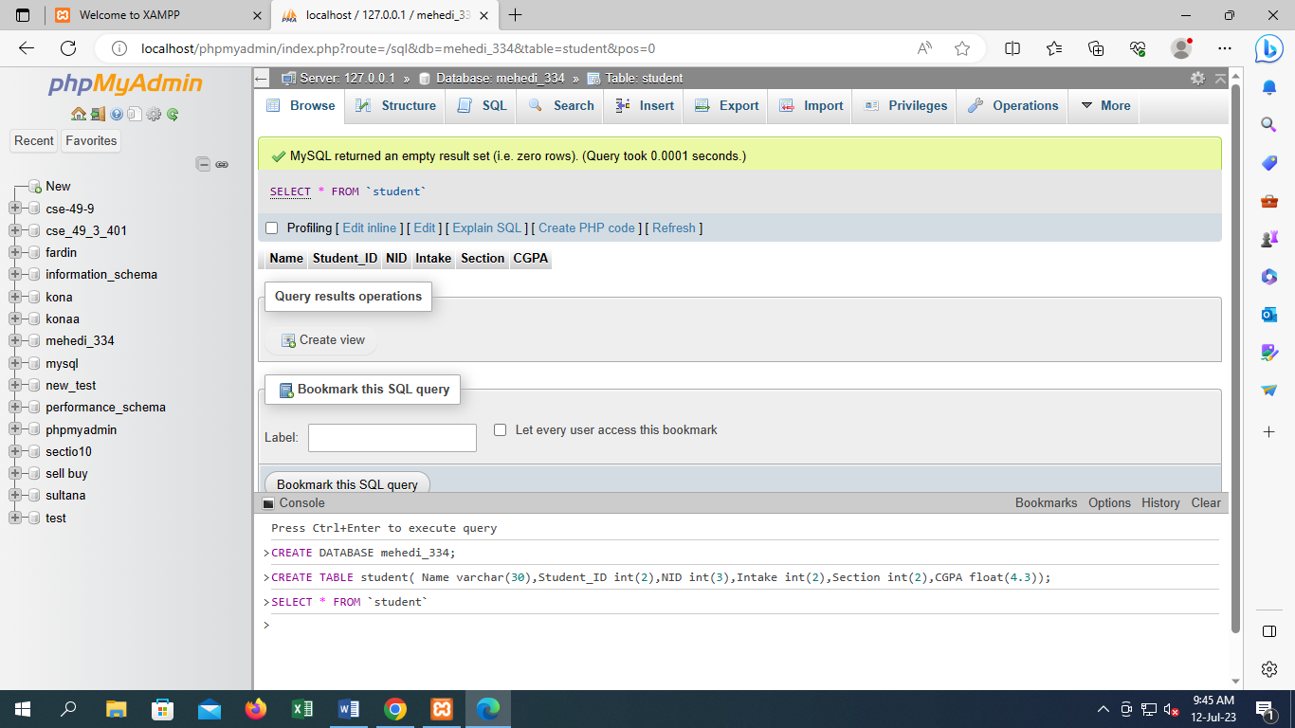

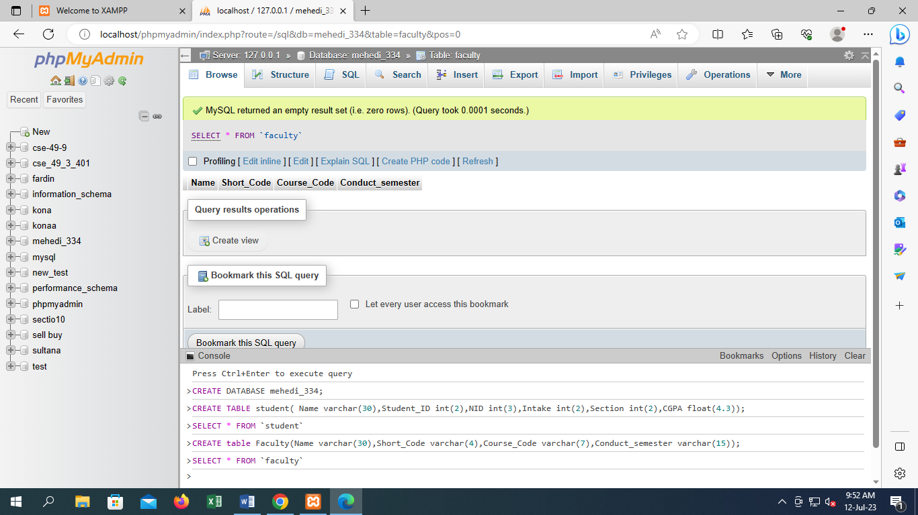

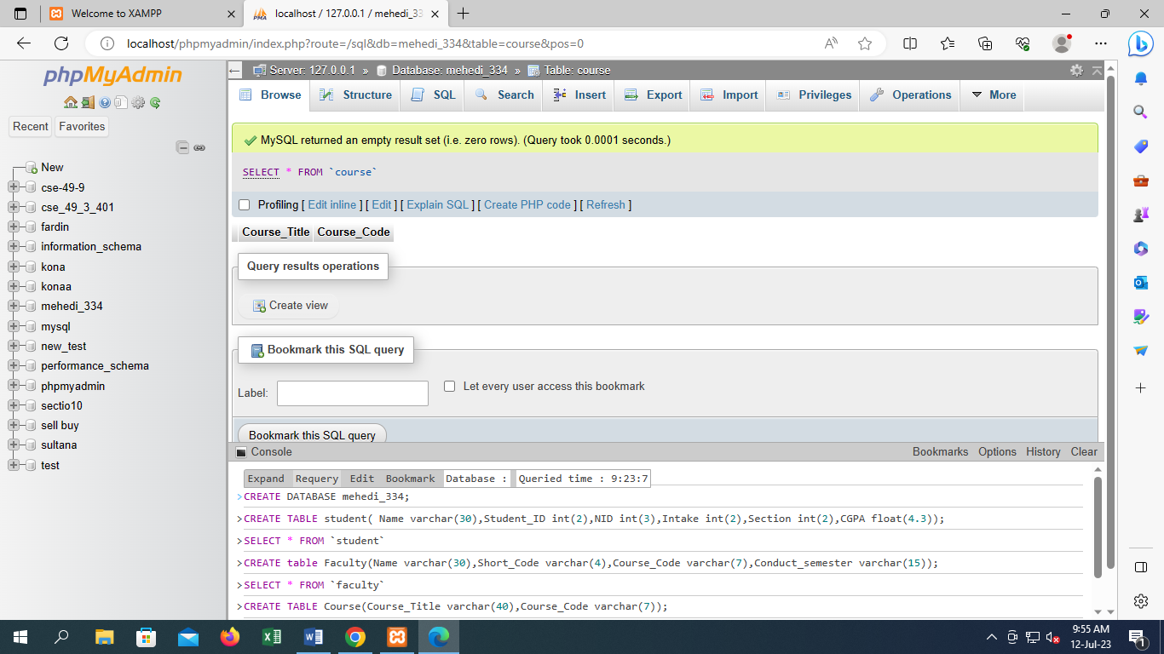

Value Insertion on Table:

insert into table_name(value1,………….valueN);

for char “value”

Update:

UPDATE Customers  
SET ContactName = 'Alfred Schmidt', City= 'Frankfurt'  
WHERE CustomerID = 1;

UPDATE student SET Name=”Tonny” ST_ID=”2” NID=”101” CGPA=”3.5” where code=”25”;

Add column :

ALTER TABLE student ADD COLUMN Age int(3);