Lab-04

**Instructor:**

**Table Create:**

CREATE TABLE `instructor` ( `Id` varchar(30), `Name` varchar(30),`Dept_Name` varchar(30),`Salary` int(30) );

**Table data input:**

INSERT INTO `instructor` (`Id`, `Name`, `Dept_Name`, `Salary`) VALUES

('10101', 'Srinivasan', 'CSE', 65000),

('12121', 'Wu', 'FIN', 90000),

('15151', 'Mozart', 'Music', 40000),

('22222', 'Einstein', 'Physics', 50000),

('32343', 'Said', 'History', 60000),

('33456', 'Gold', 'Physics', 87000),

('45555', 'Katz', 'CSE', 75000),

('58583', 'Cali', 'History', 62000),

('76543', 'Singh', 'FIN', 80000),

('76766', 'Crick', 'Bio', 72000),

('83821', 'Brandt', 'CSE', 92000),

('98345', 'Kin', 'EEE', 80000);

**Teaches:**

**Table create:**

CREATE TABLE `teaches` (`Id` varchar(30),`C_Id` varchar(30,`Section_Id` int(10));

**Table data input:** INSERT INTO `teaches` (`Id`, `C_Id`, `Section_Id`) VALUES ('10101', 'CSE_101', 1), ('12121', 'CSE_111', 2),('13131', 'CSE_311', 3);

Q1.Perform Cartesian Product Operation between these two relation.

[SELECT](http://localhost/phpmyadmin/url.php?url=https://dev.mysql.com/doc/refman/8.0/en/select.html) * FROM instructor,teaches;

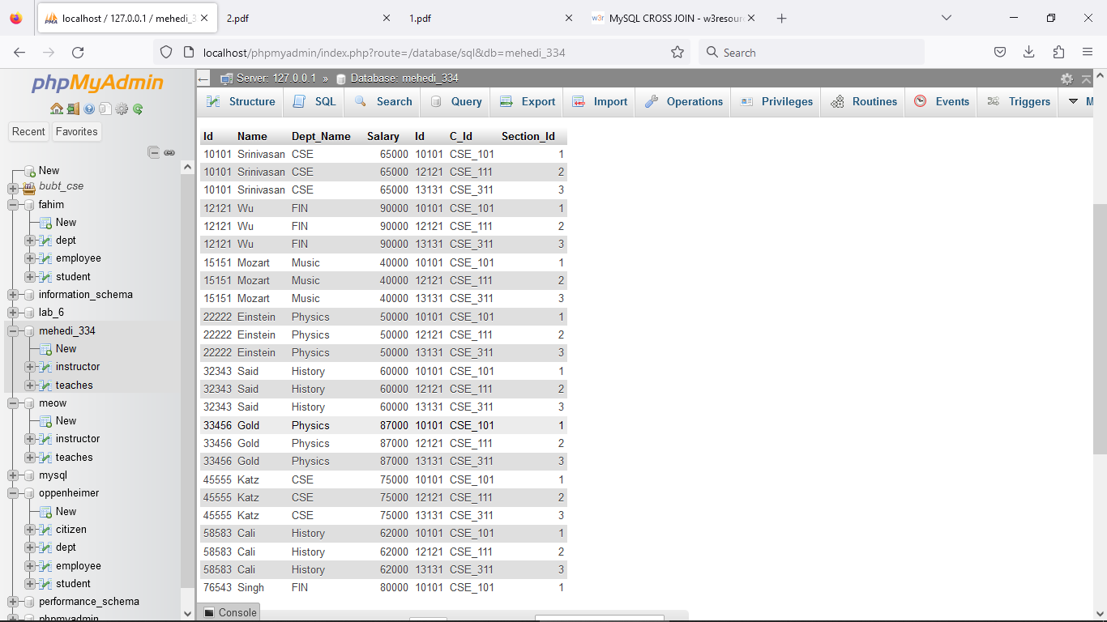

Q2. Find those instructors who teaches any of the courses.

[SELECT](http://localhost/phpmyadmin/url.php?url=https://dev.mysql.com/doc/refman/8.0/en/select.html) Name FROM instructor,teaches WHERE instructor.Id=teaches.Id;

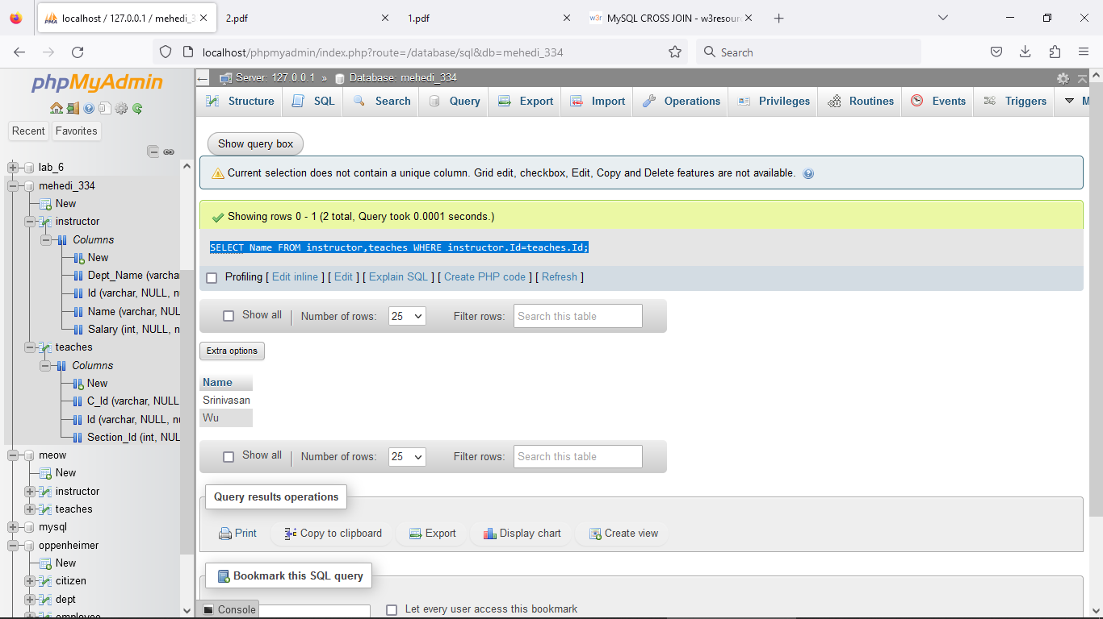

Q3. Find only instructor names and course id for instructors in the Computer Science

department.

[Select](http://localhost/phpmyadmin/url.php?url=https://dev.mysql.com/doc/refman/8.0/en/select.html) Name,instructor.Id from instructor INNER JOIN teaches where instructor.Id=teaches.Id [AND](http://localhost/phpmyadmin/url.php?url=https://dev.mysql.com/doc/refman/8.0/en/logical-operators.html%23operator_and) Dept_Name= 'CSE';

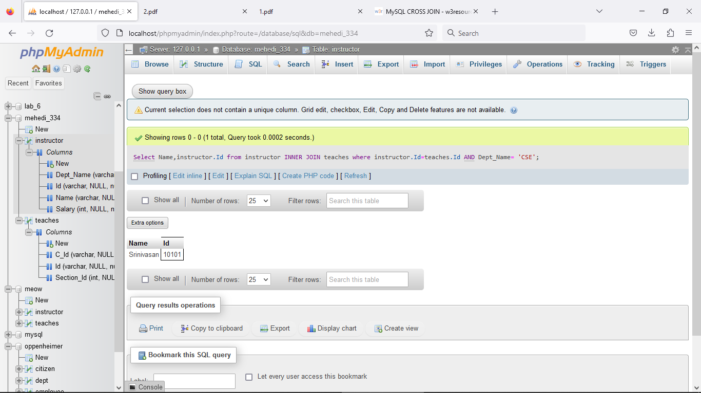

Q4. Find the total no. of tuples in “Instructor” relation.

[SELECT](http://localhost/phpmyadmin/url.php?url=https://dev.mysql.com/doc/refman/8.0/en/select.html) [COUNT](http://localhost/phpmyadmin/url.php?url=https://dev.mysql.com/doc/refman/8.0/en/aggregate-functions.html%23function_count)(*) FROM instructor;

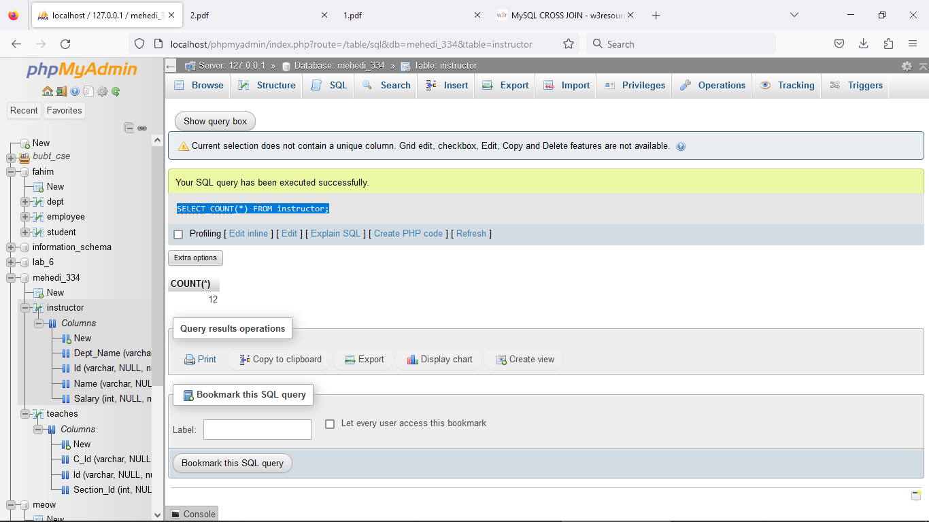

Q5. Answer Q2 using Natural Join.

[SELECT](http://localhost/phpmyadmin/url.php?url=https://dev.mysql.com/doc/refman/8.0/en/select.html) * FROM instructor NATURAL JOIN teaches;

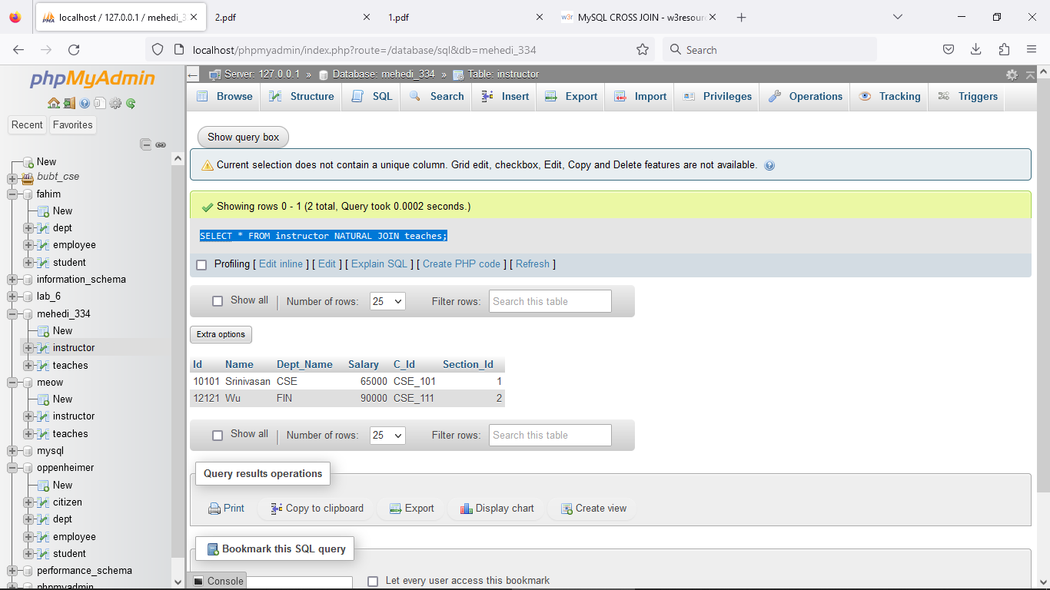

Q6. Perform Left Outer Join.

[SELECT](http://localhost/phpmyadmin/url.php?url=https://dev.mysql.com/doc/refman/8.0/en/select.html) * FROM instructor NATURAL [LEFT](http://localhost/phpmyadmin/url.php?url=https://dev.mysql.com/doc/refman/8.0/en/string-functions.html%23function_left) OUTER JOIN teaches;

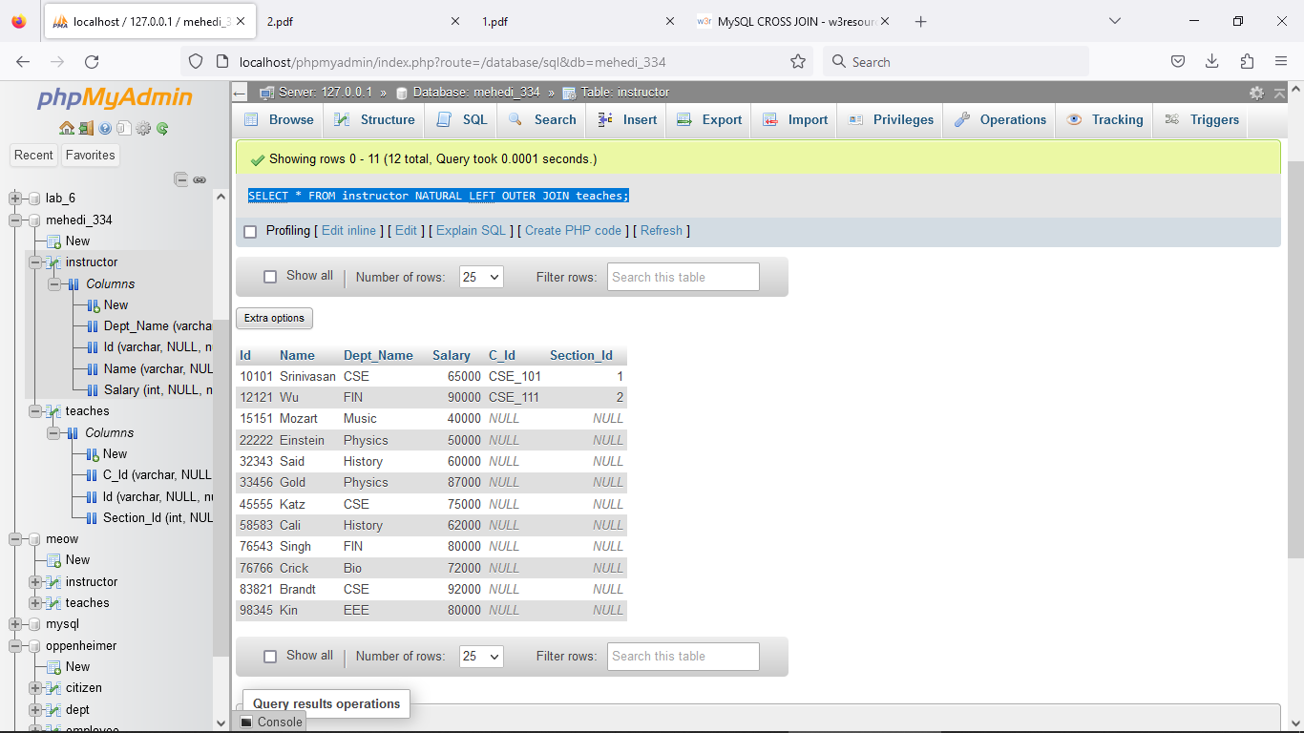

Q7. Perform Right Outer Join.

[SELECT](http://localhost/phpmyadmin/url.php?url=https://dev.mysql.com/doc/refman/8.0/en/select.html) * FROM instructor NATURAL [RIGHT](http://localhost/phpmyadmin/url.php?url=https://dev.mysql.com/doc/refman/8.0/en/string-functions.html%23function_right) OUTER JOIN teaches;

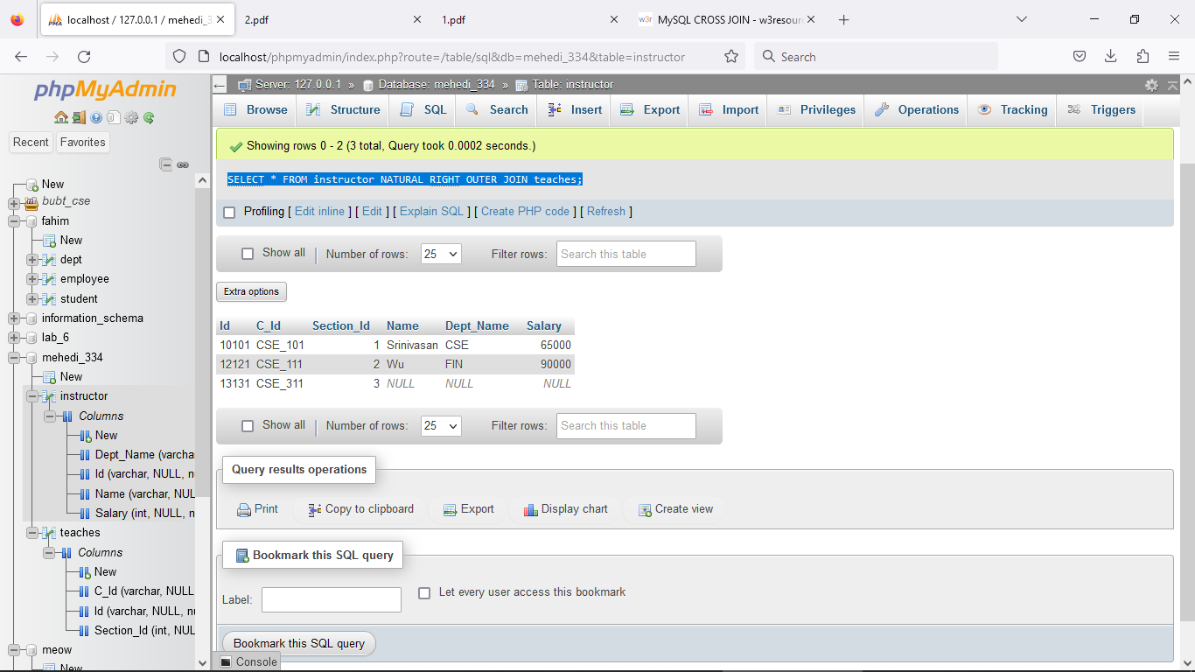

Lab-05

CREATE TABLE `customer` (

`Customer_Name` varchar(30),

`Customer_street` varchar(30),

`Customer_city` varchar(30));

INSERT INTO `customer` (`Customer_Name`, `Customer_street`, `Customer_city`) VALUES

('Adams', 'Spring', 'pittsfield'),

('Brooks', 'senter', 'Brooklyn'),

('Curry', 'North', 'Rye'),

('Glenn', 'Sand Hill', 'Woodside '),

('Green', 'Walnut', 'Stamford'),

('Hayes', 'Main', 'Harrison'),

('johnson', 'Alma', 'Palo Alto'),

('Jones', 'Main', 'Harrison'),

('Lindasy', 'Park', 'Pittsfield'),

('Smith', 'North', 'Rye'),

('Turner', 'Putnam', 'Stamford'),

('Williams', 'Nassau', 'Princeton');

**Q1. Fetch all the customer’s name in alphabetic order who lives in Harrison.**

[SELECT](http://localhost/phpmyadmin/url.php?url=https://dev.mysql.com/doc/refman/8.0/en/select.html) Customer_Name FROM customer ORDER BY Customer_Name;

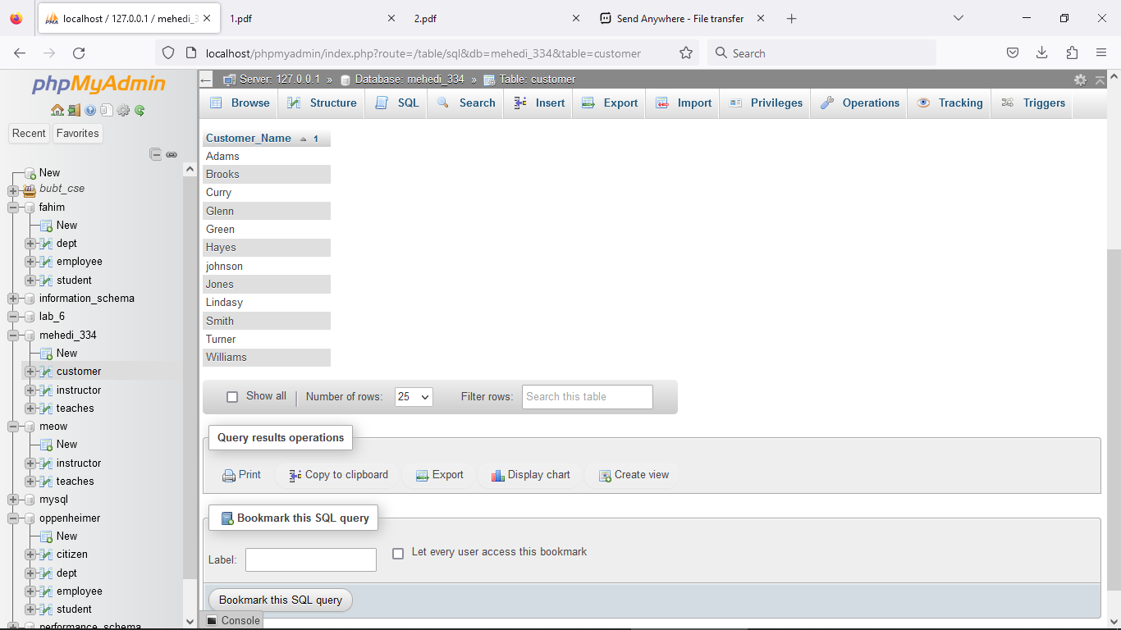

[SELECT](http://localhost/phpmyadmin/url.php?url=https://dev.mysql.com/doc/refman/8.0/en/select.html) Customer_Name FROM customer WHERE Customer_city='Harrison' ORDER BY Customer_Name;

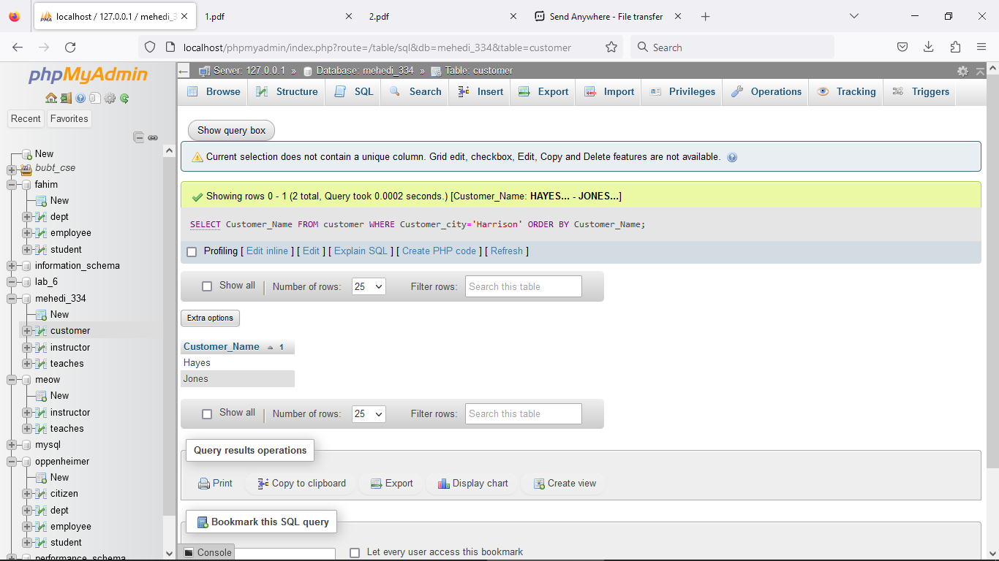

Q2. Find the list of all customers in alphabetic order who have a loan at the Perryridge branch.

[SELECT](http://localhost/phpmyadmin/url.php?url=https://dev.mysql.com/doc/refman/8.0/en/select.html) Customer_Name FROM borrower,loan where borrower.loan_number= loan.Loan_number [and](http://localhost/phpmyadmin/url.php?url=https://dev.mysql.com/doc/refman/8.0/en/logical-operators.html%23operator_and) branch_name='Perryridge' order by Customer_Name;

Q5. Find the name of all branches from “loan” table.

[SELECT](http://localhost/phpmyadmin/url.php?url=https://dev.mysql.com/doc/refman/8.0/en/select.html) DISTINCT branch_name FROM loan;

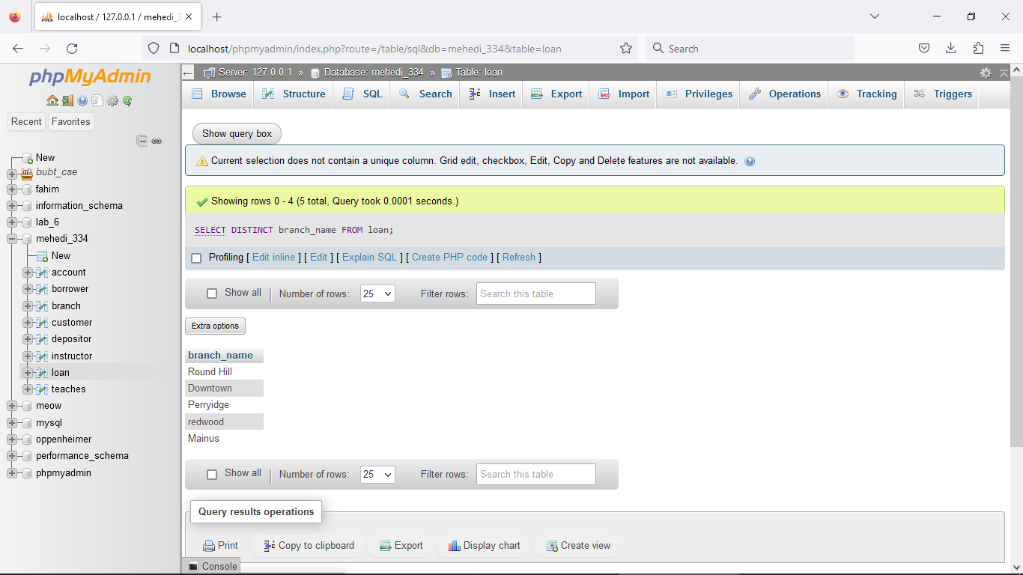

Q6. Find loan no and 5 times amount from loan relation and replace the column name with” total

balance”.

[Select](http://localhost/phpmyadmin/url.php?url=https://dev.mysql.com/doc/refman/8.0/en/select.html) Loan_number, 5*amount ”total_balance” from loan;

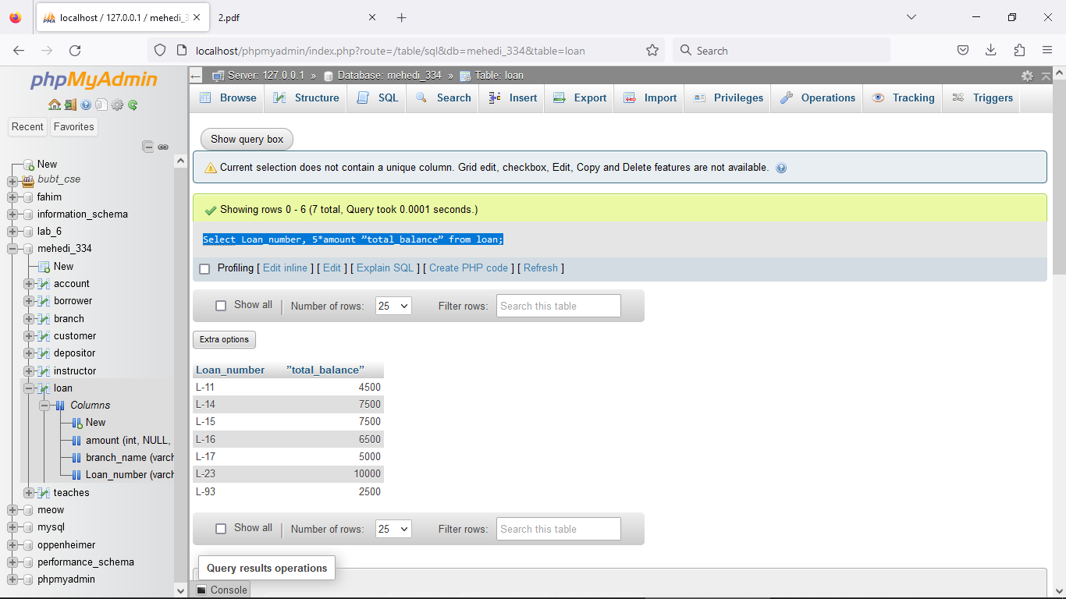

[Select](http://localhost/phpmyadmin/url.php?url=https://dev.mysql.com/doc/refman/8.0/en/select.html) Loan_number, 5*amount as total_balance from loan;

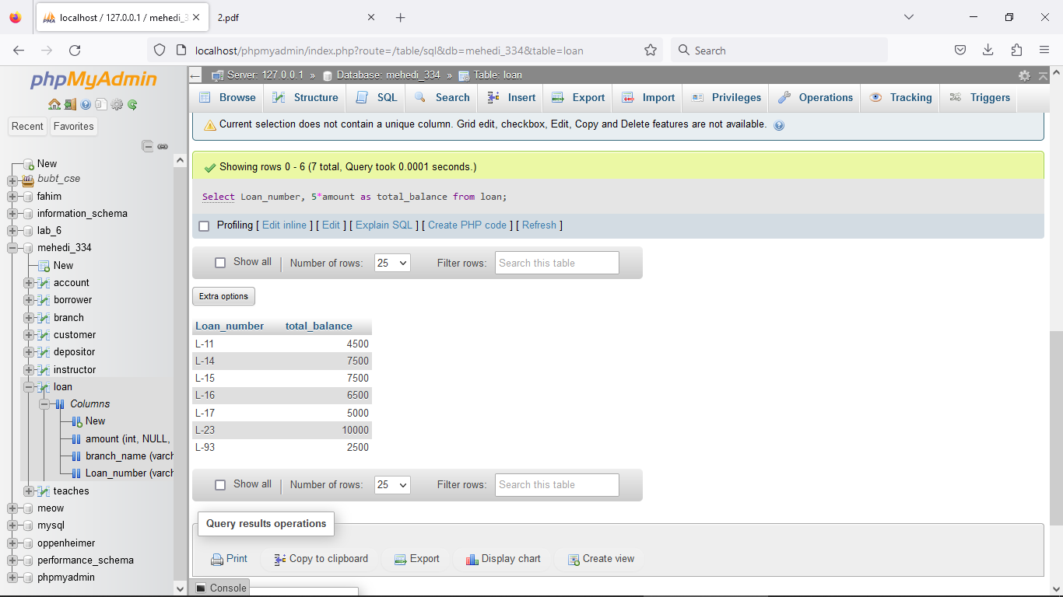

Q7. Increase all loan amount by 5 percent from loan relation.

[select](http://localhost/phpmyadmin/url.php?url=https://dev.mysql.com/doc/refman/8.0/en/select.html) Loan_number, amount*1.05 from loan;

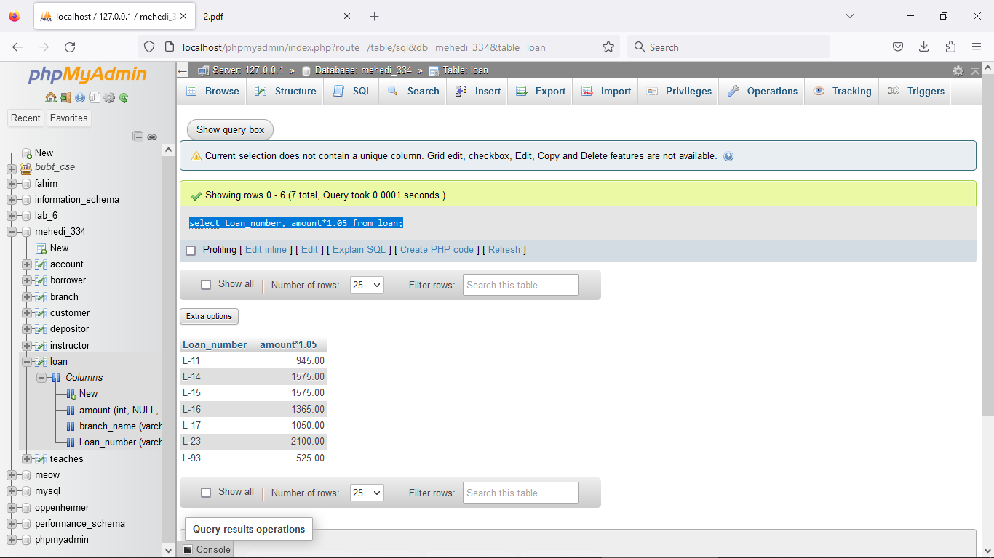

Q8. Give 6 percent interest for all loans with amount over 1000

[select](http://localhost/phpmyadmin/url.php?url=https://dev.mysql.com/doc/refman/8.0/en/select.html) Loan_number, amount*1.06 from loan WHERE amount>1000;

