iKare SS _Support Plan
Participant Details
Privacy Policy Explained - Consent gained | ☐ Verbal Consent
 | ☐ Consent (documented)
Participant Name: | {{participant_details.name}}Click or tap here to enter text.
NDIA Number: | {{ndis_number }}
Plan Start Date: | {{plan_start_date}}
Plan End Date: | {{plan_end_date}}
Date of Birth: | {{participant_details.date_of_birth}}
Gender: | {{participant_details.gender}}
Address: | {{participant_details.address}}
State: | {{participant_details.state}}
Phone Number: | {{phone}}
Email Address: | {{email}}
Preferred Contact Person: | {{participant_details.preferred_contact_person}}
Referral Details
Date of referral: {{referral_details.referral_date}}
☐New Participant {{referral_details.participant_type}} | Referred by:  {{referral_details.referred_by}}
☐ Returning participant | Contact No:  {{referral_details.referrer_contact}}
☐ Non-urgent {{referral_details.urgency}} | Email:  {{referral_details.referrer_email}}
☐ Urgent
Reason: {{referral_details.urgent_reason}}

Contact Details for Advocate

Name: | {{advocate_details.name}}
Relationship to participant: | {{advocate_details.relationship}}
Address: | {{advocate_details.address}}
Contact phone number: | {{advocate_details.phone}}
Email Address: | {{advocate_details.email}}
Special Considerations
☐ Alternate Communication Requirements  {{special_considerations.alternate_communication}} | Comments:  {{special_considerations.comments}}
☐ Auslan
{{special_considerations.auslan}}

☐ ATSI

{{special_considerations.atsi}}
☐ CALD -(Interpreter)
{{special_considerations.cald_interpreter}}

Supports or services requested
Services requested | {{services_requested.services}}
Specific requirements/ preferences (i.e., accessibility, daily living supports, health) | {{services_requested.specific_requirements}}
Interests, physical/cultural/belief-based requirements | {{services_requested.interests_requirements}}
Intake completed in collaboration with
Staff Name: |  | Date:
Participant/ Nominated Representative Name: |  | Date:

CONNECTIONS TO FORMAL & INFORMAL SUPPORTS
Service Provider/Organisation | Contact Person | Telephone Number | Do we have consent to share personal information? | Comments | Actions
{{formal_informal_supports[0].organisation}} | {{formal_informal_supports[0].contact_person}} | {{formal_informal_supports[0].telephone}} | Yes ☐ No ☐ {{formal_informal_supports[0].consent_to_share}} | {{formal_informal_supports[0].consent_to_share}} | {{formal_informal_supports[0].actions}}
 |  |  | Yes ☐ No ☐
 |  |  | Yes ☐ No ☐
 |  |  | Yes ☐ No ☐
 |  |  | Yes ☐ No ☐

Consent to contact the above and obtain information needed to establish support has been provided
Participant/ Nominated Representative Name: |  | Date:

GOALS RELATING TO THE DELIVERY OF OUR SERVICE
Goal | What I want to achieve or work towards | Achieved/Progressing | What supports do I need to help me achieve this? | Evidence and Outcomes to achieving Goal | Barriers/impacts to achieving or progressing towards your goal (if not achieved)
 |  | Yes/No |  | (For example: capacity building therapy; transport; equipment)
1 | {{goals[0].goal_number}} | {{goals[0].what_to_achieve}} | {{goals[0].achieved_progressing}} | 1 {{goals[0].supports_needed}} | 1
 |  |  |  | 2 {{goals[0].evidence_outcomes[0]}} | 2
 |  |  |  | 3{{goals[0].barriers[0]}} | 3

Goal | What I want to achieve or work towards | Achieved/Progressing | What supports do I need to help me achieve this? | Evidence and Outcomes to achieving Goal | Barriers/impacts to achieving or progressing towards your goal (if not achieved)
 |  | Yes/No |  | (For example: capacity building therapy; transport; equipment)
2 |  |  |  | 1 | 1
 |  |  |  | 2 | 2
 |  |  |  | 3 | 3

Goal | What I want to achieve or work towards | Achieved/Progressing | What supports do I need to help me achieve this? | Evidence and Outcomes to achieving Goal | Barriers/impacts to achieving or progressing towards your goal (if not achieved)
 |  | Yes/No |  | (For example: capacity building therapy; transport; equipment)
3 |  |  |  | 1 | 1
 |  |  |  | 2 | 2
 |  |  |  | 3 | 3

STRENGTHS & NEEDS ASSESSMENT

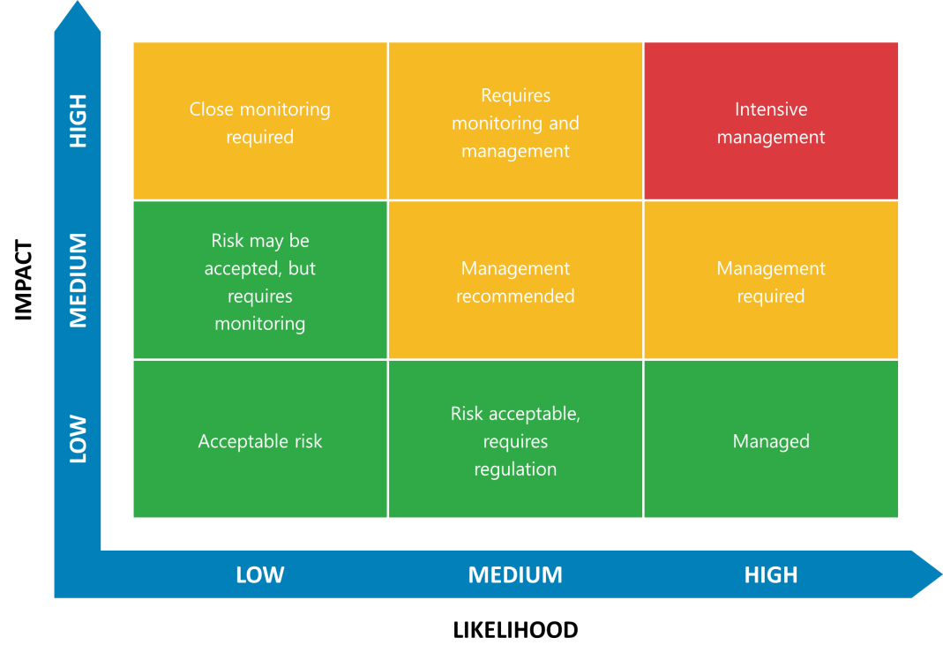 | INSTRUCTIONS:  Please use the risk assessment matrix to support the identification, assessment, and treatment of risks and needs of a person that should be identified and incorporated into the Support Plan.  Please review the risk profile indicators list below, identify, and assess the risks that are applicable to the participant.  For risks and needs that have been identified as High or Critical, a Risk Treatment Plan should be developed to provide information about:  - How things can go wrong / What is the risk  - What to do if things go wrong/ What do people need to know; and  - How to prevent things from going wrong / How can this be effectively managed.  The effectiveness of the Risk Treatment Plans will be re-evaluated on a quarterly basis. This process it to  - Effectively support people in emergency and high-risk scenarios, including physical threats, risk of homelessness and emergencies.  - Ensure the participant’s needs are known, assessed, and effectively incorporated into the Support Plan.  - Ensure service delivery and risk action plans are reviewed and evaluated for effectiveness.

STRENGTHS & NEEDS ASSESSMENT

Indicators or needs to be considered in the Support Plan | Initial Risk Assessment  Based on Likelihood of the risk occurring and the impact if & when it occurs | Inclusion in Support Plan Required? | Low Risk or Not Applicable to Support Plan
IMPACT ON PARTICIPANT’S HEALTH & SAFETY IF SUPPORTS ARE DISRUPTED | Risk Rating  Choose an item. | ☐ | ☐ | {{risk_assessment.assessor}}
POSITIVE BEHAVIOUR SUPPORT | Risk Rating  Choose an item. | ☐ | ☐ | {{risk_assessment.risks[0].risk_type}}
SUBSTANCE MISUSE | Risk Rating  Choose an item. | ☐ | ☐
CRIMINAL JUSTICE | Risk Rating  Choose an item. | ☐ | ☐
GUARDIANSHIP | Risk Rating  Choose an item. | ☐ | ☐
INFORMAL SUPPORTS | Risk Rating  Choose an item. | ☐ | ☐
MAINSTREAM SUPPORTS | Risk Rating  Choose an item. | ☐ | ☐
SOCIAL ISOLATION | Risk Rating  Choose an item. | ☐ | ☐
COMPLEX MEDICAL / PHYSICAL / SENSORY NEEDS | Risk Rating  Choose an item. | ☐ | ☐
MENTAL HEALTH | Risk Rating  Choose an item. | ☐ | ☐
HEALTH | Risk Rating  Choose an item. | ☐ | ☐
MOBILITY | Risk Rating  Choose an item. | ☐ | ☐
MEALTIME MANAGEMENT – DYSPHAGIA SWALLOWING & CHOKING, NUTRITION | Risk Rating  Choose an item. | ☐ | ☐
HOUSING | Risk Rating  Choose an item. | ☐ | ☐
LIVING SKILLS – BUILDING ON PREVIOUS EXPERIENCE AND SUCCESS | Risk Rating  Choose an item. | ☐ | ☐
PRIORITIES AND GOALS | Risk Rating  Choose an item. | ☐ | ☐
LIFESTYLE ASPIRATIONS | Risk Rating  Choose an item. | ☐ | ☐
EFFECTIVE COMMUNICATION | Risk Rating  Choose an item. | ☐ | ☐
GENDER & SEXUAL IDENTITY & NEEDS | Risk Rating  Choose an item. | ☐ | ☐
CULTURE, VALUES AND BELIEFS | Risk Rating  Choose an item. | ☐ | ☐
SOCIO-ECONOMIC DISADVANTAGE | Risk Rating  Choose an item. | ☐ | ☐
EDUCATION / EMPLOYMENT | Risk Rating  Choose an item. | ☐ | ☐
DECISION MAKING & DIGNITY OF RISK | Risk Rating  Choose an item. | ☐ | ☐

Person/s completing Assessment Click or tap here to enter text.
Identified Risk  (what can go wrong) | How they go wrong | What to do when things go wrong | Risk mitigation plan  (what do we do to prevent this)
Person is at risk of homelessness - | Person experiences decline in mental health when she in not following her medication schedule.  When Suzy declines, she may fail to meet rent requirement due to loss of time awareness which may result in eviction. | Identify when there is a mental health escalation (details)  Support the person to connect to formal supports early (local area mental health team, psychologist, psychiatrist, office public guardian)  Establish who has Power of Attorney for financial matters.  Gain consent to speak with landlord if this situation occurs. | Advise support coordinator and facilitate meeting with independent financial counsellor  Remain connected to Social Worker and family support
Residual Risk Assessment
Likelihood
Possible
Consequence
Moderate
Risk Rating
Medium
Review within 3 months |  | Review within 6 months | Review within 9 months
Review Date Date  Outcome Click or tap here to enter text. |  | Review Date Date  Outcome Click or tap here to enter text. | Review Date Date  Outcome Click or tap here to enter text.

Person/s completing Assessment Click or tap here to enter text.
Identified Risk  (What can go wrong) | How they go wrong | What to do when things go wrong | Risk mitigation plan  (What do we do to prevent this)
Residual Risk Assessment

Likelihood
Choose an item.

Consequence
Choose an item.

Risk Rating
Choose an item.
Review within 3 months |  | Review within 6 months | Review within 9 months
Review Date Date  Outcome Click or tap here to enter text. |  | Review Date Date  Outcome Click or tap here to enter text. | Review Date Date  Outcome Click or tap here to enter text.

About Me
About Me:
Key People in My Life:
My Goals

Goals |  | What supports do I need to help me achieve this?
My Aspirations:
What I like:
What I don't like:
What I look for in a support worker:
How I communicate:
Preferred language
How to support me emotionally:
My beliefs, culture, and spirituality:
My Health
Allergies:
My Mobility:
Mealtime Management:
Pain Management:
Vision:
Hearing:
Bowel/Urinary Considerations:
Medications | Independent | Needs Assistance |  | Fully Assisted
My health-related care plans.
Record date of most recent plan
Positive Behaviour Support
People need to know this about how to support positive behaviour
Details of Positive Behaviour Support Plan | Tick if applicable:  Behaviour Management Plan ☐  Interim Positive Behaviour Support Plan ☐  Comprehensive Behaviour Support Plan ☐  Authorised Restrictive Practice ☐
Date of last plan |  |  | Date to be reviewed

Other Key Information:
Additional information
Procedure if there is an incident
Staff to call On Call Manager | Insert number here
Manual Handling | No lift policy
OH&S issues | Call 000 in the event of any falls
Behaviour
Incident Reporting | If the client or staff member experiences an incident during the service, the staff member is to contact the Director as soon as it is safe to do so.
 | If it is immediately obvious that emergency assistance is required, staff are required to respond by phoning the appropriate emergency service by calling 000.
This Summary may be altered from time to time during support plan reviews if care needs change or there is a temporary unavailability of staff.
These changes will happen after consultation between the client/client’s nominated representative.
I have read and understood the above Support Plan and consent to the services being provided. I acknowledge that the Support Plan may change from time to time but not without consultation with myself and or a person chosen by me.
Client Signature
Provider Representation’s Signature

TRANSITION PLAN
Assessing Staff Member: Michelle Byrne |  | Date:
NDIS Plan Attached
Support Plan Attached
Positive Behaviour Support Plan Attached (if applicable)
Other reports attached (if applicable)

CIRCUMSTANCES OF TRANSITION
Participant is Transitioning Into [Company]
Participant is Temporarily Transitioning out of [Company]
Participant is Exiting the Service

DETAILS REGARDING TRANSITION
OTHER STAKEHOLDERS INVOLVED IN TRANSITION PLANNING
Name: |  | Position:
Organisation:
Role in Exit/Transition:
Participant/Guardian has given consent for other stakeholders to be involved in exit planning

What strategies / actions have, or can we put in place with the participant to support continuity and progress towards goals?

What risks have been identified in this exit and/or transition? Please refer to the client Strengths & Needs Assessment for further context
What referrals and linkages to other services and activities will best meet the Participant’s needs?
Timeline and responsibilities for exit:

Action | Responsibility | Timeframe

AGREEMENT
All parties agree with this Transition Plan
A copy has been provided to the participant/guardian
A copy has been provided to the nominated 3rd parties with the participant’s consent

Participant/Guardian
I have been provided with information regarding:

Rights and Responsibilities
Potential risks in transition
Service Re-Entry
Other Supports Available

I consent to personal information being provided to other people or organisations to support the transition process.

Yes, I consent
No, I do not wish my information to be shared

Participant/Guardian
Full Name: |  | Date:
Signature:
Assessing Staff Member
Full Name: |  | Date:
Signature:

