A PROJECT ON
Online Home Appliances Store

SUBMITTED IN
PARTIAL FULFILLMENT OF THE REQUIREMENT
FOR THE COURSE OF DIPLOMA IN ADVANCED COMPUTING FROM CDAC



SUNBEAM INSTITUTE OF INFORMATION TECHNOLOGY
Karad
SUBMITTED BY:
Omkar Annam

UNDER THE GUIDENCE OF:
Shubham Borle
Faculty Member
Sunbeam Institute of Information Technology, Karad



CERTIFICATE

This is to certify that the project work under the title ‘Online Home Appliances Store’ is done by Abhijeet Raut in partial fulfillment of the requirement for award of Diploma in Advanced Computing Course.

Mr. Yogesh Kolhe
Project Guide Course Co-Coordinator

Date: 24/09/2021

ACKNOWLEDGEMENT

A project usually falls short of its expectation unless aided and guided by the right persons at the right time. We avail this opportunity to express our deep sense of gratitude towards Mr. Nitin Kudale (Center Coordinator, SIIT, Karad) and Mr. Yogesh Kolhe (Course Coordinator, SIIT, Karad).
We are deeply indebted and grateful to them for their guidance, encouragement and deep concern for our project. Without their critical evaluation and suggestions at every stage of the project, this project could never have reached its present form.
Last but not the least we thank the entire faculty and the staff members of Sunbeam Institute of Information Technology, Karad for their support.

Omkar Annam (D7-49654)
eDAC May 21 Batch,
SIIT Karad

INTRODUCTION TO PROJECT

The web based “Online Home Appliances Store” project is an attempt to simulate the basic functionalities that are provided by an “E-Commerce” website. The system implemented behind this project enables the customer to perform tasks such as login into the website, choose products according to the liking and add it to their cart.
The system provides you Quick Search facility that provides you details about products. Also the user can sort the products based on their price, category and ratings of the products.
The system also allows the user to register their details onto the website so that the user can be served in a better and secured way.
Here we provided a shop page on the website that basically shows all the products available for purchasing and the user can see the products in a grid fashion so that he/she can get an overall picture of the kind of products that are available to purchase.
To purchase a product user has to simply login first and then on the shop page he/she has to click on the add cart button which is displayed on the card of each product which will simply add the selected product to the user’s cart.
If the user wants to see just the specifications of the product, then the user can simply do that by clicking on the show button available on each product’s respective card that is displayed on the shop page.

2.REQUIREMENTS
.
2.1 FUNCTIONAL REQUIREMENTS

2.1 User Account & Admin Account

The customer, who will henceforth be called the ‘user’, will be presented with different choices by this Online Home Appliances Store in the form of different pages available at the header of the website. The name of the website developed on this system is “ShopEazy” and its logo is placed at the top-left corner on the header of the website. Apart from logo there is a navigation-bar. Without login user is able to see three pages and those are ‘Home’, ‘About’ and ‘Contact’ pages on the navigation-bar. When the user enters the valid login details he is able to see 5 pages and those are ‘Home’, ‘Shop’, ‘About’, ‘Contact’ and ‘Cart’ pages on the websites navigation-bar.
After the user logs in a toast of ‘Welcome Username’ is displayed for a short span of time. Now the user is able to see all the different products on the shop page in a grid fashion and the user can add the products in the cart to purchase by clicking on the ‘Add to Cart’ button.
If the user wants to take a look at the specifications of the product, then the user can do that by clicking on the ‘Show’ button on the product’s respective card and the user will be redirected to product details page of the respective product. To access the functionality of adding products to the card
A new user, on the other hand, would either have to
- Register himself with the system by providing personal information and then
log into the system with valid username and password.
- If the user has already registered, then the user can login and access all the user (non-admin) functionalities.

2.2 Home Page

The ‘Home’ page displays a carousel of special products and the user is able to see this ‘Home’ page without logging in.

2.3 About Page

The ‘About page’ displays the information of the website and motto of the company. Here the user can see the details of the persons involved behind the system implemented for this E-commerce website. The user is able to see this page without logging in.

2.4 Contact Page

On the contact page the user is able to see the contact and email of the company and service support so that he/she can log a complaint 24/7 regarding product/service. The user is able to see this page without logging in.

2.5 Registration Page

The system shall require a user to register, in order to carry out any transactions with it except for browsing through different pages like ‘Home’, ‘About’ and ‘Contact’. It will ask the user for the following information –email address, password, confirm password, first name, last name and phone number. If the user leaves any input field empty, then warning is displayed to the user. Also if the user enters an existing Email-Id then a toast message is displayed saying that the user already exists.

2.6 Login Page

The system behind the login page is implemented such that if the user logs in via wrong username or password then a toast message is displayed displaying invalid username or password. On entering valid credentials on login page the user is redirected to ‘Shop’ page.

2.7 Shop Page

On successful login the user is redirected to the shop page and a toast is displayed saying ‘Welcome Username’. On the navigation-bar in the top right corner ‘Hello Username’ is displayed and also ‘Logout’ option is available. Also a search box is available to search for a product. The Shop page is only visible to a logged/registered user, and this measure is taken to ensure only that user whose details are verified is able to purchase the products. The Shop page displays all the products in a grid fashion and each product is displayed in a card style. Each card has the product images displaying on it in auto-scroll fashion with the name, rating and price of the product. Also the card consists of two buttons i.e. ‘Add to Cart’ and ‘Show Button’. On clicking the ‘Add to Cart’ button the respective product is added to the cart and on clicking the ‘Show button’ the user can see the specifications of the products. On this page at the top 3 buttons are available to sort the products by ‘Price’, ‘Category’ & ‘Rating’, on selecting any of these options the filters are applied on the products displayed on the ‘Shop’ page.

2.8 Product Details Page

On clicking the ‘Show button’ on ‘Shop’ page the user can see the specifications of the products. Here the user can see the name, rating, brand, category, dimension, price, color, images of product, description of the product. For a ‘Non-Admin’ login this page displays 2 buttons that are ‘Go Back’ & ‘Add to Cart’. On clicking ‘Go Back’ user is redirected to the ‘Shop’ page and on clicking the ‘Add to Cart’ button the user is able to add that product to the cart.

2.9 Cart Page

The user can go to the ‘Cart’ page via clicking the cart symbol on the navigation-bar.
On the cart page the user is able to see all his selected products in the cart, here the user can also increase or decrease the quantity of the products selected. For the selected products prices are displayed in 4 sections that are ‘Items Price’, ‘Tax Price’, ‘Shipping Price’ & ‘Total Price’. Atlas after selecting all the products for purchasing the user can click on the ‘Checkout’ button on the ‘Cart’ page and the user will be redirected to Shipping Address Page.

2.10 Shipping Address Page

On This page the user has to enter their detailed address with country, state, city, address(detailed), landmark & pin code. After entering the address, the users order is successfully placed.

2.11 Admin Functionalities

On login page if the username and password matches the Admin’s username and password then after login the ‘Shop’ page is available with an extra functionality i.e. functionality to ‘Add Product’ into the database which otherwise is not available to a normal user also on the ‘Product Details’ page also in ‘Admin’ login case a ‘Delete’ button is available on this ‘Product Details’ page, after clicking this button the product is deleted from the database.

2.12 Profile Page

After Login the user is redirected on shop page also at the top right corner under ‘Hello Username’ icon a profile button is available, on clicking that button the user is redirected to the profile page, here user can see full name, Email-Id, Contact & User-role. There is an ‘Edit’ Button on this page in the User-Profile Card, on clicking that button user is redirected to the ‘Edit Profile’ page.
2.11 Edit Profile Page

On this page user is able to edit his/her details and make the necessary changes in his/her profile.

User Functionalities Diagram
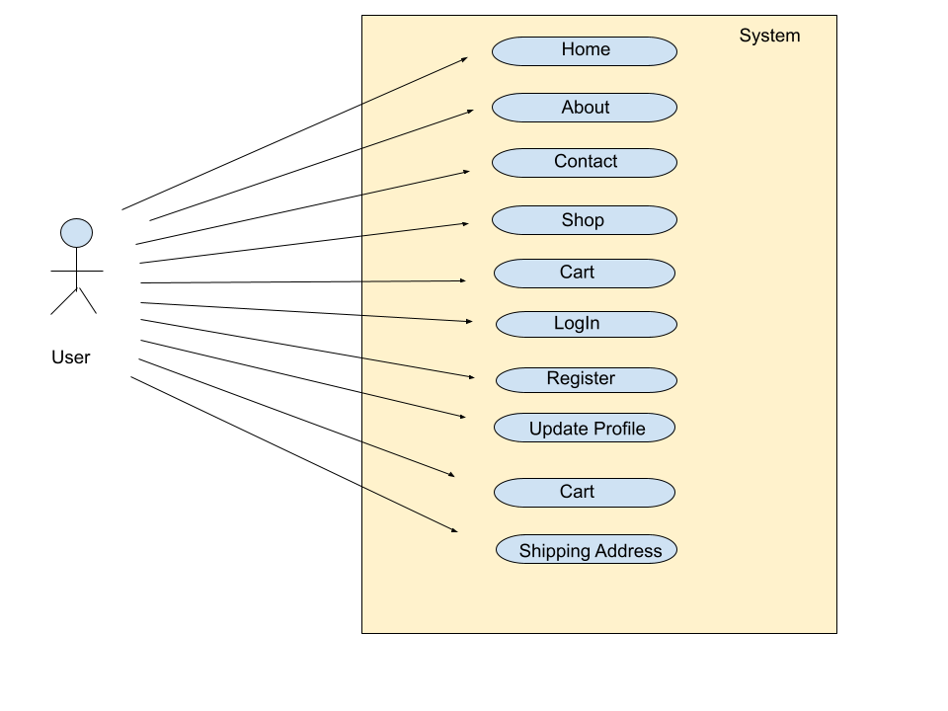

Admin Functionalities Diagram

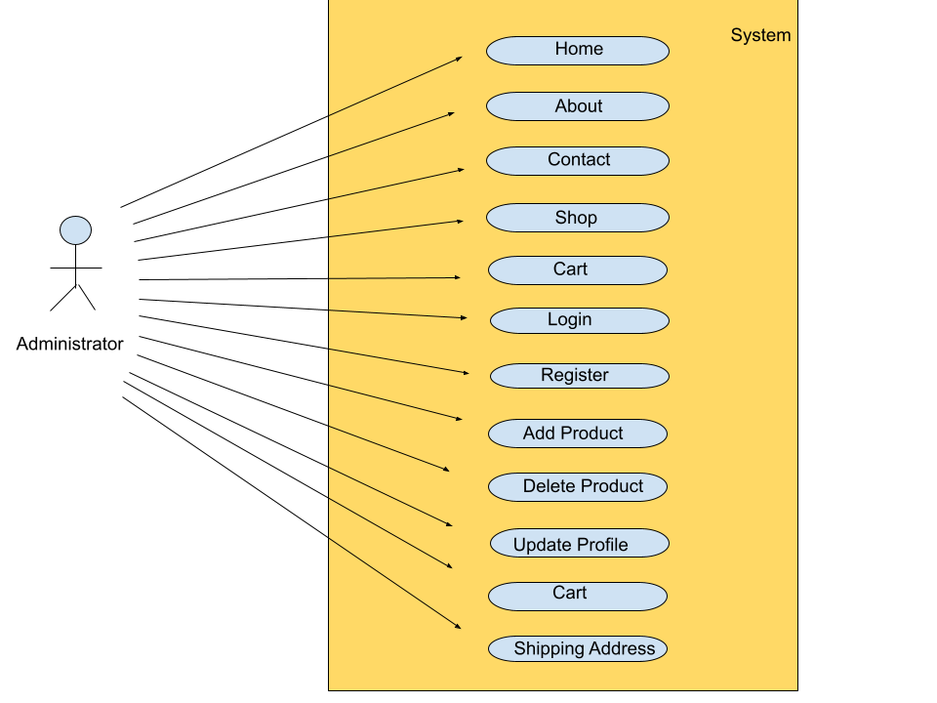

  - NON FUNCTIONAL REQUIREMENTS

2.2.1 Interface
Go to Appendix B for user interfaces

2.2.2 Performance
- Number of Concurrent Users:
Online Home Appliances Store shall be able to handle at least 1000 transactions/inquiries per
Second.

2.2.3 Constraint
Online Home Appliances Store shall be able to handle at least 1000 transactions/inquiries per second

2.2.4 Other Requirements:
- Hardware Interfaces
The SPMS is expected to function on Intel PIII 900 MHz Processor equivalent or above, 128 MB RAM, 20 GB HDD.
- Software Interfaces
The SPMS shall work on MS Windows operating systems family (MS Windows 98, MS Windows NT Workstation, MS Windows 2000, MS Windows XP). It configures to work with Oracle database. This System works on Apache Tomcat server. It uses browser IE 5.0 & above. It uses IIS 5.0 server.

3. DESIGN

3.1 Database Design

The following table structures depict the database design.

Table1: Role

Key Type/ Constraint | Column Name | Data Type | Length | Allow Null (1=Yes;0=No)
PRI | Role_Id | Int | 4 | 0
 | Name | Varchar (30) | 30 | 1

Table2: User Role

Key Type/ Constraint | Column Name | Data Type | Length | Allow Null (1=Yes;0=No)
MUL | User_Id | Int | 4 | 0
MUL | Role_Id | Int | 4 | 0

Table 3: Users

Key Type/ Constraint | Column Name | Data Type | Length | Allow Null (1=Yes;0=No)
PRI | User_Id | Int | 4 | 0
UNI | Email | Varchar (50) | 50 | 0
 | Password | Varchar (100) | 100 | 0
 | First_name | Varchar (20) | 20 | 0
 | Last_name | Varchar (20) | 20 | 0
 | Phone | Varchar (12) | 12 | 0
MUL | Role_Id | Int | 4 | 1
 | Token | Varchar (100) | 100 | 1
 | Token_creation_date | Date | 3 | 1

Table 4: Products

Key Type/ Constraint | Column Name | Data Type | Length | Allow Null (1=Yes;0=No)
PRI | Product_Id | Int | 4 | 0
 | Pname | Varchar (150) | 150 | 0
 | Brand | Varchar (50) | 50 | 0
 | Price | Double (10,2) | 8 | 0
 | Color | Varchar (30) | 30 | 0
 | Dimension | Varchar (60) | 60 | 0
 | Description | Text | 500 | 0
 | Rating | Float | 4 | 0
 | Category | Varchar (20) | 20 | 0
 | Image1 | Varchar (50) | 50 | 0
 | Image2 | Varchar (50) | 50 | 0
 | Image3 | Varchar (50) | 50 | 0

Table 5: Address

Key Type/ Constraint | Column Name | Data Type | Length | Allow Null (1=Yes;0=No)
PRI | Address_Id | Int | 4 | 0
 | Country | Varchar (20) | 20 | 0
 | State | Varchar (20) | 20 | 0
 | City | Varchar (20) | 20 | 0
 | Address | Varchar (50) | 50 | 0
 | Landmark | Varchar (50) | 50 | 0
 | Pincode | Int | 4 | 0

Table 6: Orders

Key Type/ Constraint | Column Name | Data Type | Length | Allow Null (1=Yes;0=No)
PRI | Order Id | Int | 4 | 0
 | User Id | Int | 4 | 1
 | Address Id | Int | 4 | 1
 | Amount | Double (10,2) | 8 | 0
 | Order date | Datetime | 8 | 0

E-R Diagram

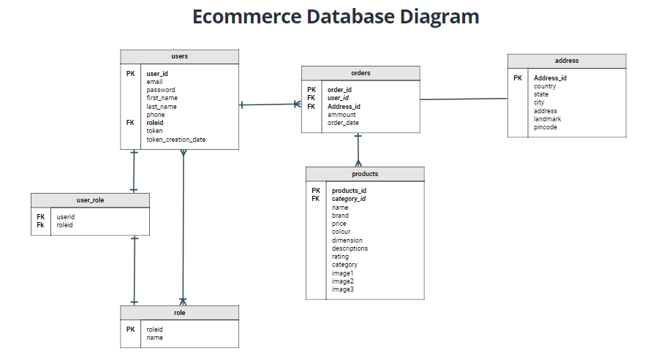

4. CODING STANDARDS IMPLEMENTED

Naming and Capitalization
Below summarize the naming recommendations for identifiers in Pascal casing is used mainly (i.e. capitalize first letter of each word) with camel casing (capitalize each word except for the first one) being used in certain circumstances.
Identifier | Case | Examples | Additional Notes
Class | Pascal | Person, BankVault, SMSMessage, Dept | Class names should be based on "objects" or "real things" and should generally be nouns. No ‘_’ signs allowed. Do not use type prefixes like ‘C’ for class.
Method | Camel | getDetails, updateStore | Methods should use verbs or verb phrases.
Parameter | Camel | personName, bankCode | Use descriptive parameter names. Parameter names should be descriptive enough that the name of the parameter and its type can be used to determine its meaning in most scenarios.
Interface | Pascal with "I" prefix | Disposable | Do not use the ‘_’ sign
Property | Pascal | ForeColor, BackColor | Use a noun or noun phrase to name properties.
Associated private member variable | _camelCase | _foreColor, _backColor | Use underscore camel casing for the private member variables
Exception Class | Pascal with "Exception" suffix | WebException,

Comments
- Comment each type, each non-public type member, and each region declaration.
- Use end-line comments only on variable declaration lines. End-line comments are comments that follow code on a single line.
- Separate comments from comment delimiters (apostrophe) or // with one space.
- Begin the comment text with an uppercase letter.
- End the comment with a period.
- Explain the code; do not repeat it.

5. TEST REPORT

Another group called Linux did the testing and the report of the testing is given hereunder.
GENERAL TESTING:
SR-NO | TEST CASE | EXPECTED RESULT | ACTUAL RESULT | ERROR MESSAGE
1 | Register Page | Redirected to Next page | OK | Nothing
2 | Login Page | Only valid user can login. | OK | Invalid username /password.
3 | Shop page | User is able to see all the products. | OK | Nothing
4 | Search Box | User can search product | OK | Nothing
5 | Sort by price | Products on shop page are sorted by price | OK | Nothing
6 | Sort by Category | Products on shop page are sorted by category | OK | Nothing
7 | Sort by rating | Products on shop page are sorted by Rating | OK | Nothing
8 | Profile | User is able to see his/her profile | OK | Nothing
9 | Add to cart | User is able to add his/her products into cart | OK | Nothing
10 | Show button | User is able to see product details | OK | Nothing
11 | Increase/Decrease product Qty. | User is able to Increase/Decrease product | OK | Nothing
12 | Shipping address | User is able to add shipping address details. | OK | Nothing
13 | Add product | Admin is able to add product. | OK | Nothing
14 | Delete product | Admin is able to delete product. | OK | Nothing
15 | Home page | User can see home page without login | OK | Nothing
16 | About page | User can see about page without login | OK | Nothing
17 | Contact page | User can see contact page without login | OK | Nothing
18 | Logout | It will logout from user profile. | OK | Nothing
 | STATIC TESTING

6. PROJECT MANAGEMENT RELATED STATISTICS

DATE | WORK PERFORMED | SLC Phase | Additional Notes
JULY 24 2021 | Project Allotment and User Requirements Gathering | Feasibility Study | Our team met the client Mr. Nitinkudale (CEO, SIIT Pune) to know his requirements.
AUG 24 2021 | Initial SRS Document Validation  And Team Structure Decided | Requirement Analysis  (Elicitation) | The initial SRS was presented to the client to understand his requirements better
AUG 31 2021 | Designing the use-cases, Class Diagram, Collaboration Diagram, E-R Diagram and User Interfaces | Requirement Analysis &  Design Phase | Database Design completed
SEPT 01 2021 | Business Logic Component design Started | Design Phase | ----------------------
SEP 05 2021 | Coding Phase Started | Coding Phase | 70% of Class Library implemented.
SEP 12 2021 | Implementation of Web Application and Window Application Started | Coding Phase | Class Library Development going on.
SEP 14 2021 | Off | Off | Off
SEP 15 2021 | Implementation of Web Application and Window Application Continued | Coding Phase and Unit Testing | Class Library Modified as per the need.
SEP 17 2021 | Implementation of Web Application and Window Application Continued | Coding Phase and Unit Testing | --
SEP 18 2021 | After Ensuring Proper Functioning the Required Validations were Implemented | Coding Phase and Unit Testing | Module Integration was done by the Project Manager
SEP 19 2021 | The Project was Tested by the respective Team Leaders and the Project Manager | Testing Phase (Module Testing) | --
SEP 20 2021 | The Project was Submitted to Other Project Leader of Other Project Group For Testing | Testing Phase (Acceptance Testing) | The Project of Other Team was Taken up by the Team for Testing
SEP 21 2021 | The Errors Found were Removed | Debugging | The Project was complete for submission
SEP 24 2021 | Final Submission of Project

Homepage

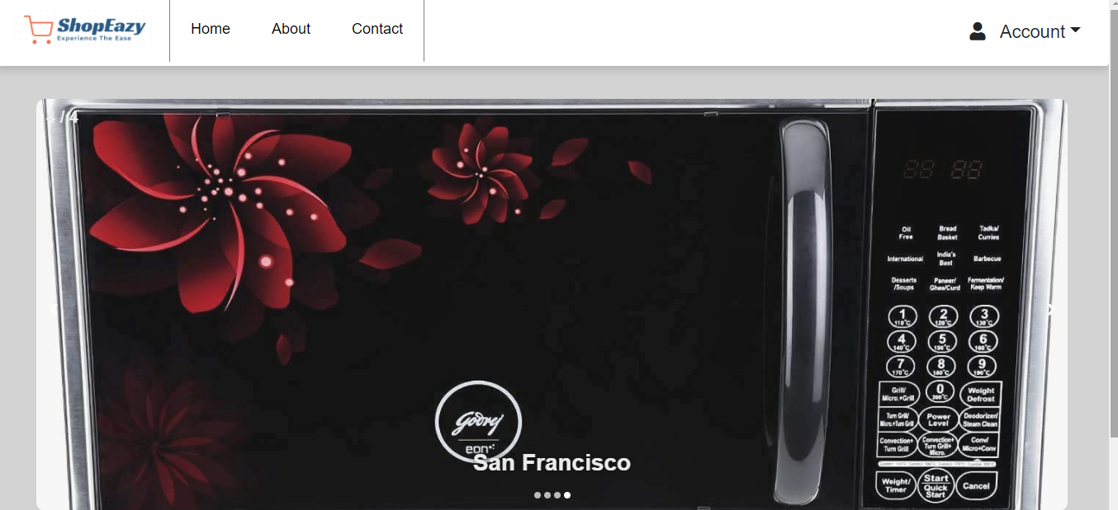

Contact Page

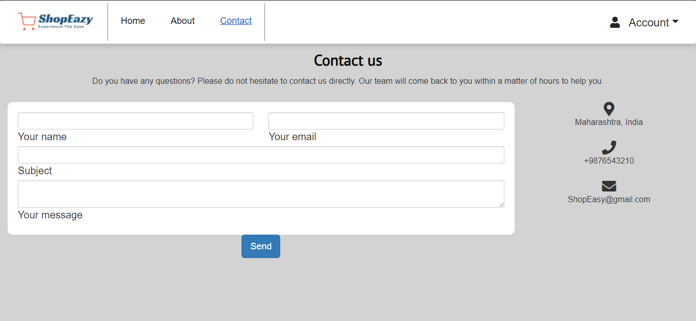

About Page

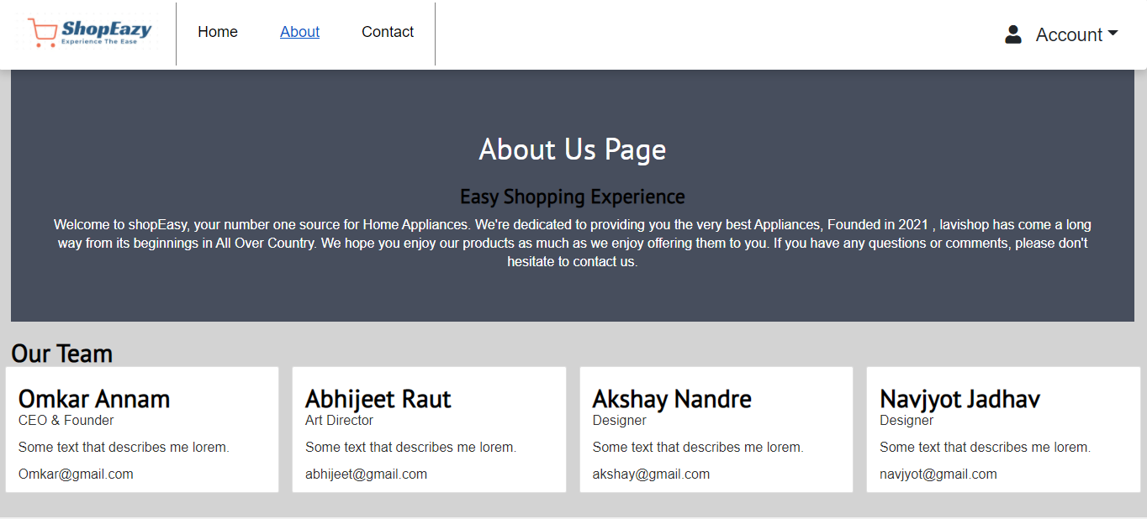

Login Page

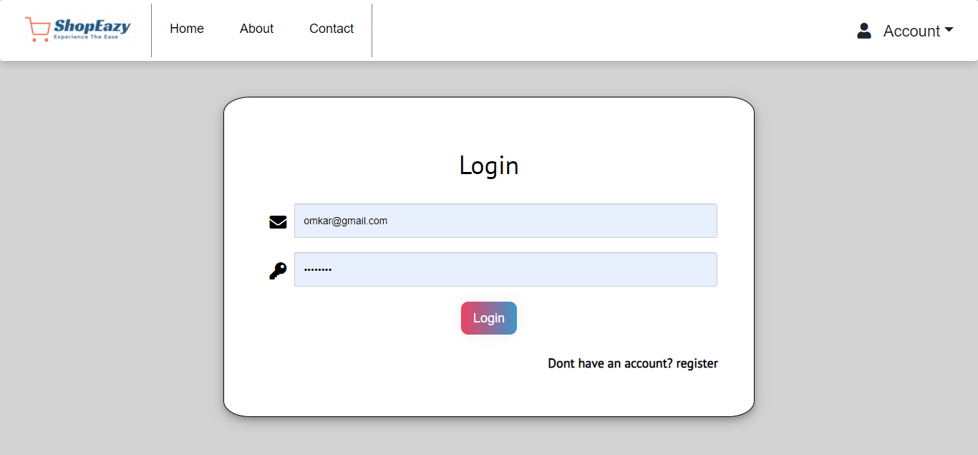

Registration Page

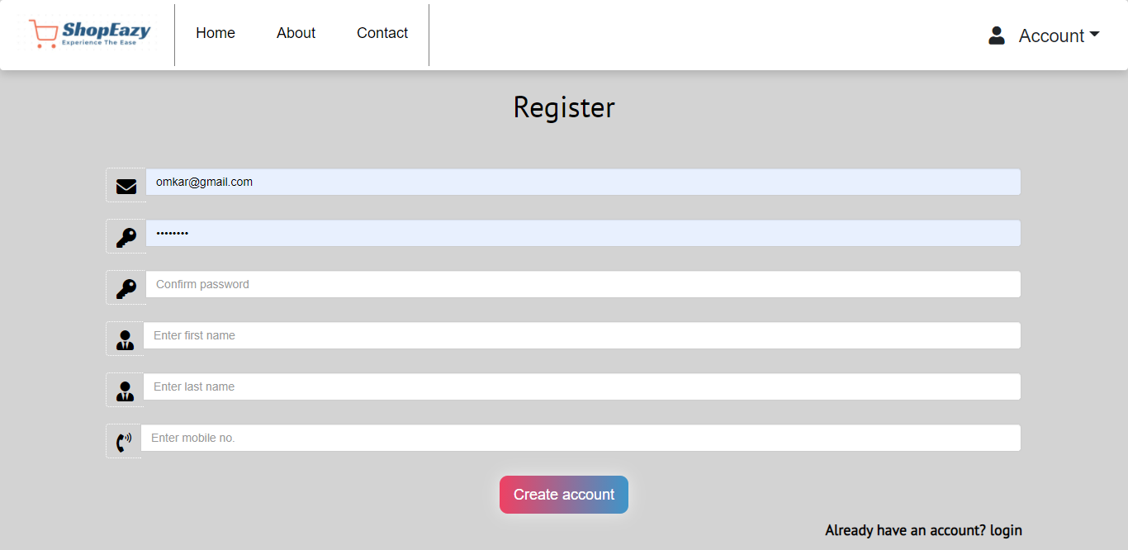

Profile Page

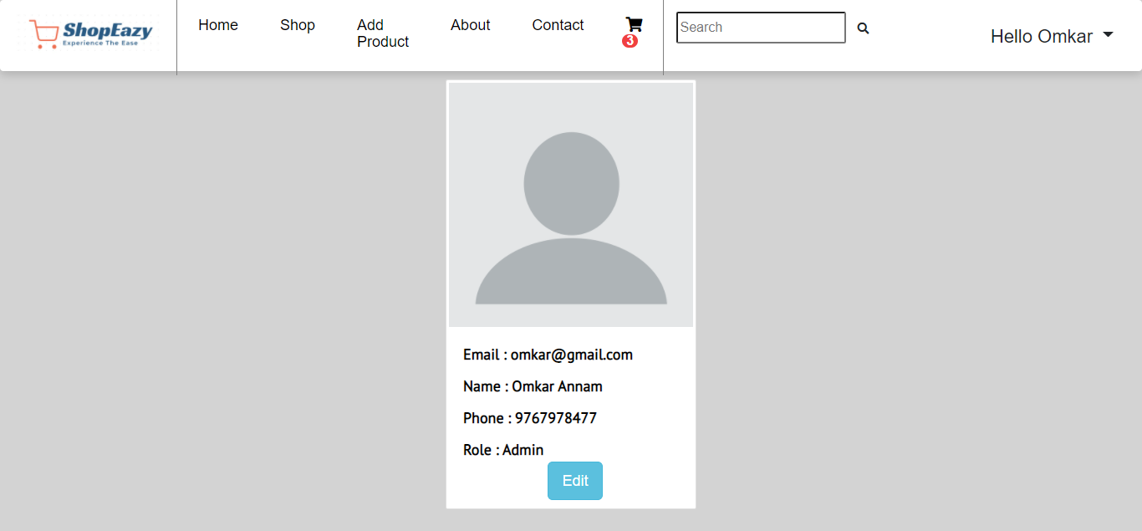

Edit Profile Page

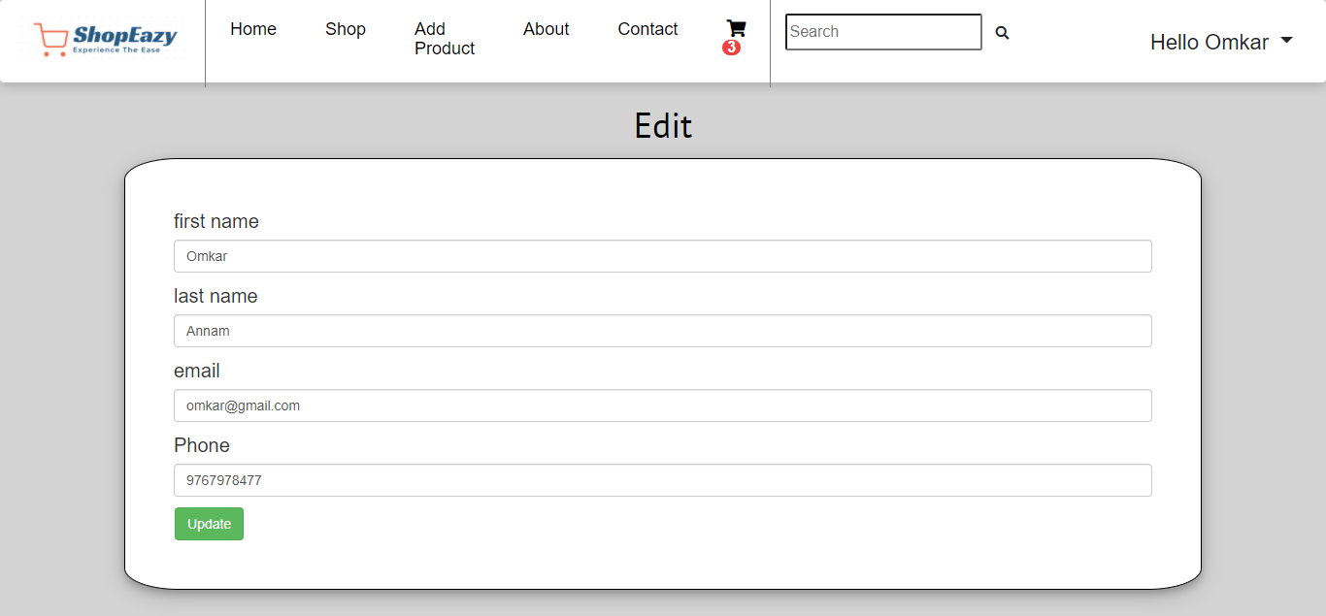

Shop Page

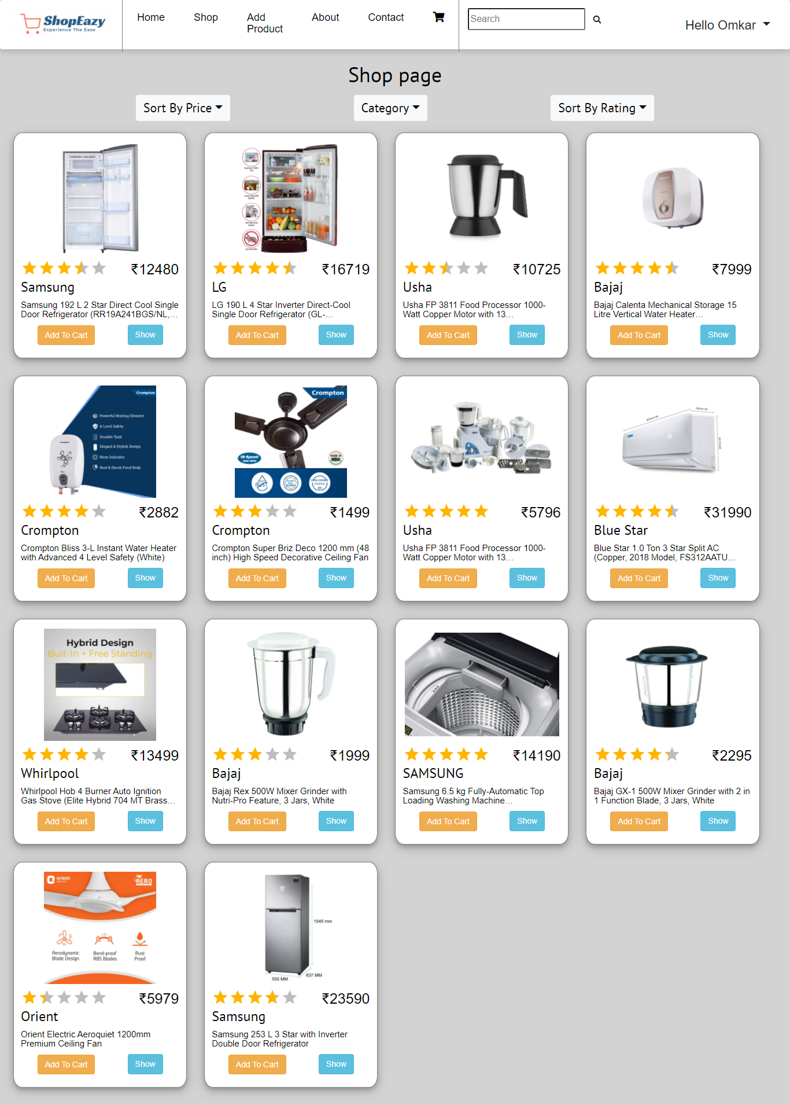

Product Details Page

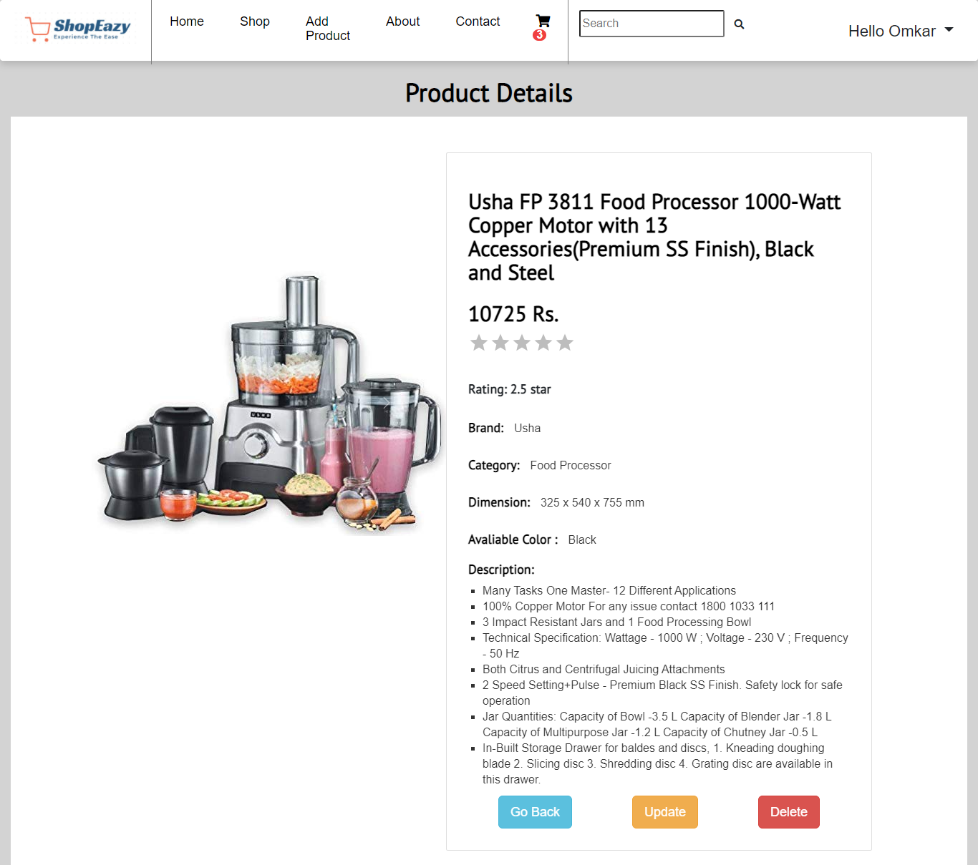

Cart Page

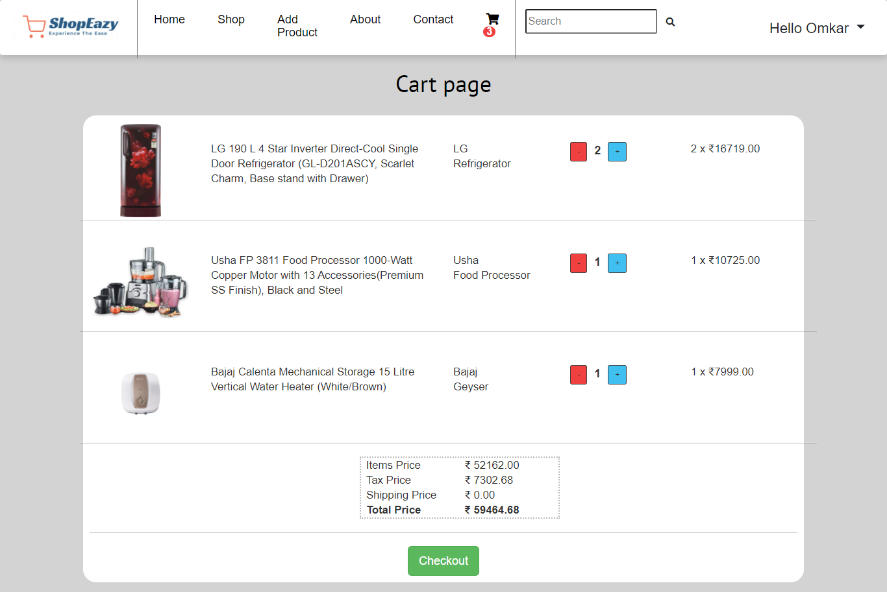

Shipping Address Page

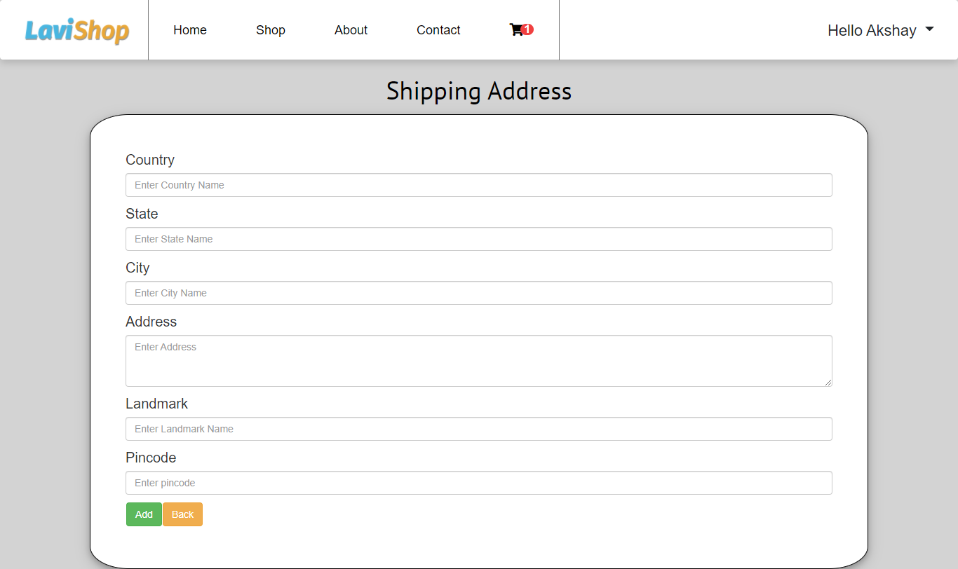

Order Success Page

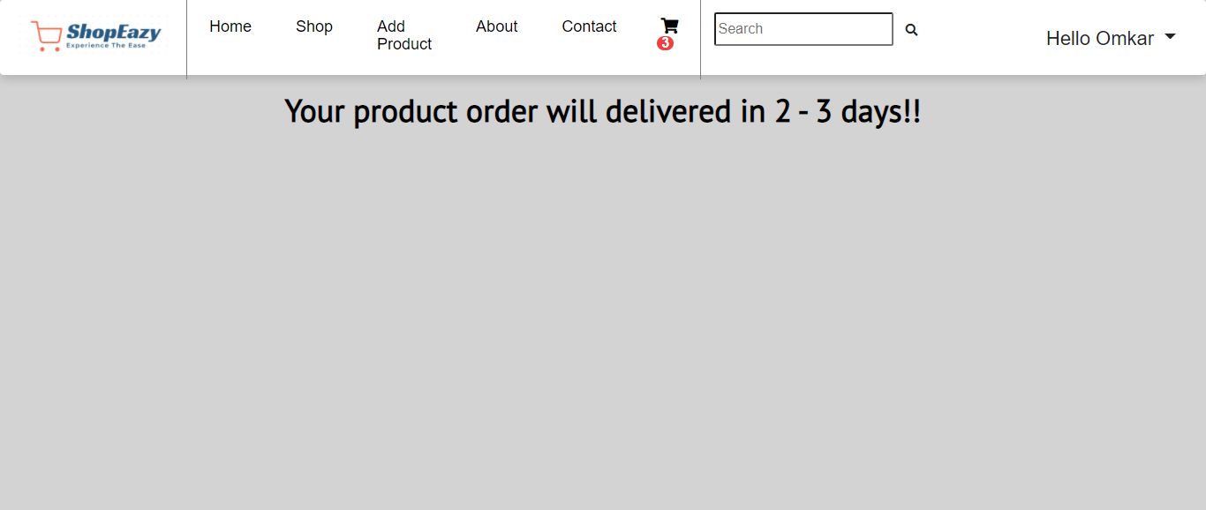

Add Products Page

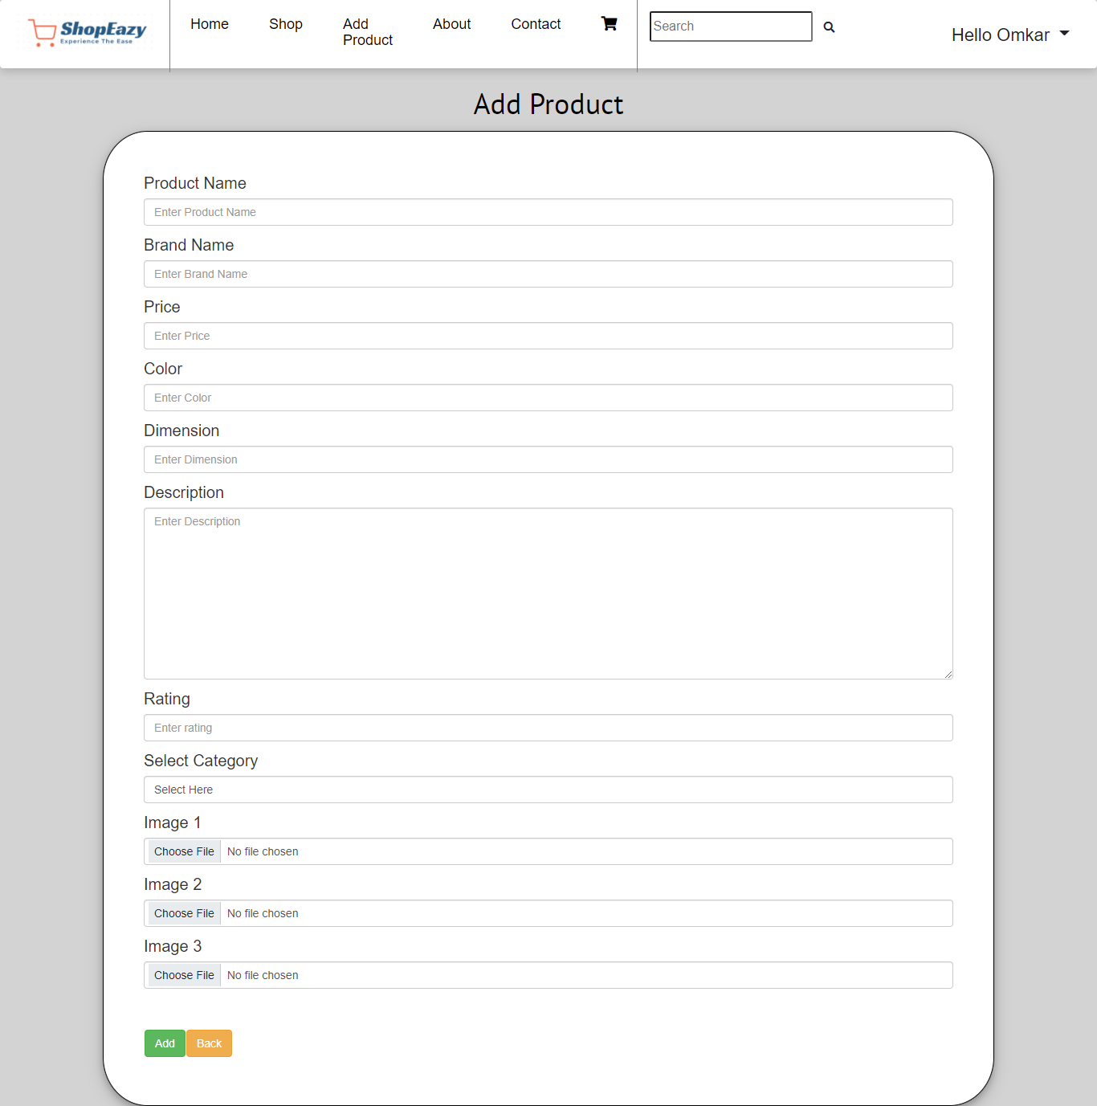

7.REFERENCES:

http://www.google.com

https://mui.com/

https://bootsnipp.com/

https://developer.mozilla.org/en-US/docs/Learn/Getting_started_with_the_web

https://developer.mozilla.org/en-US/docs/Web/JavaScript

https://javascript.info/

https://www.geeksforgeeks.org/reactjs-tutorials/?ref=ghm

https://reactrouter.com/core/api/Hooks/usehistory

https://react-redux.js.org/introduction/getting-started

https://reactjs.org/docs/getting-started.html

https://stackoverflow.com/questions/37521557/how-to-correctly-use-react-router

https://stackoverflow.com/questions/51802244/search-functionality-in-reactjs

https://css-tricks.com/

https://www.baeldung.com/

http://www.webdevelopersjournal.com/

http://www.delta.com

