Exam exercise: Bio-informatics and Modelling of kinases:

General information:
This exercise counts for two third of the points of the practical part of the Bio-molecular Model Building course and will be topic of two practical sessions. You are allowed to work in pairs and it is sufficient to hand in one report per group. This doesn’t mean that each of you only solves half of the exercise! The report has to be written on a computer. Don’t forget to put your names in the header of the file and in the filename.
During the two sessions, you have the opportunity to ask for limited explanation at the assistants present, the questions will be answered in class. Since it’s an exam, you can meanly ask technical questions. Questions regarding answers will not be answered!
The easiest way to go through this exercise is to follow the order of the questions. Information needed in further questions follow from previous exercises.
The report can be handed in until friday 22th May 2015 (5 pm). A printed version has to be submitted at the laboratory (Celestijnenlaan 200G, second floor, room 01.58). All figures require to have a white background!

Questions:

- Kinases belong to the α+β class of proteins (SCOP classification). Proteins belonging to this class are consisting mainly out of α-helices en β-sheets. Kinases have mostly two lobs, (i) the N-terminal part, consisting of antiparallel β-sheets and an α-helix and (ii) the C-terminal part, mainly consisting of α-helices. Sometimes, also regulatory domains are present.
  - Visualise (give figure) the kinase domain and the regulatory domain with PyMol (PDB code 3DDQ) and indicate on the kinase domain also the N-terminal and C-terminal part. You can do this by giving the two parts different colours.
  - Draw the topology diagram of the N-terminal domain. Keep in mind that the coordinates from some amino acids are missing in the PDB-file. Indicate which residues (give the numbers) are part of an α-helix and which are part of β-strands.

- Kinases have an active (open ➔ binding of substrate is possible) and an inactive (closed ➔ binding of substrate is impossible) form. Use 2SRC and 3LCK, two strongly alike structures but not identical, to describe the differences. Superpose the kinase domains of the structures and colour the active form green and inactive one red (give figure). Describe the role of the regulatory domains and indicate which residues of the SH2 domain are responsible for the interaction with the phosphorylated Tyr527 (give figure).

- Kinases seem to become more and more important in the research of disease like cancer and in general for the understanding of their function and working mechanisms inside the cell. Structural research is of great aid. Search the total number and the number of structures per year of kinase crystal structures in the protein databank starting from 2000. Can you make a link (give a graph)?

- Look up the 1XR1 crystal structure in the PDB and visualise it with PyMol. Look for the active site.
  - What is bound in this place?
  - One of the ligands in chemically modified. Why was this necessary?
  - Visualise (give figure) the binding of the ligands. Discuss.
  - Who determined the coordinates of this crystal structure (authors article)?

- Look up a crystal structure of the wild type death-associated protein kinase with ANP and MG bound into the active site. Choose the structure with the best quality (discuss).
  - Who determined the coordinates of this crystal structure (authors article)?
  - Look at 3F5U with Wordpad. Search for a residue with multiple alternative rotamer conformations and visualise (give figure) this with PyMol. Search for a residue for which some atoms have occupancy of zero and visualise (give figure) this with PyMol. What are the consequences for further use?
  - Discuss the temperature factors of this protein.
  - Look op the protein sequence for the human DAPK1. Which domains are present in the protein and what is their function?
  - Align the given sequences (sequences_q5.fasta) with ClustalX and discuss the alignment (global en conserved residues). Use the ‘guide tree’ and subsequent ‘tree of life’ during your analysis.
(The calculations can take a while!)

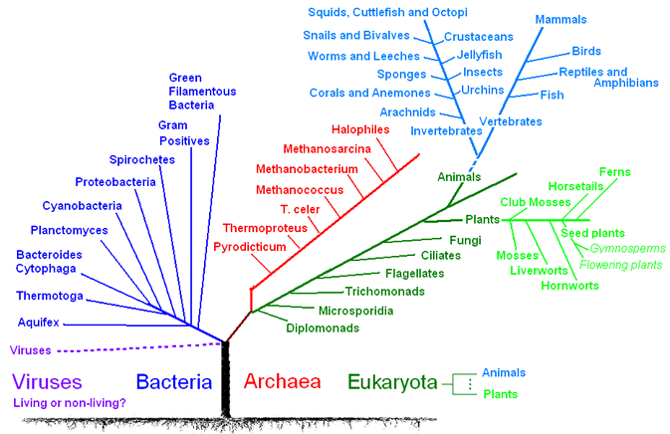( http://www.qm.qld.gov.au/education/resources/biodiscovery/images/01/1.1-tree-of-life.gif & http://www.bacterio.cict.fr/classification.html )

Animalia: Am (Apis mellifera); Bf (Branchiostoma floridae); Bm (Brugia malayi); Bt (Bos Taurus); Ce (Caenorhabditis elegans) Cf (Canis familiaris); Dm (Drosophila melanogaster); Dr (Danio rerio); Ec (Equus caballus); Hm (Hydra magnipapillata); Hs (Homo sapiens); Is (Ixodes scapularis); Md (Monodelphis domestica); Mm (Mus musculus); Nv (Nematostella vectensis); Oa (Ornithorhynchus anatinus); Phc (Pediculus humanus corporis); Rn (Rattus norvegicus); Sp (Strongylocentrotus purpuratus); Ta (Trichoplax adhaerens); Tg (Taeniopygia guttata); X(s)t (Xenopus (Silurana) tropicalis)

Eukarya: Dd (Dictyostelium discoideum)

Plantae: At (Arabidopsis thaliana)

Archaea: Ma (Methanosarcina acetivorans)

Bacteria: Am (Acaryochloris marina MBIC11017); Cs (Cyanothece sp. PCC 7822); Ct (Chlorobium tepidum); Da (Desulfatibacillum alkenivorans AK-01); Mc (Microcoleus chthonoplastes PCC 7420); Ms (Magnetococcus sp. MC-1); Np (Nostoc punctiforme PCC 73102); Ns (Nostoc sp PCC7120); Sl (Spirosoma linguale DSM 74); Ss (Sagittula stellata E-37); Te (Trichodesmium erythraeum); Vs (Verrucomicrobium spinosum DSM 4136)

- Kinases are popular targets for the development of drugs against cancer of infection diseases. Superpose following two kinase-structures: 1FIN & 2C6O. Use PyMol. What are the clearly essential features (features are the groups in a drug that are supposed to interact with the protein and correspond to the substrate, essential features are important in modelling for the construction of a model of the most import interaction spots in a complex (pharmacophore model)) of the drug when you compare it with the drug? Are there hydrogen bridges and/or hydrophobic, positive and/or negative charged groups that are on corresponding places? Give a figure where the interactions of the substrate and the inhibitor with the protein are clearly represented.
- Mutations in the LRRK2 kinase domain are responsible for certain forms of Parkinson's disease. The influence of mutations on the enzyme can be investigated by using a 3D structure, which can aid in finding a therapy against the disease.
- Construct a model of the wild type kinase domain (sequences of wt and mutants can be found on toledo: kinase-wt.fasta, kinase-mut1.fasta, kinase-mut2.fasta en kinase-mut3.fasta). Look for a suitable template in Modeller by using the updated sequence database (pdb_95_new.pir available on toledo). Generate a ramachandran plot of your model (using the following website: http://mordred.bioc.cam.ac.uk/~rapper/rampage.php) and use it to discuss the quality of your model.
- Align the sequences of the wild type with the mutant kinases in ClustalX and look for the mutated positions. Make a figure of your model in cartoon representation and display the location of the mutations as spheres.
- Discuss the influence of the mutations on the enzyme activation cycle (use information from question 2)

GOOD LUCK !

Tom, Ewald & Joren

Structural Classification Of Proteins, for more information, see http://scop.berkeley.edu/.
For more information, you can read the following article: Huse M & Kuriyan J. The conformational plasticity of protein kinases. Cell 2002 May 3;109(3):275-82.
The sequences were obtained by using the LRRK2 sequence and subject it to a BLASTP 2.2.23+ against the protein reference sequence databank. Sequences were chosen on the basis of the order (taxonomic classification). For the Nv proteins, a TBlastN was performed starting from NvLRRK2 (XP_001629165.1 (1250-1750)).
http://www.ebi.ac.uk/Tools/clustalw2/index.html

