AKDENIZ UNIVERSITY

Computer Engineering

Principles of User Interface Design

CSE 281

Intermediate Report

Prepared for

[Prof.Dr. Mustafa Berkay Yılmaz](http://aves.akdeniz.edu.tr/berkayyilmaz/)

Prepared by

Muhammed Mazlum Orhan - 20190808015

Mehmet Melih Karakaya - 20190808067

İlyas Zafer Barış – 20180808011

Yener Karaca - 20190808042

Emre Çil - 20190808058

Enes Ay - 20190808033

28th of November, 2020

**Group Member Responsibilities**

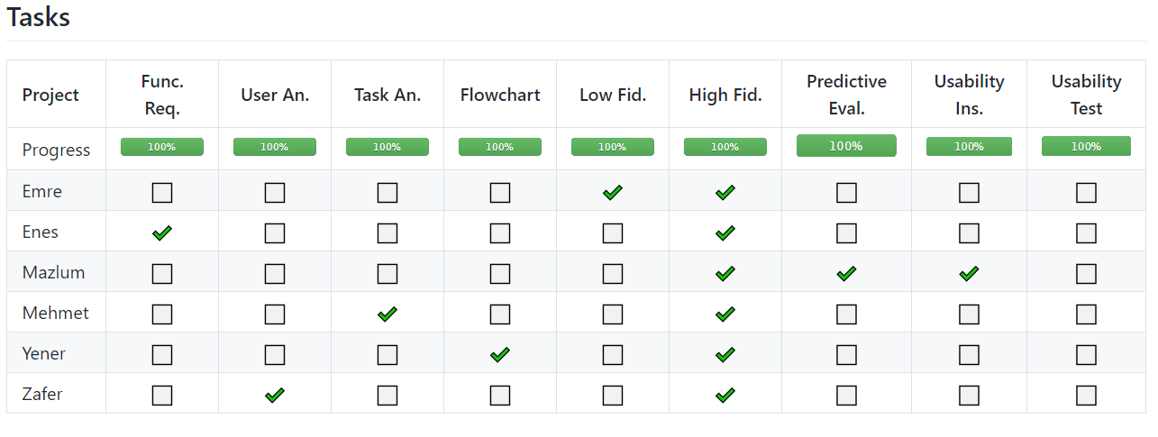

We have committed ourselves into this Project to create better and modern human interactable interfaces. We have put our full effort to this Project.

**Task Analysis**

**Goal**

– Our goal is to create an application so that users can easily see their portfolios, net gross, money status, shared market values and related news, which connects your shared market data, as well as all the accounts you have so that all of your money applications can be reduced to one, so that you don’t have to use many applications.

**Preconditions**

– Our user interface must know name, surname, password and email to create account, phone number is optional. To make transactions you need to login via E-Devlet and your bank account to enable, or you can use our application without any information about your bank accounts like a wallet app, but this means that you cannot do any transactions or buy, sell a shared market.

**Subtasks:**

– Login, sign up, forgot password → reset password, use QR code.

– Main page that shows a summary of all pages (portfolios).

– Bank Accounts → See bank accounts and credit cards details, transfer money.

– Stock Market → See/Buy/Sell/Order stock markets, related news and high/low pick of stock market.

– Net Gross → Shows net gross of each month→ See net worth and spent details.

– Expenses → Shows expenses for this month→ See net worth and spent details.

– Scheduled Bills → Show Bills → Pay your bills and automate them.

– Settings → Change password/e-mail/phone number/security preferences, set themes/language/time-zone and assistants, see history and backup data.

Where is the task performed?

– Tasks can be performed without internet connection, but if you want to refresh or do some transactions, buy/sell/order shared market or see detailed news you must be connected to the internet.

**Similar Softwares**

– Ziraat Bank, IsBank etc. → They are limited in terms of news and showing all months information.

– PaPara, Paribu etc. → They are limited in terms of transactions, shared markets and news information.

**Project Functions**

-This project provides us use different bank accounts in the same application. With that it’s easy to reach and execute processes about our accounts.

-We can access our account easily with QR code or for normal login includes mail and password.

-If you don’t have an account you can create new, if you forgot your password you can change your password after few security protocols.

-At the main screen we can see al menu details like summary. At the Expenses section we can see monthly spends and their kind (food,health,etc..) , total money we spend to them, for income and outcome we can see our saves on monthly.

-At the Bills section we can see and pay our bills, get information about them, create automatic pay.

-At Stock section we can manage our stocks, buy and sell, see instant change, read news about the firm we buy the stock.

-At Account section we can see our accounts and cards, see recent transactions we did that account, read the decont about that transaction, send money to IBAN or account.

-At settings section we can change security preferences.

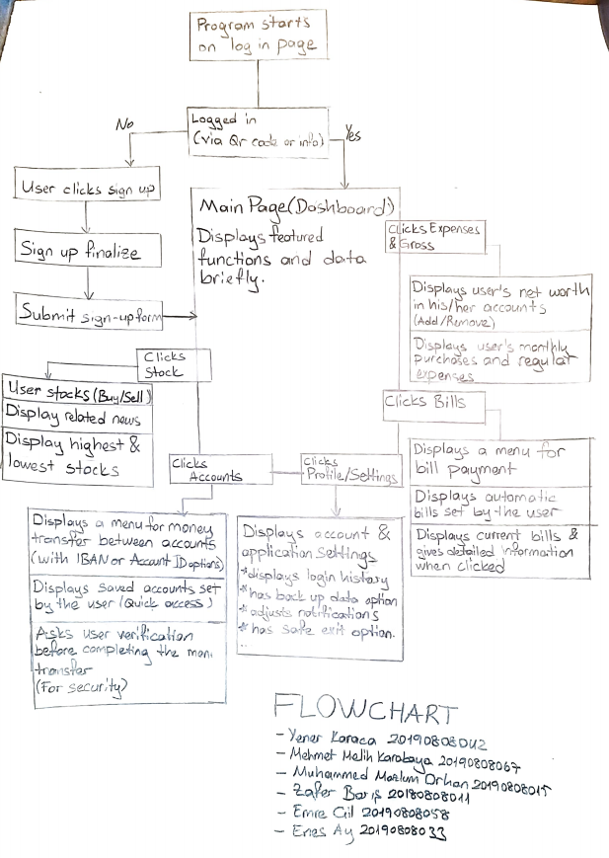

**USER ANALYSIS**

The possible user age range of this web-based application is between 18-75. It is an application that can be used by anyone in the specified age range regardless of any religion, language, or race. If we talk about the categories in the application:

1- In the bank account category, this category is for users who are bored with lots of bank account apps. Users will be able to collect all bank accounts under this menu in this application instead of checking all their bank accounts one by one.

2- In the stock market category, this category is for those who buy and sell stocks, or it will be a good start for those who are interested in the stock market and want to start.

3- In the expenses category, this category is for those who forget to pay their debts or want to see their debts in all accounts. In this menu you will see how much money you spent on what kinds of things. It will also help you compare your spending over the past months to see how you should manage your money and savings.

4- In the scheduled category, this category is for those who have trouble paying bills. In this menu, you can save all your bills and pay your bills directly. If you wish, the app will automatically pay for you by enabling automatic payment.

5- In the net gross category, this category is for users who want to see their remaining money by calculating all income and expenses. With this application, you will manage your money more easily and you will see that your remaining money will increase over time.

**Predictive Evolution and KLM**

*All KLM assumes program runs (User does not have to open from their desktop)*

* *Average name length: 6*
* *Average surname length: 6*
* *Average email length: 25*
* *Average password length: 10*

**1-Sign Up Page**

* **Using Tab key to go next input and pressing Enter to press buttons**

**Sign up:** M -> P -> B(Textbox selected)-> H ->6K(Name) -> K(Tab) -> 6K(Surname) -> K(Tab) -> 25K(Email) -> K(Tab) -> 10K(Password) -> K(Tab)-> 10K(Password) -> K(Tab) -> K(Enter Sign up button) -> R

*Time: 18.76 second*

* **Using mouse to go next input**

**Sign up:** M -> P -> B(Textbox selected) -> H -> 6K(Name) -> H -> P -> B(Textbox selected) -> H -> 6K(Surname) -> H -> P -> B (Textbox selected)-> H-> 25K(Email) -> H -> P -> B(Textbox selected) -> H-> 10K(Password) -> H -> P -> B(Textbox selected) -> H -> 10K(Password) -> H -> P-> B(Sign up Button) -> R

*Time: 30.04 second*

**2-Log In Page**

* **Using Tab key to go next input and pressing Enter to press buttons**

**Log in:** M -> P -> B(Textbox selected) -> H-> 25K(Email) -> K(Tab) -> 10K(Password) -> K (Tab)-> K(Enter Log in button) -> R

*Time: 13,44 second*

* **Using mouse to go next input**

**Log in:** M -> P -> B (Textbox selected)-> H -> 25K(Email) -> H -> P -> B(Textbox selected) -> 10K(Password) -> H -> P -> B(Log in Button) -> R

*Time: 15.8 second*

**4-Forgot Your Password Page**

**Change password:** M -> P -> B(Textbox selected) -> H -> 25K(Email) -> H-> P -> B(Send Code Button) -> R(Sends 6 digit code to email, it assumes email is open) -> P -> B(Textbox selected) -> H -> 6K(Code)-> H -> P -> B(Textbox selected) -> H -> 10K(New password)-> H -> P -> B(Textbox selected) -> H -> 10K(New password)-> H-> P -> B(Change button)-> R

*Time: 25.88 second*

**4-Bill Pay Page**

**Bill Pay:** M -> P -> B(Dropdown menu) -> M-> B(Bill type select) -> P -> B(Dropdown menu) -> M -> B(Corporation selected) -> P -> B(Text box selected)-> H ->10K(ID) -> H-> P -> B(Next Button) ->R -> M -> P -> B(Bill Selected) -> R -> M -> P -> B(Account Selected) -> R-> M -> P -> B (Verify Button)

*Time: 18.80 second*

**5-Send Money Pay Page**

**Money Send:** M -> P -> B(decides to IBAN or ID) ->

* **If it’s IBAN**: P -> B(Textbox selected) -> H -> 16K(IBAN) -> H -> P -> B(Textbox selected) -> H ->13K(name & surname ) -> H-> P -> B(Next) -> R
* **If it’s ID**: P -> B(Dropdown menu) -> M -> B(Bank selected) -> P -> B(Textbox selected) -> H -> 16K(ID) -> H ->P -> B(Textbox selected) -> H ->13K(name and surname) -> H-> P -> B(Next) -> R ->

M -> P -> B(Account Selected) -> R -> M -> P -> B(Textbox selected) -> H-> n*K(amount of money) -> H -> P -> B (Textbox selected)-> H -> n*K(Type of Sending) -> H-> P -> B (Textbox Selected) -> H -> n*K(Description) -> H-> P-> B(Date Object selected)-> P -> B(Date selected)-> P -> B(Next Button) -> R -> M -> P -> B (Verify Button)

*Time: Time changes way too much according to user’s money and description.*

*\*\* all times does not include system responds.*

**Usability Inspection**

**General**

At first, we decided to everyone will make their personal design then we going to choose one of them which fulfill our main goal and UI interface steps. After a long argument we continue on Mehmet’s interface and we took best parts and ideas of other projects and we combined them. After this, one of us redesign every element in project to make the project looks like design by one hand.

In the first project button and textbox wasn’t in the same length, we thought it’s not a good design so we change the every button’s length in projects.

Instead of listing object in order to down in rows we use big card design system. In this every object have itself n*n pixel and other object takes right side of previous one. In this domain we wrote object’s property inside of it. And this was one the best idea of application. It modern and efficient design for few items(Generally a user has few accounts not one hundred).

First Design Last Design

* A

A

B

C

* B
* C

In this design we didn’t use borders instead of this we use shadows affect to split objects and background. Objects and background have same color with this want to accomplish minimalist app. We don’t want to bother users with lots of colors.

**Log in page**

In first log in page, left side has mini stock market interface. We thoughts it is not necessary for every user so we deleted this and added a QR login option to make login more easier and safer. Remember me, Forgot your password, Don’t have an account options wasn’t in ordinary list, we want to make a clear application so we place every one of them left or side.

**Setting pages**

most of pages have two or three content, because of desktop applications are big we don’t want to make pages with empty content instead of this we did multi-layouts with fulfill content which not bother user. With this we prevent the users to lost in pages.

Application setting has lack of some options, some users may not found something that used to in other apps. This was missing part of projects.

We have basic setting with simple interface which every user will understand easily .

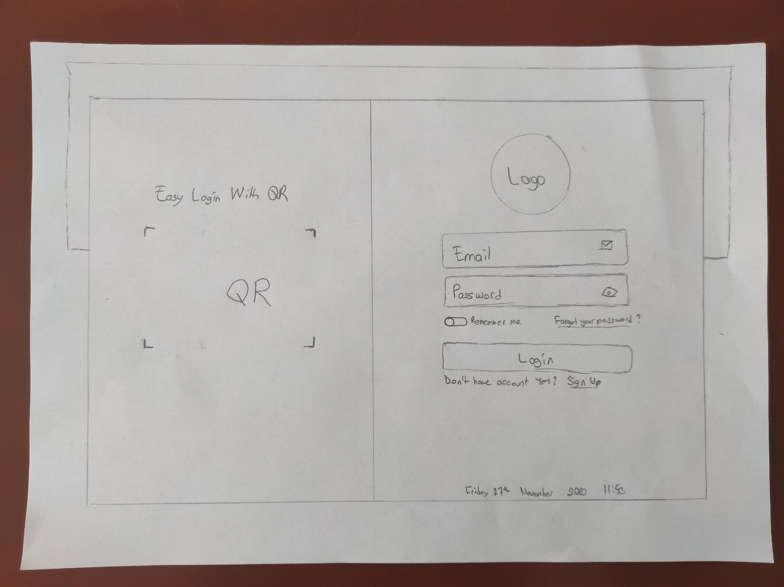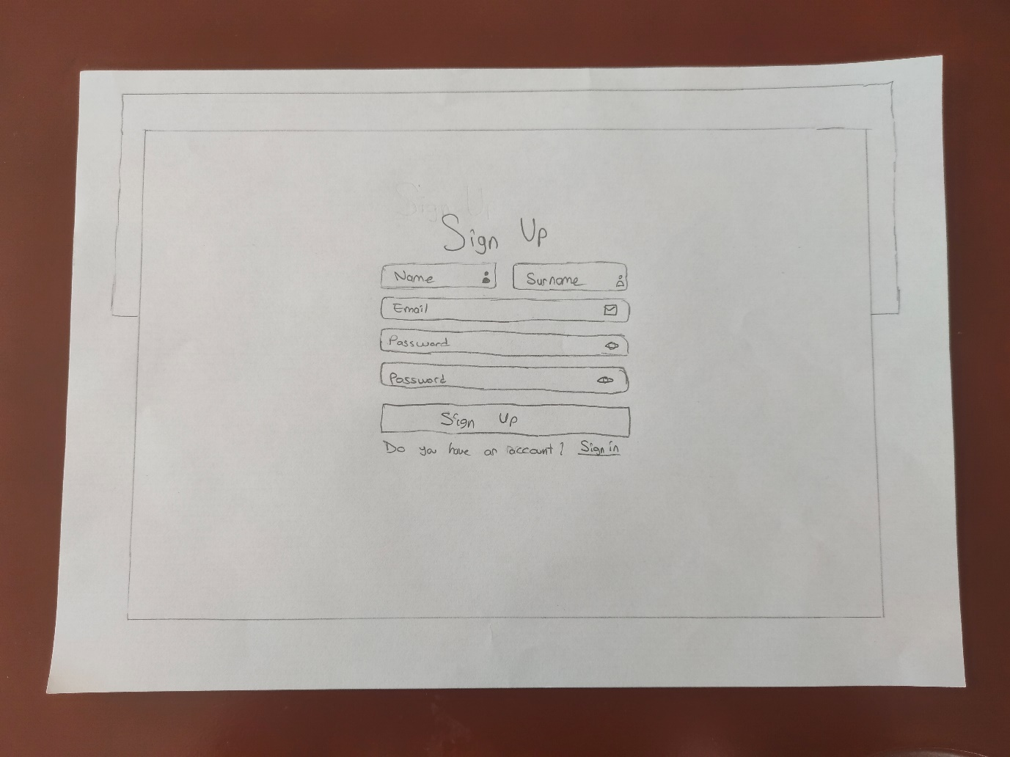

**Low Fidelity**

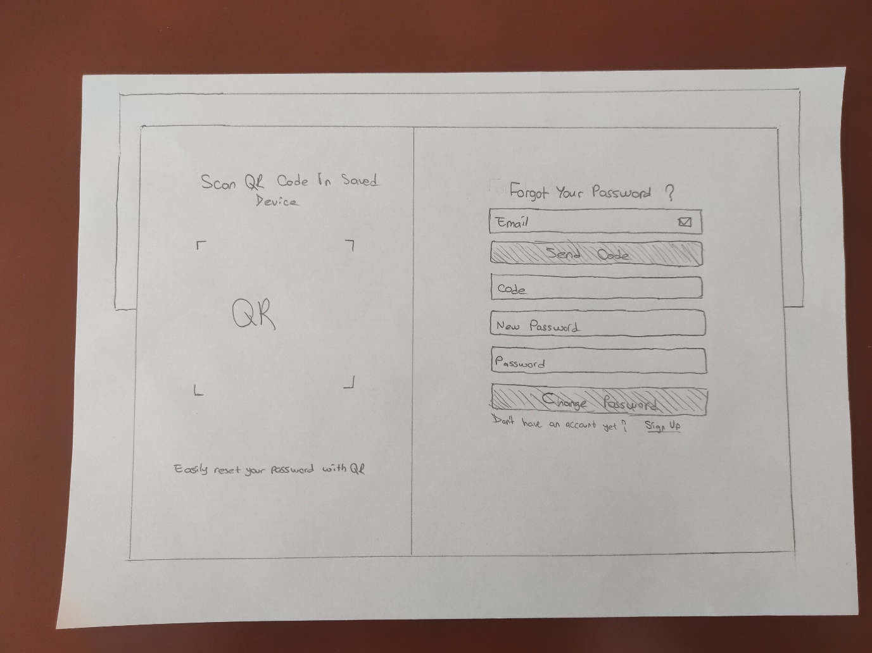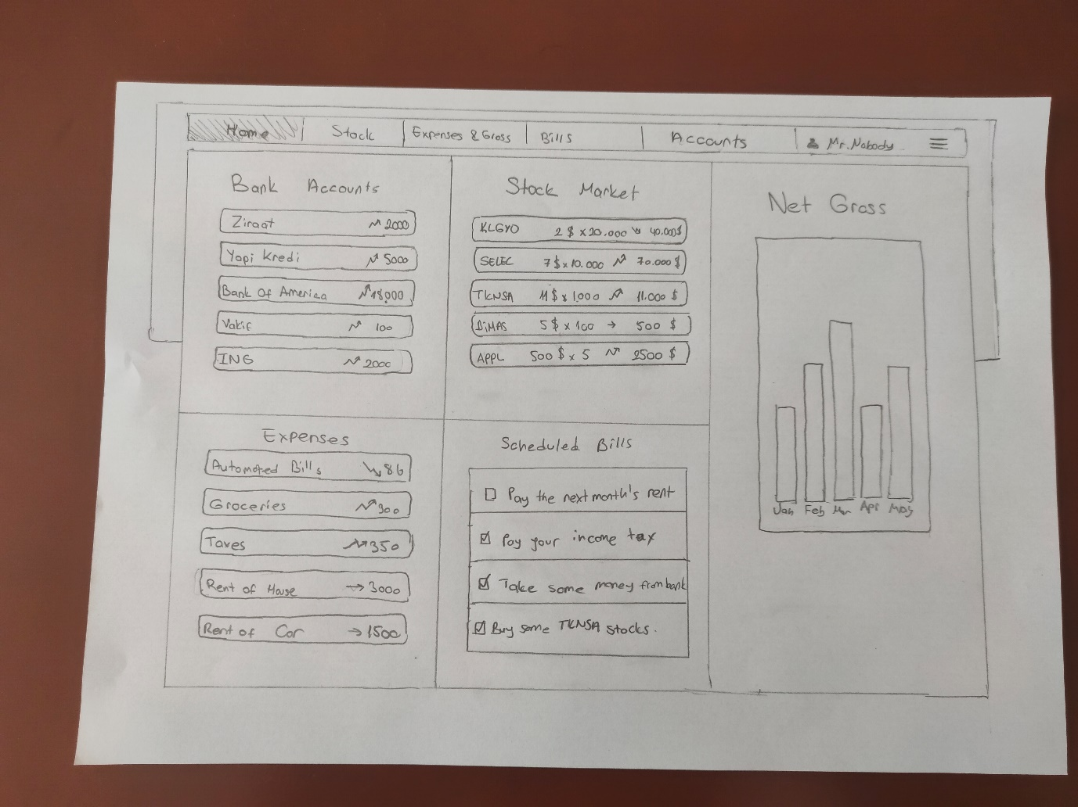

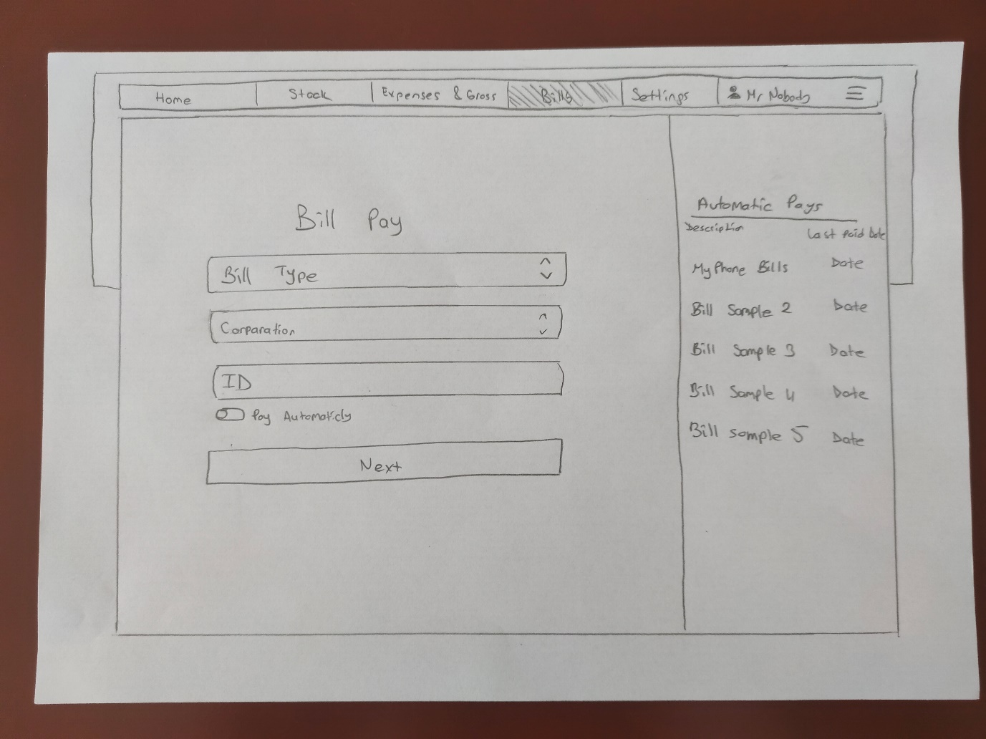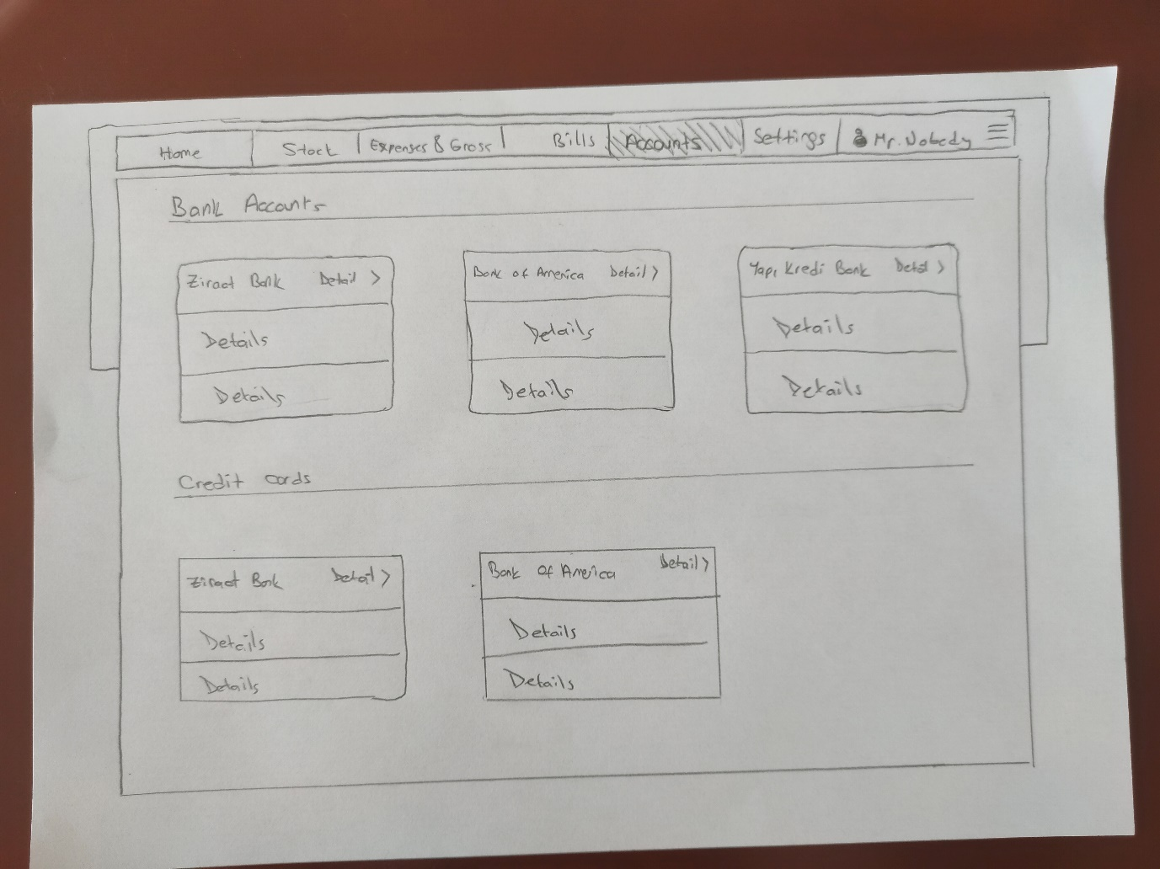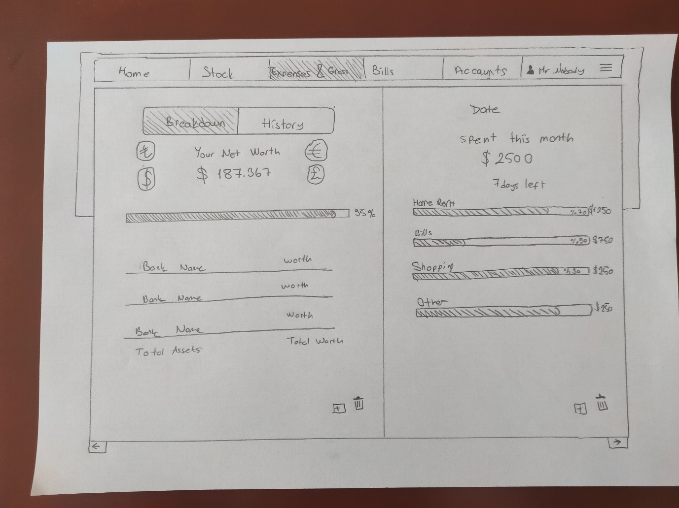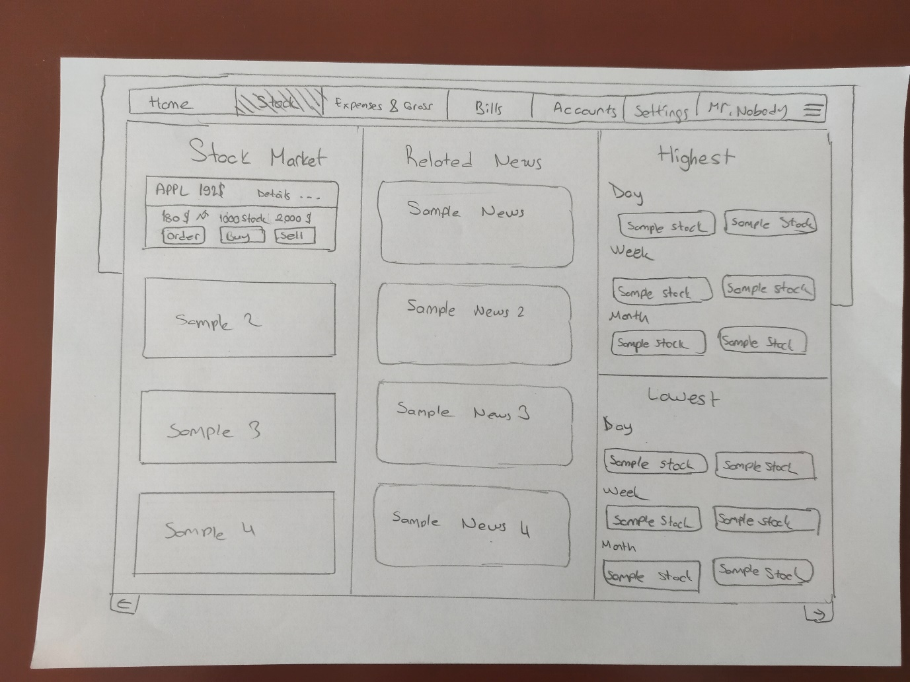

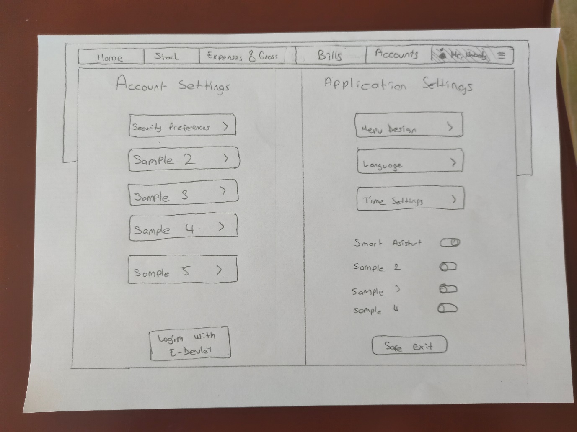

**Feedback**

Our desing is tested by Metehan Ünal, a classmate of ours. Since he is our classmate we wanted to be honest to us so that we can improve our Project. In this section we put his opinions and feedbacks.

1. It is not clear how / where the bank credit card is added
2. Login with the state below in the profile section, but the user is already logged in, isn't he? Is that button there to add credit and debit cards.
3. Again, there is both dark mode and night mode in the profile section, and the differences between the two may not be clear to someone who uses it for the first time
4. Percentages of something are shown in the Expenses section, but I could not understand what percentages

**REST OF OUR REPORT IS HIGH FIDELITY**