|  |  |  |
| --- | --- | --- |
|  | **BOSTON**  **UNIVERSITY** | **METROPOLITAN COLLEGE**  **DEPARTMENT OF ADMINISTRATIVE SCIENCES** |

**AD 616: Enterprise Risk Analytics**

**Assignment 1**

**What to submit?**

Please submit (i) a word file explaining in detail your answers to each question (you can use screenshots of the R to explain your answers) AND (ii) an R file with a separation for each question. For each question, make sure you develop the model and present the simulation results – the R file should be self-explanatory. **The assessment of your work will include both the accuracy and the clarity of your word file and the R Code.**

1. Consider a call center that receives its demand over a set of different travel websites. The weekly demand for each website is normally distributed with a mean and standard deviation given in Table 1. Develop a R script that creates a simulation with 100,000 trials to determine total call center demand.

Table 1: Weekly demand of travel sites (in hours)

|  |  |  |
| --- | --- | --- |
| Travel Site | Mean | Standard Deviation |
| A | 200 | 20 |
| B | 50 | 10 |
| C | 100 | 15 |
| D | 150 | 30 |
| E | 100 | 30 |
| F | 100 | 10 |

1. What are the mean and standard deviation of total call center demand according to your simulation?

Mean = 700.2924, sd = 51.17804

1. Develop a histogram that models the risk profile for total call center demand.

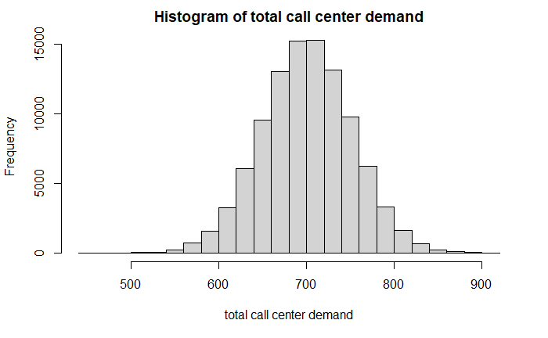

1. A cell phone manufacturer is considering to offer a refund to its customers whose battery fails before 5 years. The refunds start at $10, and increase by $1.50 for every month the battery falls short of 5 years. For example, a customer whose battery fails after 4 years and 6 months would receive a refund of $19. A customer whose battery fails after 5 years would receive no refund. Previous studies show that a battery’s life is normally distributed with a mean of 7 years and standard deviation of 2 years. Develop a simulation with 100,000 trials for the amount of a refund.
2. According to your simulation, what is the expected cost per cell phone to the manufacturer of this offer?

4.43111

1. According to your simulation, what is the probability a refund will be paid?

0.15647

1. According to your simulation, what is the average cost per refund?

28.31923

1. A coffee cart opens at 7:00 am, and they generally try to prepare a batch large enough to accommodate their customers until 10:00 am, when the cart closes. The operator only sells 16 oz. servings, and each serving costs $0.50 to prepare, which includes all costs of production and any dairy/sweetener customers may add. Any coffee that isn’t sold before 10:00 am is considered stale and disposed of for no monetary gain. When purchased, the coffee is poured into a ripple cup, which costs an additional $0.15 per cup. Demand over this period is normally distributed with a mean of 125 and a standard deviation of 35. Each cup retails for $2.75. The operator of the cart must also purchase a municipal license, which costs a flat $100 for the three hours. Assume there are no other costs associated with the cart. Develop a R model with 100,000 trials that simulates the daily profit resulting from the preparation of 75, 100, 120, 140, 160, and 180 servings of coffee a day (run them one at a time).
2. For each option, what is the expected profit, and which option results in the highest expected profit?

54.45049 97.88886 122.45818 135.78350 139.02749 134.02373

**160 servings** provide the highest expected profit.

1. Create a histogram that displays the risk profile of profit for the number of servings with the highest expected profit.

