|  |  |  |
| --- | --- | --- |
|  | **BOSTON**  **UNIVERSITY** | **METROPOLITAN COLLEGE**  **DEPARTMENT OF ADMINISTRATIVE SCIENCES** |

**AD 616: Enterprise Risk Analytics**

**Assignment 3**

**What to submit?**

Please submit (i) a word file explaining in detail your answers to each question (you can use screenshots of the R to explain your answers) AND (ii) an R file with a separate tab for each question. For each question, make sure you develop the model and present the simulation results – the R file should be self-explanatory. **The assessment of your work will include both the accuracy and the clarity of your word file and the R file. But even if you are struggling with R, we will grade favorably if you demonstrate your understanding of the concepts and how you are planning to solve the problem.**

1. GWS is a company that markets outboard motorboats directly to consumers for recreational use. Recently, they’ve been developing a project they think has a lot of potential: the first mass market boats with electric motors. They haven’t started advertising their new product yet, nor have they organized a presale because they don’t want to lose their first-mover advantage. As a result, GWS has a limited understanding of the size of the market for their new project. They plan to retail their boats for $150,000, but after two years, when competition enters the market and the novelty factor wears off, they’ll have to drop the price to $70,000. They hire a consultant who estimates that at this price point, over the next two years, demand for the new boats will be somewhere between 2,000 and 15,000, with probabilities as in the table below:

|  |  |
| --- | --- |
| Demand | Probability |
| 2,000-5,000 | 35% |
| 5,001-10,000 | 40% |
| 10,001-14,000 | 20% |
| 14,001-15,000 | 5% |

The fixed cost of manufacturing any number of boats is normally distributed, with a mean of $300 million and a standard deviation of $60 million. They estimate that the variable cost to produce one boat will be a minimum of $77 thousand and a maximum of $100 thousand, with a most likely value of $90,000. Develop four Monte Carlo Simulations to calculate their total profit over the two year period assuming they produce

1. 4,000 boats
2. 8,000 boats
3. 12,000 boats
4. 15,000 boats

For each simulation, provide the mean and standard deviation as well as a histogram.

the mean of the total profit of selling 4000 boats is

212618677

the sd of the total profit of selling 4000 boats is

71650890

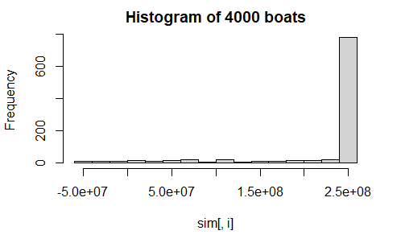

the mean of the total profit of selling 8000 boats is

206096253

the sd of the total profit of selling 8000 boats is

308542247

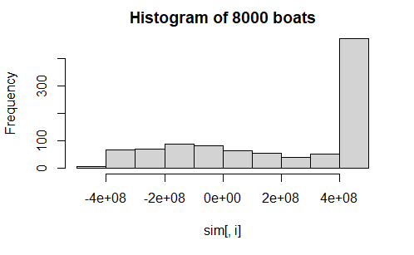

the mean of the total profit of selling 12000 boats is

12243174

the sd of the total profit of selling 12000 boats is

491820272

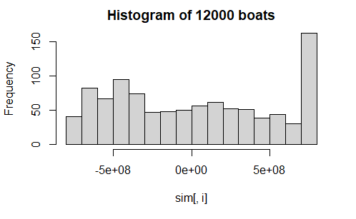

the mean of the total profit of selling 15000 boats is

-216219501

the sd of the total profit of selling 15000 boats is

553988142

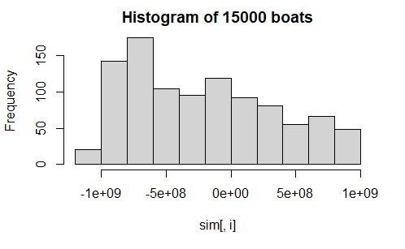

1. The Baker’s Inn is a small chain of restaurants in the New England area, that, in addition to accepting reservations, allow patrons to reserve an event space for private functions. Until now, the chain has limited reservations for its event spaces to parties of ten or more. The proprietor of the chain is considering expanding the spaces or possibly ceasing to offer private functions, but wishes to model the revenue they can generate. The chain collects data on the previous 100 private functions, including the number of people in each party and the amount each party spent per person (see .csv file).
2. Create a histogram of the party sizes. Which distribution do you think would best fit the data? Choose from among discrete uniform, geometric, and Poisson.

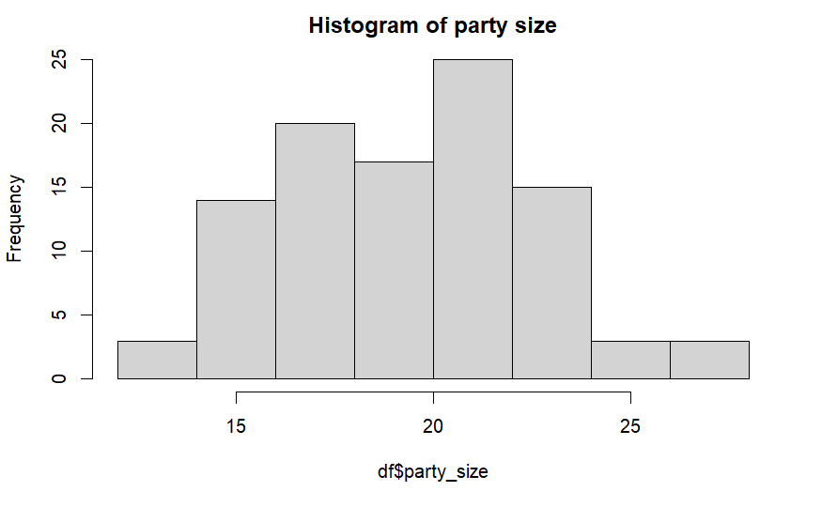

Based on the KS stats, I think a normal distribution best fit the data. However, if we can shift the data leftward by subtracting a baseline number of party size, we may get a perfect passion distribution.

1. In order to best fit the data, we need to shift the distribution to the left by subtracting a positive integer from the value of party size. What number should we subtract to get the best fit? What are the parameter(s) of the best fit distribution?

We can start from 13, which is the minimum of party size.

Then we have a Poisson distribution with lamda = 6.84

1. We now need to fit a distribution to the per person spending. Which of the following distributions results in the best fit, according to the KS statistic: Cauchy, gamma, logistic, lognormal, normal, or Weibull? What are the parameter(s)?

Gamma distribution best fit the model with shape = 15.94 and rate = 0.09

1. Create a QQ plot and a density comparison plot for the distribution you chose from part (c). Does the distribution appear to be a good fit?

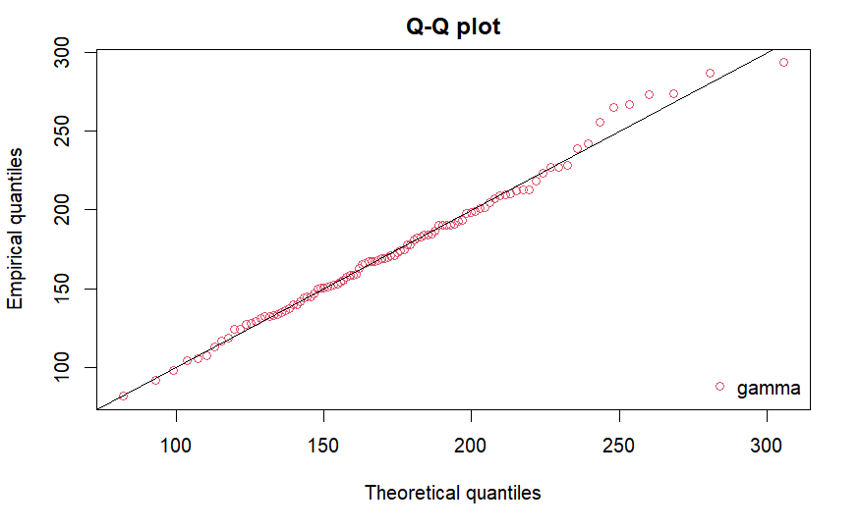

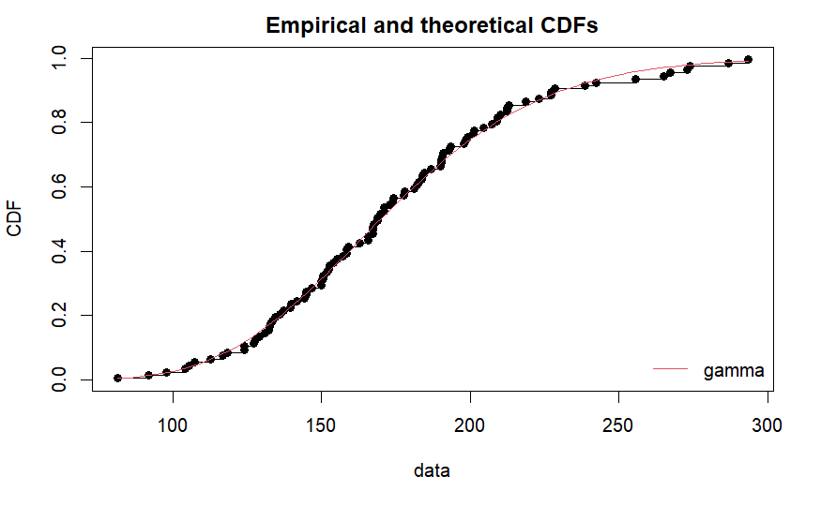

It fits perfectly

1. Does it appear that party size and per person spending are correlated?

Probably, the correlation between these two is 0.506

1. Using the distributions and parameters from parts (a)-(c) and the correlation from part e, construct an MC simulation with 100,000 trials to create a risk profile for the revenue generated from a single event. Create a histogram and provide the mean and standard deviation. (Hint: don’t forget to shift the distribution of party size back to the right.)

the mean of the total revenue is 3447.964, the sd of the total revenue is 983.1003

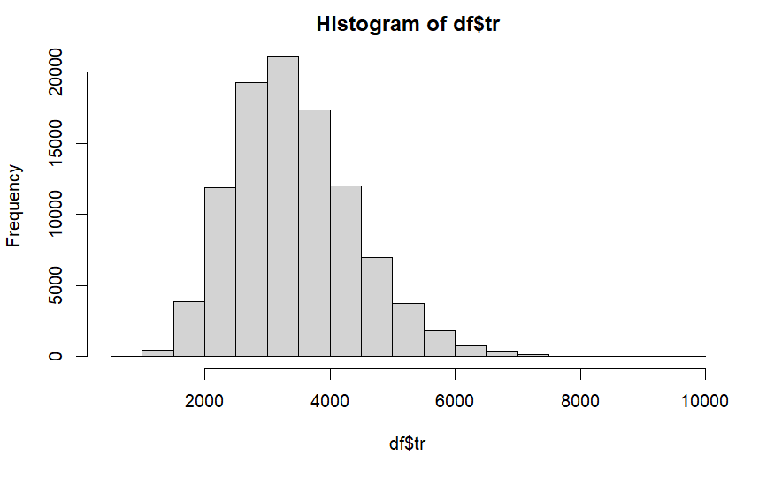

1. According to your simulation, how often will a private function generate at least $5000?

0.07045

1. Repeat parts (f) and (g), but build a simulation that ignores the correlation. How does this affect your results?