Introduction to Business Scenario
As a Small and Medium Enterprise (SME) tyring to survive in this economy of the fashion and apparel industry , faced with many challenges that could drive down performance and eventually lead to closure.
Some of these factors include Large economies, companies, Giants that could dramatically drive down the prices since they can afford to provide better profit margins. While SME’s struggle with POS systems and payment systems because the whole cost of adaptation to e-commerce store from a traditional Brick and Mortar store is high. Let alone the learning curve to familiarize with such technologies.
With the successful adaptation of such systems, it is guaranteed to pay off in the long run since the current shopping interaction is changing. The customers prefer purchase at the confort of their homes, this result to no one actually coming to a physical store and web-showroming will be the new go to. Since decisions are made by how well a product is visually represented.
This also helps in resource allocation, the supply chain as a whole will be come more efficient sice not tied to one store, but rather margins accounting for the customers order fulfillment will result to a higher customer acquisition cost.
The best way to stay ahead is if one is the sole distributor of own product to capitalize on the customer loyalty. Since it has been the greatest challenge ever since this change. Due to the rise of sole online stores that happen to resale goods from one store to another.
The best way to combat this is to understand customer behavior in order, as we fully commit to go all in as a sole distributor of the own product no matter from a reseller or our shop, the sale is made and client is retained.

Provided for this prediction is a draf of Amazon e-commerce store dataset that has both products and customer feedback. In order to achieve the goals of Sole production of our own product. We have to know what sells and at the best possible price.
Factors like profitability, Sentiment score, customer engagement, demography and gender will be key for our decision making.
Which brings us to our KPI, key performance indicators. For this transformative project to be a success we have to keep our goals aligned using a consumers mentality. *What do they want to see us implement.
- Targeted Advertising: Customers love to see what is appealing to them or their situation, and they expect us asservice providers to know that. Looking at Demography, age ,sex
- Value Visual Trust Score KPI’s: Virtually show of products : Since we have completely eliminated the upgrading of the Brick Mortatr store, we should invest heavily in virtually convinving clients by media
- Valuation Strategy & Revenue Optimization KPI’s: will help Providing a good online Experience: Proper product classification, pricing and availability of required purchase
- Critical Product Defect Matrix KPI’s: Brand Development by Customer interaction: The key to the growth of any brand depends on the customer feedback, good or bad helps in impoving or embracing what was already efficient.

KPI Scenario Driving the Research
- In this scenario dataset provided include 2 - .csv files, one with products while the other has reviews. Both files relate with an ASIN number that is a Primary key due to its characteristic of appering once as a data row identifier, to one and a foreign key to the other noticed by the characterisitic of repeating its self in multiple rows, as a value
- With the goal in mind yielding more traffic, one of the key performance indicator will be the Sale conversion index, that is influenced by factors such as the price of product, rate on the reviews together with their sentiment score, without ignoring the availability rate and time required to receive the product. All these factor influence a consumer towards making a purchase and as the moderators, make a sale.
Equation Explaining the KPI
- With the indicators of choice and data provided from the dataset. Relations and preprocessig should be done in order to perfectly attain a relationship between the values and the performance indicator.
- In our case the following equation was formulated: Where by the factor of influence of our performance indicator is directly propotional with the recent_purchases (when they go up, means somthing is working hence the sale conversion rate goes higher), similarily the saame could be applied for the product_rating but rather inversly propotional to the price, since when price goes up then consumers have a tendency to shy away.
- Factor of influence = K (W1.recent_purchases x W2.product_rating ) / (W3.price_value)
While the K being a constant value representing the average_trime_delivery_index and the W1, 2 and W3 being the wighted value of influence to the datapoint since as to presented different values hae different levels of influence towards the indicator.
Why is the KPI needed.
- In such a case scenario, where by data in its vastness, is a complication to deal with. A sign is needed to help steer the priorioties of the next course of action to be taken, inorder to achieve set goals
- A KPI is introduced to link the leaders and the mathematicans, in which case a variable is introduced and based on its perfomance in either going up which indicates the course of actions applied are useful, while if it tanks / goes down indicates an immediate course of different actions subjected toweards turining the KPI in a positive direction.

Equation & Importance
.
The KPI runs on the equation below: In which it is the square difference of the cost of manufacturing and the price sold to the client. Just because some values result to negative due to vendor discounts hence the (**2) squared. In order to attain the true margin.
((df_prod1['price'] - df_prod1['value']) / (df_prod1['value']))**2

Dataset: Data Profile
Comprehensive, immaculate data profile detailing all attributes, clear descriptions, and correct data types (numerical, categorical, etc.).

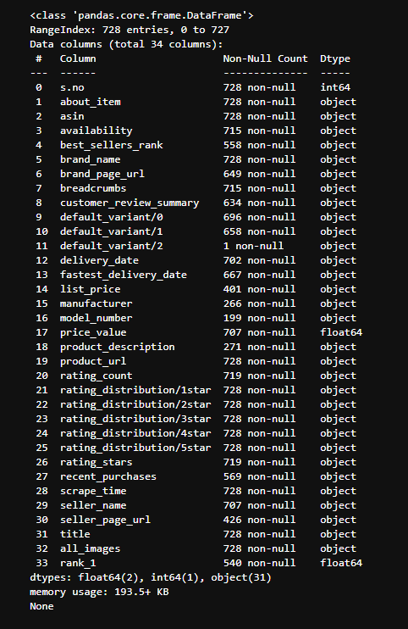

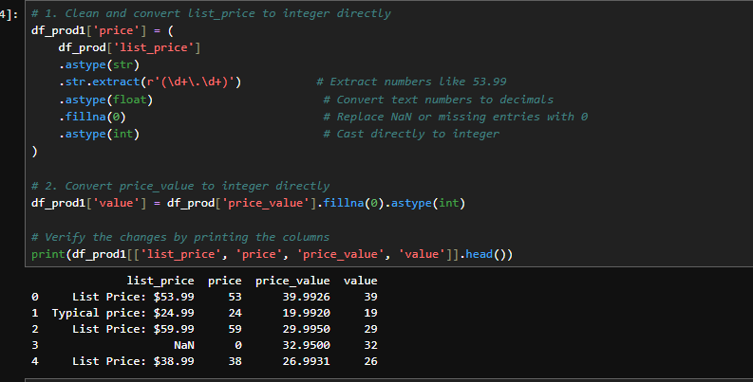

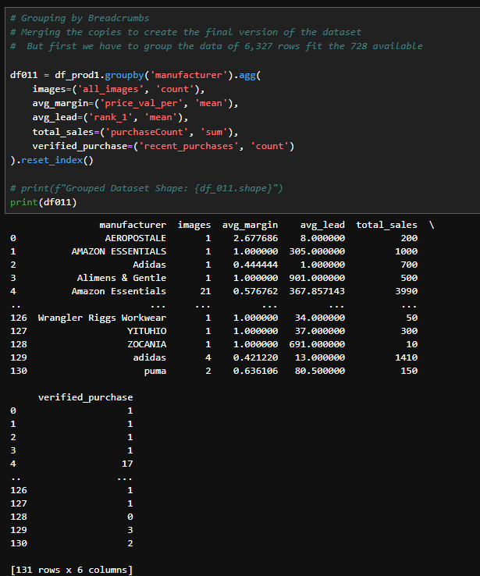

Methodology: Data Preprocessing

Methodology: Model Selection & Training/Evaluation

Results & Analysis: Presentation of Results

Interpretation of Findings & Recommendations
.

KPI Scenario Driving the Research
- In this scenario dataset provided include 2 - .csv files, one with products while the other has reviews. Both files relate with an ASIN number that is a Primary key due to its characteristic of appering once as a data row identifier, to one and a foreign key to the other noticed by the characterisitic of repeating its self in multiple rows, as a value
- With the goal in mind yielding more traffic, one of the key performance indicator will be the Sale conversion index, that is influenced by factors such as the price of product, rate on the reviews together with their sentiment score, without ignoring the availability rate and time required to receive the product. All these factor influence a consumer towards making a purchase and as the moderators, make a sale.
Equation Explaining the KPI
- With the indicators of choice and data provided from the dataset. Relations and preprocessig should be done in order to perfectly attain a relationship between the values and the performance indicator.
- In our case the following equation was formulated: Where by the factor of influence of our performance indicator is directly propotional with the recent_purchases (when they go up, means somthing is working hence the sale conversion rate goes higher), similarily the saame could be applied for the product_rating but rather inversly propotional to the price, since when price goes up then consumers have a tendency to shy away.
- Factor of influence = K (W1.recent_purchases x W2.product_rating ) / (W3.price_value)
While the K being a constant value representing the average_trime_delivery_index and the W1, 2 and W3 being the wighted value of influence to the datapoint since as to presented different values hae different levels of influence towards the indicator.
Why is the KPI needed.
- In such a case scenario, where by data in its vastness, is a complication to deal with. A sign is needed to help steer the priorioties of the next course of action to be taken, inorder to achieve set goals
- A KPI is introduced to link the leaders and the mathematicans, in which case a variable is introduced and based on its perfomance in either going up which indicates the course of actions applied are useful, while if it tanks / goes down indicates an immediate course of different actions subjected toweards turining the KPI in a positive direction.
Methodology and Data Preprocessing.
As we begin working with our dataset provided, the preprocessing step involved cleansing of dirty, unreasonable data present in the dataset. This preprocessing step acts like a bridge transforming raw, noisy data into usable data. In our case, deleteing Columns with null values more than 75%-null values, were eliminated, since they will just be unnecessary clutter.
Following up on this in order to get the full spectrum of the dataset the 2-.csv files were linked with reference on their ASIN values. Challenge encountered while doing such was, the 2-.csv filles had different data sizes, and this was going to be a problem later down the line of intergration and testing.
This was solved by Data intergration grouping all rows under the condition their ASIN numbers are the same. There for as for the ASIN column, we have a value, based on the characteristic of the different column, averages were calculated, sum-count was calculated, as for the natural lang data, words were concatenated.
Other pre-preocessing processes include

Data splitting,

Data Transformation,

Standardization and Converting non-numerical features
Data Splitting: Partitioning datasets securely into training, validation, and test subsets to guarantee-generalization capability while strictly fitting scaling objects to the training subset only.-Data Transformation: Standardizing the data format via numerical scaling (Min-Max scaling, Z-score standardization, Log transforms) and converting non-numerical features (One-Hot, Ordinal, or Target encoding).
Data Cleaning: Addressing structural issues by handling missing values (via deletion, statistical imputation like mean/median/mode, or advanced algorithms like k-NN and autoencoders) and neutralizing outliers using statistical methods (Z-score, IQR, DBSCAN, or Isolation Forests)..
Data Integration: Merging disparate multi-source data through schema matching, entity resolution, and correlation analysis to remove systemic redundancies.

Application of the Model Selected
- 2-ML algos, to fit your features
As it will be observed later in the report our data has no proper corellation, linear or quadratic, but it has potential in having a polynomial correlation and a some clusters were observed when working with the different sets of graphs from the visualisation we have done

The major Machine Learning algorithms therefor used in this case were Random Forest due to its robust ability to teach weak learners and make them stronger.
The other major Machine Learning Algorithm that had the potential of showing success was Polynomial regression due to its adaptability of rising the the powers of the initial features of the features of the logarithm.
- How KPI is predicted with what is had
Our KPIs are majorly influenced by the feature ‘purchaseCount’ and ‘CCV_Score’ in which both are heavily influenced by characteristic inputs from ‘avg_sentiment’ and ‘rating_count’ with more than 30% correlation as seen on the heatmap below.
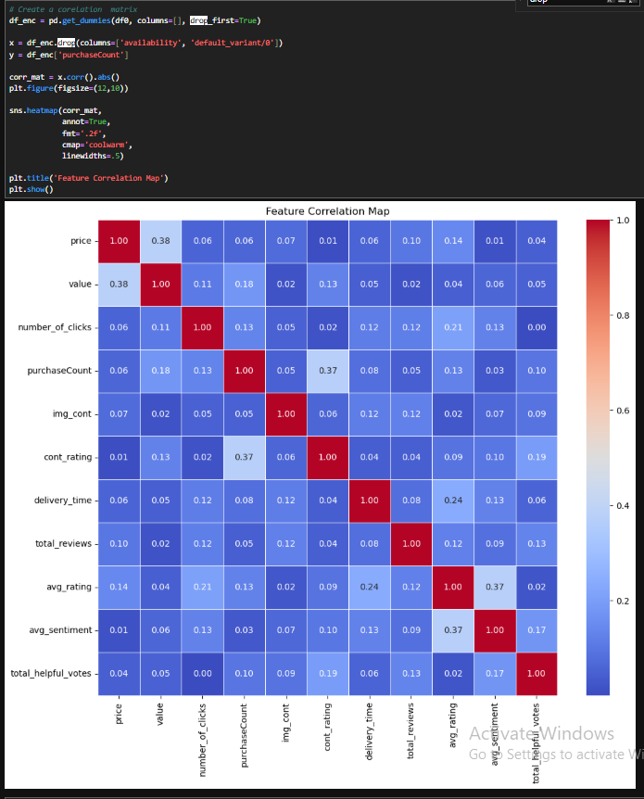

- Model Training and evaluation
With the Lasso Regression and random forest as our choice of Machine Learning algorithm, an 80-20 test train split was applied to the dataset.
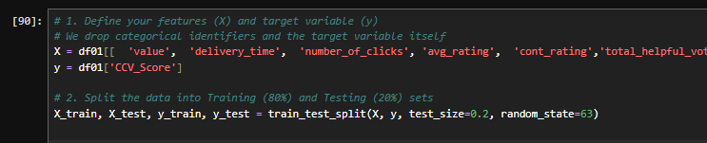
- Accuracy or precission
With the Accuracy and precission, the following is a simple glimse of how the variable came to be. CCV_Score
Lasso (L1) drives most coefficients to exactly zero, performing feature selection.
The R² and MSE tables above compare both models on the held-out test set.
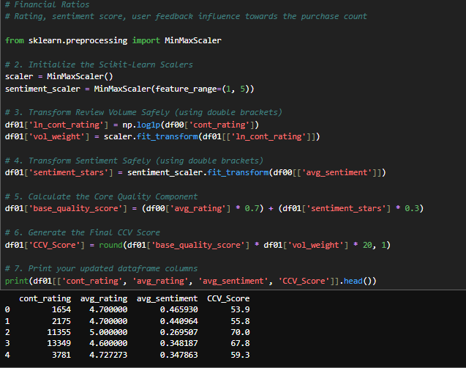
Correlation test and Data Leakage Detection.
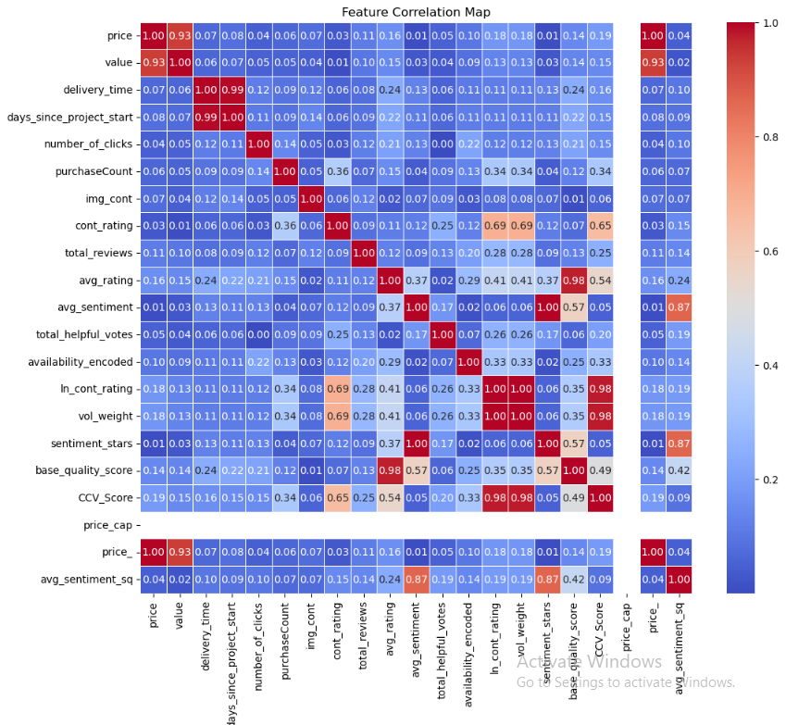

Utilize tables or chart
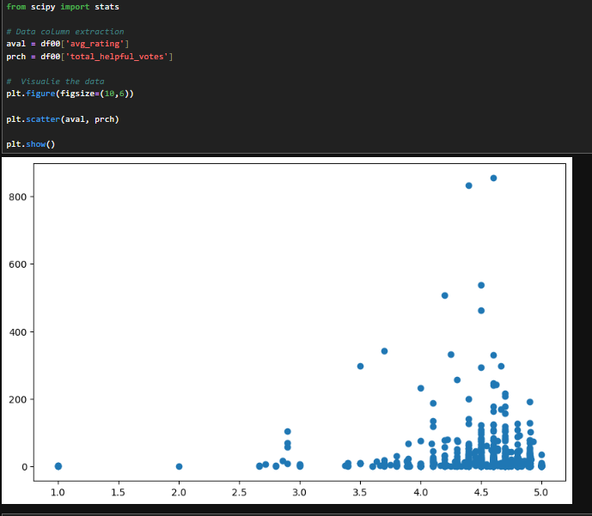
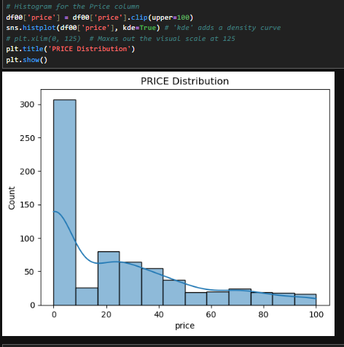
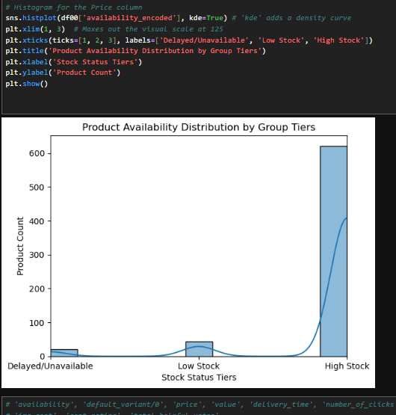
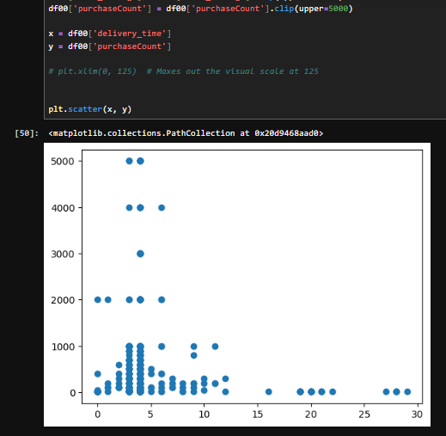
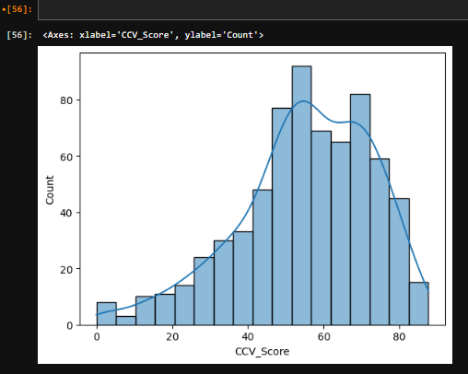
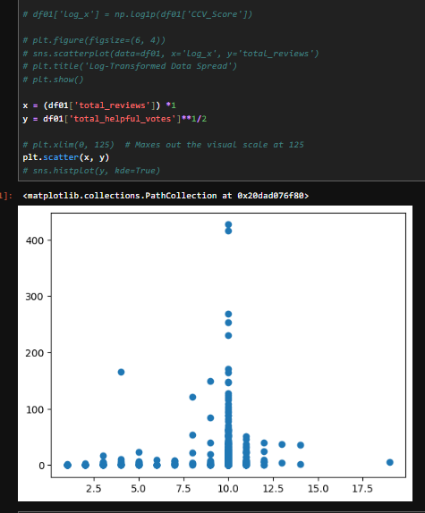
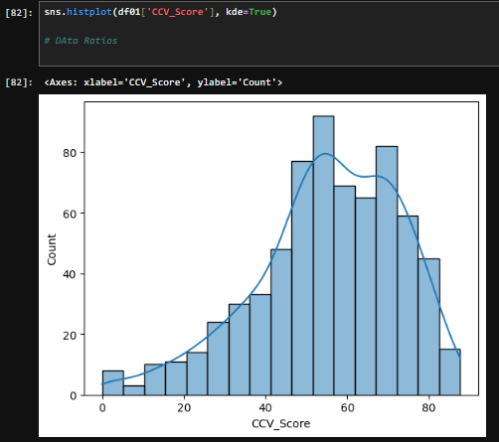
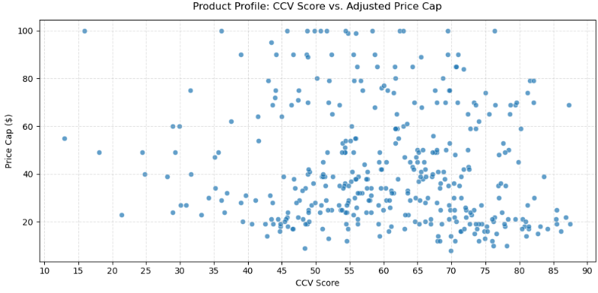

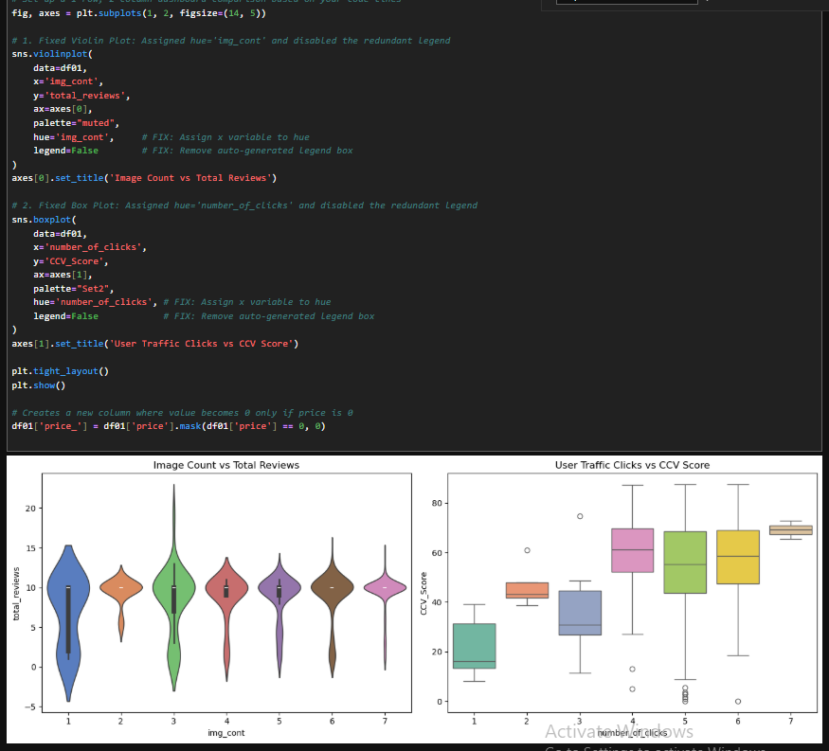

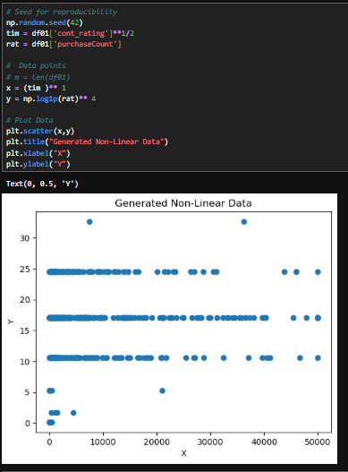
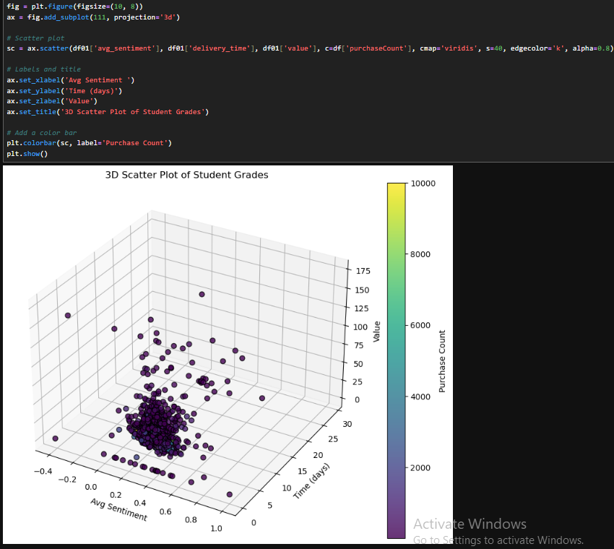
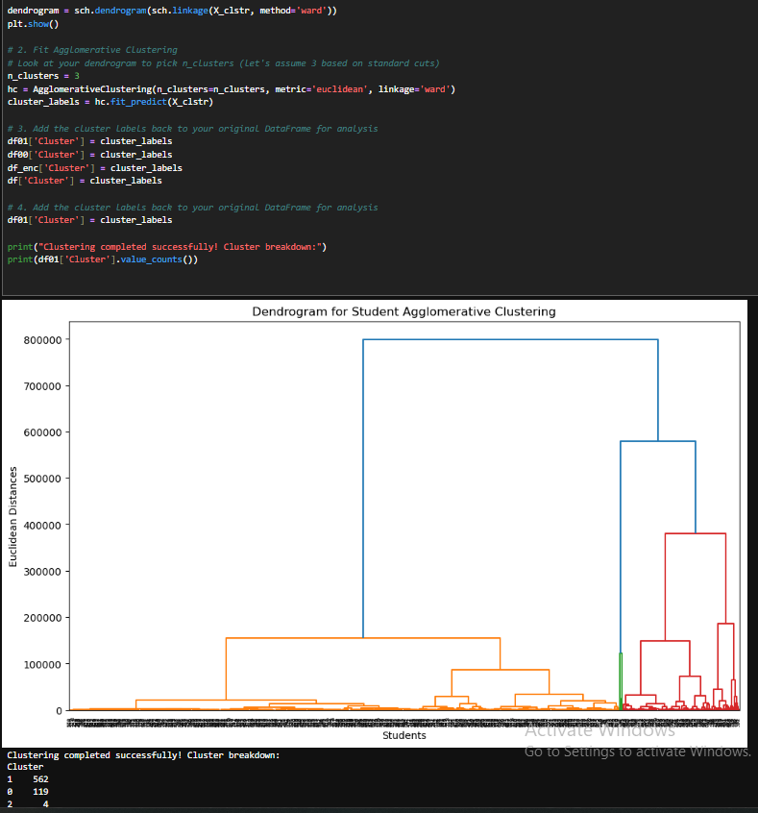
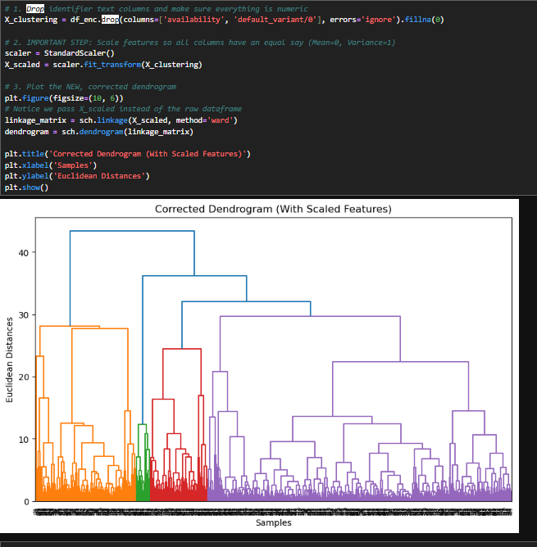
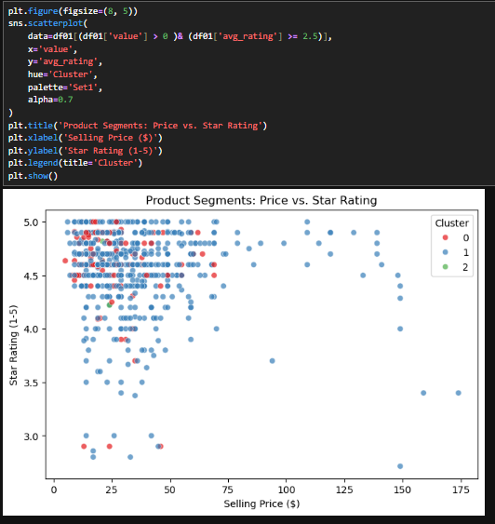

Compare the Evaluatrion metrics

CONCLUSION
Interpretation of various findings
- Key drivers of the business indicators (KPI)

Suggest next course of action
- Based on the Driver and Key results
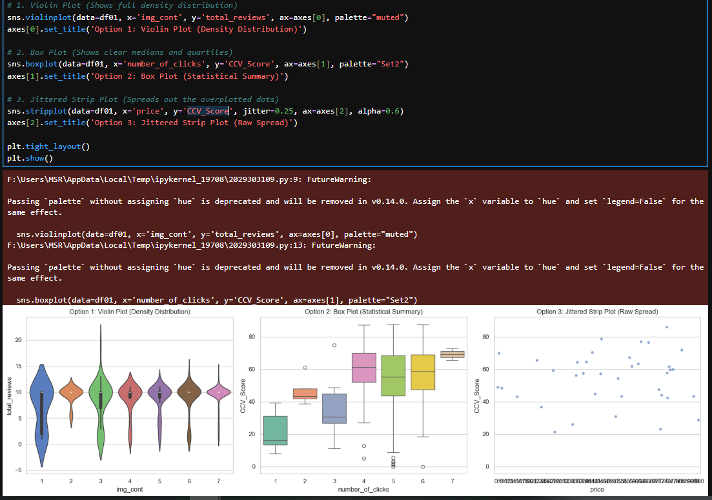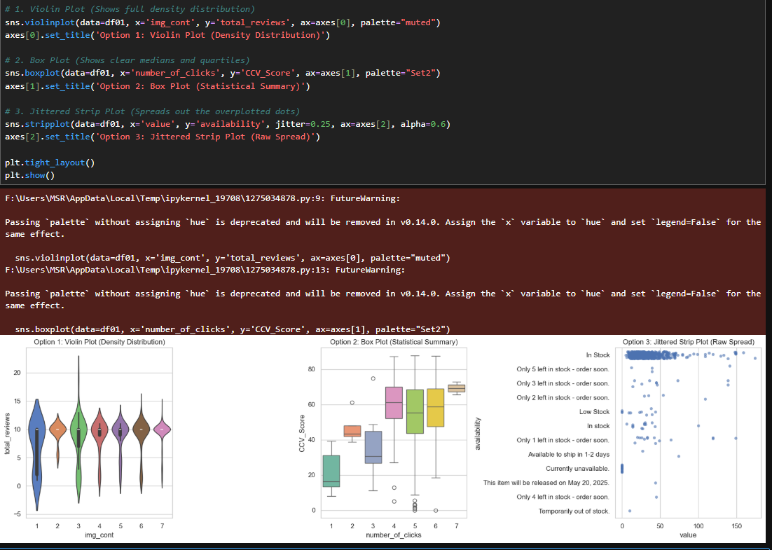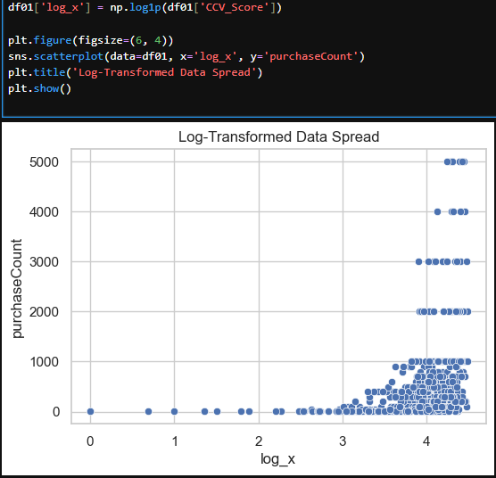

References:

- O'Connor, Kate Ann, 'The Challenges and Opportunities Created by a Global Pandemic's Effects on Consumer Shopping Behavior Within the Fashion Retail Industry' (Undergraduate Honors Thesis, University of San Diego, 2020) https://digital.sandiego.edu/cgi/viewcontent.cgi?article=1079&context=honors_theses [accessed 30 October 2026].
- Joshua Marriott, Tolga Bektaş, Eric Ka Ho Leung, Andrew Lyons,The billion-pound question in fashion E-commerce: Investigating the anatomy of returns,Transportation Research Part E: Logistics and Transportation Review, Volume 194,2025)
Digital: https://doi.org/10.1016/j.tre.2024.103904. (https://www.sciencedirect.com/science/article/pii/S1366554524004952) [accessed 30 October 2026]

