Marketing Performance SQL Queries
A. KPIs
- Total spend
select cast(sum(spend) as decimal(18, 2)) as total_spend
from campaign_performance;
Output:
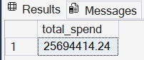

- Total revenue
select cast(sum(revenue) as decimal(18, 2)) as total_revenue
from campaign_performance;
Output:
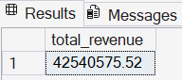

- Total Impressions
select cast(sum(impressions) as decimal(18,2)) as total_impressions from campaign_performance;
Output:
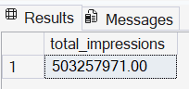

- Total clicks
select cast(sum(clicks) as decimal (18,2)) as total_clicks
from campaign_performance;
Output:
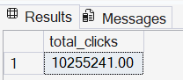

- Total conversions
select sum(conversions) as total_conversions
from campaign_performance;
Output:
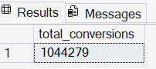

- Overall ROAS (Revenue Per Dollar Spent)
select cast(sum(revenue) / nullif(sum(spend), 0) as decimal (18,2)) as overall_roas
from campaign_performance;
Output:
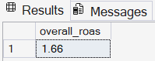

- Overall CTR (Click-Through Rate)
select cast(sum(clicks) * 1.0 / nullif(sum(impressions), 0) as
decimal (18,2)) as overall_ctr
from campaign_performance;
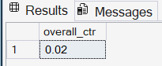
Output:

- Overall Conversion Rate
select cast(sum(conversions) * 1.0 / nullif(sum(clicks), 0) as decimal (18,2)) as overall_conversion_rate
from campaign_performance;
Output:
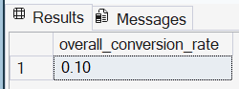

- Overall CPA (cost per conversion)
select cast(sum(spend) / nullif(sum(conversions), 0) as decimal (18,2)) as overall_cpa
from campaign_performance;
Output:
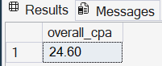

- Overall ROI
select
cast((sum(revenue) - sum(spend)) / nullif(sum(spend), 0) as decimal(18,2)) as overall_roi
from campaign_performance;
Output:
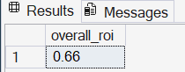

- Overall CPC (Cost Per Click)
select
cast(sum(spend) / nullif(sum(clicks), 0) as decimal(18,2)) as overall_cpc
from campaign_performance;
Output:
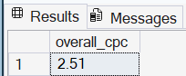

B. By campaign ROAS, CTR, Conversion Rate, CPC, CPA

select campaignname,
cast(sum(spend) as decimal (18,2)) as total_spend,
cast(sum(revenue) as decimal (18,2)) as total_revenue,
sum (impressions) as total_impressions,
sum(clicks) as total_clicks,
sum(conversions) as total_conversions,
cast((sum(revenue) - sum(spend)) / nullif(sum(spend), 0) as decimal (18,2)) as roi,
cast(sum(revenue) / nullif(sum(spend), 0) as decimal (18,2)) as roas,
cast(sum(clicks) * 1.0 / nullif(sum(impressions), 0) as decimal (18,2)) as ctr,
cast(sum(conversions) * 1.0 / nullif(sum(clicks), 0) as decimal (18,2)) as conversion_rate,
cast(sum(spend) / nullif(sum(clicks), 0) as decimal (18,2)) as cpc,
cast(sum(spend) / nullif(sum(conversions), 0) as decimal (18,2)) as cpa
from campaign_performance
group by campaignname
order by roi desc;
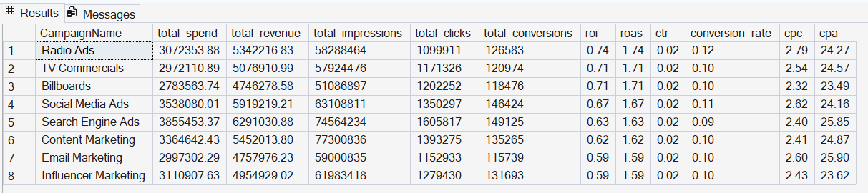
Output:

C. By region ROAS, CTR, Conversion Rate
select region,
cast(sum(spend) as decimal(18, 2)) as total_spend,
cast(sum(revenue) as decimal(18, 2)) as total_revenue,
cast((sum(revenue) - sum(spend)) / nullif(sum(spend), 0) as decimal(18, 2)) as roi,
cast(sum(revenue) / nullif(sum(spend), 0) as decimal (18,2)) as roas,
cast(sum(clicks) * 1.0 / nullif(sum(impressions), 0) as decimal(18, 4)) as ctr,
cast(sum(conversions) * 1.0 / nullif(sum(clicks), 0) as decimal(18, 4)) as conversion_rate
from campaign_performance
group by region
order by roi desc;
Output:
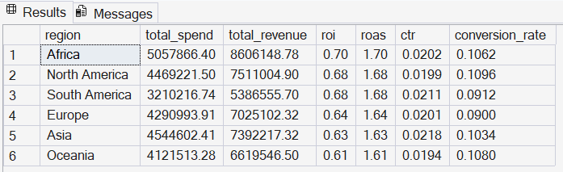
D. By Industry ROAS, CTR, Conversion Rate
select industry,
cast(sum(spend) as decimal(18, 2)) as total_spend,
cast(sum(revenue) as decimal(18, 2)) as total_revenue,
cast((sum(revenue) - sum(spend)) / nullif(sum(spend), 0) as decimal (18,2)) as roi,
cast(sum(revenue) / nullif(sum(spend), 0) as decimal (18,2)) as roas,
cast(sum(clicks) * 1.0 / nullif(sum(impressions), 0) as decimal(18, 4)) as ctr,
cast(sum(conversions) * 1.0 / nullif(sum(clicks), 0) as decimal(18, 4)) as conversion_rate
from campaign_performance
group by industry
order by roi desc;
Output:
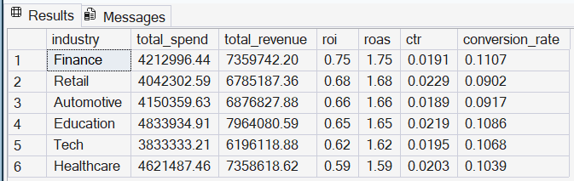

E. Digital Vs. Traditional
select
cd.type,
cast(sum(cp.spend)as decimal(18,2)) as total_spend,
cast(sum(cp.revenue)as decimal(18,2)) as total_revenue,
cast((sum(cp.revenue) - sum(cp.spend)) / nullif(sum(cp.spend), 0) as decimal(18,2)) as roi
from campaign_performance cp
join campaign_details cd
on cp.campaignname = cd.campaignname
group by cd.type
order by roi desc;
Output:
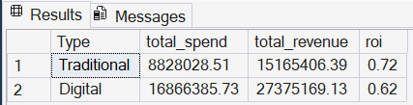

F. Best performers
select top 5
campaignname,
region,
industry,
cast(spend as decimal(18,2)) as spend,
cast(revenue as decimal(18,2)) as revenue,
cast((revenue - spend) / nullif(spend, 0) as decimal(18,2)) as roi
from campaign_performance
order by roi desc;

Output:
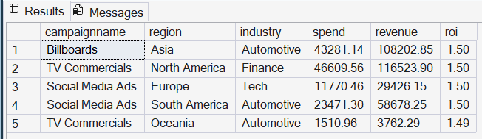

G. Worst Performers
select top 5
campaignname,
region,
industry,
cast(spend as decimal(18,2)) as spend,
cast(revenue as decimal(18,2)) as revenue,
cast((revenue - spend) / nullif(spend, 0) as decimal(18,2)) as roi
from campaign_performance
order by roi asc;
Output:
