How to backup Ubuntu

Useful links
StackOverflow

48
Who is this for: users that have normal regular use of their computer, that have done minimal or no configuration outside their home folder, did not mess up startup scripts and services. A user that wants to have his software restored to how it was when he installed it with all customizations being done and kept in their home folder.
Who this will not fit for: servers geeks, power users with software installed by source (restoring the package list might break your system), users that have changed the startup script of some application to fit better their needs. Caution: there is a big chance any modifications outside home will be over written.

Backup your current packages and user settings

Once you are ready with your system and happy with the software installed you can get a list of the installed packages using the command dpkg --get-selections and save the output in to a log file.
Create a backup folder in your home
sudo mkdir ~/backup
Save the currently installed packages list
dpkg --get-selections > ~/backup/installed_packages.log
Make a backup of your apt sources file
sudo cp /etc/apt/sources.list ~/backup/sources.bak
and a copy of your apt's list of trusted keys
sudo apt-key exportall > ~/backup/repositories.keys
Make a backup of your home folder with the integrated backup tool in Ubuntu, Deja-dup.
- Set the backup folder
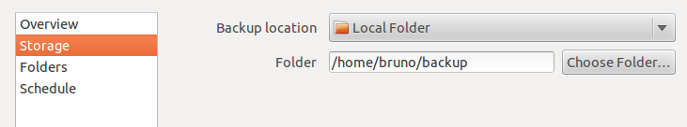
- Verify that it will make a backup of your home folder and add any folders your might not want, like for instance the Trash folder
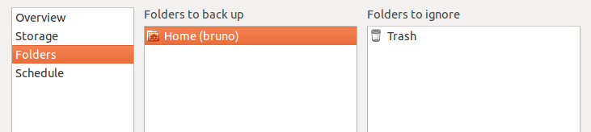
- On the overview tab press Make Backup Now to backup your home folder
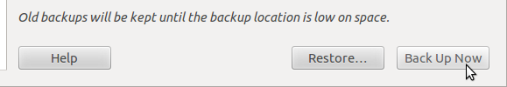
- The backup tool will ask if you want to add a password to your backup, your choice. Your backup will start after you press Continue
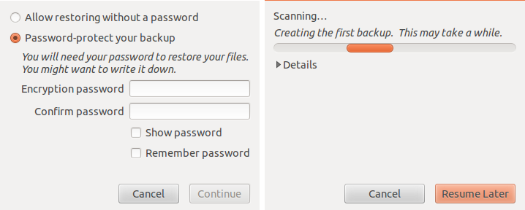
When this is done you will have a backup of your packages and configuration files relative to your user. If when necessary you will be able to restore your files from the ~/backup folder.

Restoring your backup

Start by restoring the sources file from the backup made
sudo cp ~/backup/sources.bak /etc/apt/sources.list
The backed-up keys
sudo apt-key add ~/backup/repositories.keys
Update your sources lists
sudo apt-get update
Restore the packages from the saved installed_packages.log
sudo dpkg --clear-selections
sudo dpkg --set-selections < ~/backup/installed_packages.log && sudo apt-get dselect-upgrade
sudo dpkg --clear-selections will mark all current packages installed for removal, that way when you restore your saved package list the packages that are not on the list will be removed from your system.
Remove your current configuration from your home creating a backup of the folder in their current state (after all, whats the use of restoring fresh files if there are other there that can affect the configuration?)
mkdir ~/.old-gnome-config/ && mv ~/.gnome* ~/.old-gnome-config/ && mv ~/.gconf* ~/.old-gnome-config/ && mv ~/.metacity ~/.old-gnome-config/ && mv ~/.cache ~/.old-gnome-config/ && mv ~/.dbus ~/.old-gnome-config/ && mv ~/.dmrc ~/.old-gnome-config/ && mv ~/.mission-control ~/.old-gnome-config/ && mv ~/.thumbnails ~/.old-gnome-config/ && ~/.config/dconf/* ~/.old-gnome-config/
After this is done restore the backup created with Deja-dup.
- Open the backup tool and on the overview tab press restore
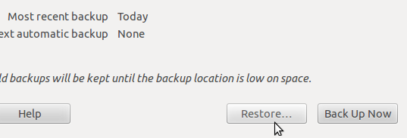
- Follow the prompts to restore the files to their original positions
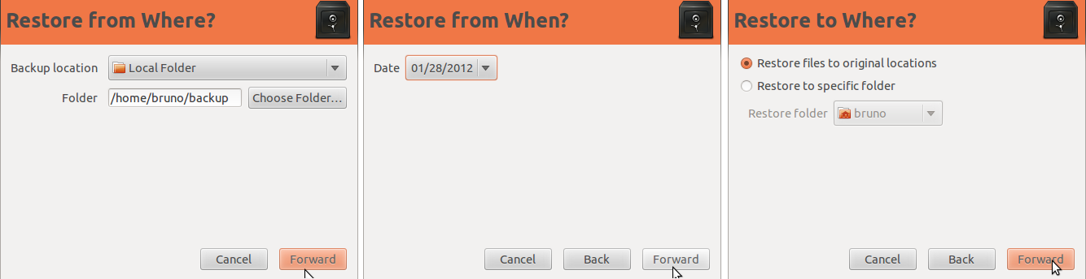
After this is done you will have your packages back to the saved selection, our configuration restored and hopefully a working desktop, all of that without installing a single extra application and using the Ubuntu default tools.
The only thing left is to do some clean up and check that everything is working.

Something went wrong, my desktop is gone

There are a few posts in Ask Ubuntu that can guide you in case something when wrong and you need to hard reset your desktop. If something when wrong and you find your self needing to do so, please have a look at these posts:
- How to reset Gnome to defaults?
- How to reset Compiz/Unity configuration?

