**Stateset**

Dominic J. Steil

Founder

Stateset v0.1: November 7, 2019

Stateset v0.2: April 16th, 2020

Stateset v0.3: February 8th, 2022

Version: 0.2

**Abstract**

A statically generated progressive web application layer on top of an interoperable decentralized, replicated, authoritative global state machine with minimal trust between nodes would allow for the creation of a distributed commerce automation platform. We present Stateset, a distributed blockchain network, and describe in detail how it achieves the goal of a globally distributed shared single-source-of-truth between firms, providing a secure and state-of-the-art platform for managing commerce operations. Stateset is built on 8 fundamental technologies; the Cosmos-SDK, Tendermint BFT Consensus Engine, CosmWasm smart contract framework, IBC for transport, authorization and ordering of packets with other blockchain networks, IPFS for content addressed networking and storage, Next.js React framework, Hasura GraphQL API Engine and the Bitcoin Lightning Network.

**Stateset Network**

**Stateset** is a next-generation commerce automation network for the world.

There will be a collective oneness for all businesses where contracts, assets, capital, transactions and messages can be securely transacted freely without intermediaries or enforcement agents. Our vision expands across enterprise SaaS computing, eCommerce and financial services. There will be an interoperable network of blockchains using a composable set of distributed business and financial workflows that have a shared common global state between organizations.

In Stateset, *data is owned by the customer, the key holder and the business processes are shared between a global network of nodes transacting sale and finance information.* Modules for different processes between counterparties are richly composable and distributed amongst a network of peers and nodes in the network. We exchange the paradigm of custom implemented and siloed workflows within one organization for a new orchestrated, shared and agreed upon set of computational contract flows between nodes in a globally distributed network. We imagine entire value chains of trade partners onboarding into the network in groups of producers or consumers, merchants and warehouses, lenders or suppliers, brokers or providers, controllers or processors of data subjects; any form of party and counterparty. Robust data mapping has been built into the platform to ensure that these types of trade partners are using a platform that is logically centralized but organizationally decentralized across network participants. This is the natural progression of computing. Going from on-premise databases, to distributed cloud multi-tenant instances, to a completely decentralized global platform for business to business and commerce workflows involving sales, finance, back office and other key revenue driving processes. Stateset is the infrastructure for the future of this computing paradigm. There will be a network of interoperable economically incentivized blockchain networks; the cornerstone of the infrastructure of global economy over the next two decades.

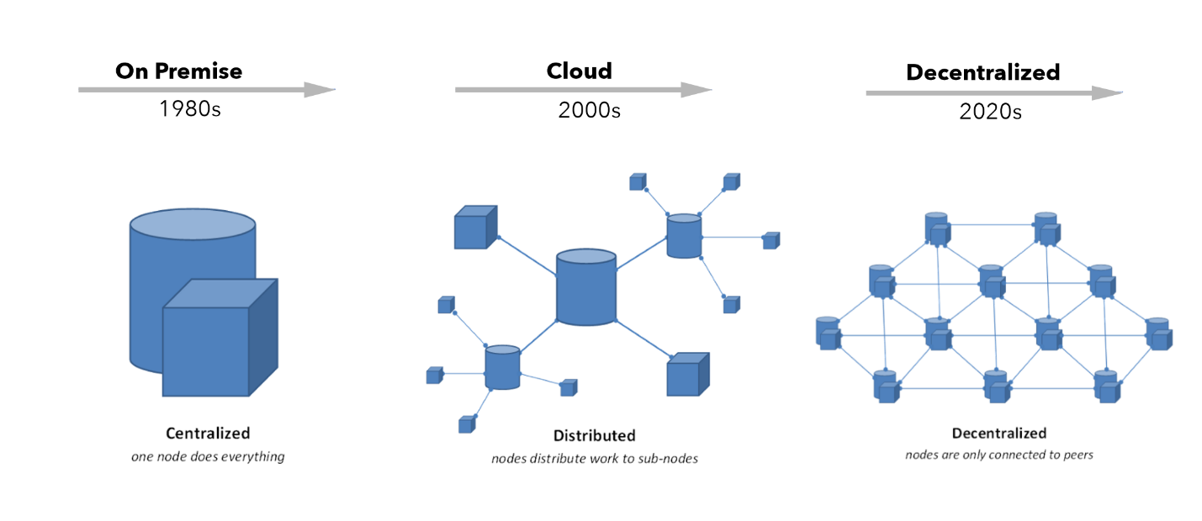

Data and processes will be implemented upon multiple blockchain protocols that are local to specific regions but that interact with each other through the infrastructure layers. These sections will have their own form and order of transactions and be able to interchange assets with Stateset leveraging the same replicated and highly available cluster of nodes communicating via ABCI. Stateset has delivered a structured format and set of workflows with deterministic transaction outputs for commerce automation that are traversable between the nodes at a point-to-point network layer.

Stateset is going to displace legacy enterprise software, on-premise and cloud business solutions; with next-generation technology that is more secure and robust. It is built on state-of-the-art Byzantine Fault Tolerant engine in Tendermint and an enterprise-grade, distributed state machine framework. It will be a global and open constant, an infrastructure and shared distributed system of record network of nodes that are able to exchange assets, messages and other types of state and information securely and instantly across the globe.

**Stateset Network**

**Stateset** at the infrastructure level is comprised of a distributed network of nodes used for instantiating commerce workflows. The network allows for net new nodes on the network to join and leave the network at will with other nodes in the network. The network leverages a thin waist and uniform peer-to-peer networking protocol for assimilation and standardization across the network. An organizations services on the network consists of the docker containers GraphQL engine, Spring REST service and each nodes PostgreSQL. Containers are provisioned using Terraform and are orchestrated using Kubernetes. Docker files are used to containerize the application as well as to update different services on the network. PostgreSQL is used as the underlying RDBMS. Nodes on the network are able to instantly communicate with other nodes on the network in real-time on a global transaction network. The business information that is executed will be the same shared computational contractual logic across same across every node in the network. Double spending of input states is prevented using a cluster of nodes using Tendermint BFT which communicate with the Stateset State Machine using ABCI (Application Blockchain Interface).

**HSM and Key Management**

**Keys** will be managed by the individual users and the organizations on the network. The Key Management is leveraging a HSM to secure the keys to sign messages on the network. The cryptographic operations that are performed by the HSM are key generation and signing. The private key material is stored in the HSM if the node is configured to use an HSM. The public keys are stored in the HSM (if configured for the node) and the respective key stores, which is the node key store for the node CA key and legal identity of the organization on the network. The certificate chain is stored there as well. The certificate chain is not stored in the HSM. Operations involving the private keys such as signature generation will be delegated by the node to the HSMs, while operations involving the public keys will be performed by the Stateset node.

**Stateset Agents**

**Agents** are individual actors on the Stateset Network that can execute computational contracts. The Stateset network will have agents living on the network that are instantiating contracts between entities on the network. The agents will also be able to give the same answer to everyone across the network. The Agents will be operated via voice and text using a deep learning based Natural Language Understanding RNN powered by GPT-3. Data from the Stateset Network can be extracted from the PostgresDB and used for training data for the Stateset Agent which can optimized for question-answering based use cases in addition to for generating code. The RNN is called upon via voice and text and the agents are able to traverse the Stateset network to execute transactions on behalf of users. The agents are able to effectively leverage the RPC calls on the network to configure parameters or metadata about the chain. A custom metadata page is accessible via the agents for updating the parameters of the network. The agents are leveraging natural language processing to perform intent and entity detection from a given utterance which can that trigger actions on other chains via Interchain Accounts. The agents are stateless and query directly data directly from the different blockchain networks connected via IBC. Many abstractions of the agent will be available depending on the endpoints. One of the most anticipated endpoints will be audio that are calling to the agent to perform state changes on the network such as transactional operations and querying state from the blockchain networks. Other anticipated application will be voice usage in VR and AR systems to make wake call at which point the agent would be leveraged as a broker between the different API endpoints and chains.

**Stateset Network Governance**

**Governance** of the Stateset Blockchain Network will be done on chain using the modules given by the Cosmos-SDK. This includes all upgrades across the network for platform versioning. These include governing limits associated with max transactions and message sizes and the computation that occurs across the network. Governance also includes the actual core committers to the codebase and the ownership of the technology. The Stateset Network is Open-Source Software. This means that developers can contribute to the opensource version of the protocol.

**Stateset Platform DevOps**

**Stateset** **Platform** uses continuous integration / continuous deployment using Terraform and Kubernetes Engine on Google Cloud Platform (GCP). The Terraform Provider for Stateset deploys the Hasura instance with a Cloud SQL Database Proxy Container connecting to the Postgres Database running on Cloud SQL. On net new customer sign up; a terraform script is called upon and deploys the entire stack of containers in GKE with a prefix dependent on the customer’s nodeName. Docker Containers and Docker Compose can also be used to standup initial networks. Consul is used for service mesh networking and service registry discovery for the Stateset Network. 3 Consul Servers are used to manage agents that are sidecars for services running on the Stateset Network. These agents are able to broker message back to the Server cluster which uses Raft consensus to come to a single source of truth on the services that are running on the network. Kubernetes on GKE with Consul based mesh networking provides visibility into the network infrastructure and services that are running.

**Virtual/Augmented Reality Interface**

**VR/AR** will be used as a graphical user interface and input layer for interacting with Stateset. Stateset leverages virtual and augmented reality headsets as well as Augmented Reality from mobile devices to interact with the Stateset network. The primary input mechanism is voice leveraging Natural Language Processing to activate flows on the network. The computational contracts are leveraged to make state changes across the Stateset network. Hololens will be used as an interface into the ledger specifically how to visualize the current state of the contracts that have been deployed on the network. The ability to see the transactions that have occurred in a simple interface that multiple companies can operate on is essential.

**IBC**

**IBC** is like TCP/IP for Blockchain Networks. Interoperability is a key component for developing the next generation of blockchain and cryptographic networks by having traversable and configurable chains that have metadata that is immutable but data that is mutable. Metadata can control governance structures, consensus algos, modifications for different type of blockchain transaction mechanisms and other types of modules. The inter-blockchain communication protocol is a catalyst for the polycentric interchain. Different application specific blockchain networks are going in to be used in different use cases. They currently cannot talk to each other, transfer packets, between blockchains such as token transfers, signatures, votes and other types of transactions. Currently all of the assets on different chains are siloed. Use the unique features of each chain communicate. IBC is a messaging protocol for the interchain. Authenticated, Ordered and Route topology between networks. IBC enables chain innovation and continuous innovation across multiple state machines. Stateset specializes in commerce automation with a focus being interoperable with other state machines and smart contracts in the IBC ecosystem. These can be interactions such as: one transfer from one to another, start a transfer on one chain, send an outgoing queue on the other, message on the other chain to receive that data, and client to verify data, send an acknowledgement that it completed, time out packets as well, after certain amount of blocks that packet can timeout.

**Bitcoin Lightning**

Bitcoin Lightning Network is an advancement in leveraging the shared security of the Bitcoin Network in order to create a privacy preserving and instant payment settlement network for the internet. It seems like the only hiccup is the initial creation and funding transaction but other than that the commitment transactions are effective at keeping low cost instant bitcoin payments between users. The best analogy is putting your card down at a bar and opening a tab. Every time you add a commitment transaction when you buy a drink, or you update the balance between you and the bar. When you are done the entire balance is cleared on the network (or in bitcoin terms the channel is closed and settled. The Lightning Network protocol is a 2-of-2 multi-signature program that allows for these transactions to be settled off of the main bitcoin network by the fulfillment of payment invoices. The program is designed to allow users to fund a channel for future payments and commitment transactions between channel participants are kept. Stateset will use the Bitcoin Lightning network for global payments and security as a base protocol for internet native money.

**Next.js and GraphQL**

Stateset Platform provides a user interface to call workflows between organizations and read state from one organizations node using graphql and the next.js react framework. The platform is closed source is a client for calling Stateset but is not required to use the Stateset network. Entities can choose to build their own clients for interacting with the Stateset Network. The Stateset platform is managed service which is hosted using serverless functions powering server rendered react web pages and statically generated web pages connected to CMS systems. Next.js is quickly becoming the leading web application framework and coupled with GraphQL it is a fast, responsive and best-in-class framework for developing a web interface to interact with the Stateset Network. GraphQL on top of the Postgres Nodes allows us to create subscriptions on states to receive the data in real time at the network level. The graphql engine combined with react hooks and the next.js routing is a great combination for traversing the stateset in real-time and implementing transaction workflows across companies. We recognize that contracts could be much more composable and written in the same language as our interface layer, JavaScript. Combined with graphql, we could create the secure third-party component system for developers to build on the Stateset platform.

Commerce is a rich set of market interactions that emerge when territory and abilities are abstracted into “rights”, and a rich set of arrangements that emerge for the mutually acceptable transfer of these rights. For large scale electronic commerce, we should concern ourselves with those rights which are both representable electronically and enforceable electronically, and with mutually enforceable arrangements for their transfer. These instruments represent the discovery of many new kinds of rights, and ways of deriving these rights from more primitive rights.

**Conclusion**

We have proposed a system for commerce automation workflows powered by computational contracts. We started with the usual framework of enterprise processes within a company related to revenue driving applications but it is incomplete without a way to share state and the business process between different organizations in the value chain. To solve this, we proposed a peer-to-peer network of nodes that are able to use the computational contractual framework for real-time transactions that are notarized using Tendermint BFT to record a history of all transactions that quickly is replicated across a cluster of notary nodes. This creates an authoritative shared and open state system between organizations around the world.