Jack Collins
Linux Administrator, with a focus in
Security and Ansible Automation

jackcollins.me.uk
jackcollins1434@yahoo.com
07598 479136
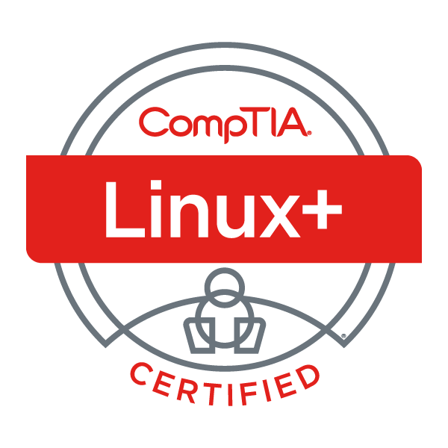
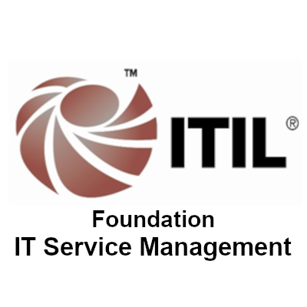

Red Hat Linux
I have been a Red Hat Linux Administrator for over 5 years so far. I have spent the vast majority of my career on the Linux command line.
I am also certified via CompTIA Linux+ and have written many Linux articles on jackcollins.me.uk.
Ansible Automation
I've been working with Ansible since 2019, implementing many automation projects, including patching solutions for hundreds of servers and integration in to Git and Ansible Tower.
I use my extensive knowledge of Ansible automation daily, to work quickly and efficiently, writing code on-the-go.
Patching & Vulnerability Management
I'm involved with daily vulnerability analysis and mitigation via Nessus (Tenable.io).
I'm also a VIP member of HackTheBox, a penetration testing learning platform, as well as having my own labs to practice hacking and learn more about vulnerabilities; how to exploit them, and how to defend against them.

Certifications
- CompTIA Linux+
- ITILv3 Foundation in IT Service Management

Attended
- Red Hat Certified Specialist in Ansible Automation
- RH124 Red Hat Administrator I
- RH134 Red Hat Administrator II
- Previously certified AWS Cloud Practitioner (valid for 3 years)

Additional Experience
- AWS EC2, S3, IAM, Amplify, Lambda
- Kali & Parrot OS (Debian), Windows
- Ansible Tower
- Checkmk (Linux monitoring solution)
- System Centre Operations Manager (SCOM)
- Nessus (Tenable.io)
- McAfee (on Linux)
- Bash, PowerShell, Python
- NVQ 2 Customer Service
- BTEC National Diploma in Design Crafts
(Highest grade – Triple Distinction)

Employment History
Employer | Position | Dates
ReAssure (Phoenix Group) | Platform Engineer (Operations) | July 2022 - Present
ReAssure | Red Hat Linux Administrator | Oct 2018 – July 2022
ReAssure | Enterprise Monitoring Engineer | Apr 2018 – Oct 2018
ReAssure | IT Service Desk Agent | Nov 2014 – Apr 2018

