ASSIGNMENT 1
Introduction to Web Development

Name: Pradyumn Singh
University Roll No.: 2415001127
Section: SB
Class Roll No.: 43

______________________________________________________________________________
Q1. Explain the difference between frontend, backend, and full-stack development with suitable real-world examples.
When we build a website or an app, the work is usually split into two major halves — what the user sees, and what runs behind the scenes. Frontend development is the visual, interactive part of a website — everything the user directly sees and clicks on, like buttons, menus, colours, forms, and animations. It is built mainly using HTML, CSS, and JavaScript, along with frameworks like React or Next.js. For example, when you open Instagram and scroll through your feed, like a post, or open the comment box, that entire experience is powered by frontend code.
Backend development, on the other hand, is the hidden engine of the application. It handles the logic, database operations, authentication, and business rules that the user never sees directly. It is usually written in languages like Node.js, Python, Java, or PHP, and it talks to databases like MySQL or MongoDB. Continuing the Instagram example, when you upload a photo, the backend is the part that stores that image, updates your profile, and notifies your followers.
Full-stack development simply means a developer is comfortable working on both sides — frontend and backend — and can build a complete, working application on their own. A full-stack developer might design the login page (frontend), and also write the code that checks the password and creates a session (backend). Many startups today prefer full-stack developers because they can single-handedly take an idea from an empty folder to a live, functioning product.

Q2. Create a simple diagram showing how the client-server model works in web architecture.
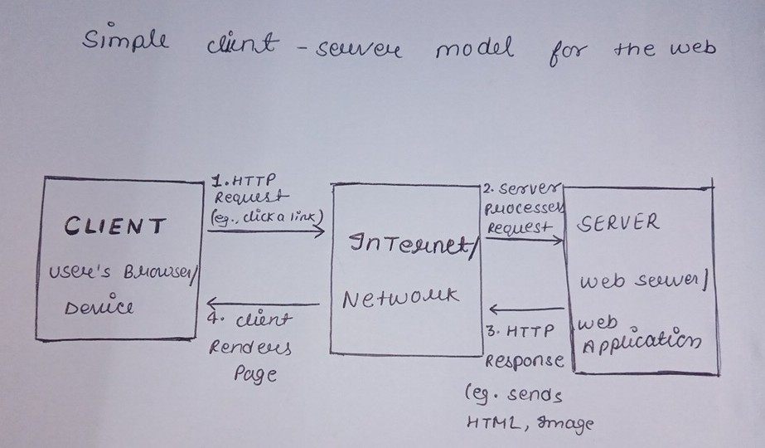

Q3. Describe how a browser requests and displays a web page from a web server.
Whenever we type a URL like www.example.com in the address bar and hit enter, a whole sequence of steps happens within a fraction of a second. First, the browser looks up the domain name using DNS (Domain Name System) to find the actual IP address of the server hosting that website. Once it has the IP address, the browser opens a connection with the server, usually using the HTTP or HTTPS protocol, and sends a request asking for the specific page.
The web server receives this request, figures out what is being asked for, and may talk to a database or run some backend code if the page is dynamic. After processing, the server sends back the response — this usually includes an HTML file, along with linked CSS and JavaScript files, and any images. The browser then reads this HTML line by line, builds the page structure (DOM), applies the CSS styling, runs the JavaScript, and finally paints everything on the screen for the user to see.

Q4. Identify and list the tools required to set up a web development environment. Explain the purpose of each.
Setting up a proper development environment makes coding faster and far less frustrating. Here are the essential tools:
- Code Editor (e.g., VS Code) — used to write, edit, and organize HTML, CSS, JavaScript, and other project files with helpful features like syntax highlighting and extensions.
- Web Browser (e.g., Chrome, Firefox) — used to run and preview the website, and also comes with built-in developer tools to inspect and debug code.
- Version Control System (Git) — tracks every change made to the code and allows multiple people to collaborate without overwriting each other's work.
- Node.js and npm — Node.js lets JavaScript run outside the browser, and npm (Node Package Manager) is used to install libraries and frameworks like React or Express.
- Terminal / Command Line — used to run commands, start servers, install packages, and manage the project without relying only on the mouse.
- Local Server (e.g., Live Server extension, XAMPP) — allows the developer to test the website on their own computer before it is deployed online.
- Browser Developer Tools — built into browsers, these help inspect HTML elements, debug JavaScript errors, and check network requests.

Q5. Explain what a web server is and give examples of commonly used servers.
A web server is a computer program (running on a physical or cloud machine) that stores website files and delivers them to users whenever they request a page through their browser. In simple terms, it is the 'waiter' of the internet — it takes the customer's (browser's) order and brings back the requested dish (webpage). Web servers listen constantly for incoming requests over HTTP or HTTPS and respond with the appropriate content, whether that is a static HTML file or a dynamically generated page.
Some commonly used web servers include:
- Apache HTTP Server — one of the oldest and most widely used open-source web servers.
- Nginx — known for being lightweight and handling a large number of connections efficiently, often used for high-traffic websites.
- Microsoft IIS (Internet Information Services) — commonly used with Windows-based servers and .NET applications.
- Node.js (Express server) — allows developers to build a custom server directly using JavaScript.

Q6. Define the roles of a frontend developer, backend developer, and database administrator in a project.
In a typical web project, work is divided among specialists so that each part of the system is handled by someone who understands it deeply. A frontend developer is responsible for the look, feel, and interactivity of the application — building the pages, ensuring the design works on different screen sizes, and making sure buttons, forms, and animations behave correctly.
A backend developer focuses on the server-side logic — writing the APIs, handling authentication, processing data, and connecting the application to the database. They make sure that when a user performs an action on the frontend, the correct data is saved, updated, or retrieved securely.
A database administrator (DBA) is responsible for designing, maintaining, and securing the database itself. Their job includes creating efficient table structures, taking regular backups, optimizing slow queries, and ensuring that sensitive data is protected from unauthorized access or loss.

Q7. Install VS Code and configure it for HTML, CSS, and JavaScript development. Take a screenshot of the setup.
To set up VS Code for web development, I downloaded and installed it from the official Visual Studio Code website, following the installer steps for my operating system. After installation, I opened the Extensions panel and installed a few extensions that are extremely useful for frontend work — Live Server (to preview HTML pages instantly with auto-reload), Prettier (to auto-format code consistently), and the built-in HTML/CSS/JavaScript IntelliSense support for autocompletion and error detection.
I then created a project folder with an index.html, a style.css, and a script.js file, linked them together, and opened the folder directly in VS Code using the 'Open Folder' option. Running the Live Server extension launched the page in the browser and automatically refreshed it whenever I saved a change, confirming that the environment was correctly configured. (Note: The actual screenshot of this setup should be captured on your own system and attached separately, as it reflects your personal machine.)
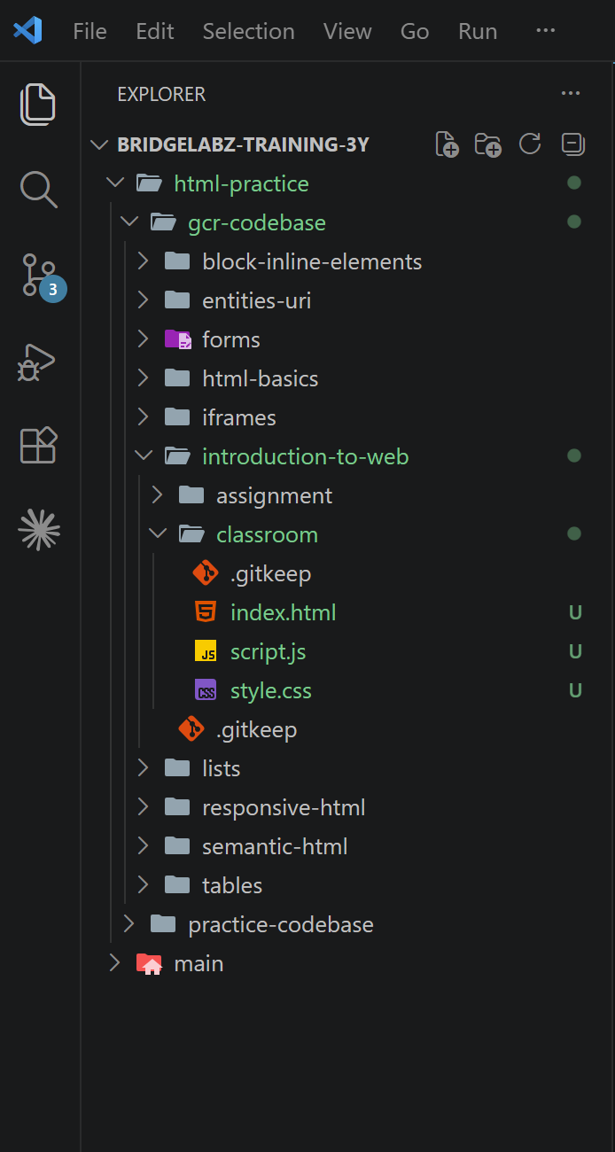
Q8. Explain the difference between static and dynamic websites. Provide an example of each.
A static website shows the exact same content to every visitor, every single time, because the pages are pre-built and do not change based on user input or database data. These sites are made purely with HTML and CSS and load very fast since there is no server-side processing involved. A good example is a simple personal portfolio website or a basic company information page that rarely changes.
A dynamic website, in contrast, generates content on the fly depending on the user, the time, or data stored in a database. The same page can look different for different users. For example, an e-commerce site like Amazon shows personalized recommendations, live stock availability, and prices that can update in real time — all powered by backend logic and a connected database.
Q9. Research and list five web browsers. Explain how rendering engines differ between them.
A rendering engine is the part of a browser that takes HTML, CSS, and JavaScript and turns it into the visual page we actually see. Different browsers use different engines, which is why the same website can occasionally look or behave slightly differently across them.
- Google Chrome — uses the Blink rendering engine, known for speed and wide support for modern web standards.
- Mozilla Firefox — uses the Gecko rendering engine, praised for strong privacy features and standards compliance.
- Apple Safari — uses the WebKit rendering engine, which is optimized for Apple devices and is generally efficient on battery usage.
- Microsoft Edge — previously used its own EdgeHTML engine but has now switched to Blink (the same engine as Chrome), improving compatibility with Chrome-based websites.
- Opera — also runs on the Blink engine, similar to Chrome, but adds extra built-in features like a free VPN and ad blocker.
Since Blink now powers Chrome, Edge, and Opera, most modern browsers render websites in a fairly similar way, whereas Firefox (Gecko) and Safari (WebKit) can sometimes interpret certain CSS or JavaScript features slightly differently, which is why developers often test their websites across multiple browsers before launch.

Q10. Draw a labeled diagram showing the basic web architecture flow — client, server, database, and APIs.
Here is a simple labeled flow of how a modern web application typically works:
