Capstone Project

I published my website on Github: <https://0prst.github.io/courseraCapstone/index.html>

The website contains three pages:

1. Home page: describes the project.
2. Boats: has a carousel with cool sailing boats pictures and corresponding article (disclaimer: the articles have not been written yet so instead I’m just using fillers e.g. Picture 1, etc.).
3. Bays: this page has an embedded Google Maps widget that shows bays that I personally find cool for anchorages.

Each page has a template layout:

Header

Navbar

Main content

Footer (empty right now)

Each has been checked in the validator and passed the tests:

Index.html(Home Page):

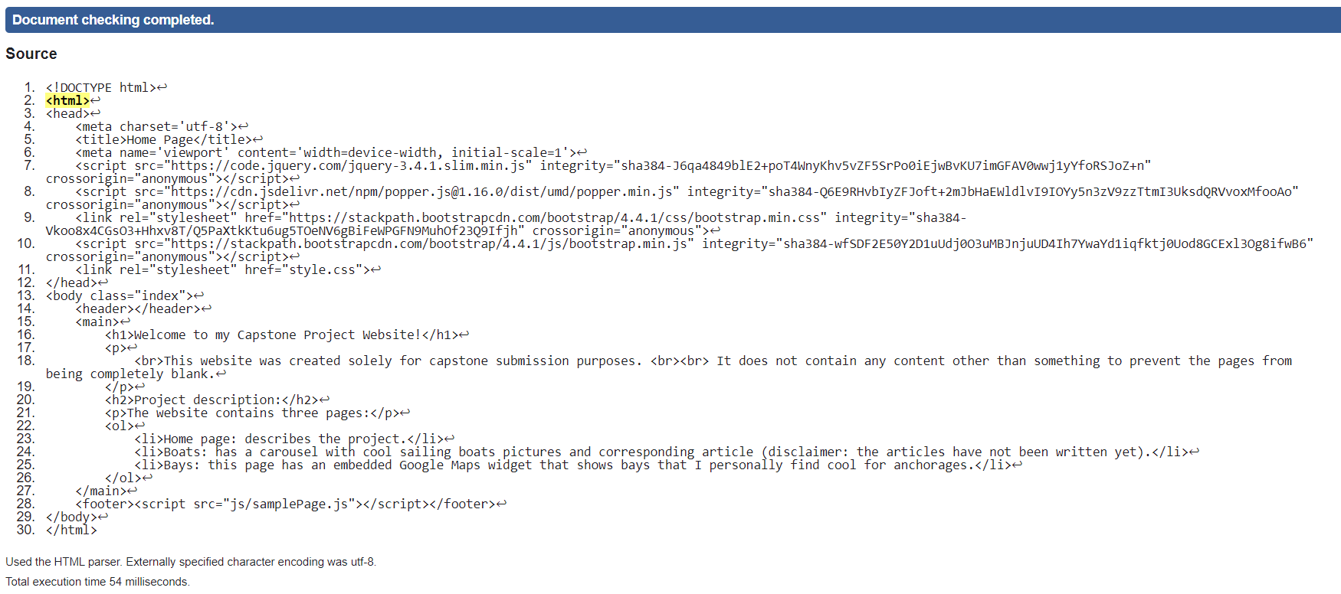

Boats.html:

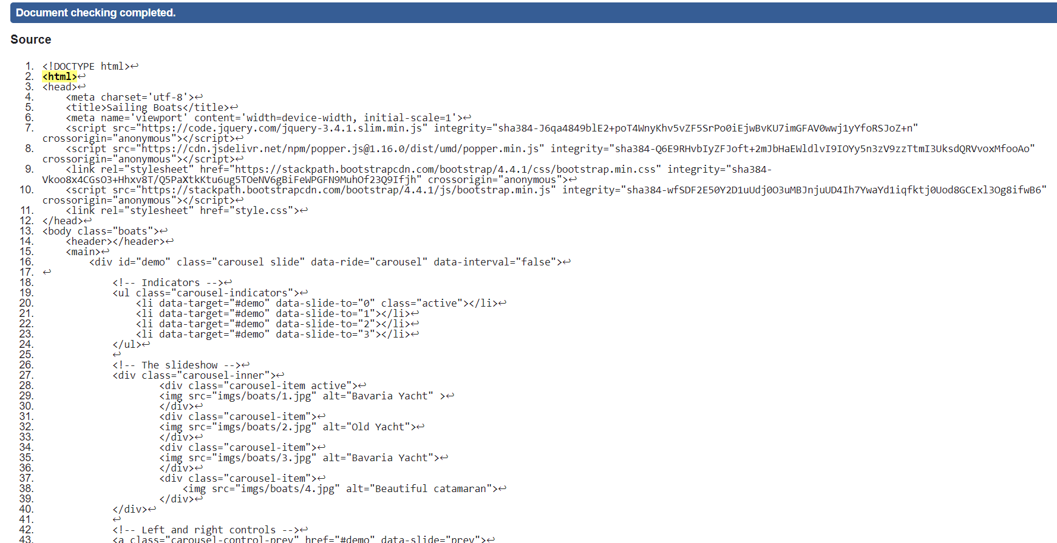

bays.html

