Signal tap and Simulation screenshots:

1)DDS signal outputs and modulation/signal select signals

2) LSFR , signal selector , modulation selector and post synchronization outputs (SIG data_out and MOD data_out)



3)LSFR simulation



Lsfr_out changing with each clock cycle

4)Signal selector simulation

Combinational logic where for each select value (“signal_selector “ signal), we see the corresponding signal being fed to “signal_out”, and for default value of “signal_selector” we get sin wave as output ( 000010100000 in binary).

5) Modulator select simulation

“qpsk” signal at the top is used to trigger qpsk modulation for the combinational block, when it is set to 0 , we move to other modulations which are selected based on the “modulation_selector” signal, in which we use “lfsr” signal to actually modulate using “sin” and “cos” signals.

6)Synchronizer simulation

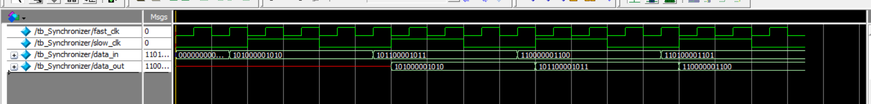

The simulation quite clearly shows the data_out being correctly synchronized with the posedge of the slower clock