**Vinegar Food Restaurant**

*Developer Guide*

|  |  |  |
| --- | --- | --- |
| **Supervisor.** | **Sir Ebad Uddin** | |
| **Batch.** | **2210C2** | |
| **Group.** | A | |
| **Serial No.** | **Enrollment Number** | **Student Name** |
| 1. | 1424655 | Abdur Raffay Sheikh |
| 2. | 1424363 | Sadia Bader |
| 3. | 1423495 | Wajiha Khadim Hussain |

1. **Home** (*index.html*)

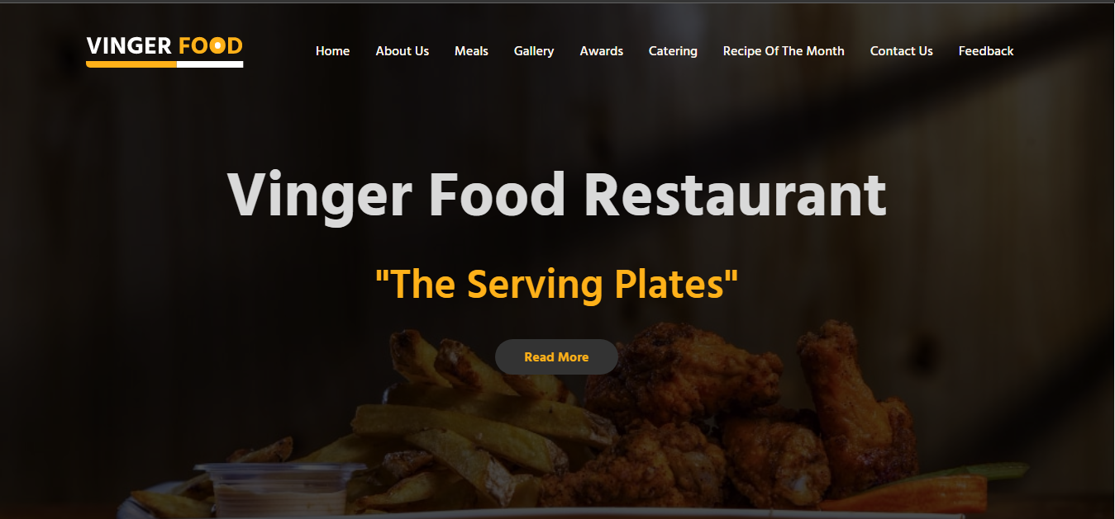

***Figure 1: Home page for Vineger Food Restaurant***

 Our Slogan has given to the peoples toward our website. “The Serving Plates ”.

* OUR HOME PAGE WELCOMES OUR CUSTUMERS WITH BEAUTIFUL QOUTE.

**Code of Home page**

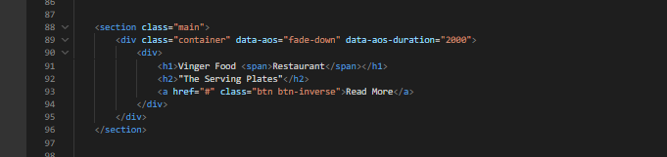

1. **Navbar (index.html)**

**

***Figure 2: Navbar***

We have given 9 essentials. By clicking any of the essential’s and redirect to the linked page.

**Code of Navbar**

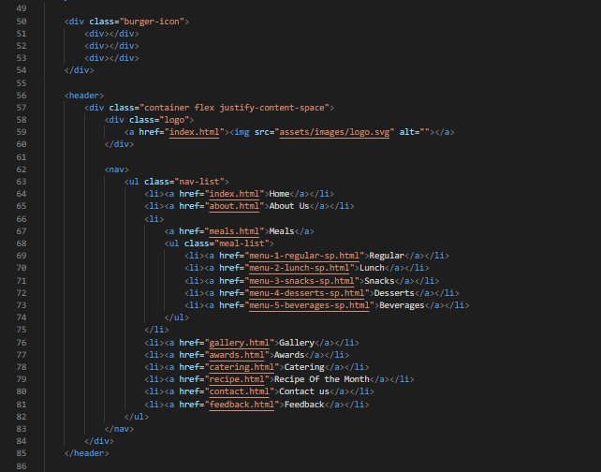

1. **About Us (about.html)**

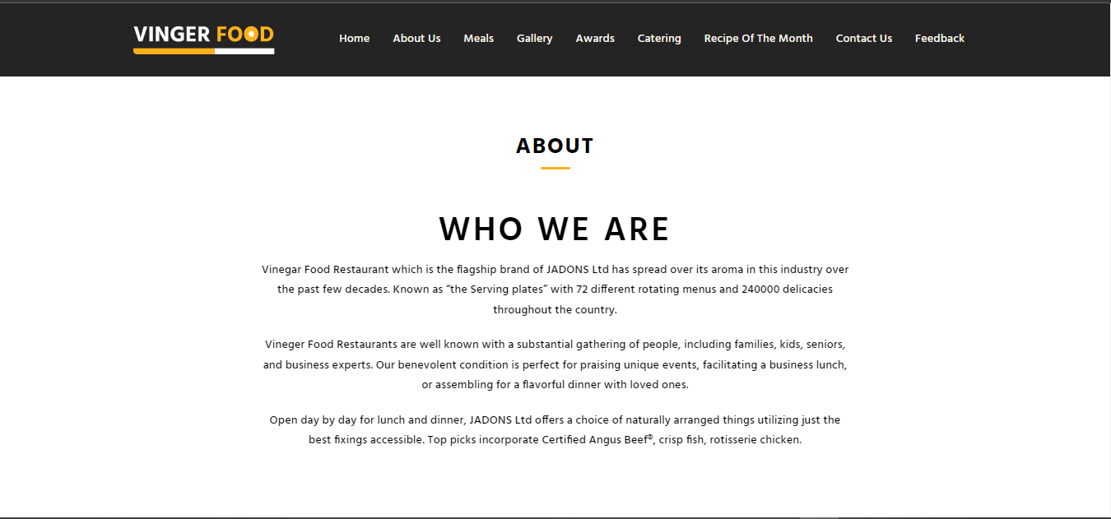

***Figure 3: About Us***

**



* We have given user an overview of who we are and what our journey is and what we have achieved.

***Code of About us***

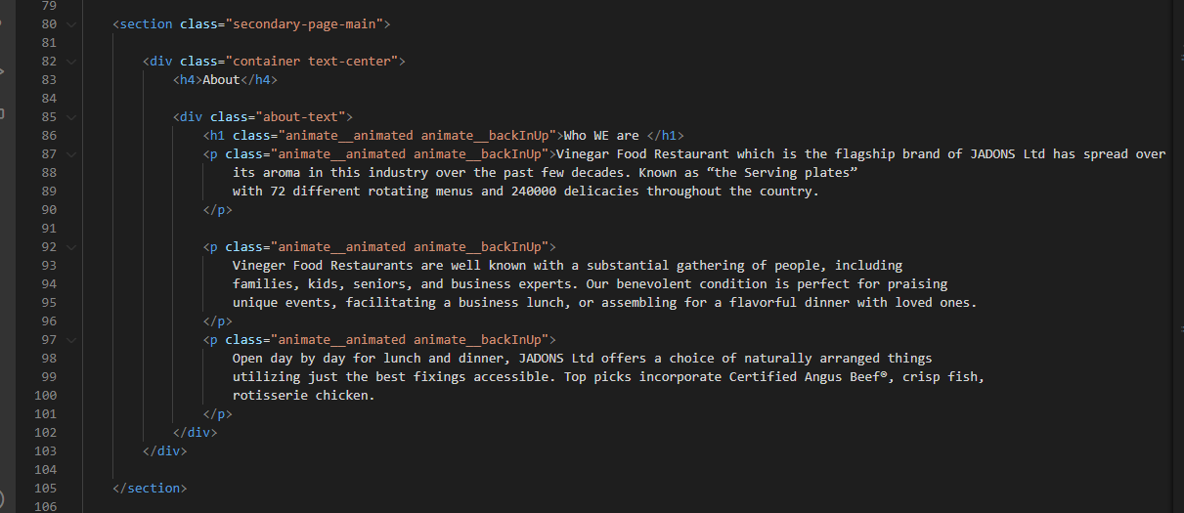

***Figure 4: Meals***

*We have mentioned our Meals Categories in this page to make people know about the items we provide.*

* ***Here we have shown 5 of our “main” Food Categories***
* ***Code of Meals***

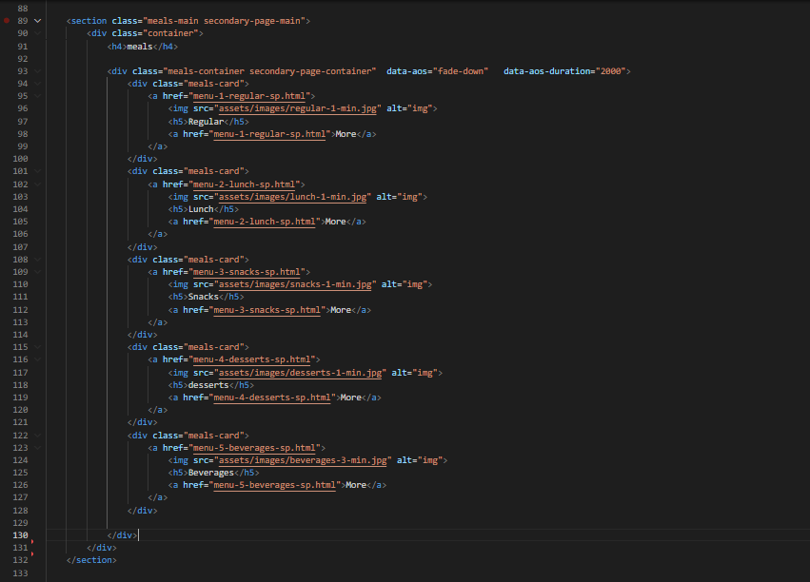

***5.Gallery(gallery.html)***

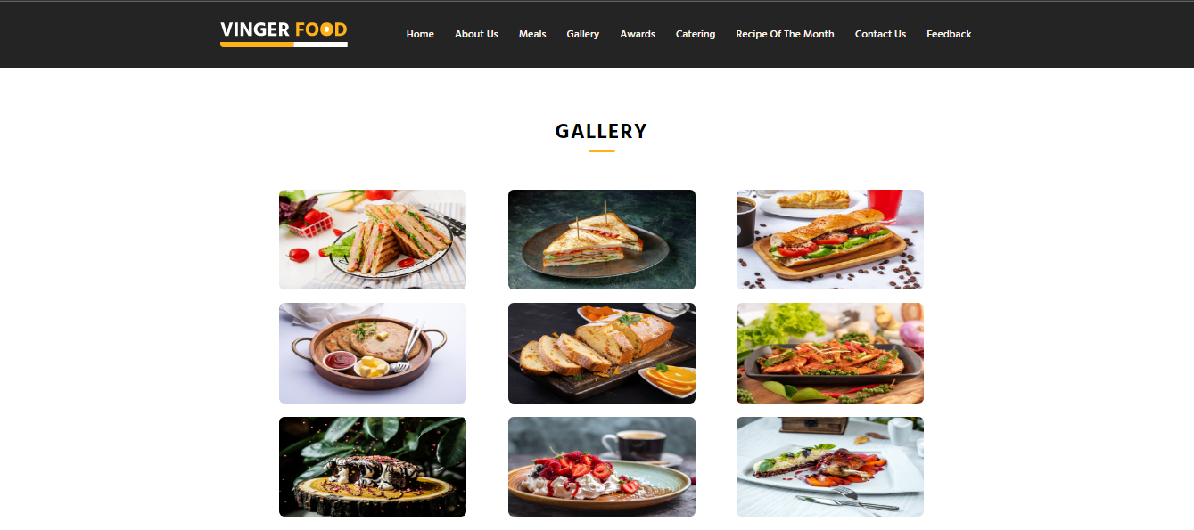



***Gallery Page:***

*.*

***“Shows Gallery of some new products”***

*We have Shown some unique kind of products in our gallery page*

***Code of Gallery:***

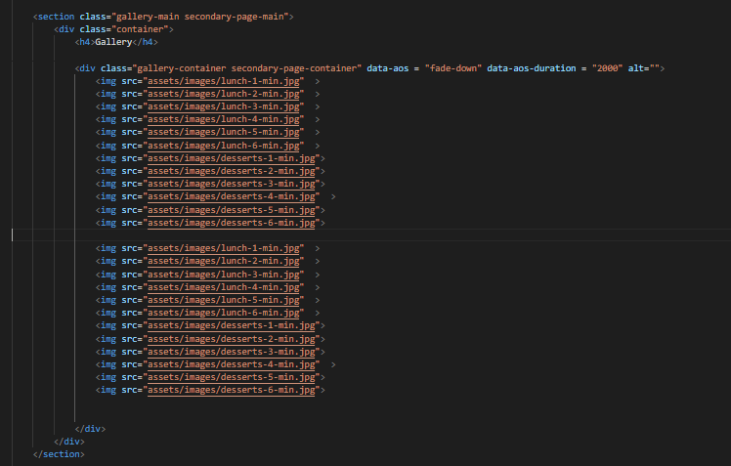

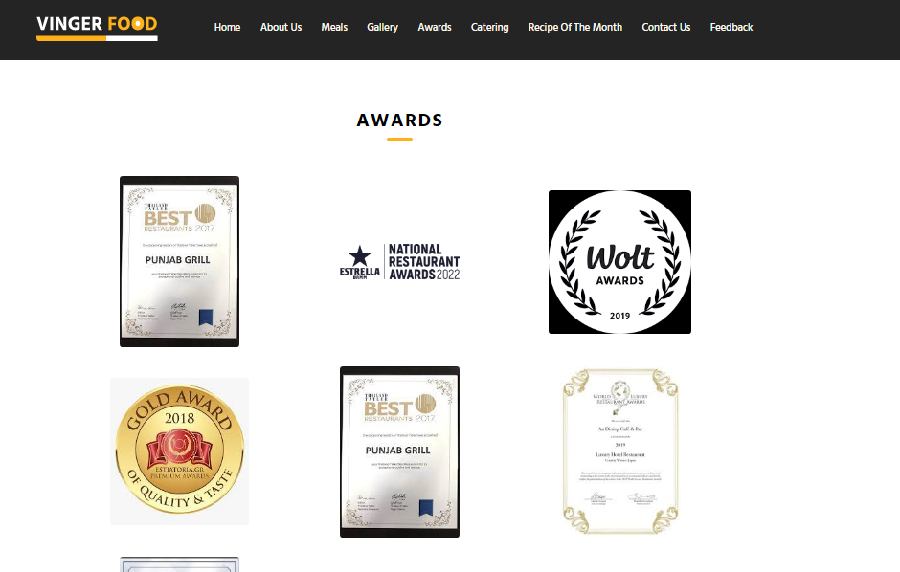***6.awards(awards.html) :***



*Our awards section displays a grid of all the awards Vinegar Food Restaurant* has received.

***Code of Awards Page***

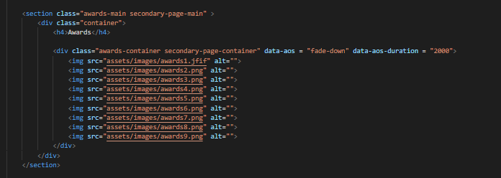

**7.Catering** (*caterging.html*)

***Figure 1: Catering page for Vinegar Food Restaurant***

1. This page tells the users about the catering of our restaurant: Delicious catering for any occasion: From casual get-togethers to formal affairs, our catering menu has something for everyone.

**Code of Catering Page**

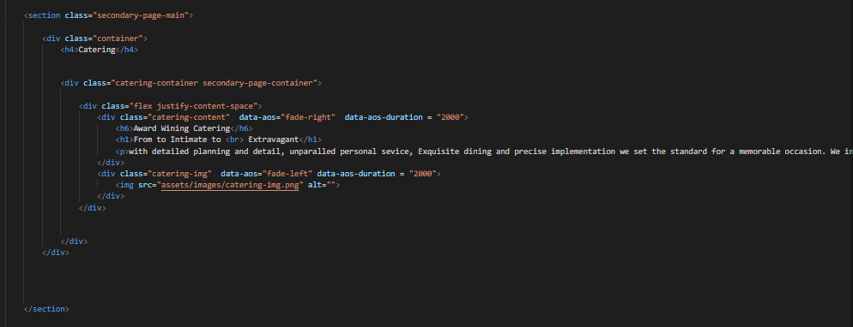

**8.Recipe Of The Month** (*recipe.html*)

***Figure 1: Recipe of the month for Vinegar Food Restaurant***

1. 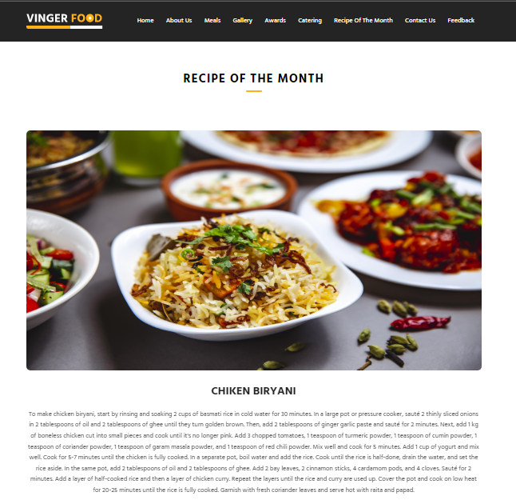
2. This page shows user a “recipe of the month”. "Discover the Flavor of the Month: Join us on a culinary adventure with our hand-picked recipe of the month, featuring fresh and seasonal ingredients."

**Code of Recipe of the month Page**

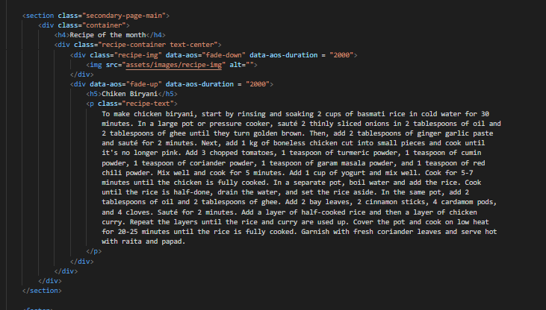

**9.Contact Us / Site Map** (*contact.html*)

***Figure 1: Contact Page for Vinegar Food Restaurant***

1. This page is a Contact Page for user to ask Queries

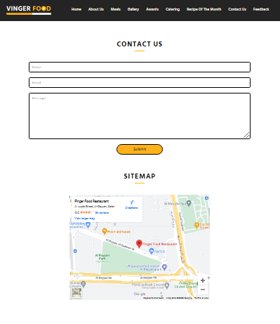

**Code of Contact Page:**

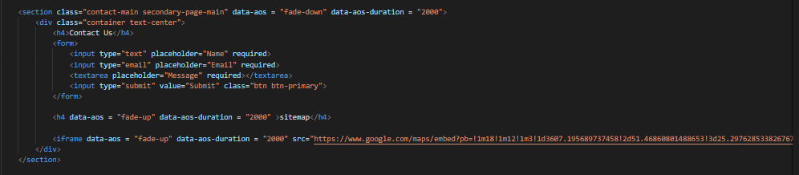

**10.Feedback** (*Feedback.html*)

***Figure 1: Feedback page for Vinegar Food Restaurant***

1. This is a Feedback page for users to give feedback and provide instructions for 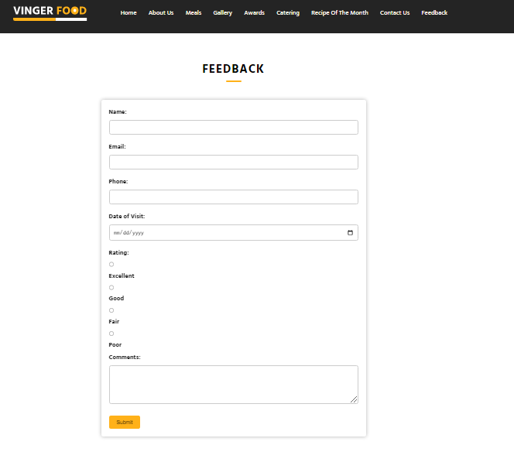improvement.

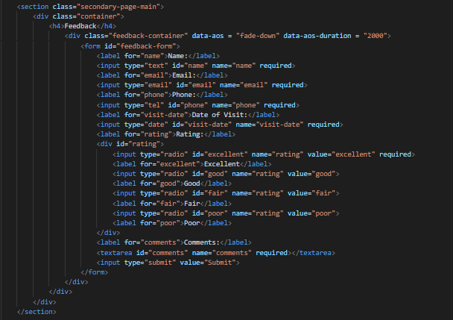

**Code of Feedback Page**



***11.footer (index .html):***

***Figure 14: Footer***

This is the footer for our website:

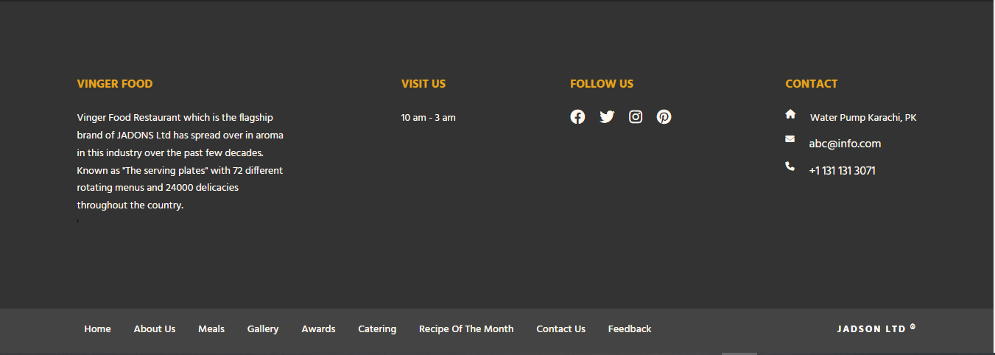***CODE FOR FOOTER:***

