**CMPT 276 - Project Proposal**

**October 18th, 2019**

**Iteration 0**

**GIT REPO:** [**https://github.com/0rv/CMPT276-NotAWebApp.git**](https://github.com/0rv/CMPT276-NotAWebApp.git)

(づ｡◕‿‿◕｡)づ

**Web Application Name: Not A Web App**

**Members:**

* Listiarini Listiarini, llistiar
* Celina Wright, ckwright
* Natasha Kanlic, nkanlic
* S m shahjiban Munjoreen, smunjore
* Ryan Vansickle, rvansick

**About our Group**

Although we have an average group experience level of “beginner”, we have already learned lots through the course content. This gives every group member beginner-level experience with at least HTML, JavaScript, CSS, NodeJS, Postgres, SQL, and use of Heroku.

More specifically, Celina has more experience with C-based programming but still has moderate knowledge of SQL and JavaScript and has plenty of experience with HTML and CSS. Lis has beginner to intermediate experience with CSS and HTML and Ryan and Natasha both have more experience with Python and are new to web-based programming. As a team, we are relatively well-rounded and plan to all learn more together.

**The Problem and Our Solution**

As a development team, we want to create an app that’s not only fun but encourages people to be both physically and mentally healthy. Through use of the Google API, we encourage player travel, and through use of our chat-puzzles, we strength player knowledge problem-solving capabilities.

Another big problem with current games is storage space and so, by using a browser login, players don’t fill up their phone storage space! Our game is both educational and a great source of entertainment during long commutes of just a boring day of travel.

**Our Projected Audience**

Our target audience can be players of all ages! Generally, players would be people our travel frequently and are looking for a way to fill the time. The minigames will be mostly catered to young adults and students, due to the bias of our developers (all young adult students). We do hope, however, to overcome this bias through future iterations and brainstorming.

**Features - Scope**

Our features include a map, features that update in real time, checkpoints that players can reach, minigame-like chat puzzles, interactions between other players online through chat, a player profile, and a login screen.

**Project Summary - Abstract**

**NotAWebApp** is a browser-based game that allows users to login and interact with the world around them, in real-time. The game is essentially a chat app but incorporates the Google Maps API to account for player location. Players, upon travelling to certain in-game locations, can enter chat-based minigame puzzles. Points, rewards, and other perks are rewarded to the player for puzzle completion. Because this is browser based, there is no need to download an app and take up phone storage space. Instead, users only need to login on any phone browser and play! The game encourages people to travel their city, exercise, and train their brains with puzzles!

In a more specific sense, multiple users are able to participate in one or more microgames to interact with the map and collaboratively "progress" across a given distance. Users are required to identify with a handle and provide login credentials if this handle is already registered, which grants access to an anonymous lobby match-finding system to connect the appropriate number of players to a game instance. Each instance requires players work through a set of procedurally-generated challenges, such as drawing, image identification, puzzle-solving, math, and minigames, in which progress also moves the "team" view in Google Maps closer to a specified goal destination. In these instances, players are provided an in-game chat which can be subject to difficulty-altering tweaks to disrupt team communication.

This app is intended primarily for recreational use but can be used to familiarize existing members with each other, as a group, or to seek out strangers online.

**Sample Epics & Stories – Scenarios**

1. **Epic**: Casual users can play short multi-player puzzle games with random users.

**Story**: I am a **casual user** seeking quick entertainment. I want to be connected to a game lobby as fast as possible, and do not care what type of users I am paired with provided there is no language barrier. I expect that I can have a relatively short but complete game session that exposes me to several fun or interesting features that create meaningful interactions with my teammates.

1. **Epic**: Players can communicate to each other in a fun way through the altered chat while solving puzzles.

**Story**: I am the **manager of a small software development team** seeking a fun and creative team-building exercise for my coworkers that does not compromise their intellectual capabilities or communication skills. I want to be able to place my team members into a publicly inaccessible game instance and challenge them in fun and unconventional to promote teamwork and creative or effective communication. I expect the platform to be both secure and allow for reasonable tweaks to the challenge provided to players.

1. **Epic**: Internet users can interact with new people online by adding them as a friend in the app.

**Story**: I am an **isolated internet user** that seeks new opportunities to interact with new people online. I want opportunities to communicate more casually with my assigned teammates without the need to focus on the presented challenge at all times, but still be offered enough content to prompt conversation. I expect the platform to provide reasonable opportunity to relax and not require intense problem solving, while also allowing communication that does not compromise the challenge of the games.

1. **Epic**: Players can view their previously solved puzzles.

**Story**: **As a player**, I want to view my previously solved puzzles. I want to learn and improve by viewing my game progress. I want to use this to analyze similarities and solve the next (current) puzzle more efficiently.

**Future Plans**

In future iterations, we hope to better solidify our development plan. We would like to create a team schedule and plan out roles and feature implementations for our team to develop. We hope to prioritize certain features, as a team, and make sure that important elements of gameplay are implemented first. We also plan to learn more about Google Maps API capabilities, options for players who can’t travel as much, and solidify our scope overall so that our team is capable of developing a fully functional product of the proper scale.

**User Interface Mock-ups**

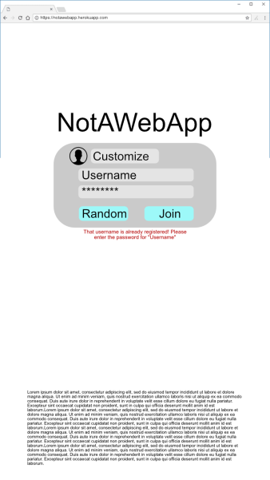

Login Screen Mock-up

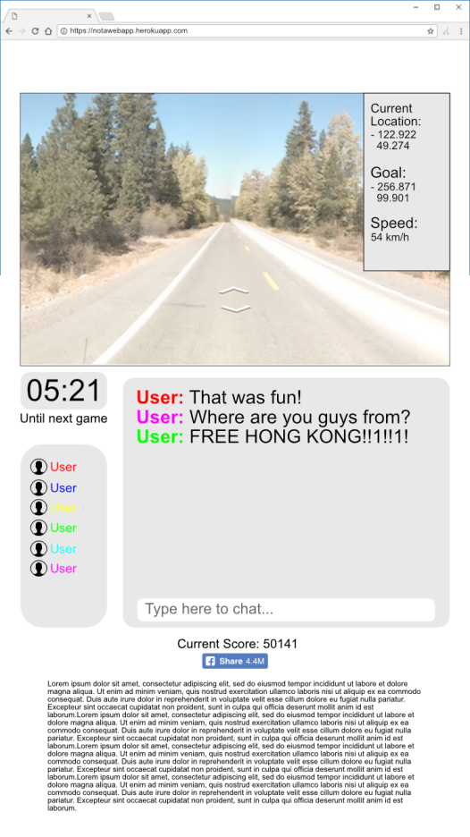

Street View & Chat Screen Mock-up

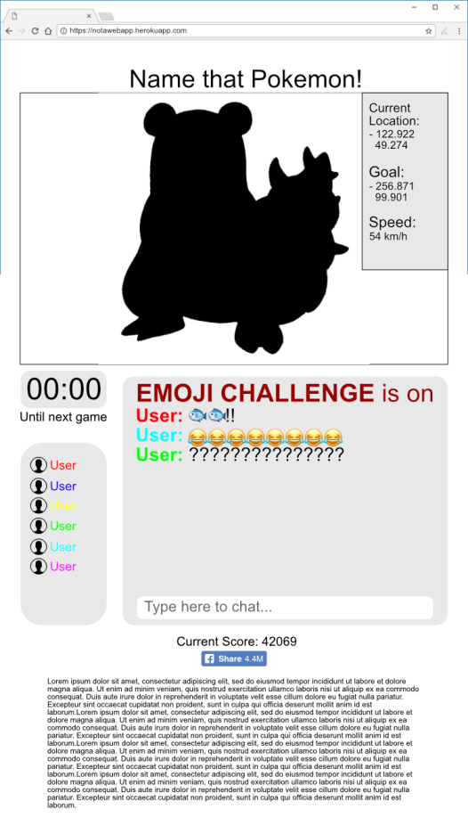

Minigame screen Mock-up