**Object Oriented Analysis and Design**

**Automated Bill Payment System**

**Project Deliverable 2**



**Submitted to**:

                      Ma’am Amina mirza

**Group Members:**

    Bsef19m013 - Osama Sultan

                      Bsef19m032 - Ameena Abdullah

                      Bsef19m029 - Iqra Hanif

*All the diagrams in this document are created on smartdraw.com

**Domain Model**

(Visual representation of conceptual classes of Automated Bill payment System)

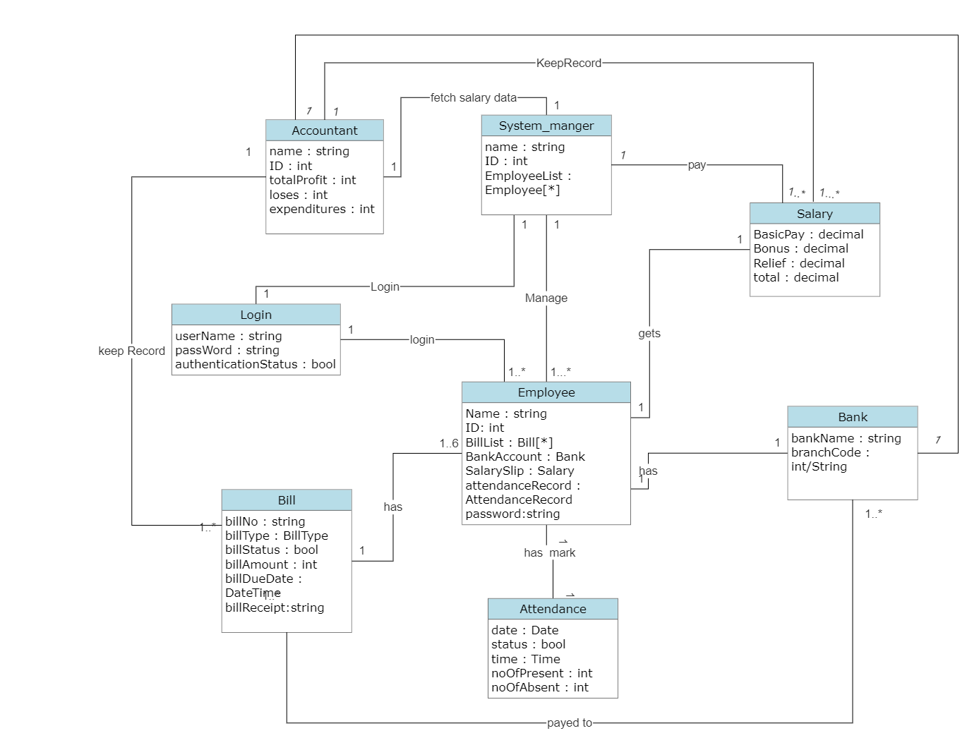

**Design Class Diagram**

**(Detailed Visual Representation of system class and their relationships)**

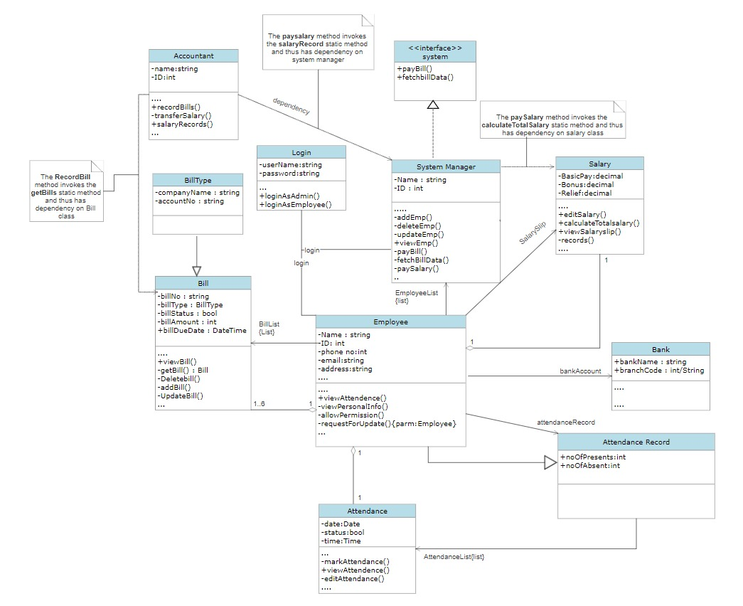

**Sequence Diagram**

**(Sequence flow of bill payment among different states)**

* Employee with add bill information once and system will then automatically fetch data from organization site, check status and performs accordingly.

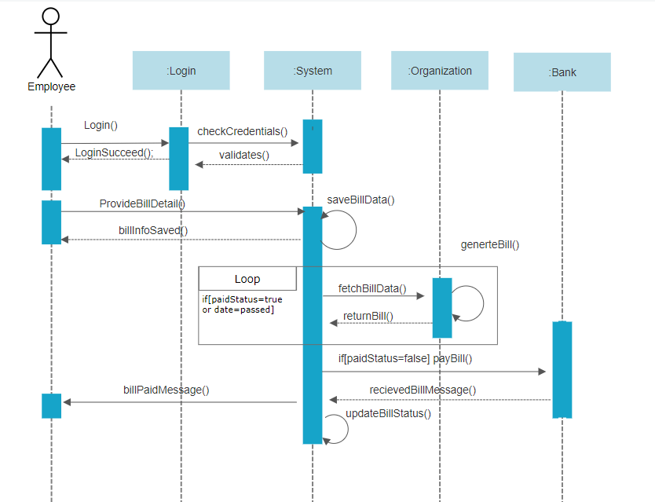

*We can have multiple actors in a Sequence Diagram

Source: https://www.geeksforgeeks.org/unified-modeling-language-uml-sequence-diagrams/

**(Sequence flow of login to add employee and then paying salaries to employees among different states of admin)**

* Admin will login and add employee to employee list then admin will pay salaries to all existing employee. System will calculate salary of each employee after checking employee salary data. Bills will be deducted from salary

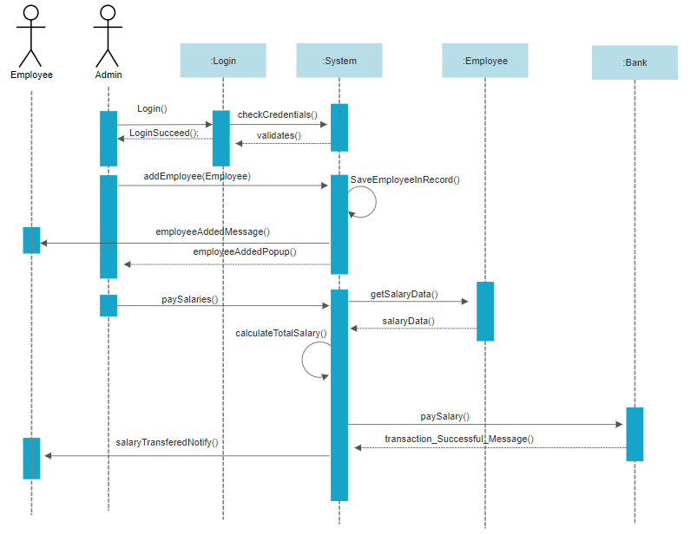

**System Sequence Diagrams**

**(System Sequence Flow of Risk Management Use Case)**

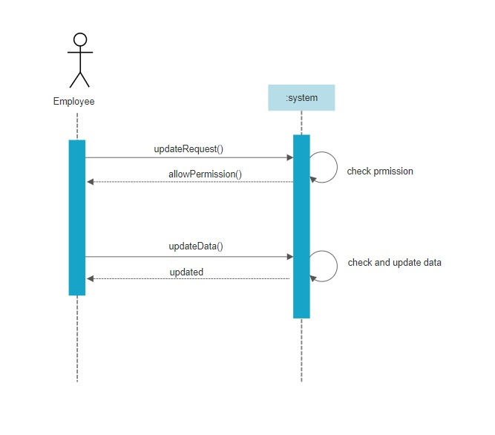

**(System Sequence Flow of Risk Management Use Case)**

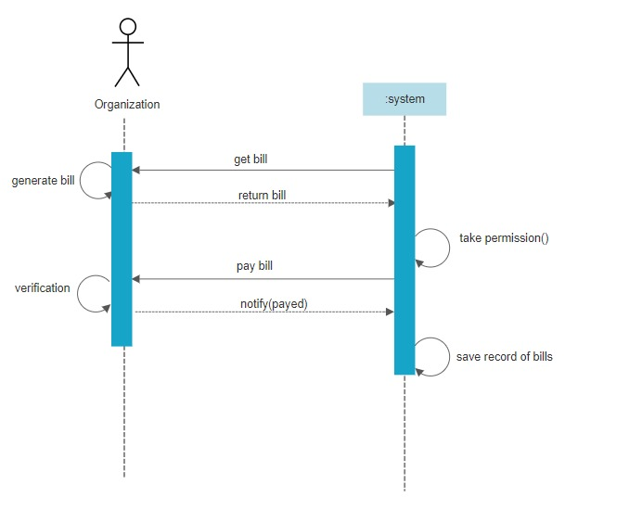

**(System Sequence Diagram of Architecture)**

**Here system is divided into three parts**

* **Model**
* **View**
* **Controller**

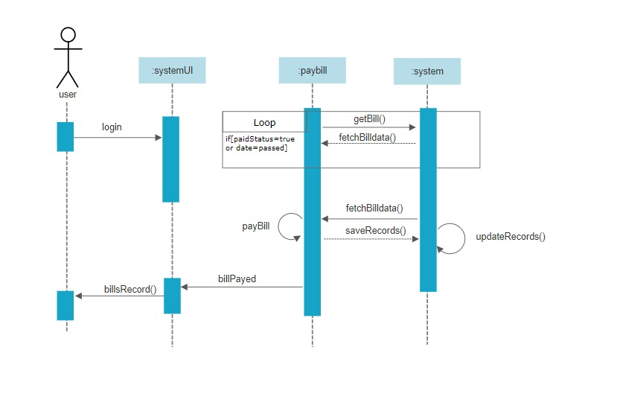

**Prototype’s**

* **Admin End UI:**

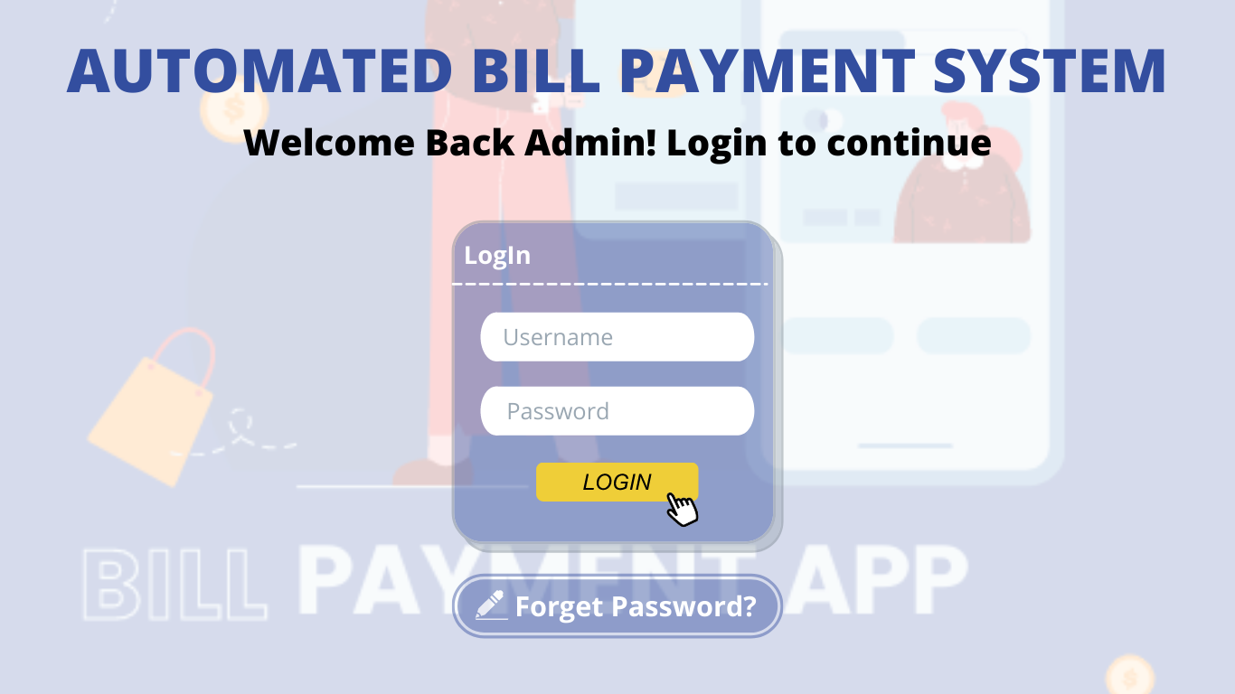

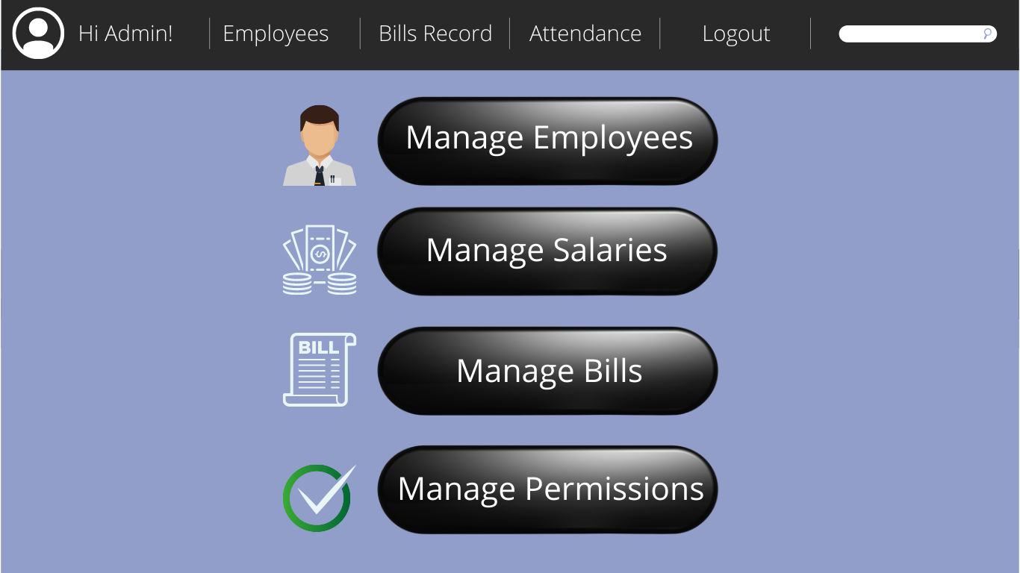

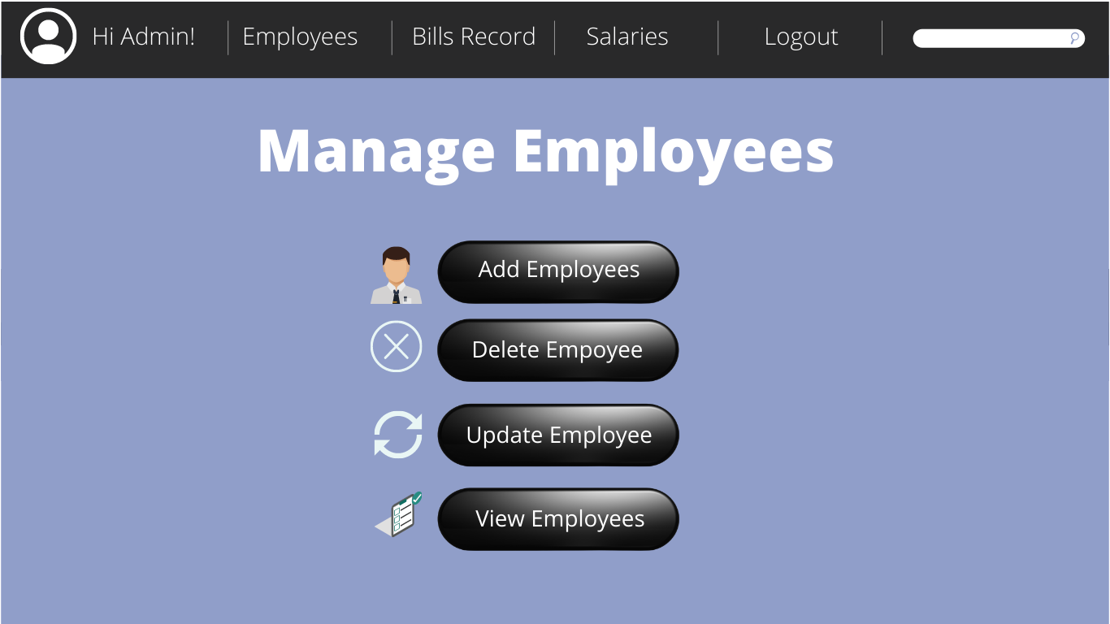

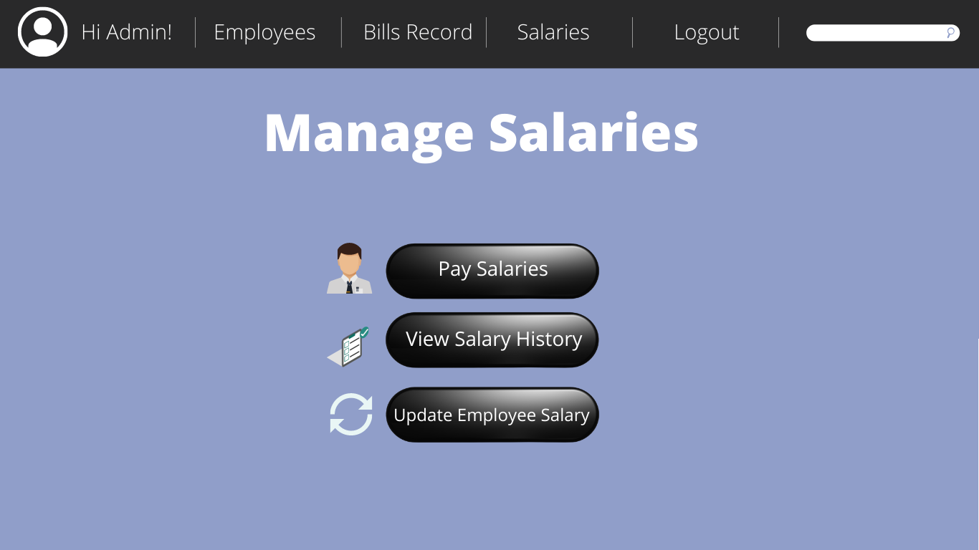

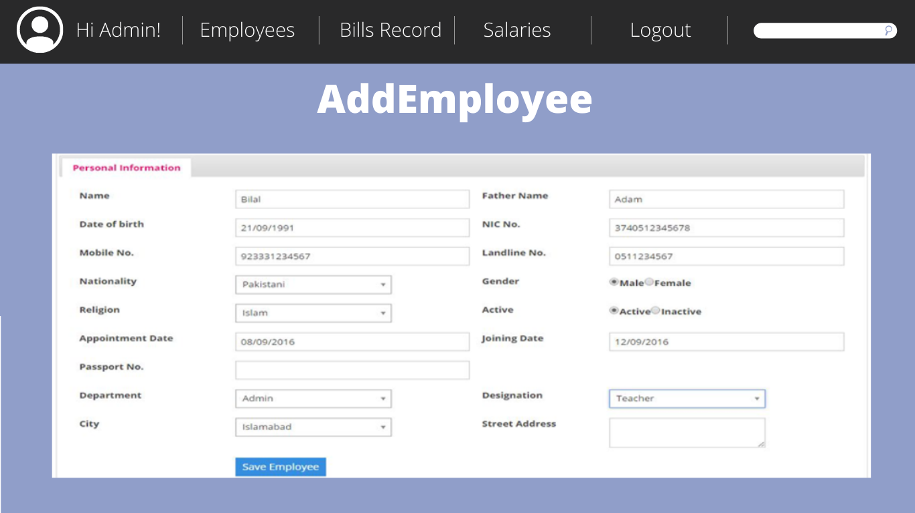

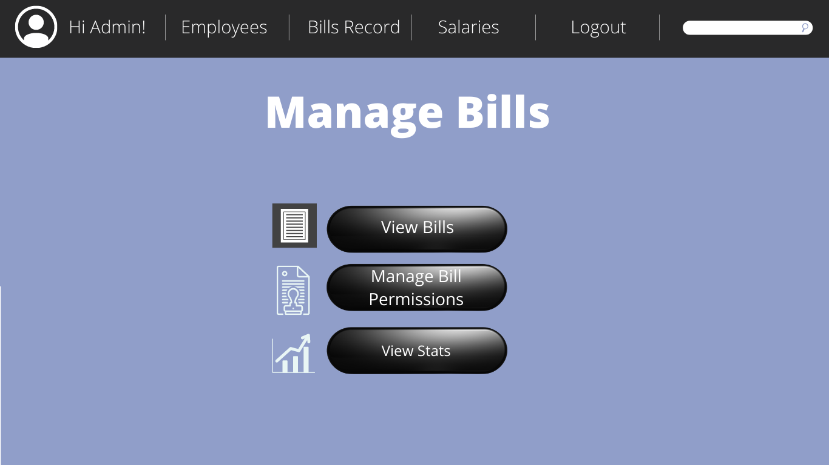

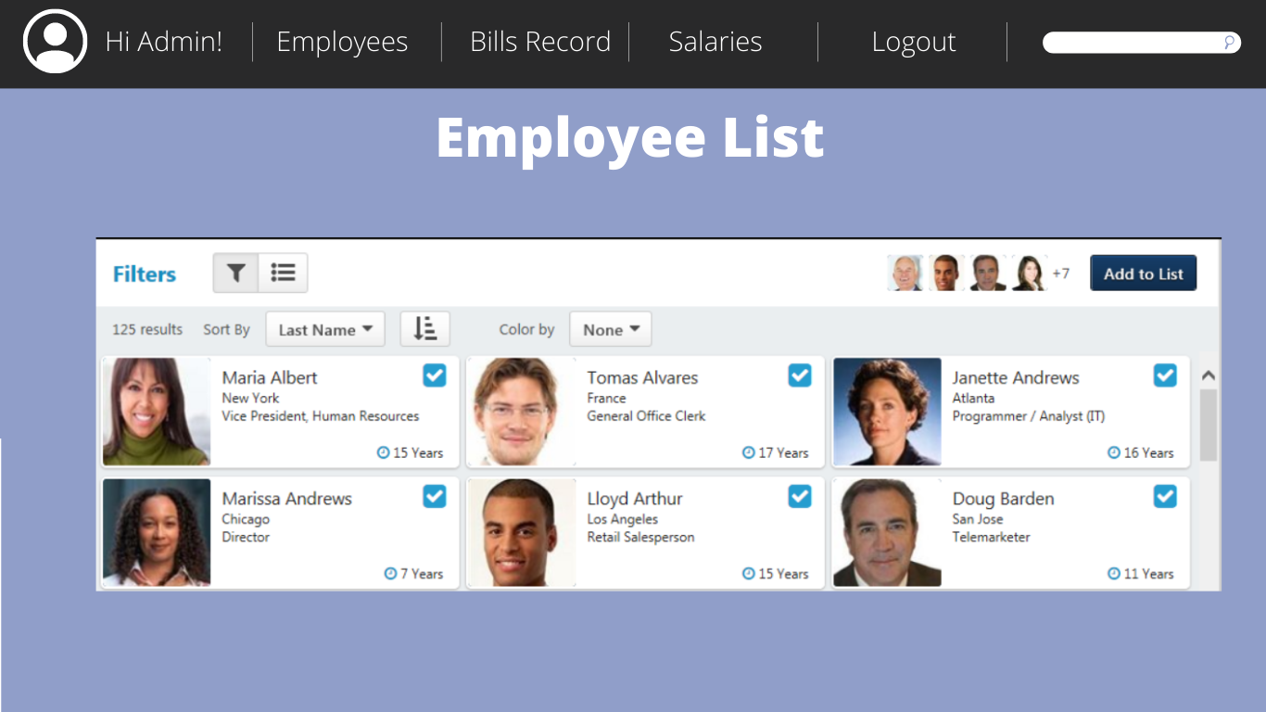

* Employee End UI:

|  |  |
| --- | --- |
|  |  |
|  |  |

