1. File > New > STM32 Project. In the commercial part number, search “STM32F446RE”,and select “STM32F446RET6”. Click Next. Name the project as Blinky and click Finish.

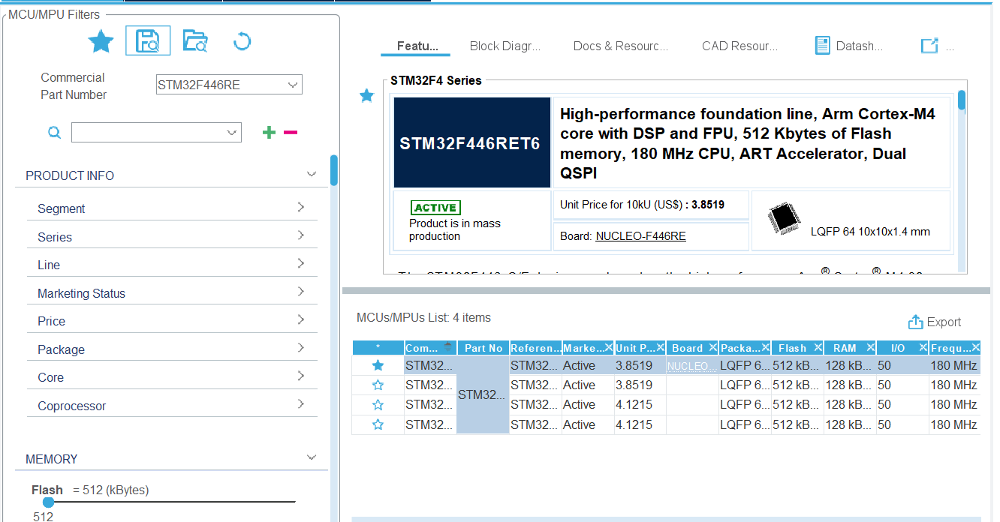

2.Configure PA5 as GPIO_OUTPUT for LED. Click on SAVE. A prompt to generate the code will appear. Click YES. Click on YES again to be brought to the code perspective.

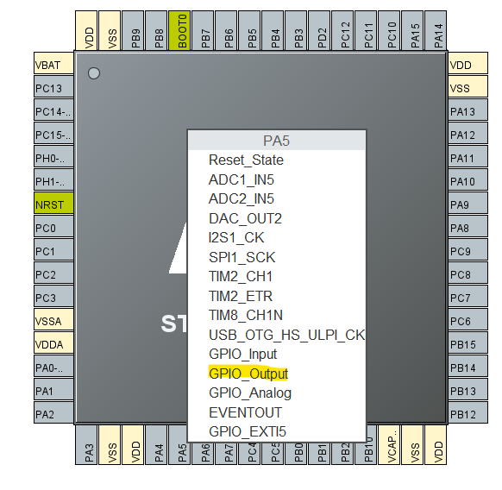

3 Add in the coding for the blinking of LED. GPIO_PIN_SET turns on the LED, while GPIO_PIN_RESET turns off the LED. And HAL_DELAY defines how long will the LED remains on/off. In this case, we chose 2s on, and 2s off.

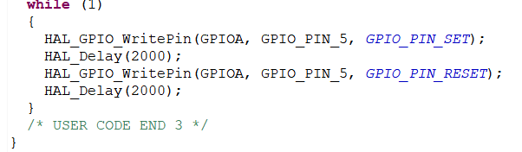 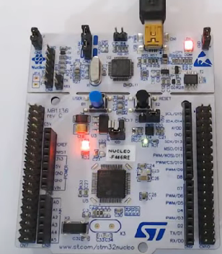

1. Left click Blinky and choose “Build Project”. Observe in the ODT Console whether there’s any build error.
2. Connect the STM32 Board to the laptop via USB port. Left click Blinky and select RUN AS > 1 STM32 C/C++ Application. Click on OK, the program will be uploaded onto the STM32 board, and LED will start blinking.