DATA SCIENCE MINOR PROJECT REPORT

CONTENTS OF THE REPORT
- Cover page
- Declaration
- Certificate
- Acknowledgement
- Table of Content

Other Conventions

- Please note the case of letters in the cover page: The 3rd line is 16 pt bold and other lines are 12 pt. The page is centred. Department and Institute names are bold.
- All the matter contained in the report should be typed in MS word (1.5 spacing) Times New Roman, 12 pt or equivalent with other software.
- Figures and tables may be inserted in the text as they appear or may be appended in order.
- Table of Content shall be in well hyperlinked
- List of figures and tables shall be maintained with captions in MS word.
- List of references shall be appended at the end.
- References shall be in IEEE format
- Total Number of pages with A4 size paper shall be minimum 30 pages and maximum 80 pages.
- Hard copy of report must be available with each student on the day of evaluation.
- In addition to Hard copy of reports e-copy shall also be submitted. An e-copy of the report shall be submitted by the student to respective teacher on their emails.

COVER PAGE
<Python Toolbox: Python Programming>
PROJECT REPORT
(Project Semester January-April 2025)

(Sales Ananlysis)

Submitted by

(Shivanshu Singh)

Registration No:- 12315457

Programme and Section :- B.tech CSE
Course Code:- INT 375

Under the Guidance of

(Anand Kumar Sir, UID: 30561)

Discipline of CSE/IT

Lovely School of Computer Science

Lovely Professional University, Phagwara

CERTIFICATE

This is to certify that ........... bearing Registration no. ......... has completed ........... <Course Code> project titled, “.................................” under my guidance and supervision. To the best of my knowledge, the present work is the result of his/her original development, effort and study.

Signature and Name of the Supervisor
Designation of the Supervisor
School of …………………………………………….
Lovely Professional University
Phagwara, Punjab.

Date:

DECLARATION

I, Shivanhshu Singh student of B.Tech CSE under CSE/IT Discipline at, Lovely Professional University, Punjab, hereby declare that all the information furnished in this project report is based on my own intensive work and is genuine.

Date: Signature
Registration No. 12315457 Name of the student: Shivanshu Singh

Sales Analysis: Project Report

1. Introduction

Sales prediction is a fundamental business activity that helps companies forecast demand, optimize inventory, and improve profitability. Traditional statistical approaches often lack the flexibility to adapt to dynamic consumer patterns. With the advent of machine learning, businesses can now make more accurate and adaptive forecasts. This research focuses on the application of machine learning, particularly Linear Regression, to analysis sales data and extract meaningful insights. This paper is structured as follows: Section II discusses the related work; Section III describes the methodology used; Section IV presents the results and discussion; and Section V concludes the paper with future work directions.
2. Source of Dataset

The dataset for this project was obtained from Kaggle, a well-known platform for machine learning competitions and datasets. It includes two CSV files:
- Fake.csv: Contains over 20,000 fabricated news articles with attributes such as title, text, subject, and date.
- True.csv: Contains more than 18,000 legitimate news articles, with the same set of features.

Code:
import pandas as pd

# Load datasets
Sales Analysis = pd.read_csv('Fake.csv')
s = pd.read_csv(sales_analysis.csv')

3. EDA Process

Exploratory Data Analysis (EDA) is a crucial step in understanding the underlying patterns and structures within the dataset. In this project, EDA involved several preprocessing and analysis steps:
- Datetime Conversion: The date column was converted to datetime format and missing values were imputed using the median.
- Text Cleaning: All text data was converted to lowercase, punctuation was removed, and stopwords were filtered.
- Length Calculation: A new column text_length was created to measure article length.
- Word Frequency Removal: The top 20 most common words were identified and removed to improve feature quality.

4. Analysis on Dataset
This section explores various analyses conducted on the dataset using statistical and visualization tools.
4.1 Class Distribution
It is important to examine whether the dataset is balanced or skewed. Class imbalance can significantly affect model training. In our case, the dataset was relatively balanced between fake and real news.

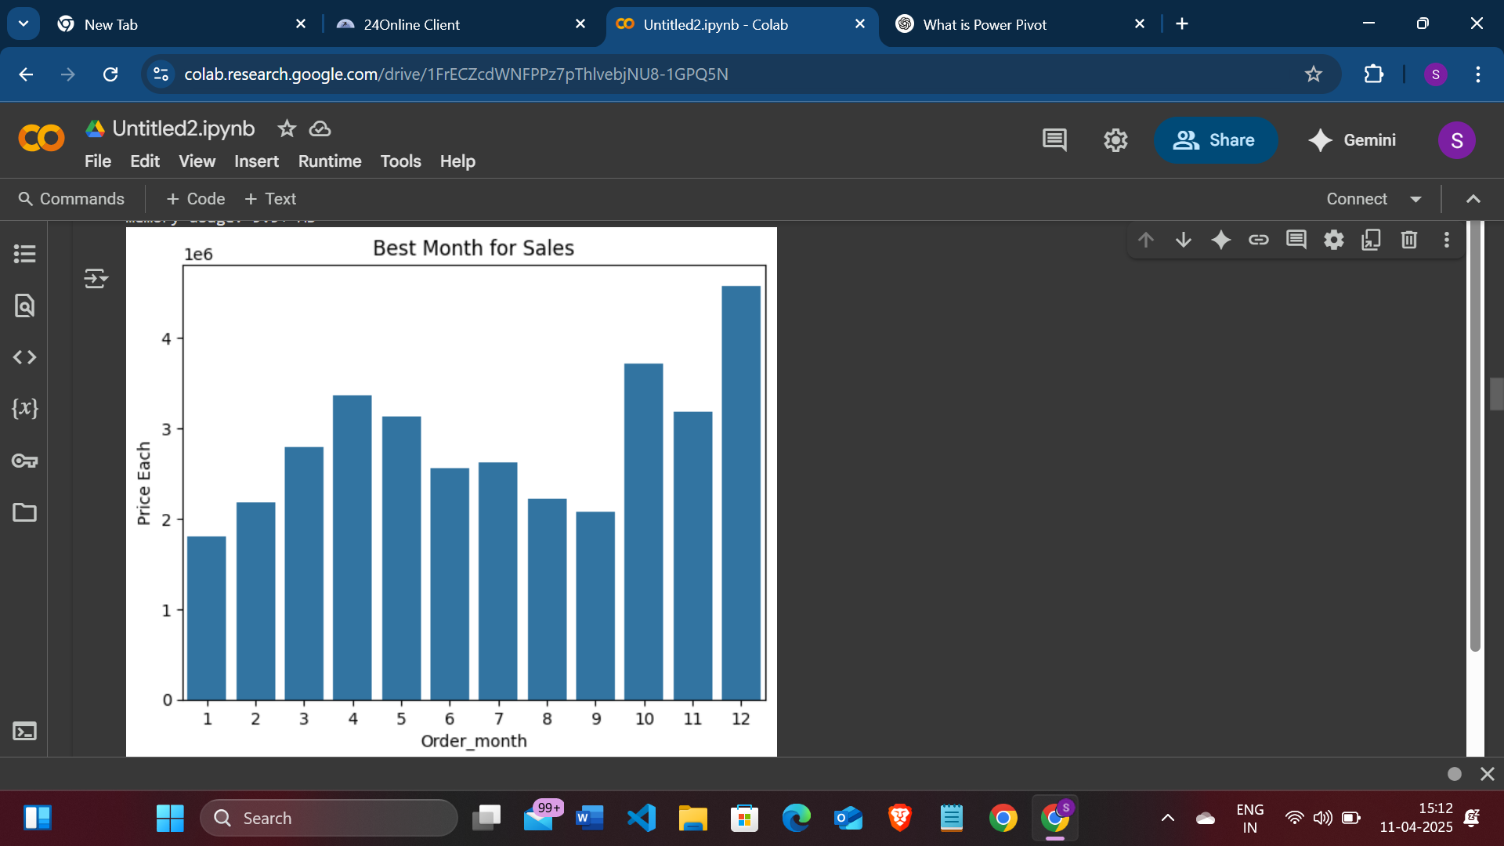

4.2 Text Length Analysis
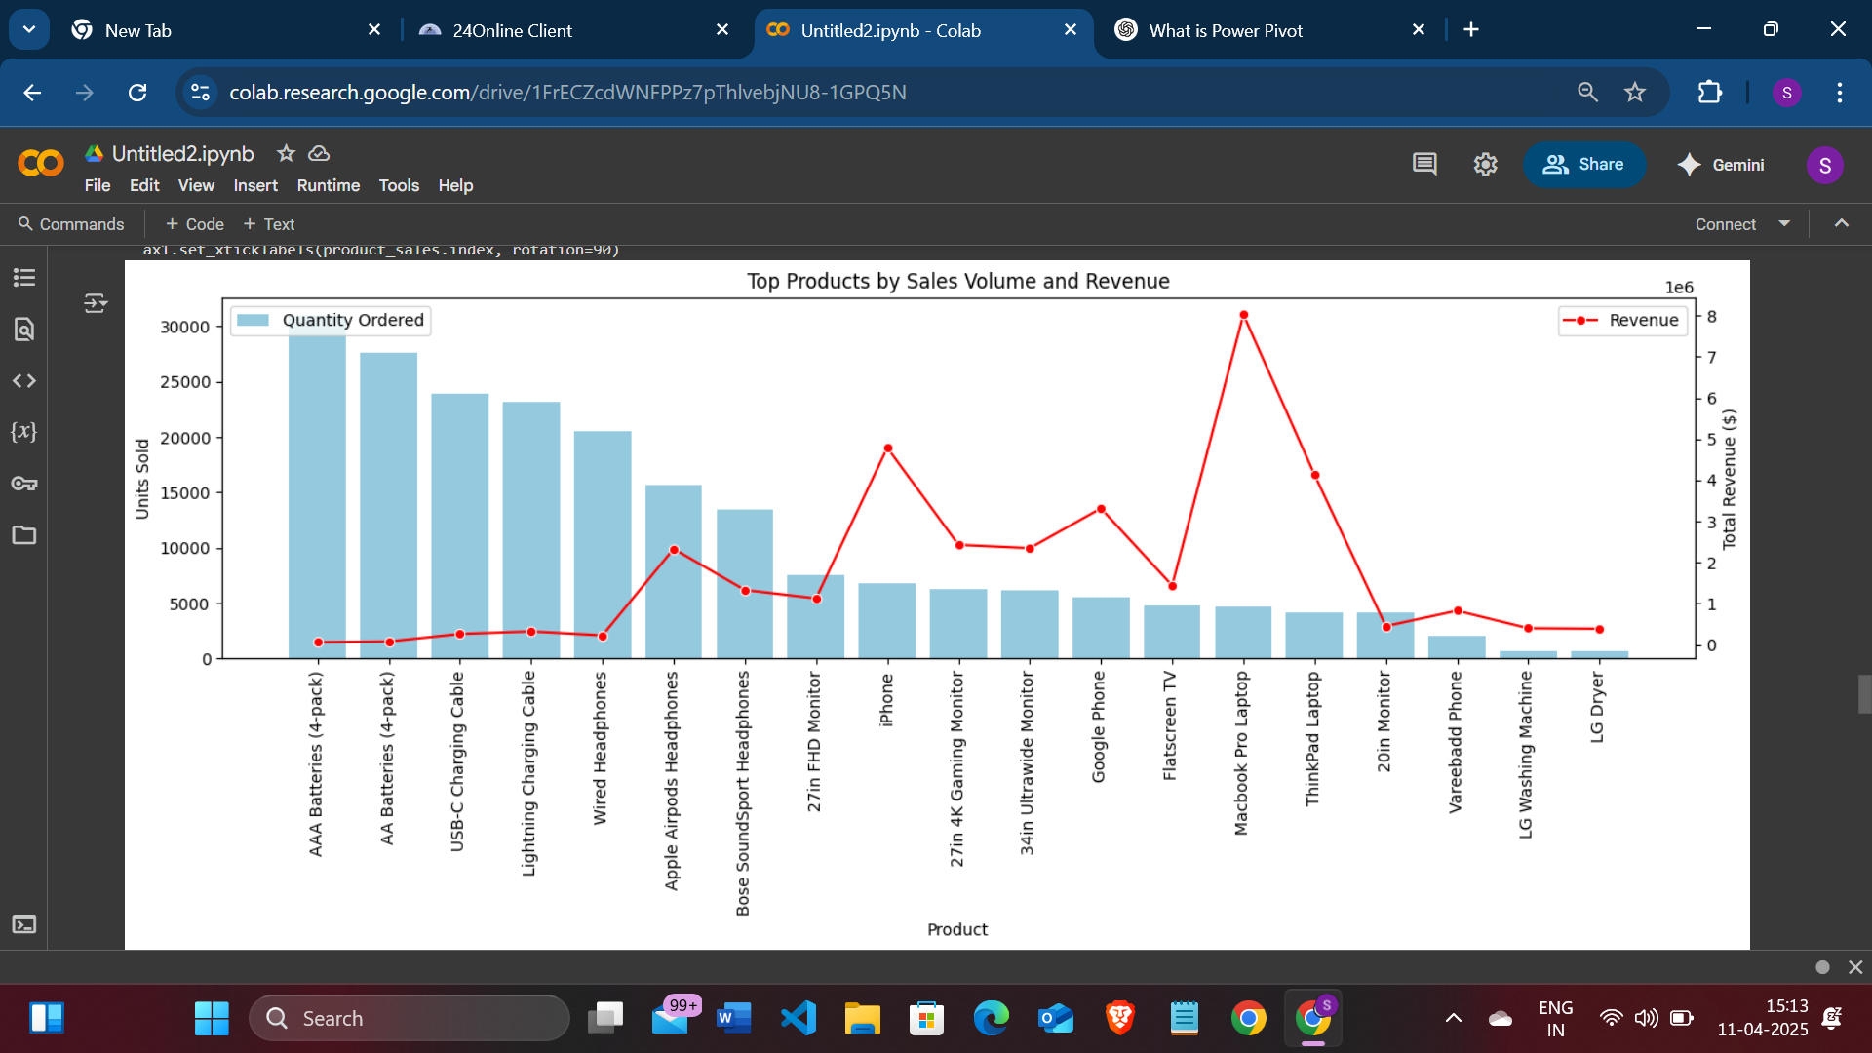

4.3 Word Clouds

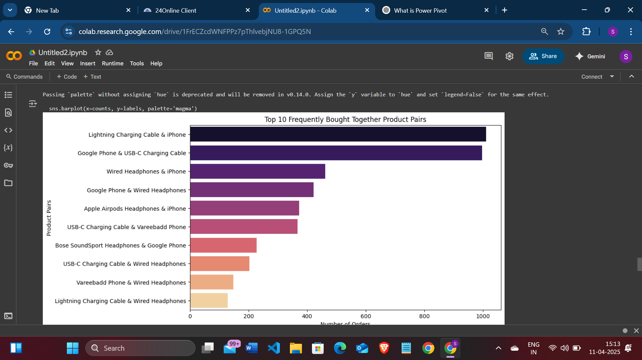

4.4 Sentiment Polarity

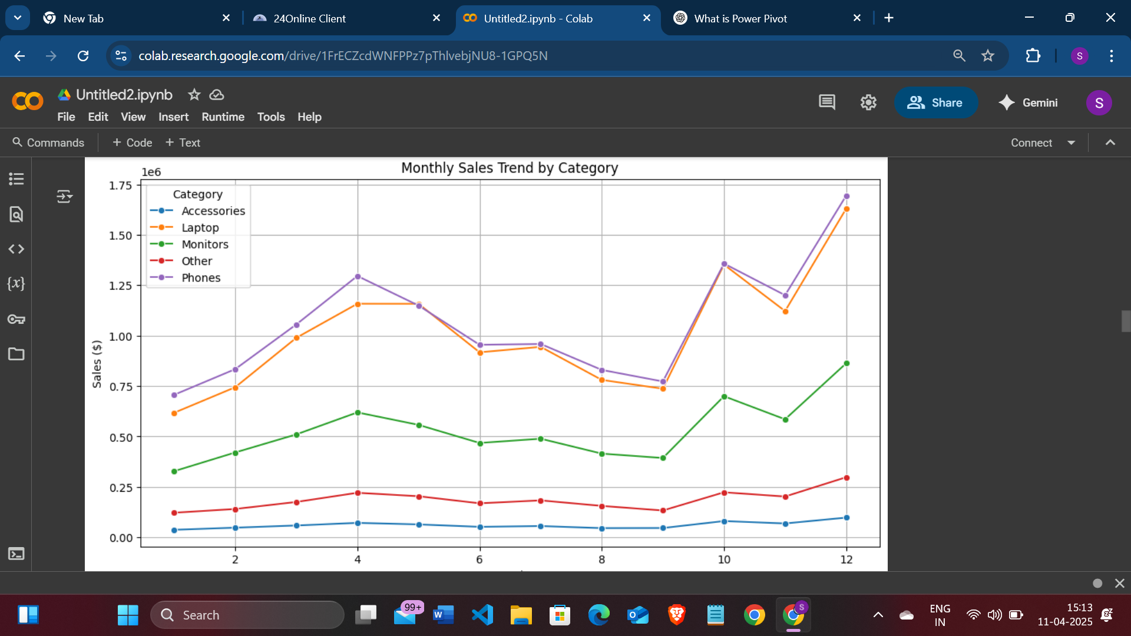

4.5 Temporal Distribution
By grouping articles by their month of publication, we observed how the quantity of fake and real news evolved over time.

Code:

4.6 Subject Distribution
The subject field helps identify topics associated with fake vs. real news.

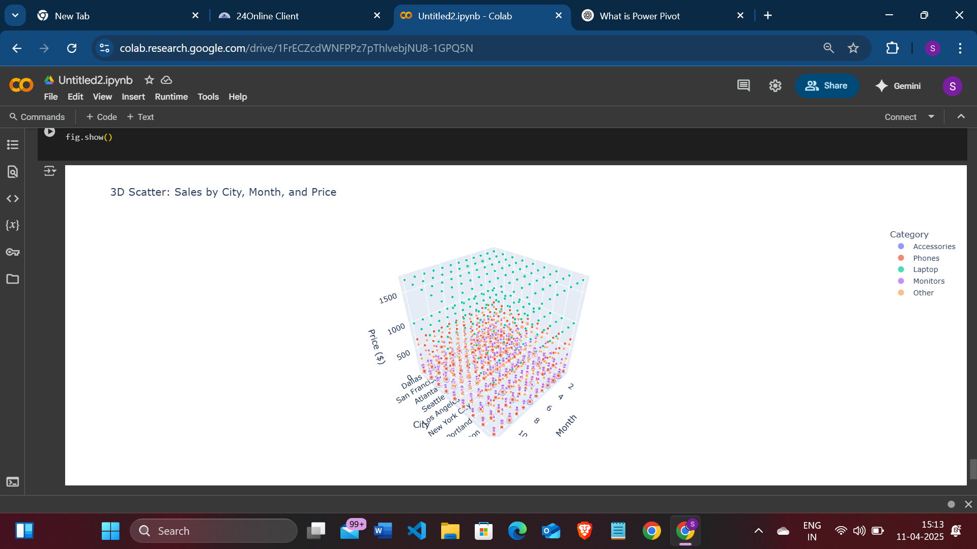

4.8 Article Length Box and Violin Plots
These plots help in understanding the distribution and spread of article lengths.
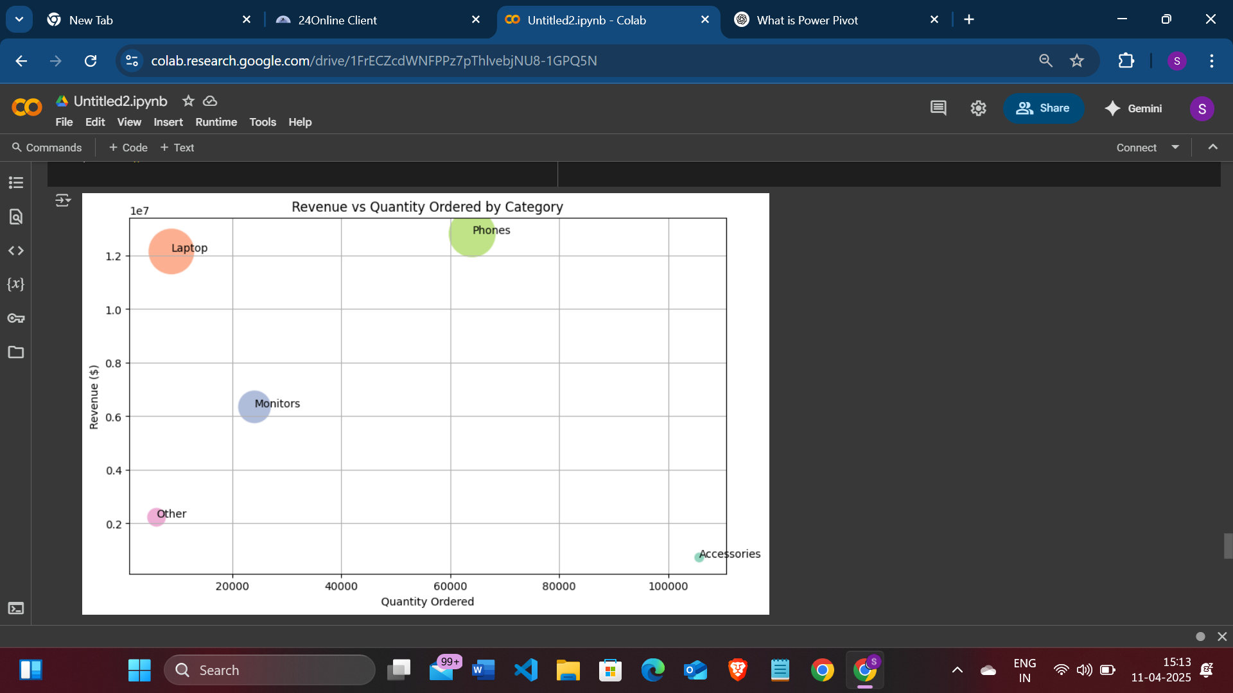

4.9 Heat Map
This heatmap helps visualize the correlation between numerical features like article length, sentiment polarity, and the target class. It reveals how strongly these variables are related, highlighting important patterns and potential redundancies that can influence model performance.
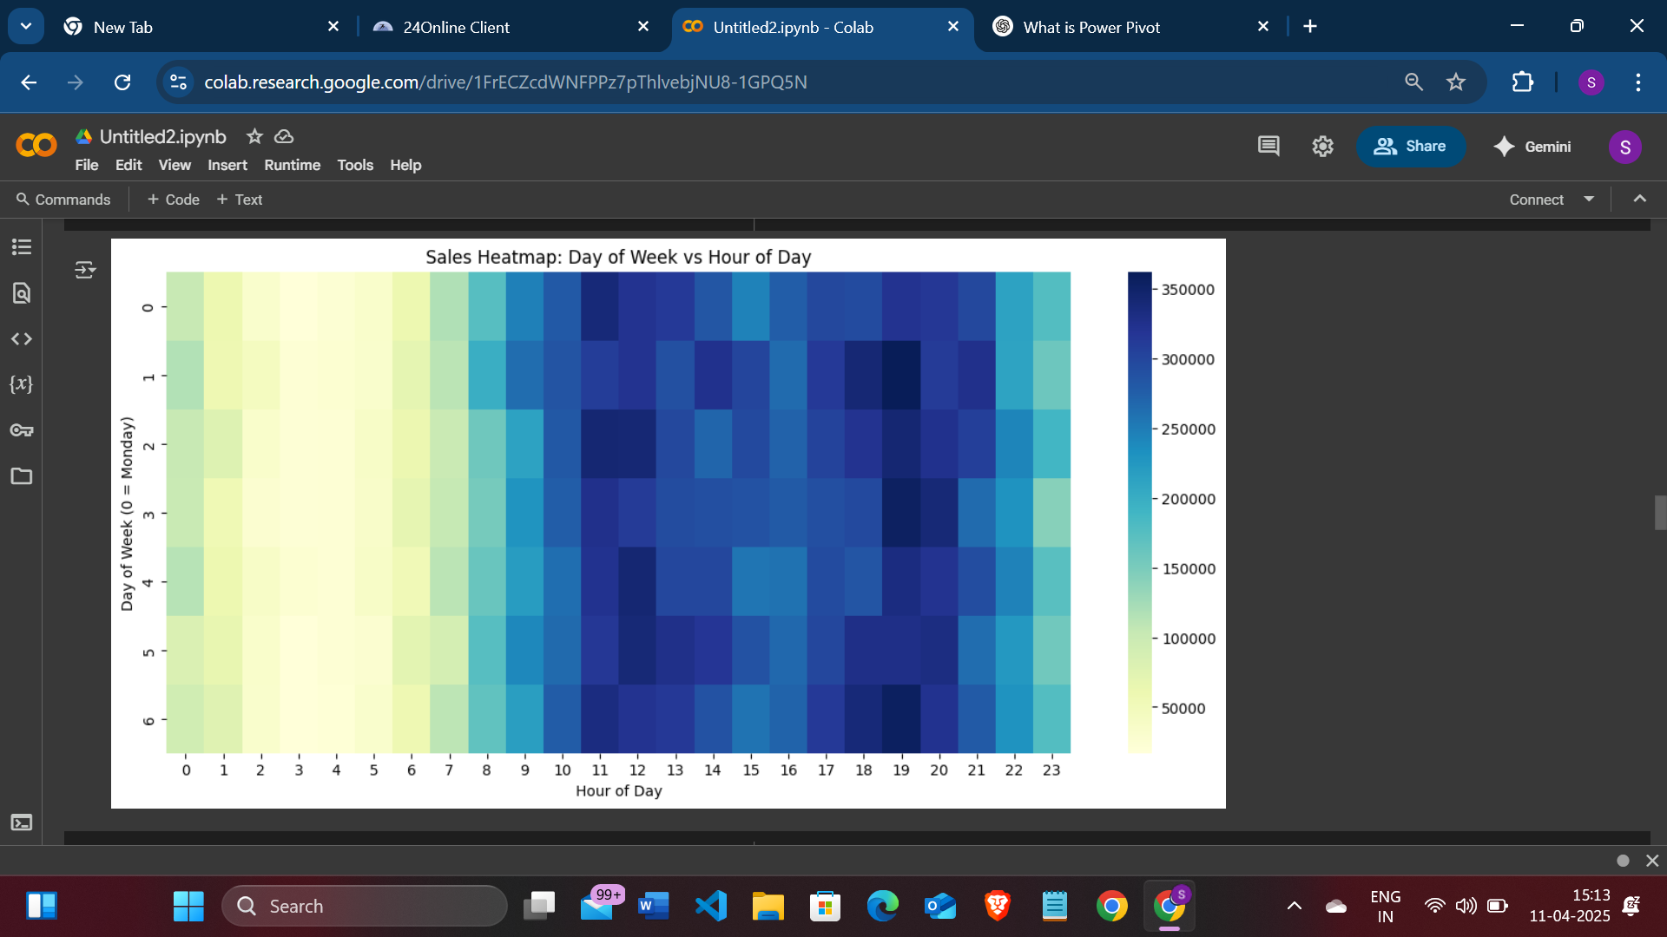

4.10 Pie chart
The pie chart provides a simple yet effective visualization of the proportion of item sales in the dataset. It helps us quickly understand the class balance and verify if the dataset is skewed or evenly distributed.
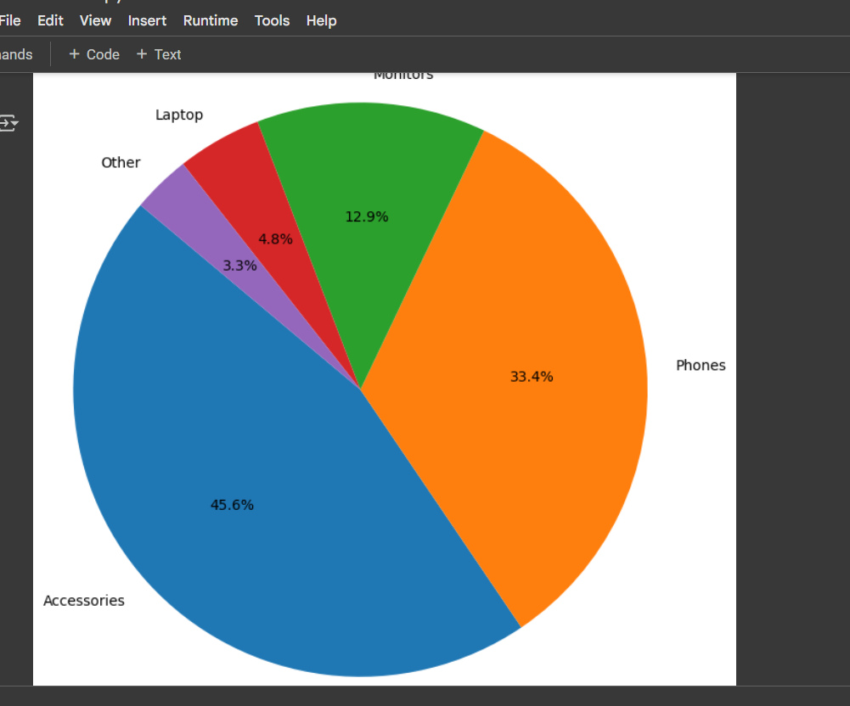

5. Machine Learning Models
Once the data was cleaned and preprocessed, the next step was to convert text into numerical form using TF-IDF Vectorization and train various machine learning models.

6. Code:-
import pandas as pd
import numpy as np
import matplotlib.pyplot as plt
import seaborn as sns

df = pd.read_csv('/content/Sales_Analysis (2).csv')
df.head(20)
df.shape
df.columns
df.info()
df.isnull().sum()
df.dropna(inplace=True)
df.isnull().sum()
df.duplicated().sum()
df.drop_duplicates(inplace=True)
df.shape
df['Order ID'] = pd.to_numeric(df['Order ID'], errors='coerce')
df['Quantity Ordered'] = pd.to_numeric(df['Quantity Ordered'], errors='coerce')
df['Price Each'] = pd.to_numeric(df['Price Each'], errors='coerce')
df['Order Date'] = pd.to_datetime(df['Order Date'], errors='coerce')
df.info()
df.isnull().sum()
df.dropna(inplace=True)
df.isnull().sum()
df['year'] = df['Order Date'].dt.year
df['month'] = df['Order Date'].dt.month
df['day'] = df['Order Date'].dt.day
df['time'] = df['Order Date'].dt.time
df['Product_integer'] = df['Price Each'].astype('int')
df['Pincodes'] = df['Purchase Address'].str[-5:]
df['Order ID'] = df['Order ID'].astype(int)
df['Order ID'].head(100)
df['Purchase Address']
df1 = df['Purchase Address'].str.split(',', n=3, expand=True)
df1.columns = ['Street', 'State', 'Zip']
df1
df1.rename(columns={'State': 'City'}, inplace=True)
df1['City']
df = pd.concat([df, df1['City']], axis=1) # 1 along the columns and 0 along the rows
df
df['Product'].unique()
patterns = {
'Phones': r'Phone',
'Accessories': r'Cable|Headphones|Batteries',
'Monitors': r'Monitor',
'Laptop': r'Laptop',
}
def categorize_product(product):
for category, pattern in patterns.items():
if pd.notnull(product) and pd.notnull(pattern) and pd.Series(product).str.contains(pattern, case=False, regex=True).any():
return category
return 'Other'

# Create a new column 'Category' based on 'Product' column
df['Category'] = df['Product'].apply(categorize_product)
df['Category'].unique()
df[df['Category'] == 'Other']
df['Order_month'] = df['Order Date'].dt.month

january_df = df[df['Order_month'] == 1].sort_values(by='Order Date')
february_df = df[df['Order_month'] == 2].sort_values(by='Order Date')
march_df = df[df['Order_month'] == 3].sort_values(by='Order Date')
april_df = df[df['Order_month'] == 4].sort_values(by='Order Date')
may_df = df[df['Order_month'] == 5].sort_values(by='Order Date')
june_df = df[df['Order_month'] == 6].sort_values(by='Order Date')
july_df = df[df['Order_month'] == 7].sort_values(by='Order Date')
august_df = df[df['Order_month'] == 8].sort_values(by='Order Date')
september_df = df[df['Order_month'] == 9].sort_values(by='Order Date')
october_df = df[df['Order_month'] == 10].sort_values(by='Order Date')
nomember_df = df[df['Order_month'] == 11].sort_values(by='Order Date')
december_df = df[df['Order_month'] == 12].sort_values(by='Order Date')
best_month = df.groupby('Order_month')[['Price Each']].sum()
best_month
sns.barplot(x=best_month.index, y=best_month['Price Each'])
plt.title("Best Month for Sales")
plt.show()
city_prod = df['City'].value_counts()
city_prod
df['Order_hour'] = df['Order Date'].dt.hour
df
hourly_orders = pd.DataFrame(df.groupby(['Order_hour']).size())
# The following line was corrected:
plt.figure(figsize=(10, 6)) # Changed 'hourly_ordersplt' to 'plt'
sns.barplot(x=hourly_orders.index, y=0, data=hourly_orders)
plt.xlabel('Hour of the Day')
plt.ylabel('Number of Orders')
plt.title('Distribution of Orders by Hour')
plt.xticks(range(24))

plt.show()

df.groupby('Category')[['Product']].value_counts().sort_values().head(1)
def season(month):
if month > 2 and month < 6:
return 'Spring'
elif month > 5 and month < 9:
return 'Summer'
elif month > 8 and month < 12:
return 'Rainy'
else:
return 'Winter'

df['Season'] = df['Order_month'].apply(season)
df
March_df = df[df['Order_month'] == 3]
March_df[March_df['Category'] == 'Phones']['Product'].value_counts().head(1)
Phones_df = df[df['Category'] == 'Phones']
Phones_df.sort_values(by='Price Each', ascending=False)
Phones_df.head(1)
price_variation = df.groupby(['Product', 'Order_month'])[
'Price Each'].agg(['min', 'max'])
price_variation['price_diff'] = price_variation['max'] - \
price_variation['min']
price_changed_products = price_variation[price_variation['price_diff'] != 0]
price_changed_products
df['Category'].unique()
df.head(10)
earphone_df = df[df['Category'] == 'Phones']
wired_quantity = earphone_df[earphone_df['Product'].str.contains(
'Wired')]['Quantity Ordered'].sum()
wireless_quantity = earphone_df[earphone_df['Product'].str.contains(
'Wireless')]['Quantity Ordered'].sum()
if wired_quantity > wireless_quantity:
preference = 'Wired earphones'
elif wired_quantity < wireless_quantity:
preference = 'Wireless earphones'
else:
preference = 'Equal preference for wired and wireless earphones'
print("People prefer", preference)
bulk_products = df.groupby('Category')['Product', 'Quantity Ordered'].max()
bulk_products_sorted = bulk_products.sort_values(
by='Quantity Ordered', ascending=False)
bulk_products_max = bulk_products_sorted.groupby('Category').first()
print(bulk_products_max)

category_month_sales = df.groupby(['Order_month', 'Category'])['Price Each'].sum().reset_index()

plt.figure(figsize=(12, 6))
sns.lineplot(data=category_month_sales, x='Order_month', y='Price Each', hue='Category', marker='o')
plt.title('Monthly Sales Trend by Category')
plt.xlabel('Month')
plt.ylabel('Sales ($)')
plt.grid(True)
plt.show()

df['Order_day'] = df['Order Date'].dt.dayofweek # 0 = Monday
sales_pivot = df.pivot_table(index='Order_day', columns='Order_hour', values='Price Each', aggfunc='sum')

plt.figure(figsize=(14, 6))
sns.heatmap(sales_pivot, cmap='YlGnBu')
plt.title('Sales Heatmap: Day of Week vs Hour of Day')
plt.xlabel('Hour of Day')
plt.ylabel('Day of Week (0 = Monday)')
plt.show()
category_counts = df['Category'].value_counts()
plt.figure(figsize=(8, 8))
plt.pie(category_counts, labels=category_counts.index, autopct='%1.1f%%', startangle=140)
plt.title('Product Category Share')
plt.axis('equal')
plt.show()
product_sales = df.groupby('Product').agg({'Quantity Ordered': 'sum', 'Price Each': 'sum'}).sort_values(by='Quantity Ordered', ascending=False)
fig, ax1 = plt.subplots(figsize=(14, 6))
sns.barplot(x=product_sales.index, y='Quantity Ordered', data=product_sales, color='skyblue', label='Quantity Ordered', ax=ax1)
ax2 = ax1.twinx()
sns.lineplot(x=product_sales.index, y='Price Each', data=product_sales, color='red', label='Revenue', marker='o', ax=ax2)
ax1.set_ylabel('Units Sold')
ax2.set_ylabel('Total Revenue ($)')
ax1.set_title('Top Products by Sales Volume and Revenue')
ax1.set_xticklabels(product_sales.index, rotation=90)
ax1.legend(loc='upper left')
ax2.legend(loc='upper right')
plt.tight_layout()
plt.show()
from itertools import combinations
from collections import Counter
order_df = df[df['Order ID'].duplicated(keep=False)]
order_df['Grouped'] = order_df.groupby('Order ID')['Product'].transform(lambda x: ','.join(x))
grouped = order_df[['Order ID', 'Grouped']].drop_duplicates()
count = Counter()
for items in grouped['Grouped']:
item_list = items.split(',')
count.update(Counter(combinations(sorted(item_list), 2)))
most_common_pairs = count.most_common(10)
products, counts = zip(*most_common_pairs)
labels = [f'{a} & {b}' for a, b in products]
plt.figure(figsize=(10, 6))
sns.barplot(x=counts, y=labels, palette='magma')
plt.title('Top 10 Frequently Bought Together Product Pairs')
plt.xlabel('Number of Orders')
plt.ylabel('Product Pairs')
plt.show()
bubble_df = df.groupby('Category').agg({'Quantity Ordered': 'sum', 'Price Each': 'sum'}).reset_index()
plt.figure(figsize=(10, 6))
sns.scatterplot(data=bubble_df, x='Quantity Ordered', y='Price Each', size='Price Each', hue='Category', sizes=(100, 2000), alpha=0.7, palette='Set2', legend=False)
for i in range(len(bubble_df)):
plt.text(x=bubble_df['Quantity Ordered'][i]+10, y=bubble_df['Price Each'][i], s=bubble_df['Category'][i])
plt.xlabel('Quantity Ordered')
plt.ylabel('Revenue ($)')
plt.title('Revenue vs Quantity Ordered by Category')
plt.grid(True)
plt.show()
!pip install plotly
import plotly.express as px
import plotly.graph_objects as go
fig = px.scatter_3d(df,
x='Order_month',
y='City',
z='Price Each',
color='Category',
size='Quantity Ordered',
hover_name='Product',
title='3D Scatter: Sales by City, Month, and Price')

fig.update_layout(scene=dict(
xaxis_title='Month',
yaxis_title='City',
zaxis_title='Price ($)'
))

fig.show()

6. Conclusion
The Sales Analysis Using Machine Learning project has effectively showcased how predictive models can be leveraged to extract valuable insights from historical sales data. By performing thorough data preprocessing, exploratory data analysis, and applying suitable machine learning algorithms, this project was able to identify key sales patterns and forecast future sales trends.
The predictive models developed demonstrated promising accuracy in estimating future sales, making them a useful tool for inventory planning, budgeting, and strategic decision-making. Moreover, visual analysis enhanced interpretability, helping stakeholders understand the underlying data behavior and market dynamics. This reinforces the potential of machine learning in automating sales analysis and supporting data-driven business strategies.

7. Future Scope
This project has the potential to evolve further:
• Integration of Real-Time Data: Incorporating live sales feeds can help models adapt to changing market trends and provide more dynamic forecasting.
• Inclusion of External Factors: Adding features like marketing spend, seasonal effects, economic indicators, and customer demographics can improve model accuracy.
• Advanced ML Models: Exploring deep learning models such as LSTM (Long Short-Term Memory) networks for time-series sales forecasting could yield better performance over large datasets.
• Interactive Dashboards: Deploying the model results via a dashboard (e.g., using Streamlit or Power BI) can allow non-technical users to interactively explore insights.
• Recommendation Systems: Building an upsell/cross-sell recommender system based on sales trends could provide personalized suggestions and boost revenue.
• Scalability: The approach can be scaled to include multiple regions or product lines, offering broader business applicability.

8. References
- Scikit-learn: https://scikit-learn.org
- Seaborn & Matplotlib for Visualization
- TextBlob for NLP sentiment analysis
- WordCloud library for visual word analysis
- Linkdin Post Link:- https://www.linkedin.com/posts/shivanshu-singh-8431a22b4_machinelearning-python-salesanalysis-activity-7316703324458610688-mG55?utm_source=share&utm_medium=member_desktop&rcm=ACoAAEt9iDMBUzrB5f7XvCvIibyraekGq6SthOs
- Git Hub: https://github.com/0shivanshuu/Python-New-Project
- Drive Link: https://drive.google.com/drive/folders/1NkF2RC971LURL1GMicI5benFObiMGy_8?usp=sharing

